Objectives

Explain basic data transmission concepts, including full duplexing, attenuation, latency, and noise

Describe the physical characteristics of coaxial cable, STP, UTP, and fiber-optic media

Compare the benefits and limitations of different networking media

Explain the principles behind and uses for serial connector cables

Identify wiring standards and the best practices for cabling buildings and work areas
Transmission Basics

Transmit

Issue signals along network medium

Transmission

Process of transmitting

Signal progress after transmitted

Transceiver

Transmit and receive signals

Analog and Digital Signaling

Important data transmission characteristic

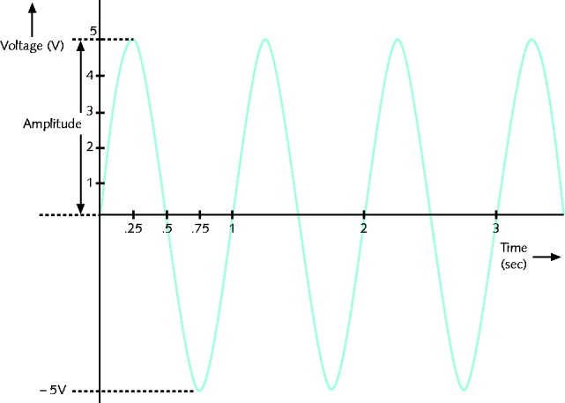
Signaling type: analog or digital

Volt

Electrical current pressure

Electrical signal strength

Directly proportional to voltage

Signal voltage

Signals

Current, light pulses, electromagnetic waves

Analog data signals

Voltage varies continuously

Properties

Amplitude, frequency, wavelength, phase

Amplitude

Analog wave’s strength

Frequency

Number of times amplitude cycles over fixed time period

Measure in hertz (Hz)

Wavelength

Distance between corresponding wave cycle points

Inversely proportional to frequency

Expressed in meters or feet

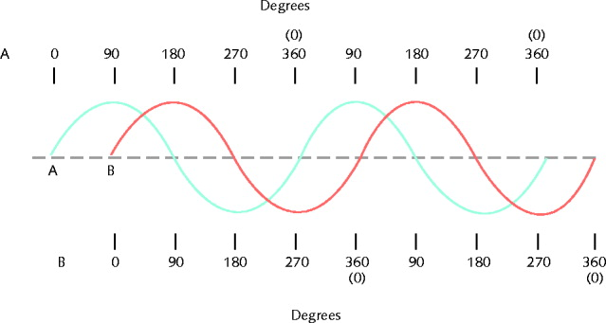
Phase

Wave’s progress over time in relationship to fixed point

Analog signal benefit over digital

More variable

Convey greater subtleties with less energy

Drawback of analog signals

Varied and imprecise voltage

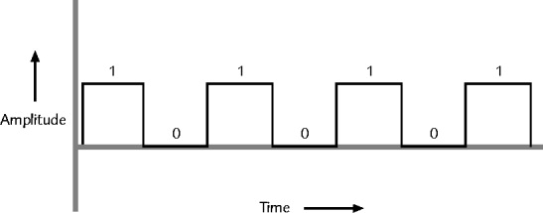
Susceptible to transmission flaws

Digital signals

Pulses of voltages

Positive voltage represents a 1

Zero voltage represents a 0

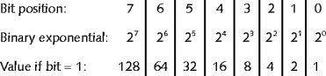
Binary system

1s and 0s represent information

Bit (binary digit)

Possible values: 1 or 0

Digital signal pulse

Byte

Eight bits together

Computers read and write information

Using bits and bytes

Find decimal value of a bit

Multiply the 1 or 0 by 2^{x} (x equals bit’s position)

Convert byte to decimal number

Determine value represented by each bit

Add values

Convert decimal number to a byte

Reverse the process

Convert between binary and decimal

By hand or calculator

Binary to Decimal conversion

Binary numbers are sometimes written prefixed with 0b

0b0001 = 0*8 + 0*4 + 0*2 + 1*1 = 1

0b1010 = 1*8 + 0*4 + 1*2 + 0*1 = 10

0b1011 = 1*8 + 0*4 + 1*2 + 1*1 = 11

Decimal to Binary

14 = 8+4+2 = 1*8 + 1*4 + 1*2 + 0*1 = 0b1110

3 = 2+1 = 0*8 + 0*4 + 1*2 + 1*1 = 0b0011

6 = 4+2 = 0*8 + 1*4 + 1*2 + 0*1 = 0b0110

Larger Values

128= 1*128 + 0*64 + 0*32 +0*16 +0*8 +0*4 + 0*2 +0*1

128 = 0b10000000

162= 128 + 32 + 2

162= 1*128 + 0*64 + 1*32 +0*16 +0*8 +0*4 + 1*2 +0*1

162 = 0b10100010

0b1111000 =

1*128 + 1*64 + 1*32 +1*16 +0*8 +0*4 + 0*2 +0*1 0 =

128 + 64 + 32 +16 = 240

Binary on Quizzes

I'll add a binary question to the next quiz, and maybe the one after that, as extra credit

I recommend that you learn binary conversion, but I don't require it

Digital signal benefit over analog signal

More reliable

Less severe noise interference

Digital signal drawback

Many pulses required to transmit same information

Overhead

Nondata information

Required for proper signal routing and interpretation

Such as addressing information

Data Modulation

Data relies on digital transmission

Network connection may handle only analog signals

Modem

Accomplishes translation

Modulator/demodulator

Data modulation

Technology modifying analog signals

Make data suitable for carrying over communication path

Carrier wave

Combined with another analog signal

Produces unique signal

Transmitted from one node to another

Preset properties

Purpose

Convey information

Information wave (data wave)

Added to carrier wave

Modifies one carrier wave property

Frequency modulation (FM)

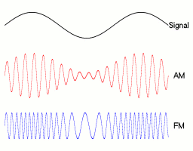
Carrier frequency modified

By application of data signal

Amplitude modulation (AM)

Carrier signal amplitude modified

By application of data signal

Simplex, Half-Duplex, and Duplex

Simplex

Signal transmission: one direction

Like broadcast TV

Half-duplex transmission

Signal transmission: both directions

One at a time

One communication channel

Shared for multiple nodes to exchange information

Full-duplex

Signals transmission: both directions simultaneously

Used on data networks
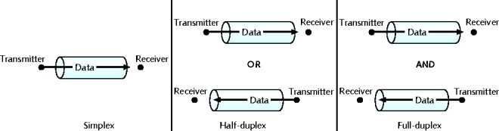

Channel

Distinct communication path between nodes

Separated physically or logically

Full duplex advantage

Increases speed

Multiplexing

Multiple signals

Travel simultaneously over one medium

Subchannels

Logical multiple smaller channels

Multiplexer (mux)

Combines many channel signals

Demultiplexer (demux)

Separates combined signals

Regenerates them

TDM (time division multiplexing)

Divides channel into multiple time intervals

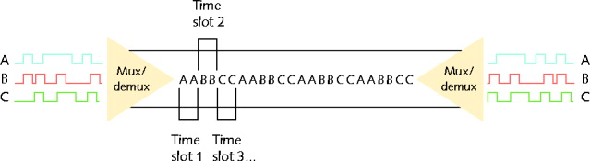
Figure 3-7 Time division multiplexing

Statistical multiplexing

Transmitter assigns slots to nodes

According to priority, need

More efficient than TDM

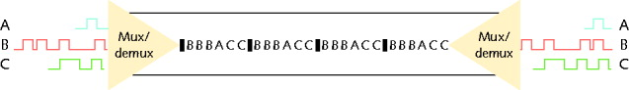
Figure 3-8 Statistical multiplexing

FDM (frequency division multiplexing)

Unique frequency band for each communications subchannel

Two types

Cellular telephone transmission

DSL Internet access

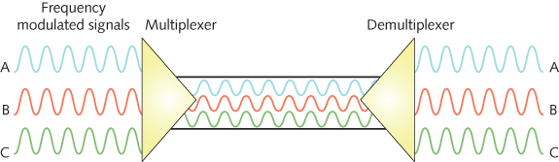
Figure 3-9 Frequency division multiplexing

WDM (wavelength division multiplexing)

One fiber-optic connection

Carries multiple light signals simultaneously

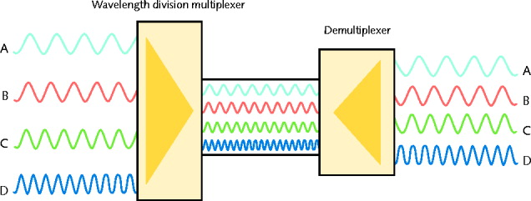
Figure 3-10 Wavelength division multiplexing

DWDM (dense wavelength division multiplexing)

Used on most modern fiber-optic networks

Extraordinary capacity

Relationships Between Nodes

Point-to-point transmission

One transmitter and one receiver

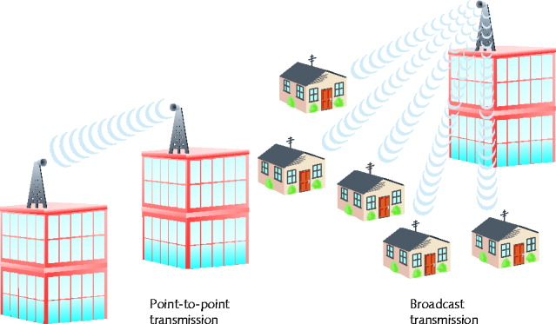
Point-to-multipoint transmission

One transmitter and multiple receivers

Broadcast transmission

One transmitter and multiple, undefined receivers

Used on wired and wireless networks

Simple and quick

Nonbroadcast

One transmitter and multiple, defined receivers

Throughput and Bandwidth

Throughput

Measures amount of data transmitted during given time period

Capacity or bandwidth

Quantity of bits transmitted per second

Bandwidth (strict definition)

Measures difference between highest and lowest frequencies medium can transmit

Range of frequencies

Measured in hertz (Hz)

Throughput
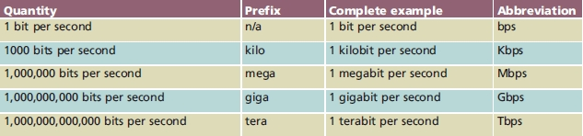

Baseband and Broadband

Baseband transmission

Digital signals sent through direct current (DC) pulses applied to wire

Requires exclusive use of wire’s capacity

Transmit one signal (channel) at a time

Example: Ethernet

Broadband transmission

Signals modulated

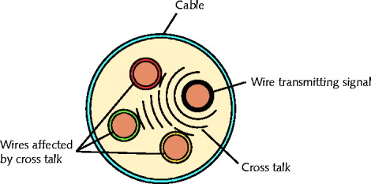
Radiofrequency (RF) analog waves

Uses different frequency ranges

Does not encode information as digital pulses

Transmission Flaws

Noise

Any undesirable influence degrading or distorting signal

Types of noise

EMI (electromagnetic interference)

EMI/RFI (radiofrequency interference)

Cross talk

NEXT (near end cross talk)

Potential cause: improper termination

Environmental influences

Heat

Attenuation

Loss of signal’s strength as it travels away from source

Signal boosting technology

Analog signals pass through amplifier

Noise also amplified

Regeneration

Digital signals retransmitted in original form

Repeater: device regenerating digital signals

Amplifiers and repeaters

OSI model Physical layer

Latency

Delay between signal transmission and receipt

Causes

Cable length

Intervening connectivity device

RTT (round trip time)

Time for packet to go from sender to receiver, then back from receiver to sender

Measured in milliseconds

May cause network transmission errors
Common Media Characteristics

Selecting transmission media

Match networking needs with media characteristics

Physical media characteristics

Throughput

Cost

Size and scalability

Connectors

Noise immunity

Throughput

Most significant transmission method factor

Causes of limitations

Laws of physics

Signaling and multiplexing techniques

Noise

Devices connected to transmission medium

Fiber-optic cables allows faster throughput

Compared to copper or wireless connections

Cost

Precise costs difficult to pinpoint

Media cost dependencies

Existing hardware, network size, labor costs

Variables influencing final cost

Installation cost

New infrastructure cost versus reuse

Maintenance and support costs

Cost of lower transmission rate affecting productivity

Cost of obsolescence

Noise Immunity

Noise distorts data signals

Distortion rate dependent upon transmission media

Fiber-optic: least susceptible to noise

Limit impact on network

Cable installation

Far away from powerful electromagnetic forces

Select media protecting signal from noise

Antinoise algorithms

Size and Scalability

Three specifications

Maximum nodes per segment

Maximum segment length

Maximum network length

Maximum nodes per segment dependency

Attenuation and latency

Maximum segment length dependency

Attenuation and latency plus segment type

Segment types

Populated: contains end nodes

Unpopulated: No end nodes

Link segment

Segment length limitation

After certain distance, signal loses strength

Cannot be accurately interpreted

Connectors and Media Converters

Connectors

Hardware connecting wire to network device

Specific to particular media type

Affect costs

Installing and maintaining network

Ease of adding new segments or nodes

Technical expertise required to maintain network

Media converter

Hardware enabling networks or segments running on different media to interconnect and exchange signals
Coaxial Cable

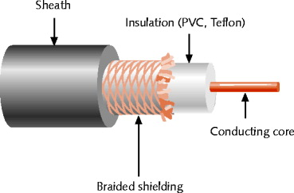
Central metal core (often copper)
Figure 3-16 Coaxial cable

Surrounded by insulator

Braided metal shielding (braiding or shield)

Outer cover (sheath or jacket)

High noise resistance

Advantage over twisted pair cabling

Carry signals farther before amplifier required

Disadvantage over twisted pair cabling

More expensive

Hundreds of specifications

RG specification number

Differences: shielding and conducting cores

Transmission characteristics

Conducting core

American Wire Gauge (AWG) size

Data networks usage

RG-6: Used in modern cable TV connections, most common

RG-8: Thicknet--obsolete

RG-58: Thinnet—also obsolete for data networks

RG-59: Used for short spans in modern cable TV connections
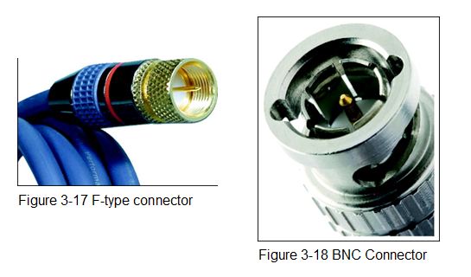

Coaxial Cable Connectors

Twisted Pair Cable

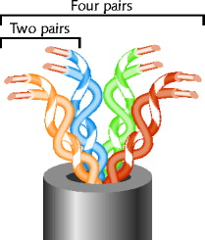
Color-coded insulated copper wire pairs
Figure 3-19 Twisted pair cable

0.4 to 0.8 mm diameter

Encased in a plastic sheath

More wire pair twists per foot

More resistance to cross talk

Higher-quality

More expensive

Twist ratio

Twists per meter or foot

High twist ratio

Greater attenuation

Hundreds of different designs

Dependencies

Twist ratio, number of wire pairs, copper grade, shielding type, shielding materials

1 to 4200 wire pairs possible

Wiring standard specification

TIA/EIA 568

Twisted pair wiring types

Cat (category) 3, 4, 5, 5e, 6, and 6e, Cat 7

CAT 5 most often used in modern LANs

Advantages

Relatively inexpensive

Flexible

Easy installation

Spans significant distance before requiring repeater

Accommodates several different topologies

Handles current faster networking transmission rates

Two categories

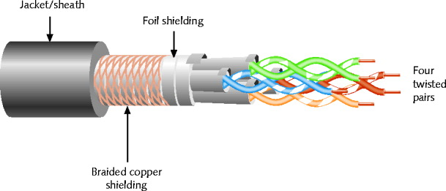
STP (shielded twisted pair)
Figure 3-20 STP cable

UTP (unshielded twisted pair)

STP (Shielded Twisted Pair)

Individually insulated

Surrounded by metallic substance shielding (foil)

Barrier to external electromagnetic forces

Contains electrical energy of signals inside

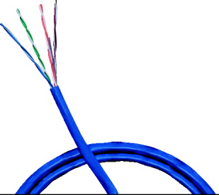
May be grounded
Figure 3-21 UTP cable

UTP (Unshielded Twisted Pair)

One or more insulated wire pairs

Encased in plastic sheath

No additional shielding

Less expensive, less noise resistance

EIA/TIA standards

Cat 3 (Category 3)

Cat 4 (Category 4)

Cat 5 (Category 5)

Cat 5e (Enhanced Category 5)

Cat 6 (Category 6)

Cat 6e (Enhanced Category 6)

Cat 7 (Category 7)
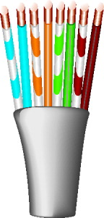
Figure 3-22 A Cat 5 UTP cable with pairs untwisted

Comparing STP and UTP

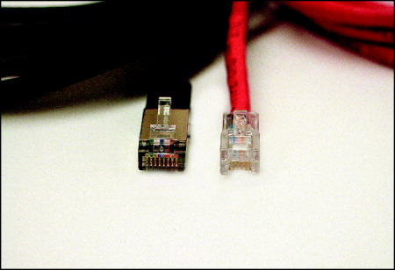
Throughput
Figure 3-23 RJ-45 and RJ-11 connectors

STP and UTP transmit the same rates

Cost

STP and UTP vary

Noise immunity

STP more noise resistant

UTP subject to techniques to offset noise

Size and scalability

STP and UTP maximum segment length

100 meters

Connector

STP and UTP use RJ-45 (Registered Jack 45)

Telephone connections use RJ-11 (Registered Jack 11)

Terminating Twisted Pair Cable

Patch cable

Relatively short cable

Connectors at both ends

Proper cable termination techniques

Basic requirement for two nodes to communicate

Poor terminations

Lead to loss or noise

TIA/EIA standards

TIA/EIA 568A

TIA/EIA 568B

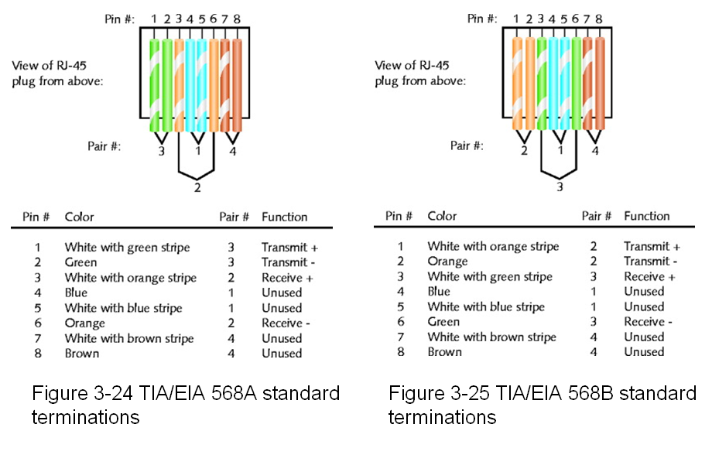

Straight-through cable

Terminate RJ-45 plugs at both ends identically

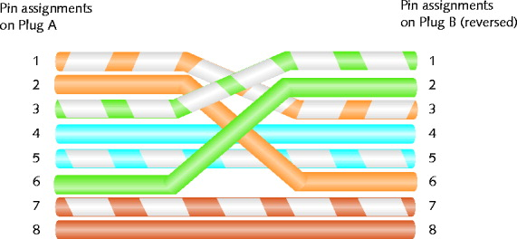
Figure 3-26 RJ-45 terminations on a crossover cable

Crossover cable

Transmit and receive wires on one end reversed

Termination tools

Wire cutter

Wire stripper

Crimping tool

After making cables

Verify data transmit and receive
Fiber-Optic Cable

Fiber-optic cable (fiber)

One (or several) glass or plastic fibers at its center (core)

Data transmission

Pulsing light sent from laser

LED (light-emitting diode) through central fibers

Cladding

Layer of glass or plastic surrounding fibers

Different density from glass or plastic in strands

Reflects light back to core

Allows fiber to bend

Plastic buffer

Outside cladding

Protects cladding and core

Opaque

Absorbs any escaping light

Kevlar strands (polymeric fiber) surround plastic buffer

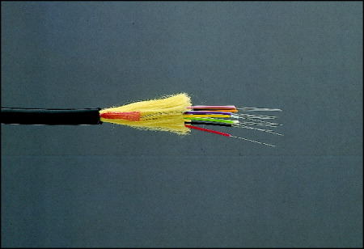
Plastic sheath covers Kevlar strands
Figure 3-30 A fiber-optic cable

Different varieties

Based on intended use and manufacturer

Two categories

Single-mode

Multimode

SMF (Single-Mode Fiber)

Uses narrow core (< 10 microns in diameter)

Laser generated light travels over one path

Little reflection

Light does not disperse

Accommodates

Highest bandwidths, longest distances

Connects carrier’s two facilities

Costs prohibit typical LANs, WANs use

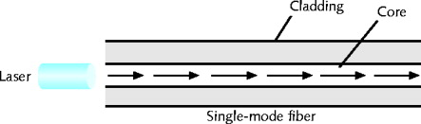
Figure 3-31 Transmission over single-mode fiber-optic cable

MMF (Multimode Fiber)

Uses core with larger diameter than single-mode fiber

Common size: 62.5 microns

Laser or LED generated light pulses travel at different angles

Common uses

Cables connecting router to a switch

Cables connecting server on network backbone

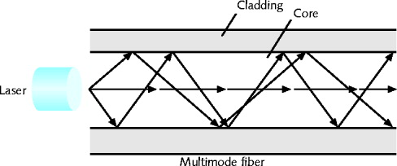
Figure 3-32 Transmission over multimode fiber-optic cable

Benefits

Extremely high throughput

Very high resistance to noise

Excellent security

Ability to carry signals for much longer distances before requiring repeaters than copper cable

Industry standard for high-speed networking

Drawback

More expensive than twisted pair cable

Requires special equipment to splice

Throughput

Reliable transmission rates

Can reach 100 gigabits (or 100,000 megabits) per second per channel (but only for singlemode, not multimode)

Cost

Most expensive transmission medium

Connectors

ST (straight tip)

SC (subscriber connector or standard connector)

LC (local connector)

MT-RJ (mechanical transfer registered jack)

Noise immunity

Unaffected by EMI

Size and scalability

Segment lengths vary

150 to 40,000 meters

Due primarily to optical loss
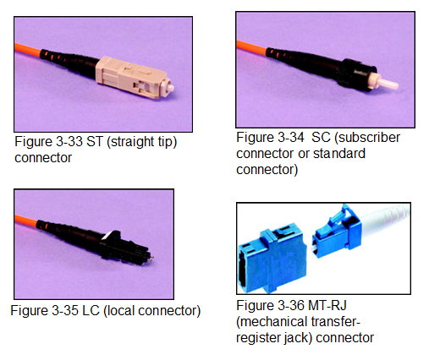

DTE (Data Terminal Equipment) and DCE (Data Circuit-Terminating Equipment) Connector Cables

DTE (data terminal equipment)

Any end-user device

DCE (data circuit-terminating equipment)

Device that processes signals

Supplies synchronization clock signal

DTE and DCE connections

Serial

Pulses flow along single transmission line

Sequentially

Serial cable

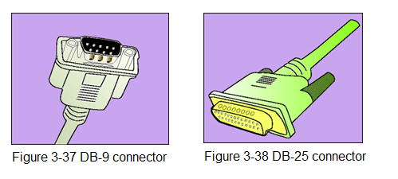
Carries serial transmissions

RS-232 (Recommended Standard 232)

EIA/TIA standard

Physical layer specification

Signal voltage, timing, compatible interface characteristics

Connector types

RJ-45 connectors, DB-9 connectors, DB-25 connectors

RS-232 used between PC and router today

RS-232 connections

Straight-through, crossover, rollover

Structured Cabling

Cable plant

Hardware making up enterprise-wide cabling system

Standard

TIA/EIA joint 568 Commercial Building Wiring Standard

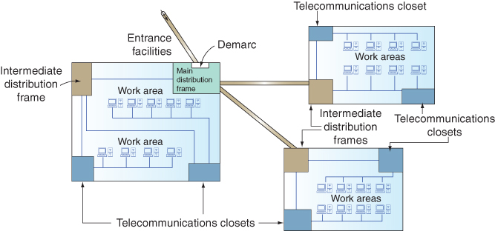
Figure 3-39 TIA/EIA structured cabling in an enterprise

Components

Entrance facilities

MDF (main distribution frame)

Cross-connect facilities

IDF (intermediate distribution frame)

Backbone wiring

Telecommunications closet

Horizontal wiring

Work area

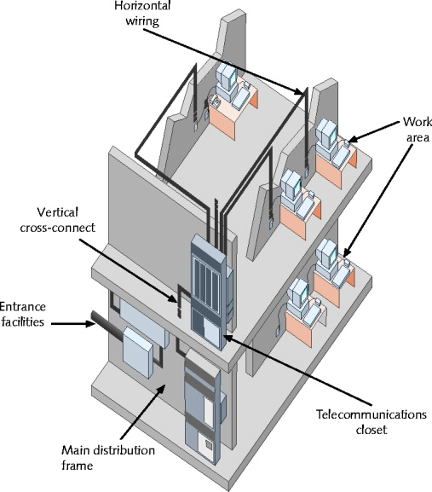
Figure 3-40 TIA/EIA structured cabling in a building

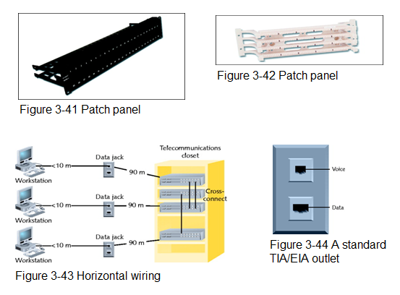

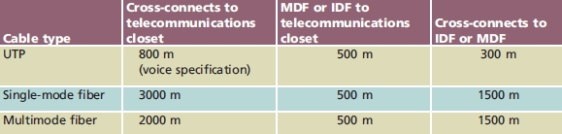
Table 3-2 TIA/EIA specifications for backbone cabling

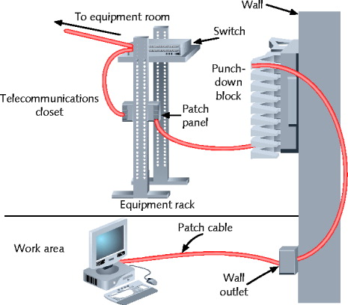
Figure 3-45 A typical UTP cabling installation
Best Practices for Cable Installation and Management

Choosing correct cabling

Follow manufacturers’ installation guidelines

Follow TIA/EIA standards

Network problems

Often traced to poor cable installation techniques

Installation tips to prevent Physical layer failures

Last modified 12-14-09

