Objectives

Identify and explain the functions of the core TCP/IP protocols

Explain how the TCP/IP protocols correlate to layers of the OSI model

Discuss addressing schemes for TCP/IP in IPv4 and IPv6 protocols

Describe the purpose and implementation of DNS (Domain Name System) and DHCP (Dynamic Host Configuration Protocol)

Identify the well-known ports for key TCP/IP services

Describe common Application layer TCP/IP protocols
Characteristics of TCP/IP (Transmission Control Protocol/ Internet Protocol)

Protocol Suite

“TCP/IP”

Subprotocols

TCP, IP, UDP, ARP

Developed by Department of Defense

ARPANET (1960s)

Internet precursor

Popularity

Low cost

Communicates between dissimilar platforms

Open nature

Routable

Spans more than one LAN (LAN segment)

Flexible

Runs on combinations of network operating systems or network media

Disadvantage: requires more configuration
The TCP/IP Core Protocols

TCP/IP suite subprotocols

Operates in Transport or Network layers of OSI model

Provide basic services to protocols in other layers

Most significant protocols in TCP/IP

TCP

IP

TCP (Transmission Control Protocol)

Transport layer protocol

Provides reliable data delivery services

Connection-oriented subprotocol

Establish connection before transmitting, with the TCP Handshake

Sequencing and checksums

Flow control

Transmitter waits for ACK before sending more

TCP segment format

Encapsulated by IP datagram in Network layer

Becomes IP datagram’s “data”

TCP Segment

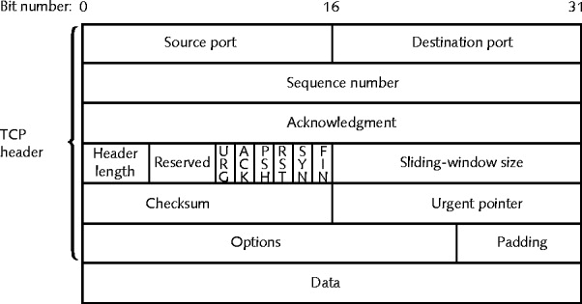

Important TCP Header Fields

Flags, especially SYN and ACK

Indicates purpose of segment

Source Port and Destination Port

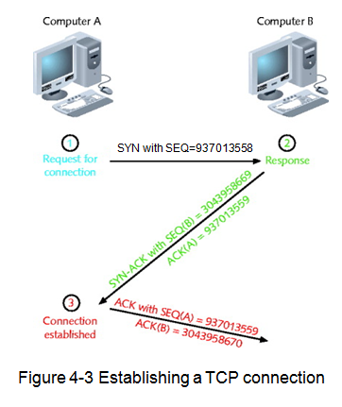
Guides data to the correct process on the destination computer

SEQ number and ACK number

Used to arrange segments in the correct order

TCP Handshake

Computer A sends SYN to Computer B

SYN flag set

SEQ field: Random initial sequence number (ISN)

ACK field: Empty (zeroes)

Computer B replies with SYN/ACK

SYN and ACK flags set

SEQ field: Computer B's random initial sequence number (ISN)

ACK field: Computer A's ISN plus 1

Computer A responds with ACK

ACK flag set

SEQ field: Computer A's ISN plus 1

ACK field: Computer B's ISN plus 1

Ending a TCP Session

FIN flag indicates transmission end

Wireshark Demonstration

Relative SEQ and ACK numbers at top

Absolute SEQ and ACK values at bottom, in hexadecimal
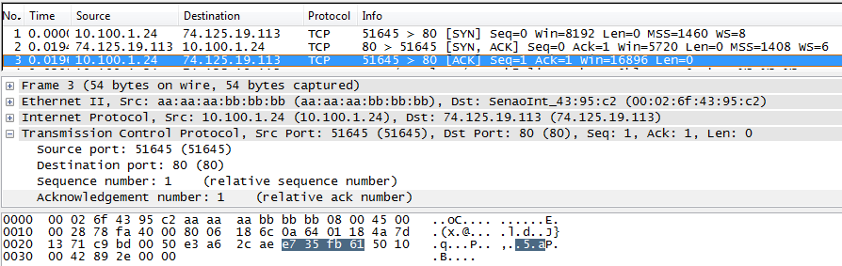

UDP (User Datagram Protocol)

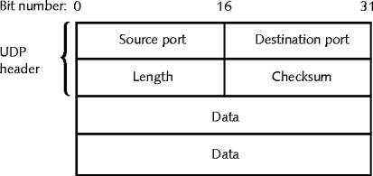
Transport layer protocol

Provides unreliable data delivery services

Connectionless transport service

No assurance packets received in correct sequence

No guarantee packets received at all

No error checking, sequencing

Lacks sophistication

More efficient than TCP

Useful situations

Great volume of data transferred quickly

IP (Internet Protocol)

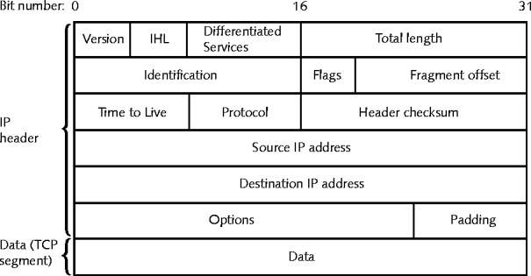
Network layer protocol

Routes packets using IP addresses

Enables TCP/IP to internetwork

Routers move IP packets move from one network to another

Unreliable, connectionless protocol

No guaranteed data delivery, no handshake

Some higher level protocols provide reliability, like TCP

Important IP Header Fields

TTL (Time to Live)

Decreases by one for each router the packet passes through (a "hop")

When TTL reaches zero, the packet is discarded

Source Destination IP Addresses

Used to deliver packet and response

ICMP (Internet Control Message Protocol)

Network layer protocol

Reports on data delivery success/failure

Announces transmission failures to sender

Network congestion

Data fails to reach destination

Data discarded: TTL expired

ICMP cannot correct errors

Provides critical network problem troubleshooting information

IGMP (Internet Group Management Protocol)

Network layer protocol

Manages multicasting

Allows one node to send data to defined group of nodes

Uses

Internet teleconferencing

Routers sending traffic reports to each other

ARP (Address Resolution Protocol)

Network layer protocol

Obtains a MAC address from an IP address

ARP table (ARP cache)

Computers store recently-used MAC-to-IP address mappings

Increases efficiency

Controlled by ARP command

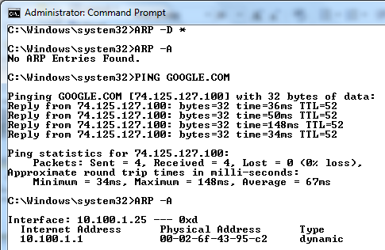
ARP Demonstration

ARP -D *

Clears the ARP cache

ARP -A

Shows the ARP cache

S

RARP (Reverse Address Resolution Protocol)

Converts MAC address to IP Address

Obsolete—replaced by DHCP
IPv4 Addressing

IPv4 Addressing

Networks recognize two addresses

Logical (Network layer)

Physical (MAC, hardware) addresses

IP protocol handles logical addressing

Specific parameters

Unique 32-bit number

Divided into four octets (sets of eight bits)

Separated by periods
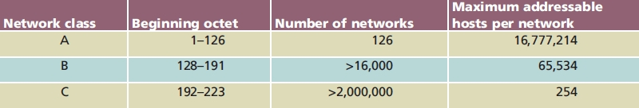

Example: 144.92.43.178

IP address information

Network Class determined by first octet

Class A, Class B, Class C

Class D, Class E rarely used (never assign)

Class D: value between 224 and 230

Multicasting

Class E: value between 240 and 254

Experimental use

Eight bits have 256 combinations

Networks use 1 through 254

0: reserved as placeholder

10.0.0.0

255: reserved for broadcast transmission

255.255.255.255

Class A devices

Share same first octet (bits 0-7)

Network ID

Host: second through fourth octets (bits 8-31)

Class B devices

Share same first two octet (bits 0-15)

Host: second through fourth octets (bits 16-31)

Class C devices

Share same first three octet (bits 0-23)

Host: second through fourth octets (bits 24-31)
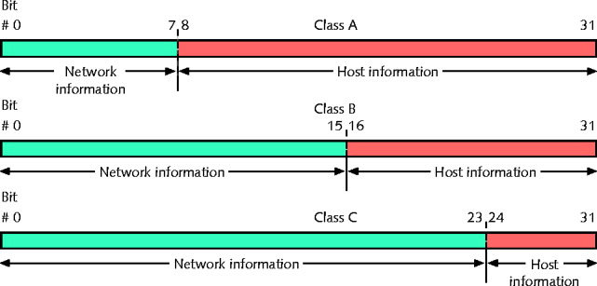

Running out of addresses

IPv6 incorporates new addressing scheme

Loop back address

First octet equals 127 (127.0.0.1)

Loopback test

Attempting to connect to own machine

Powerful troubleshooting tool

Windows XP, Vista

ipconfig command

Unix, Linux

ifconfig command

Binary and Dotted Decimal Notation

Decimal number between 0 and 255 represents each binary octet

Period (dot) separates each decimal

Dotted decimal address has binary equivalent

Converting each octet

Remove decimal points

Subnet Mask

Identifies every device on TCP/IP-based network

32-bit number (net mask)

Identifies device’s subnet

Combines with device IP address

Informs network about segment, network where device attached

Four octets (32 bits)

Expressed in binary or dotted decimal notation

Assigned same way as IP addresses

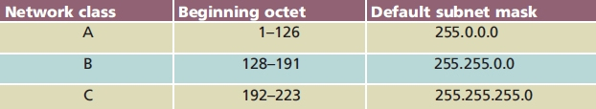
Manually, or automatically (via DHCP)

Subnetting

Subdividing network single class into multiple, smaller logical networks (segments)

Control network traffic

Make best use of limited number of IP addresses

Subnet mask varies depending on subnetting

Nonsubnetted networks use defaults
Assigning IP Addresses

Government-sponsored organizations

Dole out IP address blocks to companies

IANA, ICANN, RIRs

Companies, individuals

Obtain IP addresses from ISPs

Every network node must have unique IP address

Otherwise it cannot send or receive Internet packets

Static and Automatic IP Address Assignment

Static IP address

Manually typed into each device

Modify client workstation TCP/IP properties

Only way to change

Human error cause duplicates

Automatic IP addressing

BOOTP and DHCP

Reduce duplication error

BOOTP (Bootstrap Protocol)

Mid-1980s

Application layer protocol

Central list

IP addresses, associated devices’ MAC addresses

Assign client IP addresses dynamically

Dynamic IP address

Assigned to device upon request

Changeable

BOOTP process

Client connects to network

Sends broadcast message asking for IP address

Includes client’s NIC MAC address

BOOTP server looks up client’s MAC address in BOOTP table

Responds to client

Client’s IP address

Server IP address

Server host name

Default router IP address

Process resembles RARP

Difference

RARP requests, responses not routable

RARP only capable of issuing IP address to client

BOOTP may issue additional information (client’s subnet mask)

BOOTP surpassed by DHCP (Dynamic Host Configuration Protocol)

More sophisticated IP addressing utility

DHCP requires little intervention

BOOTP difficult to maintain on large networks

DHCP (Dynamic Host Configuration Protocol)

Assigns network device unique IP address

Automatically

Application layer protocol

Developed by IETF (BOOTP replacement)

Operation

Similar to BOOTP

Lower administrative burden

Administrator does not maintain table

Requires DHCP service on DHCP server

Reasons to Use DHCP

Saves time spent assigning IP addresses

Prevents accidental duplicate IP addresses

Allows users to move devices (like laptops) without having to change their TCP/IP configuration

DHCP Leasing Process

Device borrows (leases) IP address

Devices use IP address temporarily

Specified time limit

Lease time

Determine when client obtains IP address at log on

User may force lease termination

DHCP service configuration

Specify leased address range

Configure lease duration

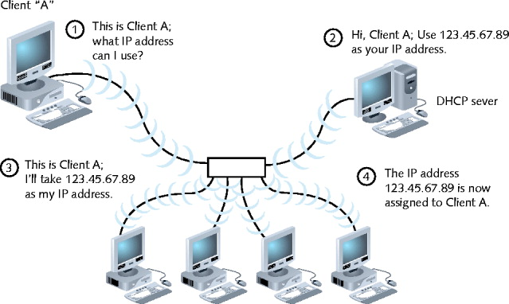
Several steps to negotiate client’s first lease

Terminating a DHCP Lease

Lease expiration

Automatic

Established in server configuration

Manually terminated at any time

Client’s TCP/IP configuration

Server’s DHCP configuration

Circumstances requiring lease termination

DHCP server fails and replaced

Windows: release of TCP/IP settings

DHCP services run on several server types

Installation and configurations vary

APIPA (Automatic Private IP Addressing)

Client cannot communicate without valid IP address

What if DHCP server not running?

Microsoft Windows offers Automatic Private IP Addressing

Provides IP address automatically

IANA (Internet Assigned Numbers Authority) reserved predefined pool of addresses

169.254.0.0 through 169.254.255.255

APIPA

Assigns a random IP address from the 169.254.y.x range

Assigns default Class B subnet mask

255.255.0.0

Disadvantage

Computer only communicates with other nodes using addresses in APIPA range

Cannot normally connect to the Internet with a 169.254.y.z address

APIPA suitable use

Small networks: no DHCP servers

APIPA unsuitable use

Networks communicating with other subnets, WAN

APIPA enabled by default: OK

First checks for DHCP server

Allows DHCP server to assign addresses

Does not reassign new address if static

Works with DHCP clients

Disabled in registry
IPv6 Addressing

IP next generation (IPng)

Replacing IPv4 (gradually)

IPv6 support

Most new applications, servers, network devices

Delay in implementation

Cost of upgrading infrastructure

IPv6 advantages

More efficient header, better security, better prioritization provisions, automatic IP address configuration

Billions of additional IP addresses

Difference between IPv4 and IPv6 addresses

Size

IPv4: 32 bits

IPv6: eight 16-bit fields (128 bits)

IPv6: 2⁹⁶ (4 billion times 4 billion times 4 billion) available IP addresses

Representation

IPv4: binary numbers separated by period

IPv6: hexadecimal numbers separated by colon

IPv6 shorthand: “::” any number of multiple, zero-value fields

Demo: IPv6 Addresses in Windows 7
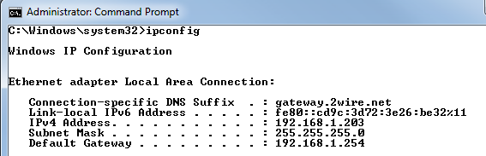

US Government requires IPv6 compatibility on its devices now

Links Ch 4f, 4g

Difference between IPv4 and IPv6 addresses (cont’d.)

Representation (cont’d.)

IPv6 loopback address is 0:0:0:0:0:0:0:1

Abbreviated loopback address ::1

Scope

IPv6 addresses can reflect scope of transmission’s recipients

Unicast address represents single device interface

Multicast address represents multiple interfaces (often on multiple devices)

Difference between IPv4 and IPv6 addresses (cont’d.)

Scope (cont’d.)

Anycast address represents any one interface from a group of interfaces

Any one can accept transmission

Format Prefix (IPv6)

Beginning of address

Variable-length field

Indicates address type: unicast, multicast, anycast
Sockets and Ports

Processes assigned unique port numbers

Process’s socket

Port number plus host machine’s IP address

Port numbers

Simplify TCP/IP communications

Ensures data transmitted correctly

Example

Telnet port number: 23

IPv4 host address: 10.43.3.87

Socket address: 10.43.3.87:23

Port number range: 0 to 65535

Three types

Well Known Ports

Range: 0 to 1023

Operating system or administrator use

Registered Ports

Range: 1024 to 49151

Network users, processes with no special privileges

Dynamic and/or Private Ports

Range: 49152 through 65535

No restrictions

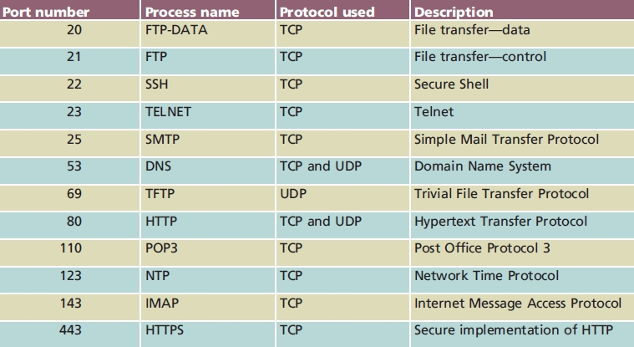
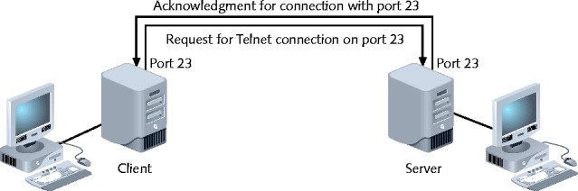

Using Non-Standard Ports

A server could be configured to use an unusual port, such as a Web server on port 8080

Not good idea: standards violation

Sometimes done for security or testing
Host Names and DNS (Domain Name System)

TCP/IP addressing

Long, complicated numbers

Good for computers

People remember words better

Internet authorities established Internet node naming system

Host

Internet device

Host name

Name describing device

Domain Names

Domain

Group of computers belonging to same organization

Share common part of IP address

Domain name

Identifies domain (loc.gov)

Associated with company, university, government organization

Fully qualified host name (jasmine.loc.gov)

Local host name plus domain name

Label (character string)

Separated by dots

Represents level in domain naming hierarchy

Example: www.google.com

Top-level domain (TLD): com

Second-level domain: google

Third-level domain: www

Second-level domain

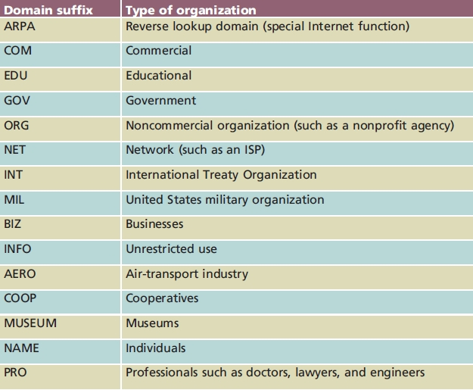
May contain multiple third-level domains

ICANN established domain naming conventions

ICANN approved over 240 country codes

Host and domain names restrictions

Any alphanumeric combination up to 63 characters

Include hyphens, underscores, periods in name

No other special characters

Hosts Files

ARPAnet used HOSTS.TXT file

Associated host names with IP addresses

Host matched by one line

Identifies host’s name, IP address

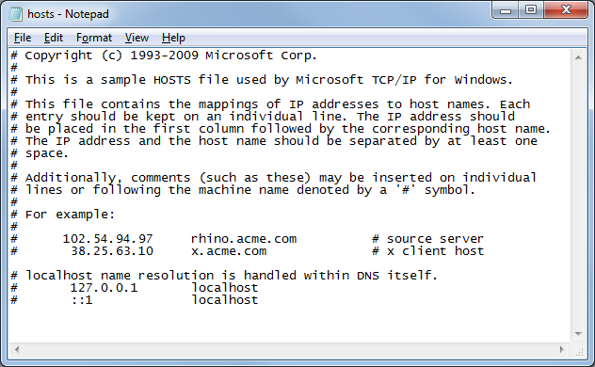
Alias provides nickname

UNIX-/Linux-based computer

Host file called hosts, located in the /etc directory

Windows 9x, NT, 2000, XP, Vista computer

Host file called hosts

Located in %systemroot%\system32\drivers\etc folder

Windows Hosts File

Rarely used, but still present

DNS (Domain Name System)

Hierarchical Distributed Database

Associates domain names with IP addresses

DNS refers to:

Application layer service accomplishing association

Organized system of computers; databases making association possible

DNS redundancy

Many computers across globe related in hierarchical manner

Root servers

13 computers (ultimate authorities)

Name servers (DNS servers)

Servers that contain databases of associated names, IP addresses

Provide information on request

To convert names like www.ccsf.edu into IP addresses like 147.144.1.212

This process is called name resolution

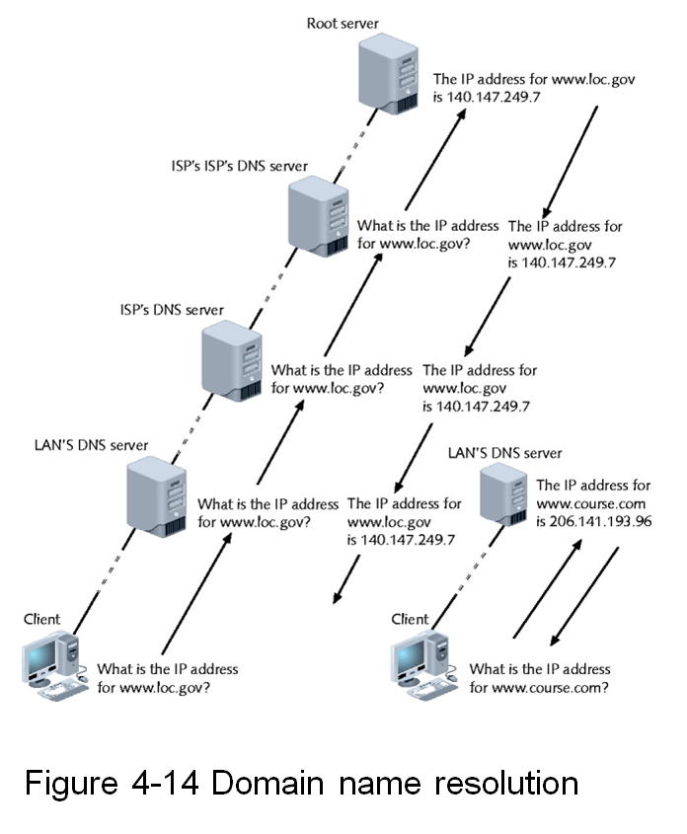
Resource record

Describes one piece of DNS database information

Many different types

Dependent on function

Contents

Name field

Type field

Class field

Time to Live field

Data length field

Actual data

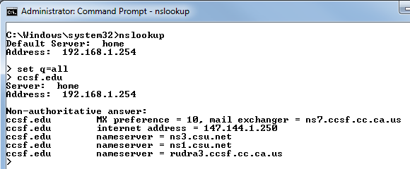
Demo: CCSF’s Name Servers

Configuring DNS

Large organizations

Often maintain two name servers

Primary and secondary

Ensures Internet connectivity

Each device must know how to find server

Automatically by DHCP

Manually configure workstation TCP/IP properties

DDNS (Dynamic DNS)

Allows a user to host a Web site on a computer with a dynamic IP address

Process

Service provider runs program on user’s computer

Notifies service provider when IP address changes

Service provider’s server launches routine to automatically update DNS record

Effective throughout Internet in minutes

Not as good as a real static IP address

Larger organizations pay for statically assigned IP address
Application Layer Protocols

Work over TCP or UDP plus IP

Translate user requests

Into format readable by network

HTTP

Application layer protocol central to using Web

BOOTP and DHCP

Automatic address assignment

Telnet

Terminal emulation protocol

Log on to remote hosts

Using TCP/IP protocol suite

TCP connection established

Keystrokes on user’s machine act like keystrokes on remotely connected machine

Often connects two dissimilar systems

Can control remote host

Drawback

Notoriously insecure

FTP (File Transfer Protocol)

Send and receive files via TCP/IP

Host running FTP server portion

Accepts commands from host running FTP client

FTP commands

Operating system’s command prompt

No special client software required

FTP hosts allow anonymous logons

After connected to host

Additional commands available

Type help

Graphical FTP clients

MacFTP, WS_FTP, CuteFTP, SmartFTP

Rendered command-line method less common

FTP file transfers directly from modern Web browser

Point browser to FTP host

Move through directories, exchange files

SFTP

More secure

TFTP (Trivial File Transfer Protocol)

Enables file transfers between computers

Simpler (more trivial) than FTP

TFTP relies on Transport layer UDP

Connectionless

Does not guarantee reliable data delivery

No ID and password required

Security risk

No directory browsing allowed

Useful to load data, programs on diskless workstation

Used to put software on IP phones and routers

NTP (Network Time Protocol)

Synchronizes network computer clocks

Depends on UDP Transport layer services

Benefits from UDP’s quick, connectionless nature

Time sensitive

Cannot wait for error checking

Time synchronization importance

Routing

Time-stamped security methods

Maintaining accuracy, consistency between multiple storage systems

NNTP (Network News Transfer Protocol)

Facilitates newsgroup messages exchange

Between multiple servers, users

Similar to e-mail

Provides means of conveying messages

Differs from e-mail

Distributes messages to wide group of users at once

User subscribes to newsgroup server host

News servers

Central collection, distribution point for newsgroup messages

PING (Packet Internet Groper)

Provides verification

TCP/IP installed, bound to NIC, configured correctly, communicating with network

Host responding

Uses ICMP services

Send echo request and echo reply messages

Determine IP address validity

Ping IP address or host name

Ping loopback address: 127.0.0.1

Determine if workstation’s TCP/IP services running

Operating system determines Ping command options, switches, syntax

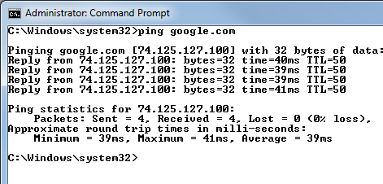

Last modified 9-14-09

