Objectives

Describe the basic and hybrid LAN physical topologies, and their uses, advantages, and disadvantages

Describe the backbone structures that form the foundation for most LANs

Understand the transmission methods underlying Ethernet networks

Compare the different types of switching used in data transmission
Topologies

Simple Physical Topologies

Physical topology

Physical network nodes layout

Depicts broad scope

Does not specify:

Device types

Connectivity methods

Addressing schemes

Fundamental shapes

Bus, ring, star

Hybrid

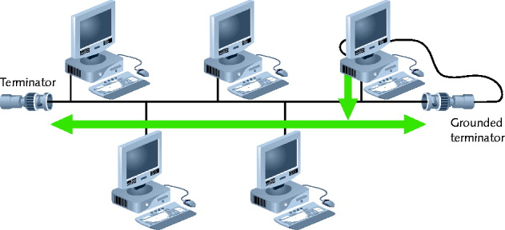
Bus topology

Bus

Single cable

Connecting all network nodes

No intervening connectivity devices

One shared communication channel

Physical medium

Coaxial cable

Passive topology

Node listens for, accepts data

Use broadcast to send

Broadcast domain

Node communicates using broadcast transmission

Terminators

50-ohm resistors

Stops signal at end of wire

Signal bounce

Signals echo between two network ends

One end grounded

Removes static electricity

Advantages

Relatively inexpensive

Disadvantage

Does not scale well

All nodes share a fixed amount of total bandwidth

Difficult to troubleshoot

Not very fault tolerant

Ring

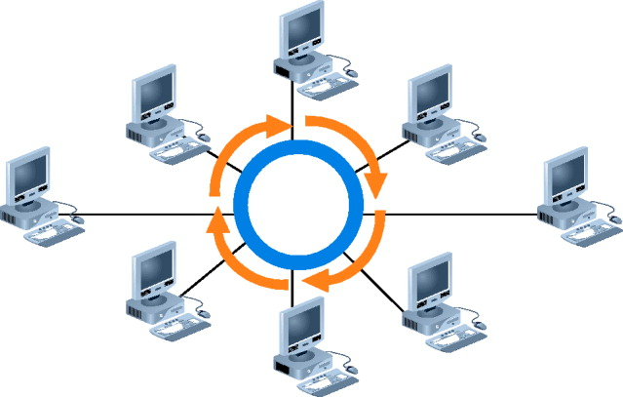
Ring topology

Node connects to nearest two nodes

Circular network

Clockwise data transmission

One direction (unidirectional) around ring

Active topology

Workstation participates in data delivery

Data stops at destination

Physical medium

Twisted pair or fiber-optic cabling

Drawback

Malfunctioning workstation can disable network

Not flexible or scalable

Star

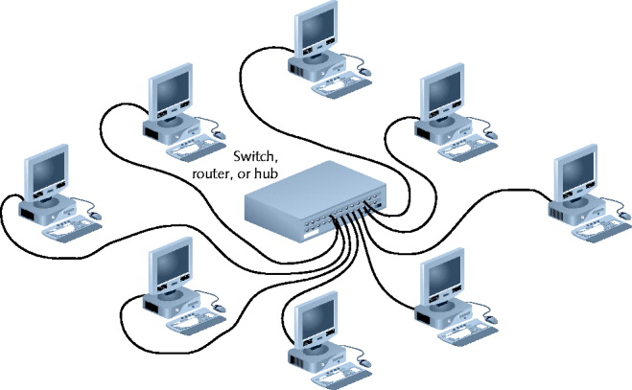
Star topology

Node connects through central device

Hub, router, or switch

Physical medium

Twisted pair or fiber-optic cabling

Single cable connects two devices

Require more cabling, configuration

Advantage

Fault tolerance

Centralized connection point can be a single point of failure, however

Scalable

Most popular fundamental layout

Ethernet networks based on star topology

1024 addressable logical network nodes maximum

Logical Topologies

Describes data transmission between nodes

Most common: bus, ring

Bus logical topology

Signals travel from one device to all other devices

May or may not travel through intervening connectivity device

Bus logical topology used by networks with:

Physical bus topology

Star, star-wired bus topology

Ethernet

Ring logical topology

Signals follow circular path

Ring logical topology used by networks with:

Pure ring topology

Star-wired ring hybrid physical topology

Token ring

Hybrid Physical Topologies

Pure bus, ring, star topologies

Rarely exist

Too restrictive

Hybrid topology

More likely

Complex combination of pure topologies

Several options

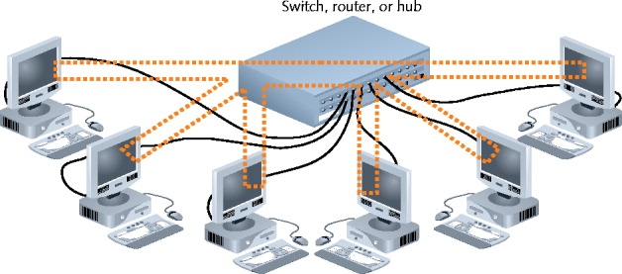
Star-Wired Ring

Star-wired ring topology

Star physical topology

Ring logical topology

Benefit

Star fault tolerance

Network use

Token Ring networks

IEEE 802.5

Star-Wired Bus

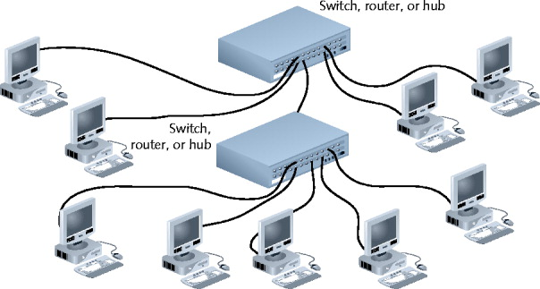
Star-wired bus topology

Workstation groups

Star-connected devices

Networked via single bus

Advantage

Cover longer distances

Easily interconnect, isolate different segments

Drawback

Cabling, connectivity device expense

Basis for modern Ethernet networks
Backbone Networks

Cabling connecting hubs, switches, routers

More throughput

Large organizations

Fiber-optic backbone

Cat 5 or better for hubs, switches

Enterprise-wide network backbones

Complex, difficult to plan

Enterprise

Entire organization

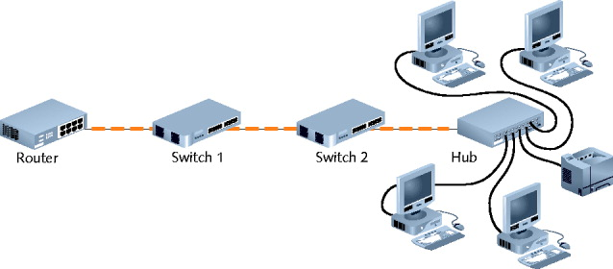
Significant building block: backbone

Serial Backbone

Simplest backbone

Two or more internetworking devices

Connect using single daisy-chain cable

Daisy-chain

Linked series of devices

Benefit

Logical growth solution

Modular additions

Low-cost LAN infrastructure expansion

Easily attach hubs

Backbone components

Hubs, gateways, routers, switches, bridges

Serial connection of repeating devices

Essential for distance communication

Standards

Define number of hubs allowed

Exceed standards

Intermittent, unpredictable data transmission errors

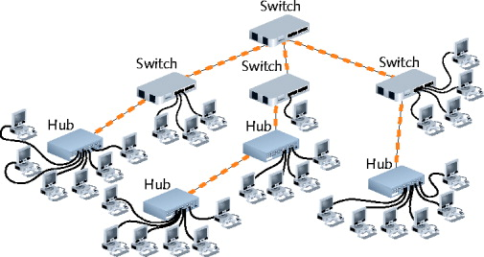
Distributed Backbone

Connectivity devices

Connected to a hierarchy of central connectivity devices

Benefit

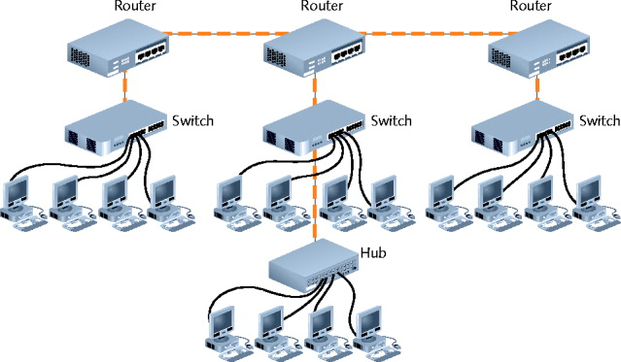
Simple expansion, limited capital outlay

More complicated distributed backbone

Connects multiple LANs, LAN segments

Using routers

More benefits

Workgroup segregation

May include daisy-chain linked hubs

Consider length

Drawback

Potential for single failure points

Collapsed Backbone

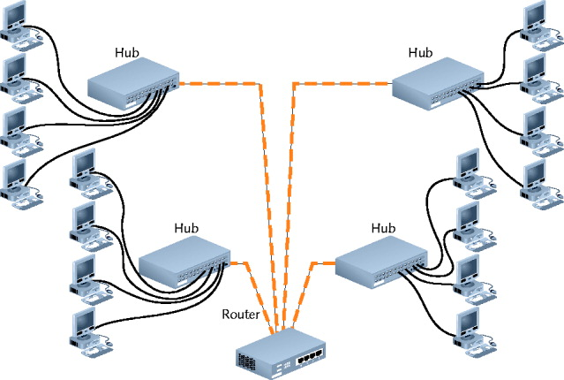
Uses router or switch

Single central connection point for multiple subnetworks

Highest layer

Router with multiprocessors

Central router failure risk

Routers may slow data transmission

Advantages

Interconnect different subnetwork types

Central management

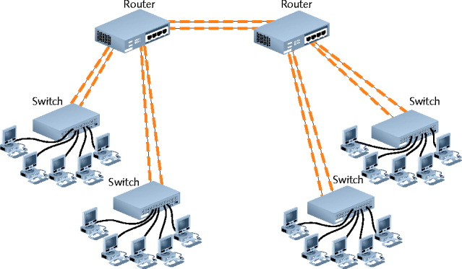
Parallel Backbone

Most robust network backbone

More than one central router, switch

Connects to each network segment

Requires duplicate connections between connectivity devices

Advantage

Redundant links

Increased performance

Better fault tolerance

Disadvantage

More cabling

Used to connect most critical devices
Switching

Switching

Logical network topology component

Determines connection creation between nodes

Three methods

Circuit switching

Message switching

Packet switching

Circuit Switching

Connection established between two network nodes

Before transmitting data

Dedicated bandwidth

Data follows same initial path selected by switch

Monopolizes bandwidth while connected

Resources are wasted

Uses

Old analog phone calls

Live audio, videoconferencing

Home modem connecting to ISP

Message Switching

Connection established between two devices

Data transferred then connection broken

Information stored and forwarded in second device

Repeat store and forward routine

Until destination reached

All information follows same physical path

Connection not continuously maintained

Device requirements

Sufficient memory, processing power

Not commonly used in modern networks, but will be used in space

See link Ch 5a, Delay-Tolerant Networking (DTN)

Packet Switching

Most popular, used by Ethernet and the Internet

Breaks data into packets before transporting

Packets

Travel any network path to destination

Find fastest circuit available at any instant

Need not follow the same path

Need not arrive in sequence

Reassembled at destination

Requires speedy connections for live audio, video transmission

Advantages

No wasted bandwidth

Devices do not process information

MPLS (Multiprotocol Label Switching)

IETF

Introduced in 1999

Multiple layer 3 protocols

Travel over any one of several connection-oriented layer 2 protocols

Supports IP

Common use

Layer 2 WAN protocols

Advantages

Use packet-switched technologies over traditionally circuit switched networks

Create end-to-end paths

Act like circuit-switched connections

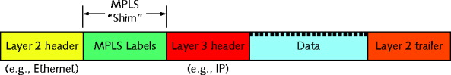
Addresses traditional packet switching limitations

Better QoS (quality of service)

Flow Routing ( not in textbook)

New technique connects streams of related packets so they all travel along the same path

No need to make routing decisions after the first packet

Saves time and power (link Ch 5c)

Ethernet

Ethernet

Developed by Xerox: 1970s

Improved by:

Digital Equipment Corporation (DEC), Intel, Xerox (DIX)

Benefits

Flexible

Excellent throughput

Reasonable cost

Popular network technology

All variations share common access method

CSMA/CD
CSMA/CD (Carrier Sense Multiple Access with Collision Detection)

Network access method

Controls how nodes access communications channel

Necessary to share finite bandwidth

Carrier sense

Ethernet NICs listen, wait until free channel detected

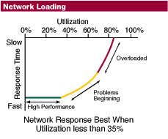
Multiple access

Ethernet nodes simultaneously monitor traffic, access media

Collision

Two nodes simultaneously:

Check channel, determine it is free, begin transmission

Collision detection

Nodes detect unusually high voltages

Perform collision detection routine

Jamming

NIC issues 32-bit sequence

Indicates previous message faulty

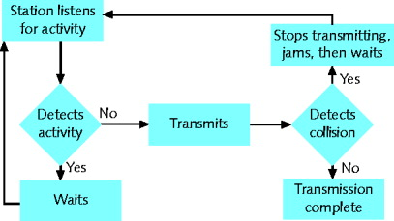
Retransmit data

Heavily trafficked network segments

Collisions common

Segment growth

Performance suffers

“Critical mass” number dependencies

Data type and volume regularly transmitted

Collisions corrupt data, truncate data frames

Network must compensate for them

Collision domain

Portion of network where collisions occur

Ethernet network design

Repeaters repeat collisions

Result in larger collision domain

Switches and routers

Separate collision domains

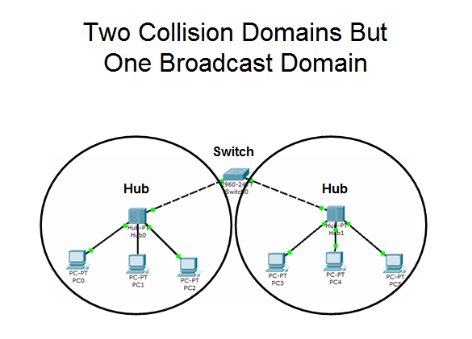
Collision domains differ from broadcast domains

Ethernet cabling distance limitations

Affected by collision domains

Data propagation delay

Time for data to travel

From one segment point to another point

Too long

Cannot identify collisions accurately

100 Mbps networks

Three segment maximum connected with two hubs

10 Mbps buses

Five segment maximum connected with four hubs
Ethernet Standards for Copper Cable

IEEE Physical layer standards

Specify how signals transmit to media

Differ significantly in signal encoding

Affect maximum throughput, segment length, wiring requirements

10Base-T

10 represents maximum throughput: 10 Mbps

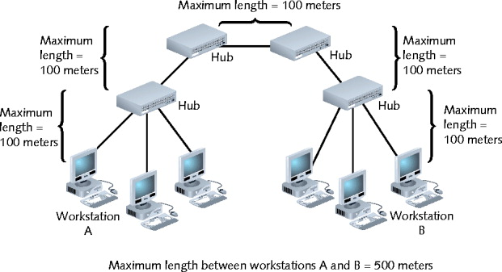
Base indicates baseband transmission

T stands for twisted pair

Two pairs of wires: transmit and receive

Full-duplex transmission

Follows 5-4-3 rule of networking

Five network segments

Four repeating devices

Three populated segments maximum

100Base-T (Fast Ethernet)

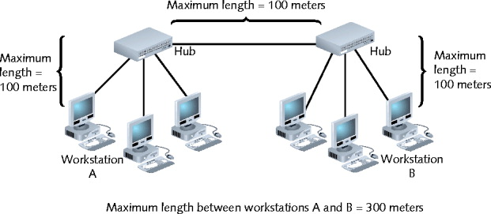
IEEE 802.3u standard

Similarities with 10Base-T

Baseband transmission, star topology, RJ-45 connectors

Supports three network segments maximum

Connected with two repeating devices

100 meter segment length limit between nodes

100Base-TX

100-Mbps throughput over twisted pair

Full-duplex transmission: doubles effective bandwidth

1000Base-T (Gigabit Ethernet)

IEEE 802.3ab standard

1000 represents 1000 Mbps

Base indicates baseband transmission

T indicates twisted pair wiring

Four pairs of wires in Cat 5 or higher cable

Transmit and receive signals

Data encoding scheme: different from 100Base-T

Standards can be combined

Maximum segment length: 100 meters, one repeater

10GBase-T

IEEE 802.3an

Pushing limits of twisted pair

Requires Cat 6 or Cat 7 cabling

Maximum segment length: 100 meters

Benefit

Very fast data transmission, lower cost than fiber-optic

Use

Connect network devices

Connect servers, workstations to LAN
Ethernet Standards for Fiber-Optic Cable

100Base-FX (Fast Ethernet)

100-Mbps throughput, broadband, fiber-optic cabling

Multimode fiber containing: at least two strands

Half-duplex mode

One strand receives, one strand transmits

412 meters segment length

Full duplex-mode

Both strands send and receive

2000 meters segment length

One repeater maximum

IEEE 802.3u standard

1000Base-LX (1-Gigabit Ethernet)

IEEE 802.3z standard

1000: 1000-Mbps throughput

Base: baseband transmission

LX: reliance on 1300 nanometers wavelengths

Longer reach than any other 1-gigabit technology

Single-mode fiber: 5000 meters maximum segment

Multimode fiber: 550 meters maximum segment

One repeater between segments

Excellent choice for long backbones

1000Base-SX (1-Gigabit Ethernet)

IEEE 802.3z standard

Differences over 1000Base-LX

Multimode fiber-optic cable (installation less expensive)

Uses short wavelengths (850 nanometers)

Maximum segment length dependencies

Fiber diameter, modal bandwidth used to transmit signals

1000Base-SX (1-Gigabit Ethernet) (cont’d.)

Modal bandwidth measurement

Highest frequency of multimode fiber signal (over specific distance)

MHz-km

Higher modal bandwidth, multimode fiber caries signal reliably longer

50 micron fibers: 550 meter maximum length

62.5 micron fibers: 275 meter maximum length

One repeater between segments

Best suited for shorter network runs

10-Gigabit Fiber-Optic Standards

Extraordinary potential for fiber-optic cable

Pushing limits

802.3ae standard

Fiber-optic Ethernet networks

Transmitting data at 10 Gbps

Several variations

Common characteristics

Star topology, allow one repeater, full-duplex mode

Differences

Signal’s light wavelength, maximum allowable segment length
10-Gigabit Fiber-Optic Standards

10GBase-SR and 10GBase-SW

10G: 10 Gbps

Base: baseband transmission

S: short reach

Physical layer encoding

R works with LAN fiber connections

W works with SONET fiber connections

Multimode fiber: 850 nanometer signal transmission

Maximum segment length

Depends on fiber diameter

10GBase-LR and 10GBase-LW

10G: 10 Gbps

Base: baseband transmission

L: long reach

Single-mode fiber: 1319 nanometer signal transmission

Maximum segment length

10,000 meters

10GBase-LR: WAN or MAN

10GBase-LW: SONET WAN links

10GBase-ER and 10GBase-EW

E: extended reach

Single-mode fiber

Transmit signals with 1550 nanometer wavelengths

Longest fiber-optic segment reach

40,000 meters (25 miles)

10GBase-EW

Encoding for SONET

Best suited for WAN use
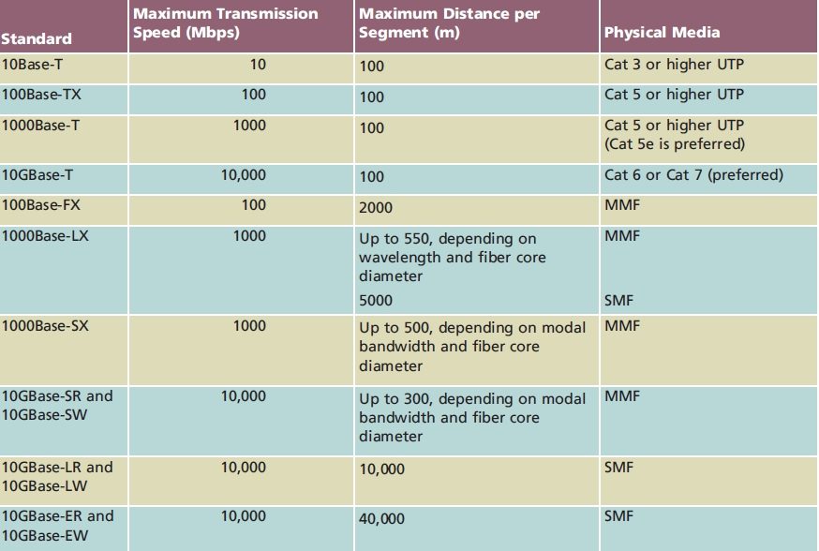

Ethernet Frames

Four types

Ethernet_802.2 (Raw)

Ethernet_802.3 (Novell proprietary)

Ethernet_II (DIX)

Ethernet_SNAP

Frame types differ slightly

Coding and decoding packets

No relation to topology, cabling characteristics

Framing

Independent of higher-level layers

Using and Configuring Frames

Ensure all devices use same, correct frame type

Node communication

Ethernet_II used today in almost all networks

Frame type configuration

Through NIC configuration software

NIC autodetect, autosense

Importance

Know frame type for troubleshooting

Frame Fields

Common fields

7-byte preamble, 1-byte start-of-frame delimiter

SFD (start-of-frame delimiter) identifies where data field begins

14-byte header

4-byte FCS (Frame Check Sequence)

Frame size range: 64 to 1518 total bytes

Larger frame sizes result in faster throughput

Improve network performance

Properly manage frames

Ethernet_II (DIX)

Developed by DEC, Intel, Xerox (abbreviated DIX)

Before IEEE

Contains 2-byte type field

Identifies the Network layer protocol

Ethernet_SNAP frame type

Provides type field

Calls for additional control fields

Less room for data

Most commonly used on contemporary Ethernet networks
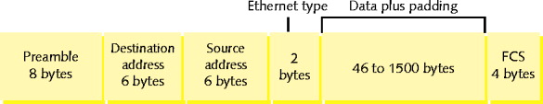

PoE (Power over Ethernet)

IEEE 802.3af standard

Supplying electrical power over Ethernet connections

Two device types

PSE (power sourcing equipment)

PDs (powered devices)

Requires Cat 5 or better copper cable

Connectivity devices must support PoE

Compatible with current 802.3 installations

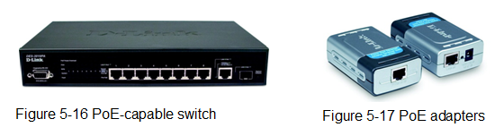

Last modified 9-22-09

