Objectives

Identify the functions of LAN connectivity hardware

Install, configure, and differentiate between network devices such as, NICs, hubs, bridges, switches, routers, and gateways

Explain the advanced features of a switch and understand popular switching techniques, including VLAN management

Explain the purposes and properties of routing

Describe common IPv4 and IPv6 routing protocols
NICs (Network Interface Cards)

NICs (Network Interface Cards)

Connectivity devices

Enable device transmission

Transceiver

Transmits and receives data

Physical layer and Data Link layer functions

Issue data signals

Assemble and disassemble data frames

Interpret physical addressing information

Determine right to transmit data

Smart hardware

Perform prioritization (link Ch 6a)

Network management

Buffering

Traffic-filtering (link Ch 6b)

Do not analyze information at layers 3 through 7

Importance

Common to every networking device, network

Types of NICs

Before ordering or installing NIC

Know device interface type

Types of NICs

Access method (Ethernet or Token Ring)

Network transmission speed

Connector interfaces

Compatible motherboard or device type

Manufacturer

Bus

Circuit, signaling pathway

Motherboard uses to transmit data to computer’s components

Memory, processor, hard disk, NIC

Differ according to capacity

Defined by data path width and clock speed

Data path size

Parallel bits transmitting at any given time

Proportional to attached device’s speed

Internal Bus Standards

Expansion slots

Multiple electrical contacts on motherboard

Allows bus expansion

Expansion card (expansion board)

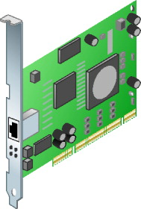
Circuit board for additional devices
Figure 6-1 PCI NIC

Inserts into expansion slot, establishes electrical connection

Device connects to computer’s main circuit or bus

Computer centrally controls device

Multiple bus types

PCI bus: most popular expansion board NIC

PCI (Peripheral Component Interconnect)

32- or 64-bit bus

Clock speeds rated at 33-, 66- or 133-MHz

Maximum data transfer rate: 1 Gbps

Introduced by Intel (1992)

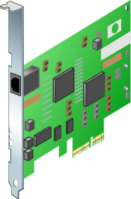
Latest official version: 3.0 (2004)
Figure 6-2 PCIe NIC

ISA (Industry Standard Architecture)

Original PC bus type (early 1980s)

Support for 8-bit and 16-bit data path, 4.77-MHz clock

PCI bus characteristics

Shorter connector length, faster data transmission

Compared to previous bus types (ISA)

PCs and Macintosh compatible

PCIe (PCI Express)

32- or 64-bit bus

Maximum 133-MHz clock speed

Transfer rate

500 Mbps per data path (full-duplex transmission)

PCIe advantages over PCI

More efficient data transfer

Quality of service distinctions support

Error reporting, handling

Current PCI software compatible

PCIe slots differ from conventional PCI

Vary by lanes supported

Lane offers full-duplex throughput of 500 Mbps

Support up to 16 lanes

x16 slot : 8 Gbps throughput

Determining bus type

Read documentation

Look inside PC case

If more than one expansion slot type:

Refer to NIC, PC manufacturers’ guidelines

Choose NIC matching most modern bus

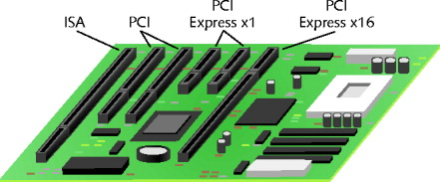
Figure 6-3 A motherboard with multiple expansion slots

Peripheral Bus Standards

Attach peripheral devices externally

External connection advantage

Simple installation

Personal Computer Memory Card International Association or PCMCIA

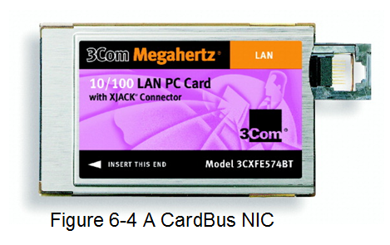
Sets standards for externally attached cards

Connect virtually any external device type

PC Card

First standard PCMCIA-standard adapter

16- bit interface running at 8 MHz

CardBus standard (1990s)

32-bit interface running at 33 MHz

Matches PCI expansion board standard

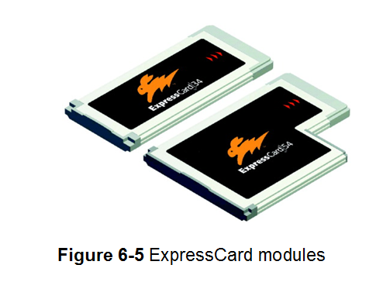
ExpressCard standard

Many different external devices connect to portable computers

26-pin interface

Data transfer rates: 250 Mbps in each direction

500 Mbps total

Same data transfer standards as PCIe specification

Two sizes

34 mm, 54 mm wide

USB (universal serial bus) port

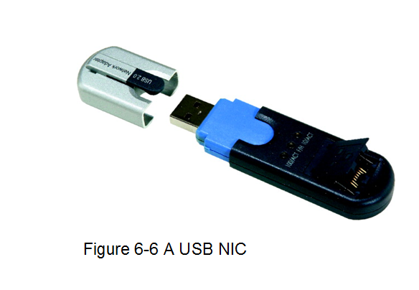
Two USB standards

Difference: speed

USB 1.1: transfer rate of 12 Mbps

USB 2.0: transfer rate of 480 Mbps

Future

USB 3.0 (SuperSpeed USB)

Transfer rate: 4.8 Gbps

Firewire

Apple Computer (1980s)

IEEE 1394 standard (1995)

Traditional Firewire connection: 400 Mbps (max)

Newer version: 3 Gbps

Connects most peripheral types

Connects small network

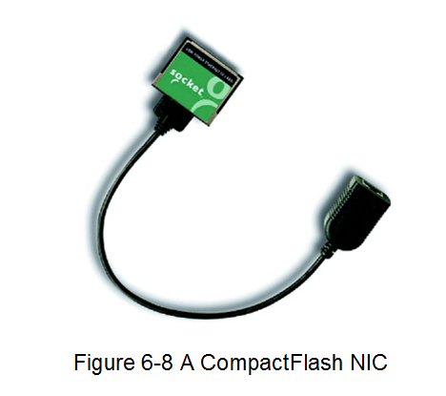
Two or more computers using bus topology

FireWire-connected peripherals

Similar to USB- and PCMCIA-connected peripherals

Simple installation

Supported by most modern operating systems

Two connector varieties: 4-pin and 6-pin

6-pin connector

Two pins supply power

Interconnect computers

CompactFlash

Designed by CompactFlash Association (CFA)

Ultrasmall

Removable data and input/output device

Latest standard: 4.0

Data transfer rate: 133 Mbps

Uses

Connects devices too small for PCMCIA slots

Wireless connections

On-Board NICs

Connect device directly to motherboard

On-board ports: mouse, keyboard

New computers, laptops

Use onboard NICs integrated into motherboard

Advantages

Saves space

Frees expansion slots

Wireless NICs

Contain antennas

Send, receive signals

All bus types supported

Disadvantages over wire-bound NICs

More expensive

Bandwidth and security limitations

Installing NICs

Three general steps

Install hardware

Install NIC software

Configure firmware (if necessary)

Set of data, instructions

Saved to NIC’s ROM (read-only memory) chip

Use configuration utility program

EEPROM (electrically erasable programmable read-only memory)

Apply electrical charges

ROM data erased, changed

Installing and Configuring NIC Hardware

Read manufacturer’s documentation

Install expansion card NIC

Verify toolkit contents

Unplug computer

Ground yourself

Open computer case

Select slot, insert NIC, attach bracket, verify cables

Replace cover, turn on computer

Configure NIC software

Modern operating systems

Do not require restart for PCMCIA-standard adapter

Servers, other high-powered computers

Install multiple NICs

Repeat installation process for additional NIC

Choose different slot

Installing and Configuring NIC Software

Device driver

Software

Enables attached device to communicate with operating system

Purchased computer

Drivers installed

Add hardware to computer

Must install drivers

Operating system built-in drivers

Automatically recognize hardware, install drivers

Computer startup

Device drivers loaded into RAM

Computer can communicate with devices

Drivers not available from operating system

Install and configure NIC software

Use operating system interface

Interpreting LED Indicators

After NIC is installed:

Test by transmitting data

Assess NIC LEDs for network communication

Vary by manufacturer

Read documentation

Common lights

ACT, LNK, LED, TX, RX

IRQ (Interrupt Request)

Message to computer

Stop and pay attention to something else

Interrupt

Circuit board wire

Device issues voltage to signal request

IRQ number

Uniquely identifies component to main bus

NICs use IRQ 9, 10, or 11

Two devices using same interrupt

Resource conflicts, performance problems

Many symptoms

Must reassign IRQ

Through operating system

Through adapter’s EEPROM configuration utility

Through computer’s CMOS configuration utility

CMOS (complementary metal oxide semiconductor)

Microchip requiring very little energy to operate

Stores settings pertaining to computer’s devices

Battery powered

Settings saved after computer turned off

Information used by BIOS (basic input/output system)

BIOS

Simple instruction set

Enables computer to initially recognize hardware

Memory Range

Memory NIC, CPU use for exchanging, buffering data

Some are reserved for specific devices

NICS

High memory area (A0000–FFFFF range)

Manufacturers prefer certain ranges

Resource conflicts less likely (than IRQ settings)

Base I/O Port

Memory area

Channel for moving data between NIC and CPU

Cannot be used by other devices

NICs use two channel memory ranges

Base I/O port settings identify beginning of each range

Firmware Settings

Contain NIC’s transmission characteristics

Combination

EEPROM chip on NIC and data it holds

Change firmware

Change EEPROM chip

Requires bootable CD-ROM

Configuration, install utility shipped with NIC

Configuration utility

View IRQ, I/O port, base memory, node address

Change settings

Perform diagnostics

NIC’s physical components, connectivity

Loopback plug (loopback adapter)

Outgoing signals redirected into computer for testing

Use with loopback test

Choosing the Right NIC

Considerations

Compatibility with existing system

Network bus type, access method, connector types, transmission speed

Drivers available

Operating system, hardware

Subtle differences

Affecting network performance

Important for server
Repeaters and Hubs

Repeater

Simplest connectivity device regenerating signals

Operates at Physical layer

Has no means to interpret data

Limited scope

One input port, one output port

Receives and repeats single data stream

Suitable for bus topology networks

Extend network inexpensively

Rarely used on modern networks

Limitations; other devices decreasing costs

Hub

Repeater with more than one output port

Multiple data ports, uplink port

Repeats signal in broadcast fashion

Operates at Physical layer

Ethernet network hub

Star or star-based hybrid central connection point

Connect workstations, print servers, switches, file servers, other devices

Devices share same bandwidth amount, collision domain

More nodes leads to transmission errors, slow performance

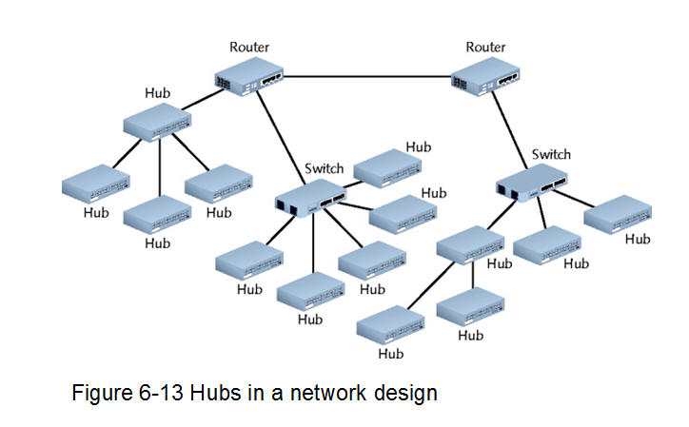

Placement in network varies

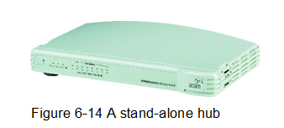
Simplest: stand-alone workgroup hub

Different hub to each small workgroup

Placement must adhering to maximum segment and length limitations

Hubs vary according to:

Supported media type, data transmission speeds

Passive hubs, Intelligent hubs (managed hubs), Stand-alone hubs (workgroup hubs)

Replaced by switches or routers

Limited features

Merely repeat signals
Bridges

Bridges

Connects two network segments

Analyze incoming frames and decide where to send

Based on frame’s MAC address

Operate at Data Link layer

Single input port and single output port

Interpret physical addressing information

Advantages over repeaters and hubs

Protocol independence

Add length beyond maximum segments limits

Improve network performance

Disadvantage compared to repeaters and hubs

Longer to transmit data

Filtering database (forwarding table)

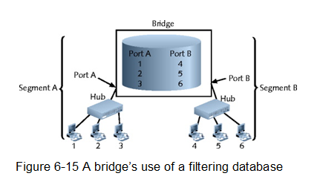
Used in decision making

Filter or forward

New bridge installation

Bridge must learn network MAC addresses

Fills its filtering database

Destination node’s MAC address

Associated port

All network nodes discovered over time

Today bridges nearly extinct

Improved router and switch speed, functionality

Lowered router and switch cost
Switches

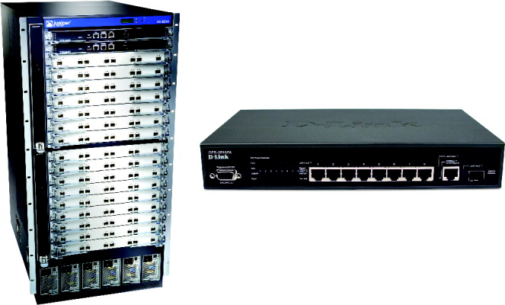
Switches
Figure 6-16 Switches

Subdivide network

Smaller logical pieces, segments

Operates at Data Link layer (traditional)

Operate at layers 3 and 4 (advanced)

Interpret MAC address information

Components

Internal processor, operating system, memory, several ports

Multiport switch advantages over bridge

Better bandwidth use, more cost-efficient

Each port acts like a bridge

Each device effectively receives own dedicated channel

Ethernet perspective

Dedicated channel represents collision domain

Historically

Switches replaced hubs, eased congestion, provided better security, performance

Disadvantages

Can become overwhelmed despite buffers

Cannot prevent data loss

UDP collisions mount: network traffic halts

Switches replaced workgroup hubs

Decreased cost, easy installation, configuration,

Separate traffic according to port

Installing a Switch

Follow manufacturer’s guidelines

General steps (assume Cat 5 or better UTP)

Verify switch placement

Turn on switch

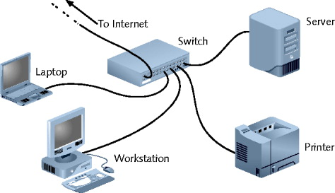
Verify lights, self power tests
Figure 6-18 A switch on a small network

Configure (if necessary)

Connect NIC to a switch port (repeat for all nodes)

After all nodes connected, turn on nodes

Connect switch to larger network (optional)

Switching Methods

Difference in switches

Incoming frames interpretation

Frame forwarding decisions making

Four switching modes exist

Two basic methods discussed

Cut-Through Mode

Store-and-Forward Mode

Cut-Through Mode

Switch reads frame’s header

Forwarding decision made before receiving entire packet

Uses frame header: first 14 bytes contains destination MAC address

Cannot verify data integrity using frame check sequence

Can detect runts

Erroneously shortened packets

Runt detected: wait for integrity check

Cannot detect corrupt packets

May propagate flawed packets

Advantage

Speed

Disadvantage

Data buffering (switch flooded with traffic)

Best use

Small workgroups needing speed

Low number of devices

Store-and-Forward Mode

Switch reads entire data frame into memory

Checks for accuracy before transmitting information

Advantage over cut-through mode

Transmit data more accurately

Disadvantage over cut-through mode

More time consuming

Best use

Larger LAN environments; mixed environments

Can transfer data between segments running different transmission speeds

VLANs and Trunking

VLANs (virtual local area networks)

Logically separate networks within networks

Groups ports into broadcast domain

Broadcast domain (subnet)

Port combination making a Layer 2 segment

Ports rely on layer 2 device to forward broadcast frames

Collision domain

Remember, switches prevent collisions

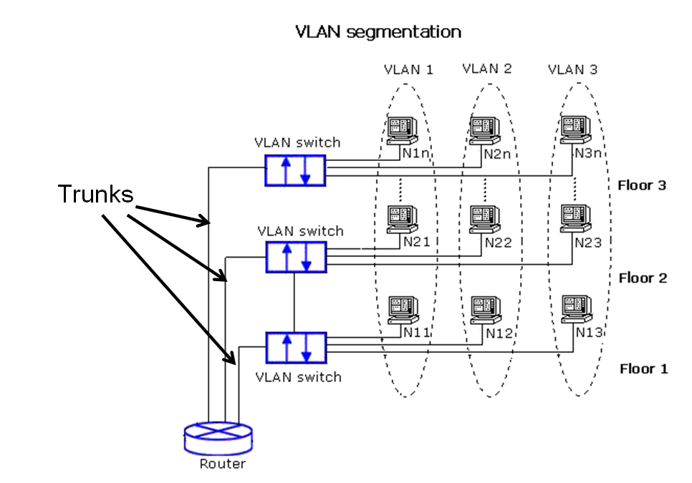
Each device is on a separate collision domain

Image from link Ch 6c

Advantage of VLANs

Flexible

Ports from multiple switches or segments

Use any end node type

Reasons for using VLAN

Separating user groups who need special security

Isolating connections with heavy traffic

Identifying priority device groups

Grouping legacy protocol devices

VLAN creation

Configuring switch software

Manually through configuration utility

Automatically using VLAN software tool

Critical step

Indicate to which VLAN each port belongs

Additional specifications

Security parameters, filtering instructions, port performance requirements, network addressing and management options

Maintain VLAN by switch software

Potential VLAN issues

Cutting off group from rest of network

Correct by using router

Trunking

Switch’s interface carries traffic of multiple VLANs

Trunk

Single physical connection between devices

Many logical VLANs transmit, receive data

VLAN data separation

Frame contains VLAN identifier in header

Advantage of VLAN trunking

Economical interface usage

Switches make efficient use of processing capabilities

VLAN configuration

Can be complex

Requires careful planning

Ensure users and devices can exchange data

Ensure VLAN switch properly interacts with other devices

STP (Spanning Tree Protocol)

IEEE standard 802.1D

Operates in Data Link layer

Prevents traffic loops

Calculating paths avoiding potential loops

Artificially blocking links completing loop

Three steps

Select root bridge based on Bridge ID

Examine possible paths between network bridge and root bridge

Disables links not part of shortest path

History

Introduced in 1980s

Original STP too slow

RSTP (Rapid Spanning Tree Protocol)

Newer version

IEEE’s 802.1w standard

Cisco and Extreme Networks

Proprietary versions

No enabling or configuration needed

Included in switch operating software

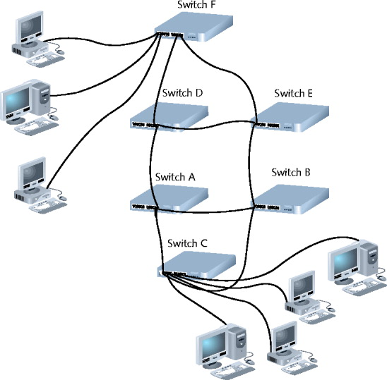
May alter default priorities
Figure 6-21 Enterprise-wide switched network

Content and Multilayer Switches

Layer 3 switch (routing switch)

Interprets Layer 3 data

Layer 4 switch

Interprets Layer 4 data

Content switch (application switch)

Interprets Layer 4 through Layer 7 data

Advantages

Advanced filtering, statistics keeping, security functions

Disadvantages

No agreed upon standard

Layer 3 and Layer 4 switch features vary widely

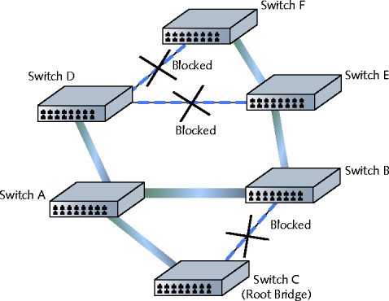
Figure 6-22 STP-selected paths on a switched network

Distinguishing between Layer 3 and Layer 4 switch

Manufacturer dependent

Higher-layer switches

Three times Layer 2 switches

Used in backbone

Routers

Multiport connectivity device

Directs data between network nodes

Integrates LANs and WANs

Different transmission speeds, protocols

Operate at Network layer (Layer 3)

Directs data from one segment or network to another

Logical addressing

Protocol dependent

Slower than switches and bridges

Need to interpret Layers 3 and higher information

Traditional stand-alone LAN routers

Being replaced by Layer 3 routing switches

New niche for routers

Specialized applications

Linking large Internet nodes

Completing digitized telephone calls

Router Characteristics and Functions

Intelligence

Tracks node location

Determine shortest, fastest path between two nodes

Connects dissimilar network types

Large LANs and WANs

Routers indispensible
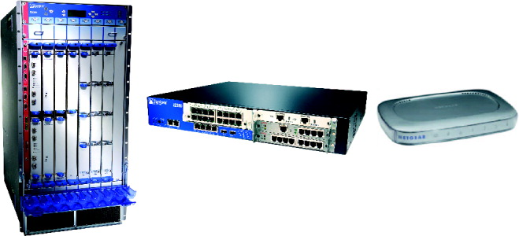
Figure 6-23 Routers

Router components

Internal processor, operating system, memory, input and output jacks, management control interface

Modular router

Multiple slots

Holding different interface cards, other devices

Inexpensive routers

Home, small office use

Router tasks

Connect dissimilar networks

Interpret Layer 3 addressing

Determine best data path

Reroute traffic
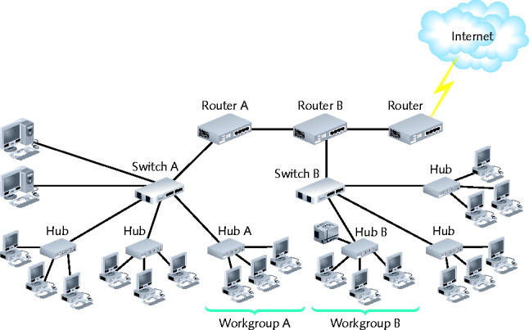
Figure 6-24 The placement of routers on a LAN

Optional functions

Filter broadcast transmissions

Enable custom segregation, security

Provide fault tolerance

Monitor network traffic, diagnose problems

Directing network data

Static routing

Administrator programs specific paths between nodes

Dynamic routing

Router automatically calculates best path between two nodes

Routing table

Installation

Simple: small office, home LANs

Challenging: sizeable networks

Routing Protocols

Best path

Most efficient route from one node to another

Dependent on:

Number of hops between nodes

Current network activity

Unavailable link

Network transmission speed

Topology

Determined by routing protocol

Routing protocol

Router communication

Collects current network status data

Contribute to best path selection

Routing table creation

Router convergence time

Time router takes to recognize best path

Change or network outage event

Distinguishing feature

Overhead; burden on network to support routing protocol

Distance-Vector: RIP, RIPv2, BGP

Distance-vector routing protocols

Determine best route based on distance to destination

Factors

Hops, latency, network traffic conditions

RIP (Routing Information Protocol)

Only factors in number of hops between nodes

Limits 15 hops

Interior routing protocol

Slow and less secure

RIPv2 (Routing Information Protocol Version 2)

Generates less broadcast traffic, more secure

Cannot exceed 15 hops

Less commonly used

BGP (Border Gateway Protocol)

Communicates using BGP-specific messages

Many factors determine best paths

Configurable to follow policies

Most complex (choice for Internet traffic)

Link-State: OSPF, IS-IS

Link-state routing protocol

Routers share information

Each router independently maps network, determines best path

OSPF (Open Shortest Path First)

Interior or border router use

No hop limit

Complex algorithm for determining best paths

Each OSPF router

Maintains database containing other routers’ links

IS-IS (Intermediate System to Intermediate System)

Codified by ISO

Interior routers only

Less common than OSPF

Hybrid: EIGRP

Hybrid

Link-state and distance-vector characteristics

EIGRP (Enhanced Interior Gateway Routing Protocol)

Cisco network routers only

EIGRP benefits

Fast convergence time, low network overhead

Easier to configure and less CPU-intensive than OSPF

Supports multiple protocols

Accommodates very large, heterogeneous networks
Gateways and Other Multifunction Devices

Gateway

Combinations of networking hardware and software

Connecting two dissimilar networks

Connect two systems using different formatting, communications protocols, architecture

Repackages information

Reside on servers, microcomputers, connectivity devices, mainframes

Popular gateways

E-mail gateway, Internet gateway, LAN gateway, Voice/data gateway, Firewall

Last modified 10-1-09

