Objectives

Identify a variety of uses for WANs

Explain different WAN topologies, including their advantages and disadvantages

Compare the characteristics of WAN technologies, including their switching type, throughput, media, security, and reliability

Describe several WAN transmission and connection methods, including PSTN, ISDN, T-carriers, DSL, broadband cable, ATM, and SONET

Describe multiple methods for remotely connecting to a network
WAN Essentials

WAN Essentials

WAN

Network traversing some distance, connecting LANs

Transmission methods dependent on business needs

WAN and LAN common properties

Client-host resource sharing, Layer 3 protocols, packet-switched digitized data

WAN and LAN differences

Layers 1 and 2 access methods, topologies, media

LAN wiring: private

WAN wiring: public through NSPs (network service providers)

WAN site

Individual geographic locations

WAN link

WAN site to WAN site connection
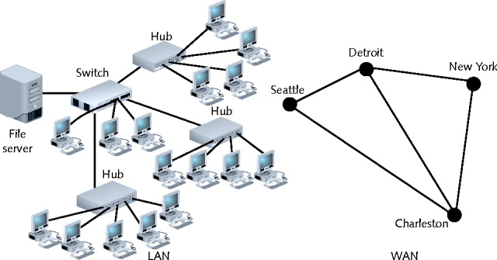

WAN Topologies

Differences from LAN topologies

Distance covered, number of users, distance traveled

Connect sites via dedicated links

Much slower than LAN connections

Use different connectivity devices

WAN connections

Require Layer 3 devices

Routers

Not capable of nonroutable protocols

Exception: Metro Ethernet (not in book here)

Bus

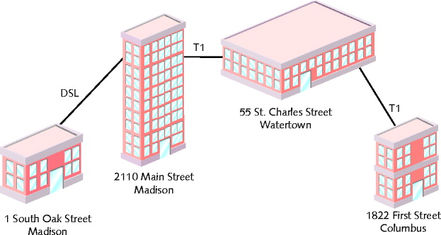
Each site connects to two sites maximum serially

Similar LAN topology site dependency

Network site dependent on every other site to transmit and receive traffic

Difference from LAN topology

Different locations connected to another through point-to-point links

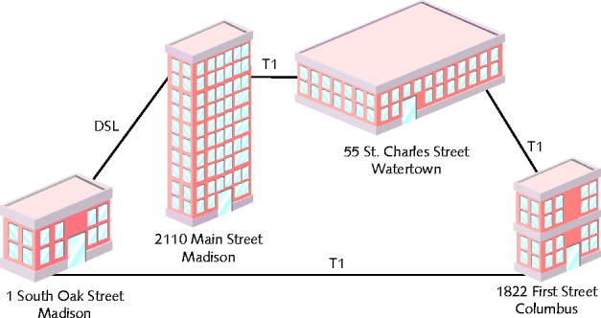
Best use

Organizations requiring small WAN, dedicated circuits

Drawback

Not scalable

Ring

Each site connected to two other sites

Forms ring pattern

Similar to LAN ring topology

Differences from LAN ring topology

Connects locations

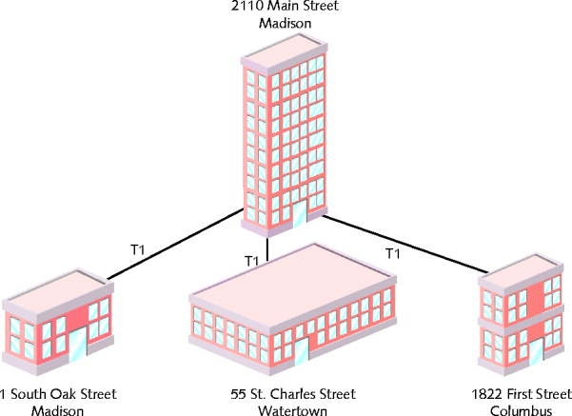
Relies on redundant rings

Data rerouted upon site failure

Expansion

Difficult, expensive

Best use

Connecting four, five locations maximum

Star

Mimics star topology LAN

Single site central connection point

Separate data routes between any two sites

Advantages

Single connection failure affects one location

Different from bus, star topology

Shorter data paths between any two sites

When all dedicated circuits functioning

Expansion: simple, less costly

Drawback

Central site is a single point of failure

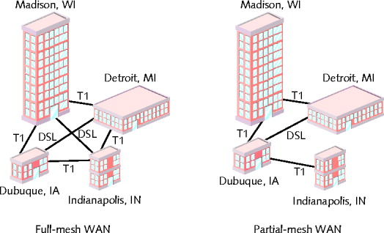
Mesh

Incorporates many directly interconnected sites

Data travels directly from origin to destination

Routers can redirect data easily, quickly

Most fault-tolerant WAN type

Full-mesh WAN

Every WAN site directly connected to every other site

Drawback: cost

Partial-mesh WAN

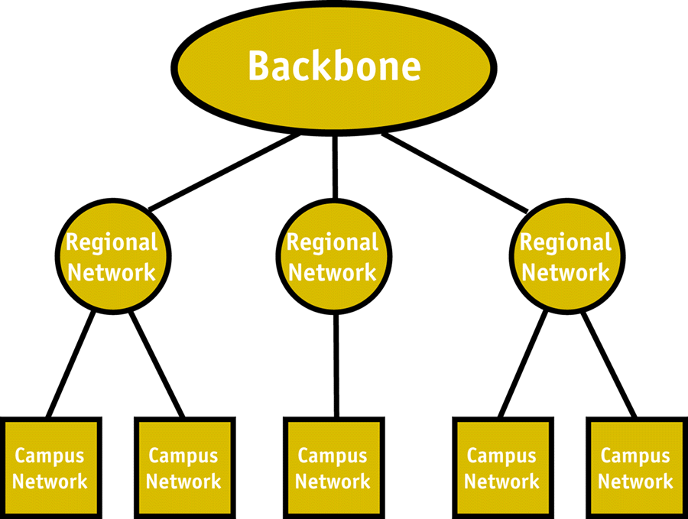
Reduce costs

Tiered

Sites connected in star or ring formations

Interconnected at different levels

Interconnection points organized into layers

Form hierarchical groupings

Flexibility

Allows many variations, practicality

Requires careful considerations:

Geography, usage patterns, growth potential

Image from link Ch 7a
PSTN

PSTN (Public Switched Telephone Network)

Network of lines, carrier equipment providing telephone service

POTS (plain old telephone service)

Encompasses entire telephone system

Originally: analog traffic

Today: digital data, computer controlled switching

Dial-up connection

Used early on

Modem connects computer to distant network

Not always on—you need to dial up to connect

PSTN Elements

Cannot handle digital transmission (older parts of the network)

Requires modem to convert digital to analog and vice versa

Signal travels path between modems

Over carrier’s network

Includes CO (central office), remote switching facility

Signal converts back to digital pulses

CO (central office)

Where telephone company terminates lines

Switches calls between different locations

Local loop (last mile)

Portion connecting residence, business to nearest CO

Most likely uses copper wire, carries analog signal

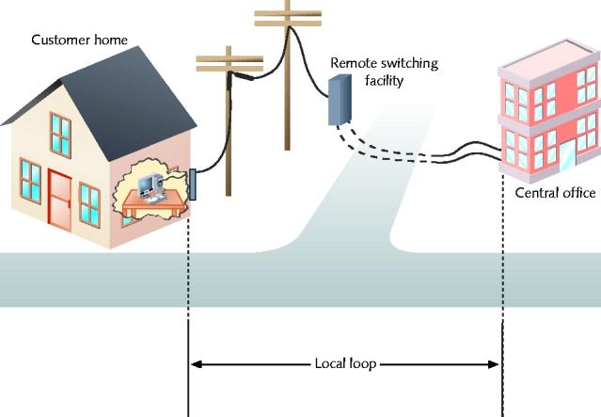
Some cities have fiber to the home (FTTH)

Demarcation point

Local loop endpoint

Carriers responsibility ends

Wires terminate at NIU (network interface unit)

PSTN Internet connection advantages

Ubiquity, ease of use, low cost

PSTN disadvantages

Some circuit switching used

Marginal security

Slow (56 kbps max.)
X.25 and Frame Relay

X.25 ITU standard

Analog, packet-switching technology

Designed for long distance

Original standard: mid 1970s

Mainframe to remote computers: 64 Kbps throughput

Update: 1992

2.048 Mbps throughput

Client, servers over WANs

Verifies transmission at every node

Excellent flow control, ensures data reliability

Slow and unsuitable for time-sensitive applications

Never adopted widely in the USA

Frame relay

Updated X.25: digital, packet-switching

Protocols operate at Data Link layer

Supports multiple Network, Transport layer protocols

Both perform error checking

Frame relay: no reliable data delivery guarantee

Checks for errors but does not fix them

X.25: errors fixed or retransmitted

Throughput

Frame relay: 64 Kbps to 45 Mbps

Customer chooses

Both use virtual circuits

Based on potentially disparate physical links

Logically appear direct

Advantage: efficient bandwidth use

Both configurable as SVCs (switched virtual circuits)

Connection established for transmission, terminated when complete

Both configurable as PVCs (permanent virtual circuits)

Connection established before transmission, remains after transmission

PVCs

Not a dedicated line--you are sharing the wires with other people

Path can change

X.25 or frame relay lease contract

Specify endpoints, bandwidth

CIR (committed information rate)

Minimum bandwidth guaranteed by carrier

PVC lease

Share bandwidth with other users

Frame relay lease advantage

Pay for bandwidth required

Less expensive technology

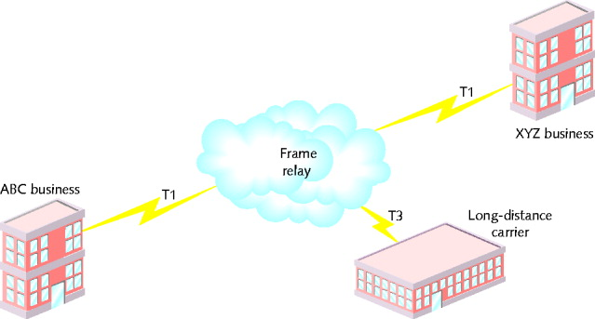
Long-established worldwide standard

Frame relay and X.25 disadvantage

Throughput variability, due to shared lines

Not as private or secure as dedicated lines

Frame relay and X.25 easily upgrade to T-carrier dedicated lines

Due to same connectivity equipment
ISDN

Digital data transmitted over PSTN

Gained popularity: 1990s

Connecting WAN locations

Exchanges data, voice signals

Protocols at Physical, Data Link, Network layers

Signaling, framing, connection setup and termination, routing, flow control, error detection and correction

Relies on PSTN for transmission medium

Dial-up or dedicated connections

Dial-up relies exclusively on digital transmission

Error in Textbook

Page 311, second paragraph

“ISDN specifies protocols at the Physical, Data Link, and Transport layers”

SHOULD BE

“ISDN specifies protocols at the Physical, Data Link, and Network layers”

Single line

Simultaneously: two voice calls, one data connection

Two channel types

B channel: “bearer”

Circuit switching for voice, video, audio: 64 Kbps

D channel: “data”

Packet-switching for call information: 16 or 64 Kbps

BRI (Basic Rate Interface) connection

PRI (Primary Rate Interface) connection

BRI: two B channels, one D channel (2B+D)

B channels treated as separate connections

Carry voice and data

Bonding

Two 64-Kbps B channels combined

Achieve 128 Kbps

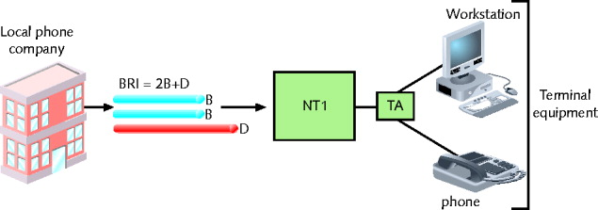
Figure 7-10 A BRI link

NT1: Network Termination 1

TA: Terminal Adapter

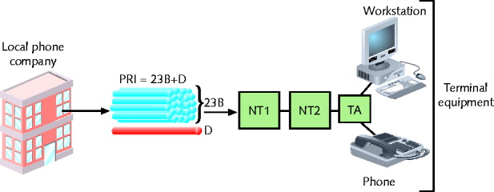
Figure 7-11 A PRI link

PRI: 23 B channels, one 64-Kbps D channel (23B+D)

Separate B channels independently carry voice, data

Maximum throughput: 1.544 Mbps

PRI and BRI may interconnect
T-Carriers

T1s, fractional T1s, T3s

Physical layer operation

Single channel divided into multiple channels

Using TDM (time division multiplexing) over two wire pairs

Medium

Telephone wire, fiber-optic cable, wireless links

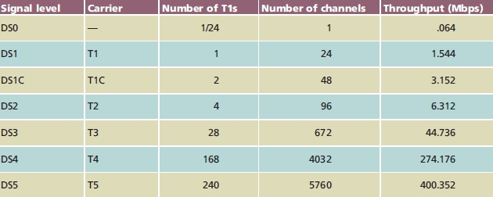
Types of T-Carriers

Many available

Most common: T1 and T3

T1: 24 voice or data channels

Maximum data throughput: 1.544 Mbps

T3: 672 voice or data channels

Maximum data throughput: 44.736 Mbps (45 Mbps)

T-carrier speed dependent on signal level

Physical layer electrical signaling characteristics

DS0 (digital signal, level 0)

One data, voice channel

T1 use

Connects branch offices, connects to carrier

Connects telephone company COs, ISPs

T3 use

Data-intensive businesses

T3 provides 28 times more throughput (expensive)

Multiple T1’s may accommodate needs

TI costs vary by region

Fractional T1 lease

Use some T1 channels, charged accordingly

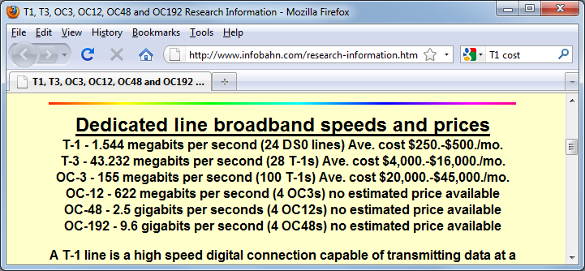
T-Carrier Cost

Link Ch 7b

T-Carrier Connectivity

T-carrier line requires connectivity hardware

Customer site, switching facility

Purchased or leased

T-carrier line requires different media

Throughput dependent

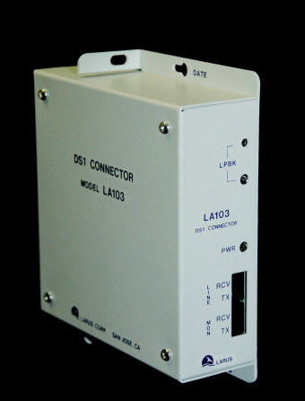
Wiring
Figure 7-12 A T1 smart jack

Plain telephone wire

UTP or STP copper wiring

STP preferred for clean connection

Coaxial cable, microwave, fiber-optic cable

T1s using STP require repeater every 6000 feet

Multiple T1s

Coaxial cable, microwave, fiber-optic cabling

T3s require microwave, fiber-optic cabling

Smart Jack

Terminate T-carrier wire pairs

Customer’s demarc (demarcation point)

Inside or outside building

Connection monitoring point

CSU/DSU (Channel Service Unit/Data Service Unit)

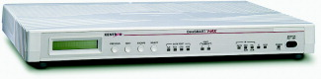
Two separate devices

Combined into single stand-alone device

Interface card

T1 line connection point

At customer’s site

CSU

Provides digital signal termination

Ensures connection integrity

DSU

Converts T-carrier frames into frames LAN can interpret (vice versa)

Connects T-carrier lines with terminating equipment

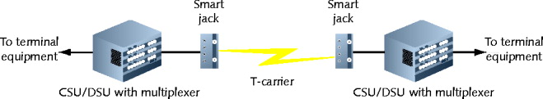
Incorporates multiplexer

Incoming T-carrier line

Multiplexer separates combined channels

Outgoing T-carrier line

Multiplexer combines multiple LAN signals

Terminal Equipment

Switches, routers, bridges

Best option: router, Layer 3 or higher switch

Accepts incoming CSU/DSU signals

Translates Network layer protocols

Directs data to destination

CSU/DSU may be integrated with router, switch

Expansion card

Faster signal processing, better performance

Less expensive, lower maintenance solution
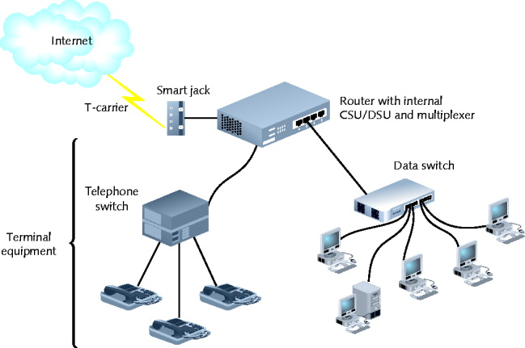

DSL

DSL (digital subscriber line)

Operates over PSTN

Directly competes with ISDN, T1 services

Not available in all areas: must be close to a telco central office

Best suited for WAN local loop

Supports multiple data, voice channels

Over single line

Higher, inaudible telephone line frequencies

Uses advanced data modulation techniques

Data signal alters carrier signal properties

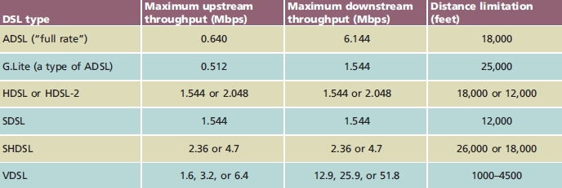
Amplitude or phase modulation

Types of DSL

xDSL refers to all DSL varieties

ADSL, G.Lite, HDSL, SDSL, VDSL, SHDSL

Two DSL categories

Asymmetrical and symmetrical

Downstream

Data travels from carrier’s switching facility to customer

Upstream

Data travels from customer to carrier’s switching facility

Downstream, upstream throughput rates may differ

Asymmetrical

More throughput in one direction

Downstream throughput higher than upstream throughput

Best use: video conferencing, web surfing

Symmetrical

Equal capacity for upstream, downstream data

Examples : HDSL, SDSL, SHDSL

Best use: uploading, downloading significant data amounts

How DSL types vary

Data modulation techniques

Capacity

Distance limitations

PSTN use

DSL Connectivity

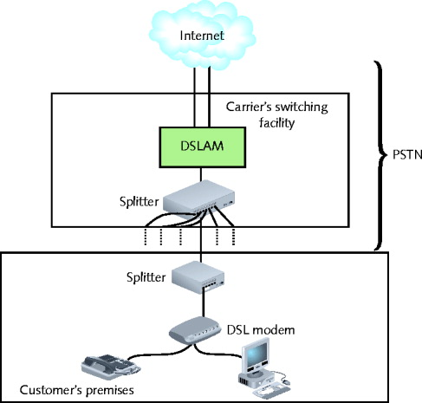
ADSL: common example on home computer

Establish TCP connection

Transmit through DSL modem

Internal or external

Splitter separates incoming voice, data signals

May connect to hub, switch, router

DSL modem forwards modulated signal to local loop

Signal continues over four-pair UTP wire

Distance less than 18,000 feet: signal combined with other modulated signals in telephone switch

Carrier’s remote switching facility

Splitter separates data signal from voice signals

Request sent to DSLAM (DSL access multiplexer) which aggregates many DSL lines together

Combined signal is sent to the Internet backbone

DSL competition

T1, ISDN, broadband cable

DSL installation

Hardware, monthly access costs

Slightly less than ISDN, significantly less than T1s

DSL drawbacks

Not available in all areas

Upstream throughput lower than broadband cable
Broadband Cable

Cable companies connectivity option

Based on TV signals coaxial cable wiring

Theoretical maximum speed

150 Mbps downstream, 10 Mbps upstream

Real transmission

10 Mbps downstream, 2 Mbps upstream

Transmission limited (throttled)

Shared physical connections

Best use

Web surfing

Network data download

Requires cable modem

Modulates, demodulates transmission, reception signals via cable wiring

Operates at Physical and Data Link layer

May connect to connectivity device, like a hub, switch, or router to allow several computers to share the bandwidth

Infrastructure required

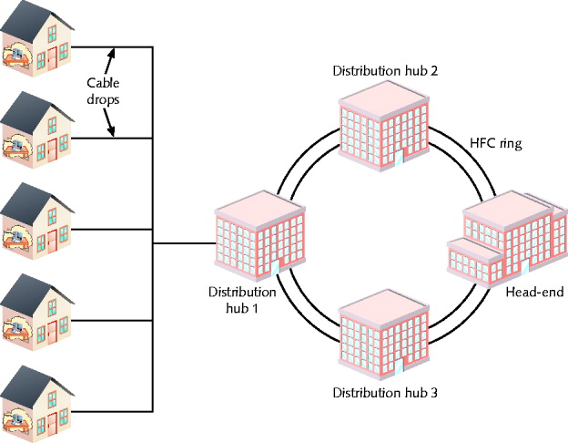
HFC (hybrid fiber-coax)

Expensive fiber-optic link supporting high frequencies

connects cable company’s offices to node

Location near customer

Cable drop

Connects node to customer’s business or residence

Fiber-optic or coaxial cable

Connects to head end

Provides dedicated connection

Many subscribers share same local line, throughput
ATM (Asynchronous Transfer Mode)

Functions in Data Link layer

Asynchronous communications method

Each frame transmitted with start and stop bits

Specifies Data Link layer framing techniques

Fixed packet size

Sets ATM apart from Ethernet

Packet (cell)

48 data bytes plus 5-byte header

Smaller packet size requires more overhead

Decrease potential throughput

Cell efficiency compensates for loss

ATM relies on virtual circuits

ATM considered packet-switching technology

Virtual circuits provide circuit switching advantage

Reliably available point-to-point connection

Reliable connection

Allows specific QoS (quality of service) guarantee

Important for time-sensitive applications

Compatible with other leading network technologies

Cells support multiple higher-layer protocols

LANE (LAN Emulation)

Allows integration with Ethernet, token ring network

Encapsulates incoming Ethernet or token ring frames

Converts to ATM cells for transmission

Throughput

25 Mbps to 622 Mbps

Cost

Relatively expensive

Gigabit Ethernet is replacing ATM on many networks

ATM Service Costs

256 Kbps $ 600 /month

3 Mbps $ 1,200 /month

45 Mbps $ 8,000 /month

From links Ch 6c, 6d
SONET (Synchronous Optical Network)

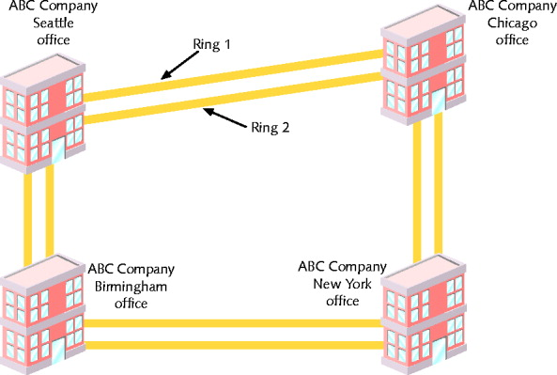
Four key strengths

It can integrate many other WAN technologies

Fast data transfer rates

Simple link additions, removals

High degree of fault tolerance

Synchronous

Data transmitted, received by nodes conforms to timing scheme

Advantage

Interoperability

Fault tolerance

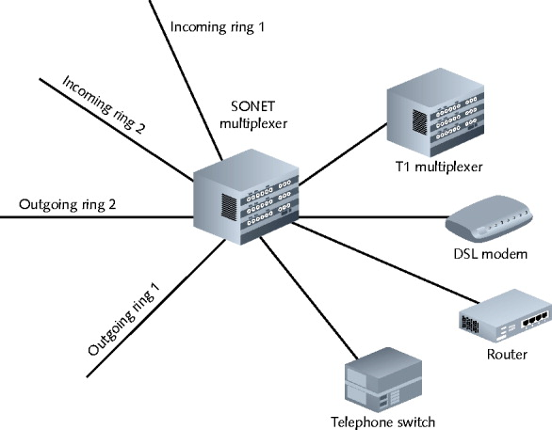
Double-ring topology over fiber-optic cable

SONET Ring

Begins, ends at telecommunications carrier’s facility

Connects organization’s multiple WAN sites in ring fashion

Connect with multiple carrier facilities

Additional fault tolerance

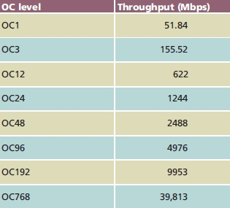
Terminates at multiplexer on carrier and customer premises

Easy SONET ring connection additions, removals

Data rate

Indicated by OC (Optical Carrier) level

Implementation

Large companies

Long-distance companies

Linking metropolitan areas and countries

ISPs

Guarantying fast, reliable Internet access

Telephone companies

Connecting Cos

COST

Expensive

SONET Prices

OC1 51.84 Mbps $ 10,000- $20,000 /month

OC3 155.52 Mbps $ 30,000- $50,000 /month

OC24 1.244 Gbps over $100,000 /month

OC255 13.21 Gbps costs are extremely high

From Link Ch 6e
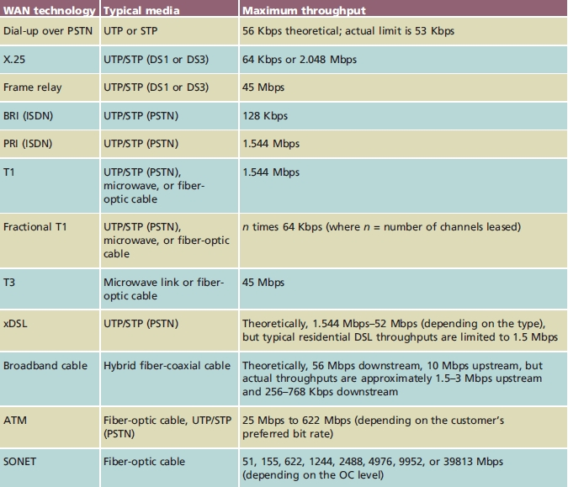
WAN Technologies Compared

Remote Connectivity

Remote access

Service allowing client connection, log on capability

LAN or WAN in different geographical location

Remote client

Access files, applications, shared resources

Remote access communication requirement

Client, host transmission path

Appropriate software

Dial-up networking, Microsoft’s RAS or RRAS, VPNs

Dial-Up Networking

Dialing directly into private network’s or ISP’s remote access server

Log on to network

Transmission methods

PSTN, X.25, ISDN

Advantages

Technology well understood

Software availability

Disadvantages

Throughput

Quality

Administrative maintenance

Microsoft software

RAS (Remote Access Service) (Early Windows versions)

RRAS (Routing and Remote Access Service) (Windows 2000 Server, XP, and later versions)

Remote Access Servers

Server requirements

Accept client connection

Grant privileges to network’s resources

Device types

Dedicated devices: Cisco’s AS5800 access servers

Computers installed with special software

Microsoft remote access software

RRAS (Routing and Remote Access Service)

Computer accepts multiple remote client connections

Server acts as router

Multiple security provisions

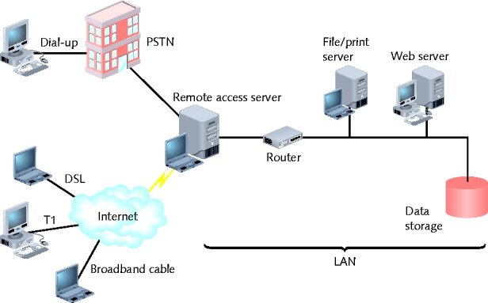

Remote Access Protocols

SLIP and PPP

Workstations connect using serial connection

Encapsulate higher-layer networking protocols, in lower-layer data frames

SLIP carries IP packets only

Harder to set up

Supports only asynchronous data

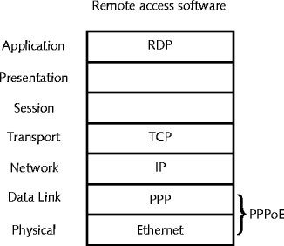
PPP carries many different Network layer packets

Automatic set up

Performs error correction, data compression, supports encryption

Supports asynchronous and synchronous transmission

PPPoE (PPP over Ethernet) standard

Connects home computers to ISP

Via DSL, broadband cable

Remote Virtual Computing

Computer client controls computer host (server)

Across network connection

Dedicated WAN link, Internet connection, dial-up

Established directly between client, host modems

Host allows client access

User name or computer name, password credentials

Thin client

Remote virtual computing software requires little bandwidth

Advantage

Simple configuration

Runs on any connection type

Single host

Accept simultaneous connections from multiple clients

Remote virtual computing software

Differences

Capabilities, security mechanisms, supported platforms

Examples

Microsoft’s Remote Desktop, VNC, Citrix’s ICA

Remote desktop

Windows client and server operating systems

Relies on RDP (Remote Desktop Protocol)

Application layer protocol

Uses TCP/IP to transmit graphics, text quickly

Carries session, licensing, encryption information

Exists for other operating systems

Not included in Windows home editions

VNC (Virtual Network Computing)

Open source system

One workstation remotely manipulates, receives screen updates from another workstation

Free, anyone can modify

Protocols operate in Application layer

Advantages

Multiple computer platform operation

Open source

Single computer supports multiple sessions

Drawback: screen refresh rate

ICA (Independent Computing Architecture)

Citrix System’s Presentation Server

Proprietary software

Advantages

Ease of use

Broad compatibility

Disadvantages

High cost of Citrix products

Server software configuration complexity
VPNs (Virtual Private Networks)

Wide area networks

Logically defined over public transmission systems

Isolated from other public line traffic

Software

Inexpensive

Sometimes included with other widely used software

Tailored to customer’s distance, bandwidth needs

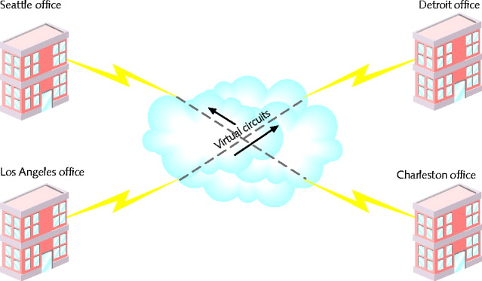
Two important design considerations

Interoperability and security

Tunneling

Ensures VPN carries all data types privately

Tunnel

Virtual connection between two VPN nodes

PPTP (Point-to-Point Tunneling Protocol)

Microsoft

Encryption, authentication, access services

Dial directly into RRAS access server

Dial into ISP’s remote access server first

L2TP (Layer 2 Tunneling Protocol)

Cisco

Connects VPN using equipment mix

Connect two routers

Tunnel endpoints not on same packet-switched network

Last modified 10-12-09

