Objectives

Explain how nodes exchange wireless signals

Identify potential obstacles to successful wireless transmission and their repercussions, such as interference and reflection

Understand WLAN (wireless LAN) architecture

Objectives (cont’d.)

Specify the characteristics of popular WLAN transmission methods, including 802.11 a/b/g/n

Install and configure wireless access points and their clients

Describe wireless MAN and WAN technologies, including 802.16 and satellite communications
The Wireless Spectrum

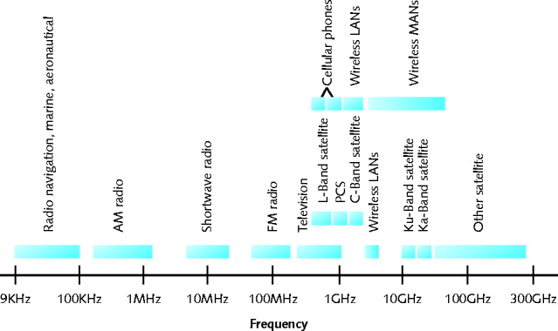
Continuum of electromagnetic waves

Data, voice communication

Arranged by frequencies

Lowest to highest

Spans 9 KHz and 300 GHz

Wireless services associated with one area

FCC oversees United States frequencies

ITU oversees international frequencies

Air signals propagate across borders
Characteristics of Wireless Transmission

Similarities with wired

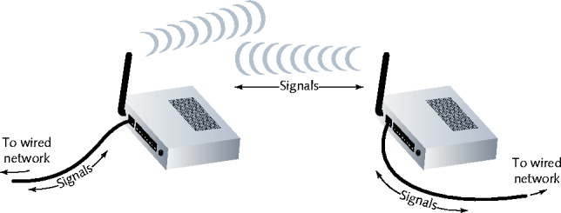
Layer 3 and higher protocols

Signal origination

From electrical current, travel along conductor

Differences from wired

Signal transmission

No fixed path, guidance

Antenna

Signal transmission and reception

Same frequency required on each antenna

Share same channel

Antennas

Radiation pattern

Relative strength over three-dimensional area

All electromagnetic energy antenna sends, receives

Directional antenna

Issues wireless signals along single direction

Omnidirectional antenna

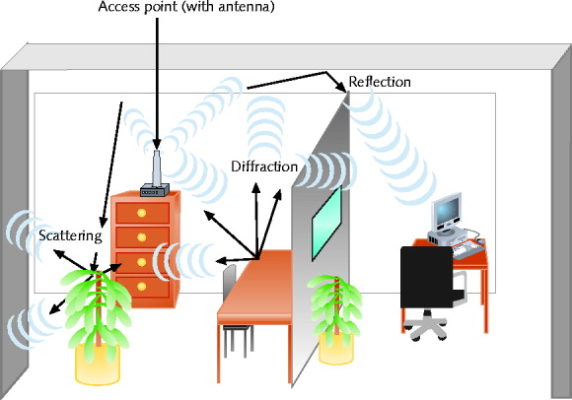
Issues, receives wireless signals

Equal strength, clarity

All directions

Range

Reachable geographical area

Signal Propagation

LOS (line-of-sight)

Signal travels

In straight line, directly from transmitter to receiver

Obstacles affect signal travel

Pass through them

Absorb into them

Subject signal to three phenomena

Reflection: bounce back to source

Diffraction: splits into secondary waves

Scattering: diffusion in multiple different directions

Multipath signals

Wireless signals follow different paths to destination

Caused by reflection, diffraction, scattering

Advantage

Better chance of reaching destination

Disadvantage

Signal delay

Signal Degradation

Fading

Change in signal strength

Electromagnetic energy scattered, reflected, diffracted

Attenuation

Signal weakens

Moving away from transmission antenna

Correcting signal attenuation

Amplify (analog), repeat (digital)

Noise

Usually the worst problem

No wireless conduit, shielding

Frequency Ranges

2.4-GHz band (older)

Frequency range: 2.4–2.4835 GHz

11 unlicensed communications channels

Susceptible to interference

Unlicensed

No FCC registration required

5-GHz band (newer)

Frequency bands

5.1 GHz, 5.3 GHz, 5.4 GHz, 5.8 GHz

24 unlicensed bands, each 20 MHz wide

Used by weather, military radar communications

Narrowband, Broadband, and Spread Spectrum Signals

Defines wireless spectrum use:

Narrowband

Transmitter concentrates signal energy at single frequency, very small frequency range

Broadband

Relatively wide wireless spectrum band

Higher throughputs than narrowband

Spread-spectrum

Multiple frequencies used to transmit signal

Offers security

FHSS (frequency hopping spread spectrum)

Signal jumps between several different frequencies within band

Synchronization pattern known only to channel’s receiver, transmitter

DSSS (direct-sequence spread spectrum)

Signal’s bits distributed over entire frequency band at once

Each bit coded

Receiver reassembles original signal upon receiving bits

Fixed versus Mobile

Fixed communications wireless systems

Transmitter, receiver locations do not move

Transmitting antenna focuses energy directly toward receiving antenna

Point-to-point link results

Advantage

No wasted energy issuing signals

More energy used for signal itself

Mobile communications wireless systems

Receiver located anywhere within transmitter’s range

Receiver can roam
WLAN (Wireless LAN) Architecture

Ad hoc WLAN

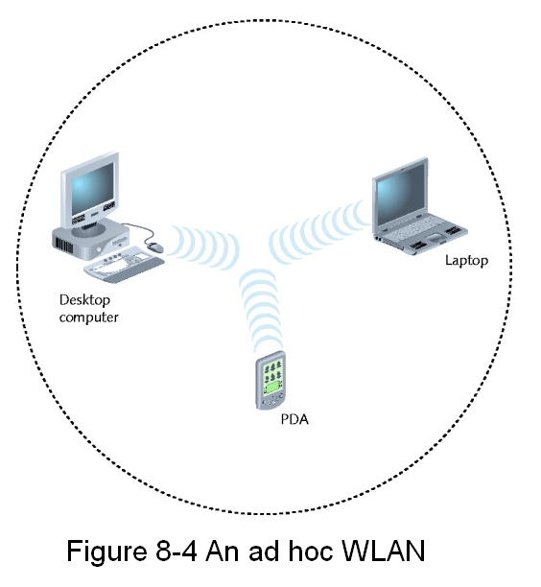
Wireless nodes transmit directly to each other

Use wireless NICs

No intervening connectivity device

Poor performance

Many spread out users, obstacles block signals

Access point (AP)

Accepts wireless signals from multiple nodes

Retransmits signals to network

Base stations, wireless routers, wireless gateways

Infrastructure WLAN

Stations communicate with access point

Not directly with each other

Access point requires sufficient power, strategic placement

WLAN may include several access points

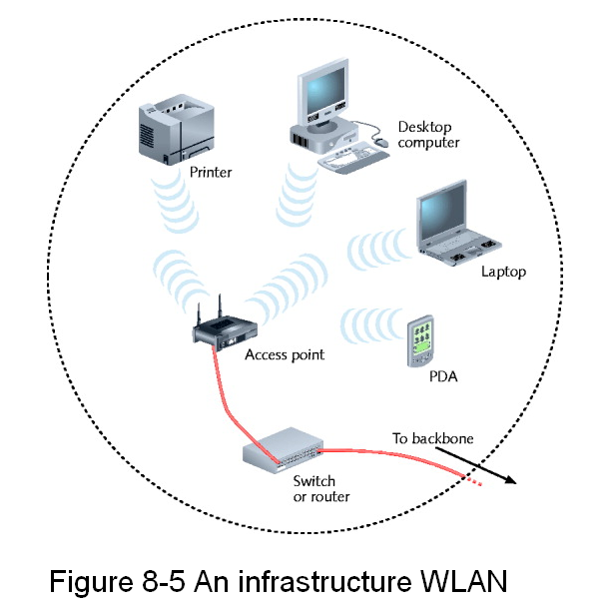
Dependent upon number of stations

Stations per access point varies: 10-100

Mobile networking allows roaming wireless nodes

Range dependent upon wireless access method, equipment manufacturer, office environment

Access point range: 300 feet maximum

Point-to-point link

Can connect two separate LANs

Fixed link, directional antennas between two access points

Allows access points 1000 feet apart

Support for same protocols, operating systems as wired LANs

Ensures compatibility
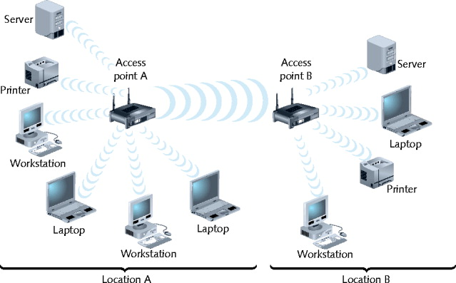

802.11 WLANs

Wireless technology standard

Describes unique functions

Physical and Data Link layers

Differences

Specified signaling methods, geographic ranges, frequency usages

Developed by IEEE’s 802.11 committee

Wi-Fi (wireless fidelity) standards

802.11b, 802.11a, 802.11g, 802.11n (draft)

Share characteristics

Half-duplexing, access method, frame format

802.11n Approved

Approved on 9-11-09

See link Ch 8b

Access Method

802.11 MAC services

Append 48-bit (6-byte) physical addresses to frame

Identifies source, destination

Same physical addressing scheme as 802.3

Allows easy combination

Wireless devices

Not designed for simultaneous transmit, receive

Cannot quickly detect collisions

Use different access method

CSMA/CA (Carrier Sense Multiple Access with Collision Avoidance)

Minimizes collision potential

Uses ACK packets to verify every transmission

Requires more overhead than 802.3

Real throughput less than theoretical maximum

RTS/CTS (Request to Send/Clear to Send) protocol

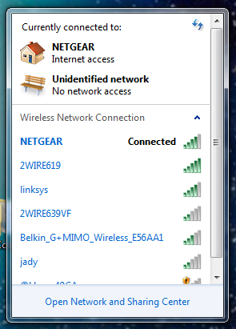
Optional

Ensure packets not inhibited by other transmissions

Efficient for large transmission packets

Further decreases overall 802.11 efficiency

Association

Several packet exchanged between computer, access point

Gain Internet access

Scanning

Surveying surroundings for access point

Active scanning transmits special frame

Probe

Passive scanning listens for special signal

Beacon frame

SSID (service set identifier)

As shown, names like NETGEAR or 2WIRE619

Unique character string identifying access point

In beacon fame information

Configured in access point

Better security, easier network management

BSS (basic service set)

Station groups sharing Access Point

BSSID (basic service set identifier)

Station group identifier

The MAC address of the Access Point

ESS (extended service set)

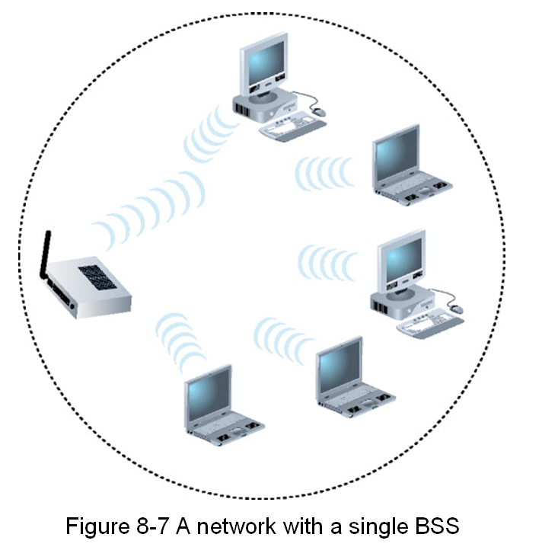
Access point group connecting same LAN

Share ESSID (extended service set identifier)

Allows roaming

Station moving from one BSS to another without losing connectivity

Example: "CCSF Wi-Fi" is the ESSID of our ESS with 100 Access Points

Several access points detected

Select strongest signal, lowest error rate

Poses security risk

Powerful, rogue access point can perform a man-in-the-middle attack

ESS with several authorized access points

Must allow station association with any access point

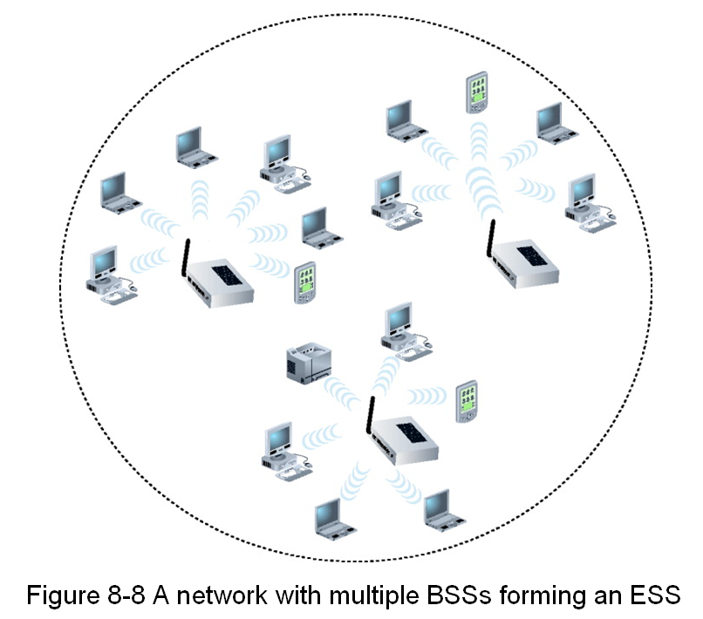
While maintaining network connectivity

Reassociation

Mobile user moves from one access point’s range into another’s range

Occurs by simply moving, high error rate

Stations’ scanning feature

Used to automatically balance transmission loads

Between access points

Frames

802.11 specifies MAC sublayer frame type

Three categories of frames

Management: association and reassociation

Probe, beacon frames

Control: medium access, data delivery

ACK and RTS/CTS frames

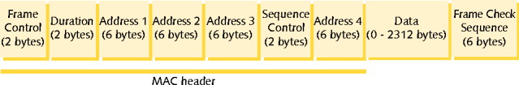
Data: carry data sent between stations

802.11 data frame overhead

Four address fields

Source address and destination address are the same as in Ethernet

Transmitter address and receiver address refer to an intermediate access point in large WLANs

Sequence Control field

Labels fragmented frames so they can be reassembled

Frame Control field

Type of frame, encryption, retry, etc.

All forms of Wi-Fi share the same MAC sublayer characteristics

802.11a, b, g, n

They differ in modulation methods, frequency, usage, ranges

802.11b

DSSS (direct-sequence spread spectrum) signaling

2.4-GHz band

Separated into 22-MHz channels

Throughput

11 Mbps theoretical

5 Mbps actual throughput

100 meters distance limit

Node to Access Point

Oldest, least expensive

Being replaced by 802.11g

802.11a

Released after 802.11b

5-GHz band

Not congested like 2.4-GHz band

Lower interference, requires more transmit power

Throughput

54 Mbps theoretical

11 and 18 Mbps effective

Attributable to higher frequencies, unique modulating data method, more available bandwidth

20 meter distance limit

More expensive, least popular

Orthogonal Frequency Division Multiplexing (OFDM)

Uses each frequency to carry data in parallel

Faster than DSSS

Used by 802.11a, g

802.11g

Affordable as 802.11b

Throughput

54 Mbps theoretical

20 to 25 Mbps effective

100 meter node range

2.4-GHz frequency band

Compatible with 802.11b networks

802.11n

Draft: expected ratification in late 2009

Manufacturers

Selling 802.11n-compatible transceivers

Primary goal

Wireless standard providing much higher effective throughput

Maximum throughput: 600 Mbps

Threat to Fast Ethernet

Backward compatible with 802.11a, b, g standards

2.4-GHz or 5-GHz frequency range

Compared with 802.11a, 802.11g

Same data modulation techniques

Compared with three 802.11 standards

Manages frames, channels, encoding differently

Allows high throughput

MIMO (multiple input-multiple output)

Multiple access point antennas may issue signal to one or more receivers

Receivers combine signal together

Increases network’s throughput, access point’s range

Channel bonding

Two adjacent 20-MHz channels bonded to make 40-MHz channel

More than doubles the bandwidth available in single 20-MHz channel

Because less bandwidth is used to buffer between channels

Higher modulation rates

More efficient use of channels

Frame aggregation

Combine multiple frames into one larger frame

Advantage: reduces overhead

Maximum throughput depends on the strategies used

2.4-GHz or 5-GHz band

Actual throughput: 65 to 600 Mbps

Backward compatible, can be mixed with 802.11a, 802.11b, or 802.11 g

Not all 802.11n features work in mixed-mode WLANs

Recommendation

Use 802.11n-compatible devices
Bluetooth Networks

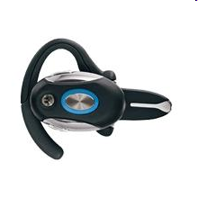
Ericson’s original goals

Wireless technology compatible with multiple devices

Require little power

Cover short ranges

Aim of Bluetooth Special Interest Group (SIG)

Refine and standardize technology

Result: Bluetooth

Mobile wireless networking standard using FHSS (frequency hopping spread spectrum) RF signaling in 2.4-GHz band

Version 1.1

Maximum theoretical throughput: 1 Mbps

Effective throughput: 723 Kbps

10 meter node distance

Designed for PANs (personal area networks)

Version 2.0 (2004)

Different encoding schemes

2.1-Mbps throughput

30 meters node distance

Usage: cellular telephones, phone headsets, computer peripherals, PDAs

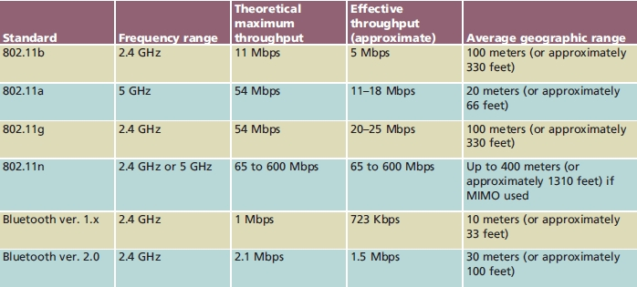
Summary of WLAN Standards

Implementing a WLAN

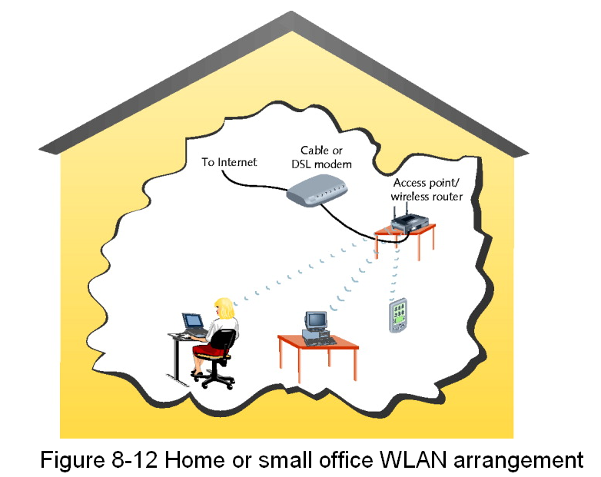
Designing a small WLAN

Home, small office

Formation of larger, enterprise-wide WANs

Installing and configuring access points and clients

Implementation pitfalls

Avoidance

Material applies to 802.11b and 802.11g

Most popular

Determining the Design

One access point

Combine with switching, routing functions

Connects wireless clients to LAN

Acts as Internet gateway

Access point WLAN placement considerations

Typical distances between access point and client

Obstacles

Type, number between access point and clients

Larger WLANs

Systematic approach to access point placement

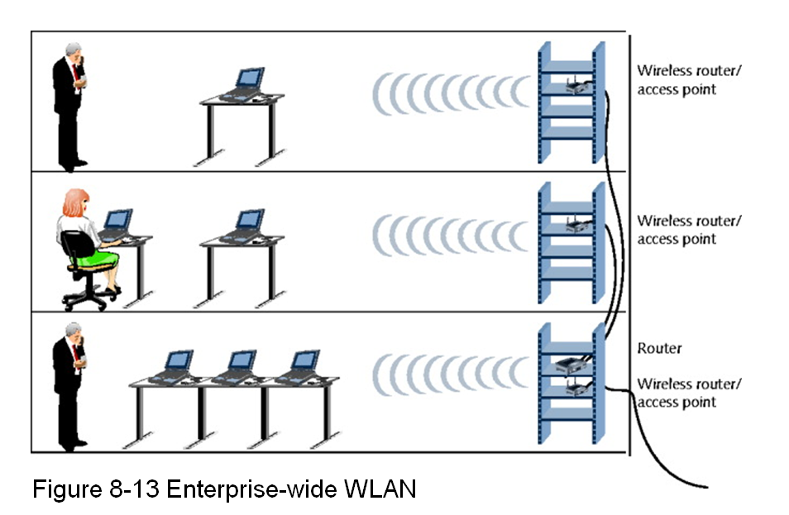
Site survey

Assesses client requirements, facility characteristics, coverage areas

Determines access point arrangement ensuring reliable wireless connectivity

Within given area

Proposes access point testing

Testing wireless access from farthest corners

Install access points

Must belong to same ESS, share ESSID

Enterprise-wide WLAN design considerations

How wireless LAN portions will integrate with wired portions

Configuring Wireless Connectivity Devices

Netgear WGR614 (v7)

Popular, low-cost access point

Four switch ports, routing capabilities

Supports 802.11b, 802.11g transmission

Configuration steps on other small wireless connectivity devices

Differ somewhat

Follow similar process, modify same variables

Configuring Wireless Clients

Configuration varies from one client type to another

Windows XP client WLAN configuration

Use graphical interface

Linux and UNIX clients wireless interface configuration

Use graphical interface

iwconfig command-line function

View, set wireless interface parameters

Avoiding Pitfalls

Access point versus client configurations

SSID mismatch

Incorrect encryption

Incorrect channel, frequency

Standard mismatch (802.11 a/b/g/n)

Incorrect antenna placement

Verify client within 330 feet

Interference

Check for EMI sources
Wireless WANs and Internet Access

Wireless broadband

Latest wireless WAN technologies

Specifically designed for:

High-throughput, long-distance digital data exchange

802.11 Internet Access

Access points: 802.11b or 802.11g access methods

Hot spots

Places with publicly available wireless Internet access

Free or subscription

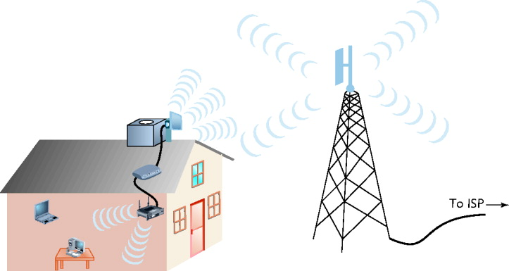
Hot spot subscription Internet access

Log on via Web page

Client software managing client’s connection

Network log on, secure data exchange

Added security: accept connection based on MAC address

Accept user’s connection based on MAC address

802.16 (WiMAX) Internet Access

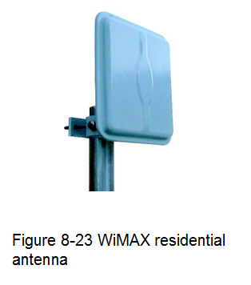
WiMAX (Worldwide Interoperability for Microwave Access)

Current version: 802.16e (2005)

Improved mobility, QoS characteristics

Digital voice signals, mobile phone users

Functions in 2 and 66 GHz range

Licensed, nonlicensed frequencies

Line-of-sight paths between antennas

Throughput potential maximized

Non-line-of-sight paths

Exchange signals with multiple stations at once

Two distinct advantages over Wi-Fi

Much greater throughput (70 Mbps)

Much farther range (30 miles)

Appropriate for MANs and WANs

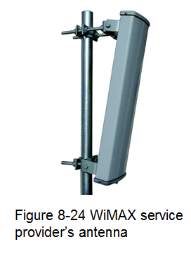
Highest throughput achieved over shortest distances between transceivers

Possible uses

Alternative to DSL, broadband cable

Well suited to rural users

Internet access to mobile computerized devices

Residential homes

Metropolitan area installation

No need for home antenna

WiMAX MANs

Extensive connectivity

Download data rates faster than home broadband connection

Shared service

Apportioned bandwidth

Drawback

Expensive

Clear

WIMAX provider

Available in ten cities so far, including Portland and Las Vegas, but not San Francisco yet

Links: Ch 8f, 8g

Satellite Internet Access

Satellite Orbits

Geosynchronous orbit

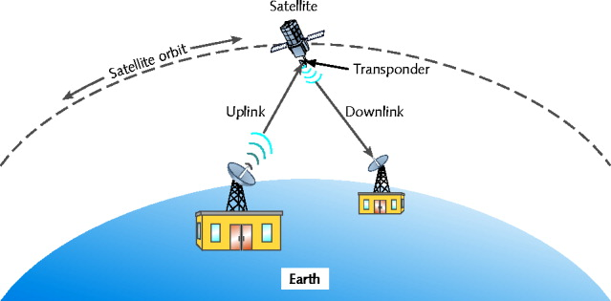
Satellites orbit the Earth at the same rate as the Earth turns

Downlink

Satellite transponder transmits signal to Earth-based receiver

Typical satellite

24 to 32 transponders

Unique downlink frequencies

LEO (low Earth orbiting) satellites

Orbit Earth with altitude 100 miles to 1240 miles

Not positioned over equator

MEO (medium Earth orbiting) satellites

Orbit Earth 6000 to 12,000 miles above surface

Not positioned over equator

Latitude between equator and poles

Advantage

Cover larger Earth surface area than LEO satellites

Less power, less signal delay than GEO satellites

Geosynchronous orbiting satellites most popular for satellite Internet access

Satellite Frequencies

Five frequency bands

L-band—1.5–2.7 GHz

S-band—2.7–3.5 GHz

C-band—3.4–6.7 GHz

Ku-band—12–18 GHz

Ka-band—18–40 GHz

Within bands

Uplink, downlink transmissions differ

Satellite Internet access providers

Use C- or Ku-bands and Ka-band (future)

Satellite Internet Services

Subscriber

Small satellite dish antenna, receiver

Exchanges signals with provider’s satellite network

Satellite Internet access service

Dial return arrangement (asymmetrical)

Receives Internet data via downlink transmission

Sends data to satellite via analog modem connection

Satellite return arrangement (symmetrical)

Send, receive data to and from Internet using satellite uplink and downlink
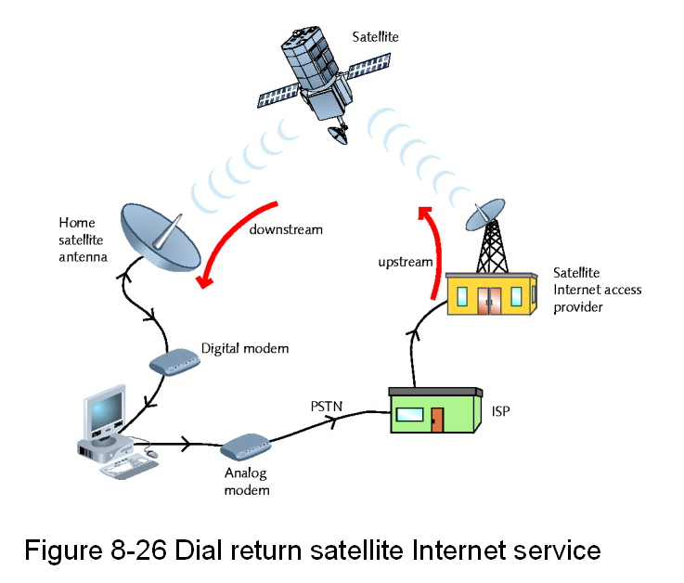

Last modified 10-15-09

