Objectives

Describe characteristics common to all NOSs (network operating systems)

Compare and evaluate NOSs to select the right one for your Network

Define the requirements for and features of the Windows Server 2008 NOS

Define the requirements for and features of UNIX and Linux NOSs

Create users and groups and assign file permissions on systems running Windows Server 2008 and UNIX
Characteristics of Network Operating Systems

Based on client/server architecture

NOS manages resource sharing

NOS provides many other functions

Some built in

Some configured at installation

Default, customizable settings

NOS components vary by NOS version and type

Network Operating Systems and Servers

Networks use servers exceeding minimum hardware

Determining optimal server hardware

Questions

What kinds of applications will run on the server?

How many clients will connect to the server?

How much storage space will each user need?

How much downtime, if any, is acceptable?

What can the organization afford?

Determining optimal server hardware (cont’d.)

Applications influence:

Type of application

Resources used

Processing burden

Vendor reputation requirements

High quality, dependability, excellent technical support

Reliable server

Spend as much as necessary

Component failure: widespread effects

Client Support

Important NOS function

Allows efficient communication, resource sharing

NOS client support tasks

Creating and managing client accounts

Enabling clients to connect to the network

Allowing clients to share resources

Managing clients’ access to shared resources

Facilitating communication between clients

Client/Server Communication

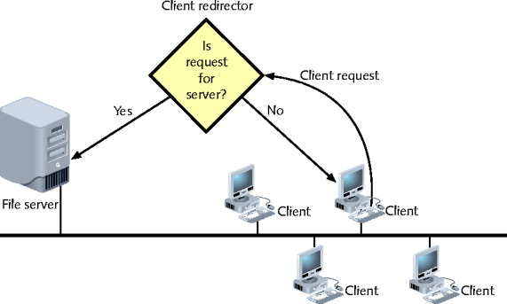
Logon process

Redirector

Intercepts requests, determines where to handle

File access protocol

Windows XP client communication with Windows Server 2008

CIFS (Common Internet File System)

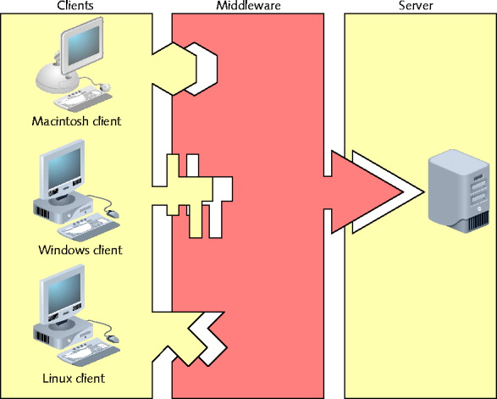
Older protocol SMB (Server Message Block)

Broad support allows every client type to authenticate, access resources

Middleware

Translates requests, responses between client, server

3-tier architecture

Client/server environment incorporating middleware

Users and Groups

After NOS client authentication

Client gains access to NOS services, resources

Administrator account

Most privileged user account

Unlimited rights to server, domain resources, objects

Created by default

Root on UNIX or Linux systems

User names

NOS grants each network user access to files and other shared resources

Groups

Basis for resource and account management

Assists in resource sharing and security control

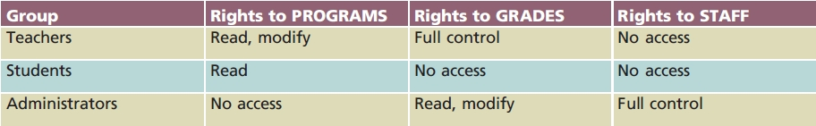
Example: network administrator for public elementary school

Nesting or hierarchical group arrangement

Simplifies management

Group arrangement

Affects permissions granted to each group’s members

Inherited permissions

Passed down from parent group to child group

After user, group restrictions applied

Client allowed to share network resources

Identifying and Organizing Network Elements

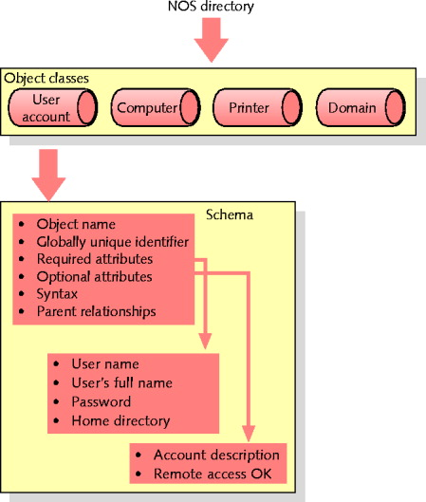
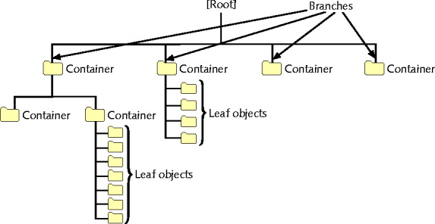
Modern NOSs

Similar patterns for organizing information

Users, printers, servers, data files, and applications

Directory

List organizing resources

Associates resources with characteristics

Example: file system directory

LDAP (Lightweight Directory Access Protocol)

Used to access information stored in directory

Object

Thing or person associated with network

Attributes

Properties associated with object

Schema

Set of definitions

Kinds of objects and object-related information contained in directory

Two types of definitions:

Classes (object classes): identifies object type specified in directory

Attributes: stores information about object

Containers (OUs or organizational units)

Logically defined receptacles

Assemble similar objects

Account

User record containing all properties

LDAP standard

Directories and contents form trees

Tree

Logical representation of multiple, hierarchical levels within directory

Root, branches, leaves

Identifying and Organizing Network Elements

Before installing NOS

Plan directory tree

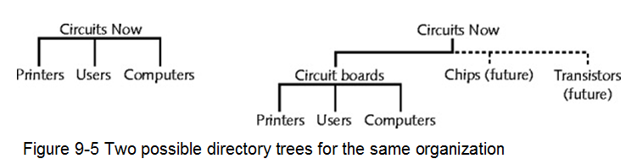
Consider current, future needs

Book example

New manufacturing firm: Circuits Now

Sharing Applications

Shared applications

Often installed on file server

Specifically designed to run applications

Application licensing types

Per user licensing

Per seat licensing

Site license

Installing application on server

Purchase appropriate type and number of licenses

Verify server resources

Install application

Make application available

Provide users access to application

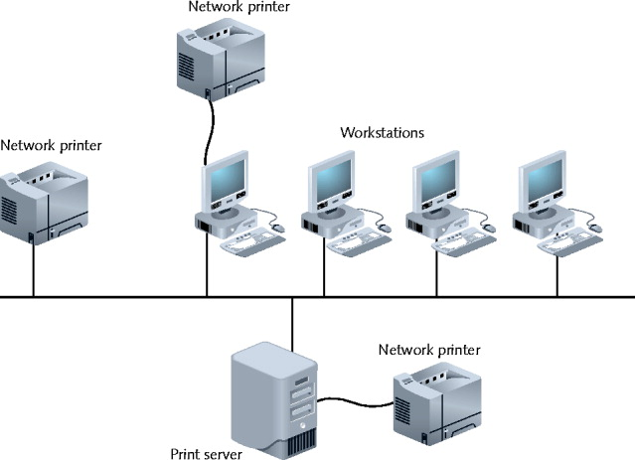
NOS responsible for arbitrating file access

Problem with shared file access

Multiple users simultaneously accessing same data files, same program files

Sharing Printers

Increases resource management efficiency; reduces costs

Print server

Manages print services

Printer attaches to print server

Directly

To convenient network location

All NOSs perform common tasks in managing printers

To create new printer

Install printer driver

Provides printer availability to users

Ensure appropriate printer queue user rights

Networked printers

Appear as icons in Printers folder

Client redirector

Determines where print request should transmitted

Network, workstation

Managing System Resources

Limited server system resources

Required by multiple users

Modern NOSs capabilities

Maximize server memory, processor, bus, and hard drive use

Accommodates more client requests faster

Improves overall network performance

Memory

Virtual memory can boost total memory available

Physical memory: RAM chips

Physical memory required by server varies

Task dependent

Virtual memory: stored on hard drive

Page file (paging file, swap file)

Managed by operating system

Paging

Moving blocks (pages) from RAM into virtual memory

Virtual memory advantages

Easily expands memory available to server applications

Engaged by default

Virtual memory disadvantage

Slows operations

Hard drive access versus physical memory access

Multitasking

Execution of multiple tasks at one time

All operating system perform

Does not mean performing more than one operation simultaneously

Preemptive multitasking (time sharing: UNIX)

Happens quickly

Appearance of tasks occurring simultaneously

Multiprocessing

Process

Routine of sequential instructions that runs until goal is achieved

Thread

Self-contained; well-defined task within process

Main thread

All processes have one

One processor systems

One thread handled at any time

Support use of multiple processors to handle multiple threads

Technique to improve response time

Splits tasks among more than one processor

Expedites single instruction completion

Symmetric multiprocessing

Splits all operations equally among two or more processors

Asymmetric multiprocessing

Assigns each subtask to specific processor

Multiprocessing advantage to servers with high processor usage

Numerous tasks simultaneously
Windows Server 2008

Released February 2008

Enhancement of Windows Server 2003

GUI (graphical user interface)

Pictorial representation of computer function

NOS GIUs

Enable administrator to manage files, users, groups, security, and printers

Enhanced security, reliability, remote client support, and performance

New server management features

Editions

Standard Edition

Web Edition

Enterprise Edition

Datacenter Edition

Popular NOS

Address most network administrator’s needs well

Well-established vendor

Device; program compatibility

Larger market offers technical support

General benefits

Offers several general benefits

Offers simple user interfaces

Disadvantage

Past criticism for performance, security

Hardware Requirements

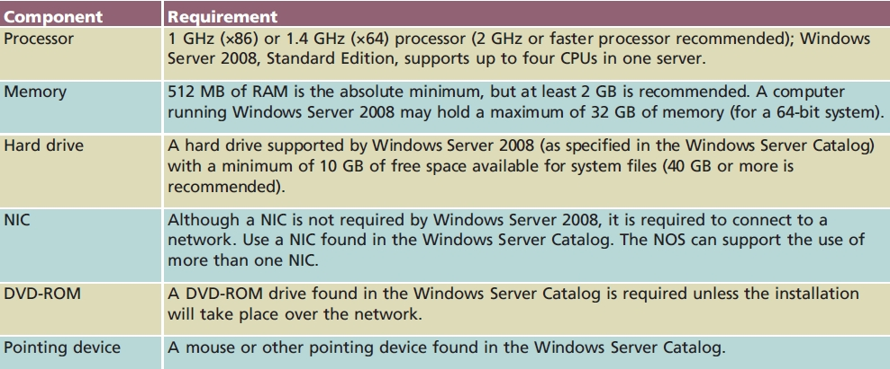

Server components

Processing power, memory, and hard drive space

Windows Server Catalog

Windows Server 2008 compatible computer components

Available online

Consult it prior to hardware purchases

Memory Model

Addressing schemes

32-bit addressing scheme

64-bit addressing scheme

Assigns each application (process)

Own 32-bit memory area

Logical subdivision memory available to server

Important Windows Server 2008 feature

Install more server physical memory than allowed in earlier versions

Uses virtual memory

NTFS (New Technology File System)

File system

Methods of organizing, managing, and accessing files

Through logical structures, software routines

NTFS (New Technology File System)

Installed by default

Disk data distribution

Disks divided into allocation units (clusters)

Allocation units combine to form partition

Logically separate hard disk storage area

Advantages

Secure, reliable, and allows file compression

Handles massive files

Allow fast access to resources

Used on all Windows operating system versions

Since Windows NT

Offers many features

Drawback

Cannot be read by older operating systems (Win 98)

Active Directory

Directory service

Originally designed for Windows 2000 Server

Enhanced with Windows Server 2008

Windows Server 2008 network

Workgroup model

Domain model

Workgroups

Peer-to-peer network

Decentralized management

Each computer has own database

User accounts, security privileges

Significantly more administration effort

Practical for small networks

Few users

Simple to design, implement

Domains

Group of users, servers, and other resources

Share centralized account and security information database

Client/server network

Active directory

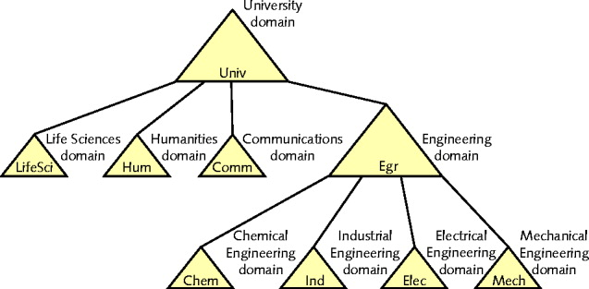
Contains domain databases
Domains

Easier to organize and manage resources and security

Domain not confined by geographical boundaries

Domain controllers

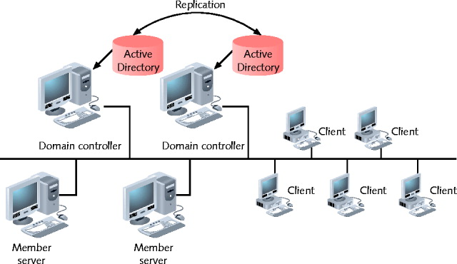
Contains directory containing information about objects in domain

Member servers

Do not store directory information

Replication

Process of copying directory data to multiple domain controllers

OUs (Organizational Units)

Hold multiple objects having similar characteristics

Can be nested

Provides allows simpler, more flexible administration

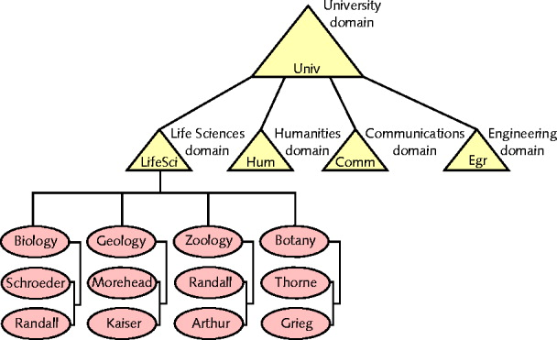
Trees and Forests

Directory structure above domains

Large organizations use multiple domains

Domain tree

Organizes multiple domains hierarchically

Root domain

Active Directory tree base
OUs

Child domains

Branch off from root domain

Separate groups of objects with same policies

Forest

A collection of one or more domain trees

Share common schema

Domains within a forest can communicate

Domains within same tree

Share common Active Directory database

Trust Relationships

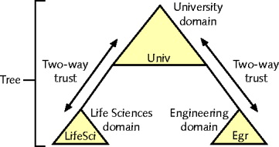
Relationship between two domains

One domain allows another domain to authenticate its users

Active Directory supports two trust relationship types

Two-way transitive trusts

Explicit one-way trusts

Naming Conventions

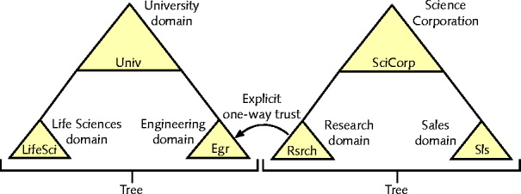
Active Directory naming (addressing) conventions

Based on LDAP naming

Internet namespace

Complete hierarchical names database

Used to map IP addresses to hosts’ names

Active Directory namespace

Collection of object names, associated places in Windows Server 2003, Server 2008 network

Two namespaces are compatible

Windows Server 2008 network object

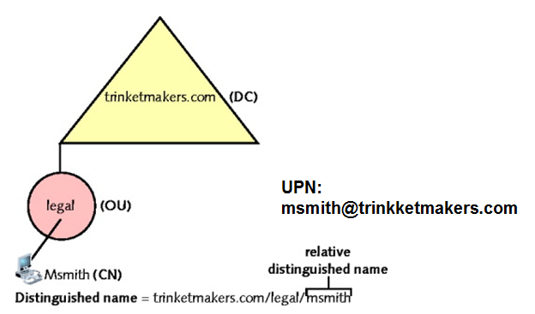
Three different names

DN (distinguished name): DC (domain component) and CN (common name) – long and complete name

RDN (relative distinguished name) – unique within a container

UPN (user principal name) – like an email address

GUID (globally unique identifier)

128-bit number

Ensures no two objects have duplicate names

Server Management

Setting up and managing server

Choose role

Reflects server’s primary purpose

Conduct server management task

Server Manager: GUI tool

Many functions available

Use Server Manager window

UNIX and Linux

Popular NOSs

Provide resource sharing

Older

UNIX developed in 1969

UNIX preceded, led to TCP/IP protocol suite development

Most Internet servers run UNIX

Efficient and flexible

Some difficulty to master UNIX

Not controlled, distributed by single manufacturer

Some version nonproprietary and freely distributed

A Brief History of UNIX

Late 1960s: UNIX operating system

1970s

Antitrust laws and AT&T

Anyone could purchase the source code

New versions of UNIX appeared

System V, BSD

1980s

Rights changes hands, now owned by Novell

Open Group owns UNIX trademark

Varieties of UNIX

Many varieties (flavors, distributions)

Share several features

UNIX operating system

Divided into two main categories

Proprietary

Open source

Proprietary UNIX

Source code unavailable

Available only by purchasing licensed copy from Novell

Vendors

Apple Computer: Mac OS X Server

Sun Microsystems: Solaris

IBM: AIX

Proprietary UNIX system advantages

Accountability and support

Optimization of hardware and software

Predictability and compatibility

Proprietary UNIX system drawback

No source code access

No customization

Open Source UNIX

Customizable

Not owned by any one company

No licensing fees

Open source software (freely distributable software)

UNIX GNU, BSD, and Linux

Variety of implementations

Run on wider range of systems

Key difference from proprietary implementations

Software license

Two Flavors of UNIX

Solaris

Sun Microsystems

Runs on SPARC-based servers

All commercially supported operating system benefits

Use: Runs intensive applications

Examples: large, multiterabyte databases, weather prediction systems, and large economic modeling applications

Linux follows standard UNIX conventions

Highly stable, free

Developed by Linus Torvalds (1991)

All UNIX and Linux versions

Offer host of features

TCP/IP protocol suite

Applications to support networking infrastructure

Support non-IP protocols like SLIP and Appletalk

Programs necessary for routing, firewall protection, DNS services, DHCP services

Operates over many different network topologies, physical media

Efficiently and securely handle growth, change, stability

Source code used, thoroughly debugged

Solaris Hardware Requirements

Similar to Windows Server 2003, Server 2008

Key differences

UNIX, Linux operating system can act as workstation or server operating system

GUI (graphical user interface) remains optional

No single “right” server configuration exists

Solaris Hardware Requirements

Computers containing Sun SPARC processors or Intel-based processors
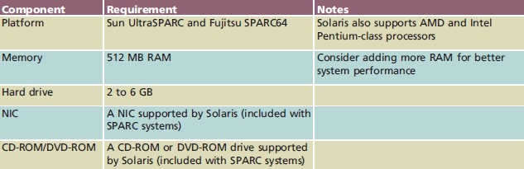

Linux Hardware Requirements

Linux servers adhere to certain minimum requirements
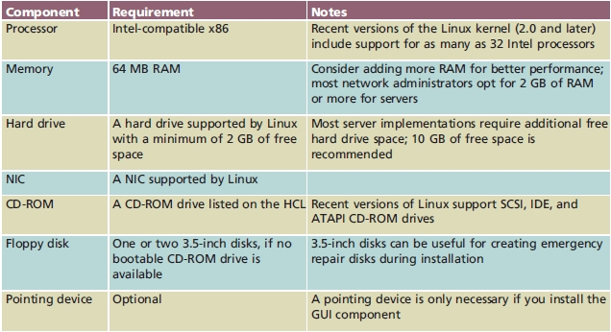

UNIX Multiprocessing

UNIX and Linux

Support processes and threads

Allocate separate resources (memory space) to each process

When created

Manage access to resources

Advantage: prevents one program from disrupting system

Support symmetric multiprocessing

Different versions support different number of processors

The UNIX Memory Model

Use physical, virtual memory efficiently

Allocate memory area for each application

Share memory between programs when possible

Use 32-bit addressing scheme

Programs access 4 GB memory

Most systems also run on CPUs employing 64-bit addresses

18 exabytes (264 bytes) memory

Virtual memory

Disk partition or file

The UNIX Kernel

Kernel

Core of all UNIX and Linux systems

Kernel module

File containing instructions for performing specific task

Reading data from and writing data to hard drive

UNIX System File and Directory Structure

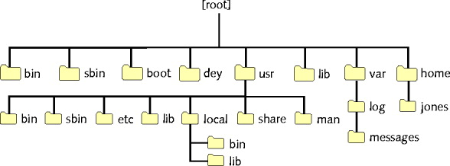
Hierarchical file system

Disk directories may contain files, other directories

/boot directory: kernel, system initialization files

/sbin directory: applications, services

/var directory: variable data

/home directory: created for new users

UNIX File Systems

Two broad categories

Disk file systems

Network file systems

Disk File Systems

Organizing, managing, accessing files

Through logical structures, software routines

Linux native file system type

ext3: “third extended” file system

Solaris native file system

UFS (UNIX file system)

Network File Systems

Analogous to Windows shares

Attach shared file systems (drives)

From Windows, other UNIX servers

Share files with users on other computers

UNIX and Linux popular remote file system type

Sun Microsystems’ NFS (Network File System)

Open source application implementing Windows SMB, CIFS file system protocols

Samba

A UNIX and Linux Command Sampler

Many system administrators prefer command line

GUI executes commands

Responds to mouse clicks

Command interpreter (shell)

Accepts keyboard commands and runs them

Man pages (manual pages)

Full documentation of UNIX commands

Nine sections

apropos command

Helps find possible man page entries

Commands function like sentences

Rules guide UNIX command use

Significant UNIX and Windows command-line interface difference

Character separating directories

Windows separator character: ( \ )

UNIX separator character: ( / )

Most frequently used UNIX command

ls

Provides file information

Stores in file inode (information node)

ls –l command

Access permissions field

Files type designations

Pipe

Direct one command output to input of another command

Unix: vertical bar ( | )

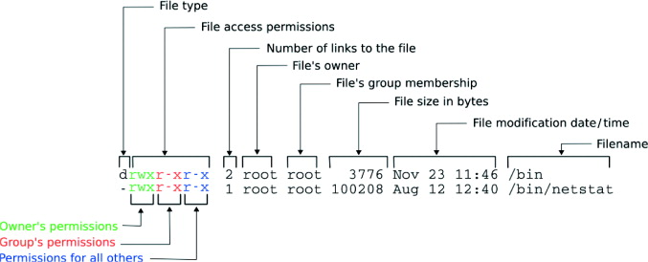
Figure 9-18 Anatomy of ls –l output

Last modified 10-21-09

