Objectives

Understand methods of network design unique to TCP/IP networks, including subnetting, CIDR, and address translation

Explain the differences between public and private TCP/IP networks

Describe protocols used between mail clients and mail servers, including SMTP, POP3, and IMAP4

Employ multiple TCP/IP utilities for network discovery and troubleshooting

Designing TCP/IP-Based Networks

TCP/IP protocol suite use

Public Internet connectivity

Private connection data transmission

TCP/IP fundamentals

IP: routable protocol

Interfaces requires unique IP address

Node may use multiple IP addresses

Two IP versions: IPv4 and IPv6

IPv4: older; more common

IPv4 addresses

Four 8-bit octets

Binary or dotted decimal

Network host name assignment

Dynamic using DHCP

Static

Network classes: A, B, C, D, E

Class D, E addresses reserved

Node’s network class provides information about segment network node belongs to

Subnetting

Separates network

Multiple logically defined segments (subnets)

Geographic locations, departmental boundaries, technology types

Subnet traffic separated from other subnet traffic

Reasons to separate traffic

Enhance security

Improve performance

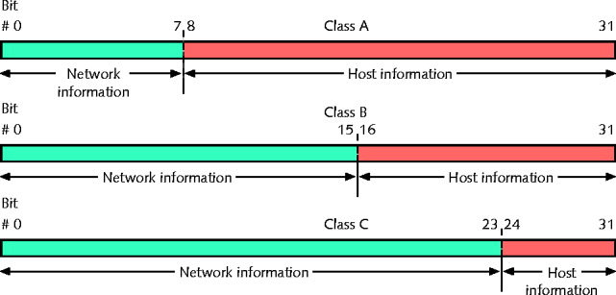
Simplify troubleshooting

Classful Addressing in IPv4

First, simplest IPv4 addressing type

Adheres to network class distinctions

Recognizes Class A, B, C addresses

Network information (network ID)

First 8 bits in Class A address

First 16 bits in Class B address

First 24 bits in a Class C address

Host information

Last 24 bits in Class A address

Last 16 bits in Class B address

Last 8 bits in Class C address

Drawbacks

Fixed network ID size limits number of network hosts

Difficult to separate traffic from various parts of a network

Class | Subnet Mask in Binary  Subnet Mask in Decimal | # Network Bits | CIDR  Notation
A | 11111111 00000000 00000000 00000000  255 0 0 0 | 8 | /8
B | 11111111 11111111 00000000 00000000  255 255 0 0 | 16 | /16
C | 11111111 11111111 11111111 00000000  255 255 255 0 | 24 | /24

IPv4 Subnet Masks

Identifies how network subdivided

Indicates where network information located

Subnet mask bits

1: corresponding IPv4 address bits contain network information

0: corresponding IPv4 address bits contain host information

Network class

Associated with subnet mask

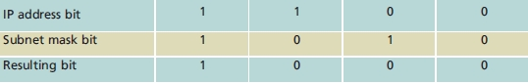
ANDing

Combining bits

Bit value of 1 AND another bit value of 1 results in 1

Bit value of 0 AND any other bit results in 0

ANDing logic

1: “true”, 0: “false

ANDing example

Address’s fourth octet

Any combination of 1s and 0s

Results in network ID fourth octet of 0s

Reserved Addresses

Cannot be assigned to node network interface; used as subnet masks

Network ID

Bits available for host information set to 0

Classful IPv4 addressing network ID ends with 0 octet

Subnetting allows network ID with other decimal values in last octet(s)

Broadcast address

Octet(s) representing host information equal all 1s

Decimal notation: 255 (for class C)

IPv4 Subnetting Techniques

Subnetting breaks classful IPv4 addressing rules

IP address bits representing host information change to represent network information

Reduce usable host addresses per subnet

Hosts, subnets available after subnetting related to host information bits borrowed

Subnetting a Class C Address

Subnet Mask in Binary  Subnet Mask in Decimal | # Usable Addr | CIDR  Notation
11111111 11111111 11111111 10000000  255 255 255 128 | 254 | /25
11111111 11111111 11111111 11000000  255 255 255 192 | 62 | /26
11111111 11111111 11111111 11100000  255 255 255 224 | 30 | /27
11111111 11111111 11111111 11110000  255 255 255 240 | 14 | /28
11111111 11111111 11111111 11111000  255 255 255 248 | 6 | /29
11111111 11111111 11111111 11111100  255 255 255 252 | 2 | /30

Calculating IPv4 Subnets

Formula: # Usable Addresses = 2^{n} −2

n: number of subnet mask bits that are zero

Example

Class C network

Network ID: 199.34.89.0

Want to divide into six subnets

Class A, Class B, and Class C networks

Can be subnetted

Each class has different number of host information bits usable for subnet information

Varies depending on network class and the way subnetting is used

LAN subnetting

LAN’s devices interpret device subnetting information

External routers

Need network portion of device IP address
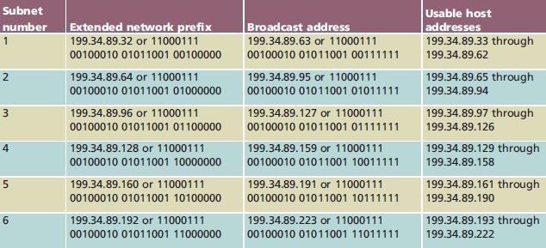
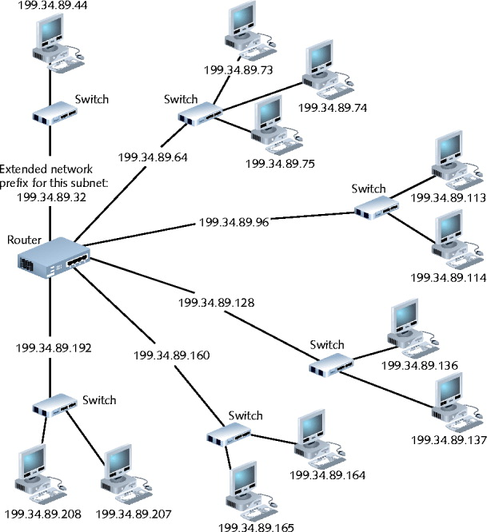
Figure 10-3 A router connecting several subnets

CIDR (Classless Interdomain Routing)

Also called classless routing or supernetting

Not exclusive of subnetting

Provides additional ways of arranging network and host information in an IP address

Conventional network class distinctions do not exist

Example: subdividing Class C network into six subnets of 30 addressable hosts each

Supernet

Subnet created by moving subnet boundary left

Subnet and Supernet Masks

Suppose you are starting with a class C address like 192.168.0.0/24

This would be a subnet:

Subnet Address: 192.168.0.0 / 26

Subnet Mask: 11111111 11111111 11111111 11000000

255 255 255 192

Usable address range: 192.168.0.1 - 192.168.0.62

This would be a supernet:

Subnet Address: 192.168.0.0 / 22

Subnet Mask: 11111111 11111111 11111100 00000000

255 255 252 0

Usable address range: 192.168.0.1 - 192.168.3.254
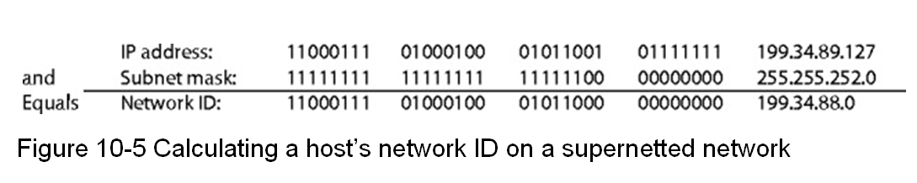

Example: class C range of IPv4 addresses sharing network ID 199.34.89.0

Need to greatly increase number of default host addresses

CIDR notation (or slash notation)

Shorthand denoting subnet boundary position

Form

Network ID followed by forward slash ( / ), followed by number of bits used for network portion of the address

Like 147.144.51.0/24

Internet Gateways

Gateway

A device that connects two networks or subnets

Default gateway

Sends LAN traffic to other subnets, such as the Internet

Usually a router

Network nodes

Have one default gateway address

Assigned manually or automatically (DHCP)

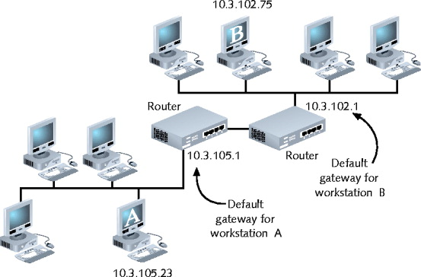
Address Translation

Public network

Any user may access

Little or no restrictions

Private network

Access restricted

Clients, machines with proper credentials

Hiding IP addresses

Provides more flexibility in assigning addresses

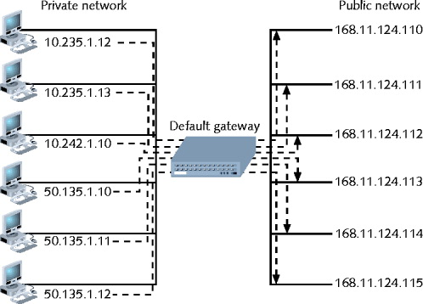
NAT (Network Address Translation)
SNAT

Gateway replaces client’s private IP address with Internet-recognized IP address

Reasons for using address translation

Overcome IPv4 address quantity limitations

Add marginal security to private network when connected to public network

Develop network addressing scheme

SNAT (Static Network Address Translation)

Client associated with one private IP address, one public IP address

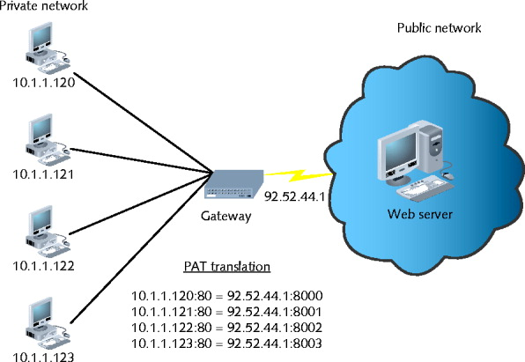
Never changes

Useful when operating mail server

DNAT (Dynamic Network Address Translation)

Also called IP masquerading

Internet-valid IP address might be assigned to any client’s outgoing transmission

PAT (Port Address Translation)

Each client session with server on Internet assigned separate TCP port number

Client server request datagram contains port number

Internet server responds with datagram’s destination address including same port number

NAT

Separates private, public transmissions on TCP/IP network

Gateways conduct network translation

Most networks use router

Gateway might operate on network host

Windows operating systems

ICS (Internet Connection Sharing)
TCP/IP Mail Services

E-mail

Most frequently used Internet services

Functions

Mail delivery, storage, pickup

Mail servers

Communicate with other mail servers

Deliver messages, send, receive, store messages

Mail clients

Send messages to; retrieve messages from mail servers

SMTP (Simple Mail Transfer Protocol)

Used to send email

From one mail server to another

Operates at Application layer

Relies on TCP at Transport layer

Uses TCP port 25

Email client software

Administrator must specify SMTP server name

Such as smtp.gmail.com

MIME (Multipurpose Internet Mail Extensions)

SMPT drawback: ASCII characters only

MIME standard encodes, interprets binary files, images, video, non-ASCII character sets within e-mail message

Identifies each mail message element according to content type

Text, graphics, audio, video, multipart

Does not replace SMTP

Works in conjunction with it

Encodes different content types

Fools SMTP

POP (Post Office Protocol)

Application layer protocol

Retrieve messages from mail server

POP3 (Post Office Protocol, version 3)

Current, popular version

Relies on TCP, operates over port 110

Store-and-forward type of service

Advantages

Minimizes server resources

Mail deleted from server after retrieval

Disadvantage for mobile users

Mail server, client applications support POP3

IMAP (Internet Message Access Protocol)

More sophisticated alternative to POP3

IMAP4: current version

Advantages

Replace POP3 without having to change e-mail programs

E-mail stays on server after retrieval

Good for mobile users

Features

Users can retrieve all or portion of mail message

Users can review messages and delete them

While messages remain on server

Users can create sophisticated methods of organizing messages on server

Users can share mailbox in central location

Disadvantages

Requires more storage space, processing resources than POP servers

Network managers must watch user allocations closely

If the IMAP4 server fails, users cannot access mail
Additional TCP/IP Utilities

TCP/IP transmission process

Many points of failure

Increase with network size, distance

Utilities

Help track down most TCP/IP-related problems

Help discover information about node, network

Nearly all TCP/IP utilities

Accessible from command prompt

Syntax differs per operating system

Ipconfig

Command-line utility providing network adapter information

IP address, subnet mask, default gateway

Windows operating system tool

Command prompt window

Type ipconfig and press Enter

Switches manage TCP/IP settings

Forward slash ( / ) precedes command switches

Requires administrator rights

To change workstation’s IP configuration

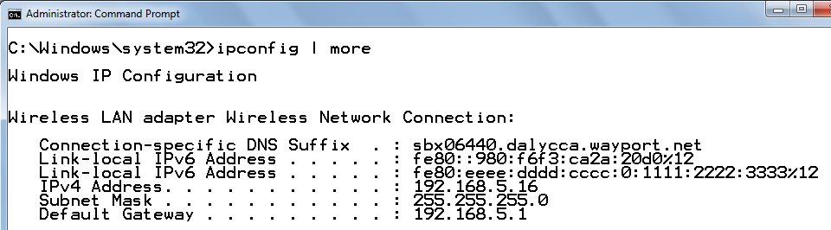
IPCONFIG | MORE

Useful in Vista and Windows 7

Because they have a lot of extra virtual network adapters

Renewing a IP Address

IPCONFIG /RELEASE

Ends the current IP address lease

IPCONFIG /RENEW

Asks DHCP for a new IP address

These commands are often required when moving from one LAN to another

Ifconfig

Utility used on UNIX and Linux systems

Modify TCP/IP network interface settings, release and renew DHCP-assigned addresses, check TCP/IP setting status

Runs at UNIX, Linux system starts

Establishes computer TCP/IP configuration

Used alone or with switches

Uses hyphen ( - ) before some switches

No preceding character for other switches

Netstat

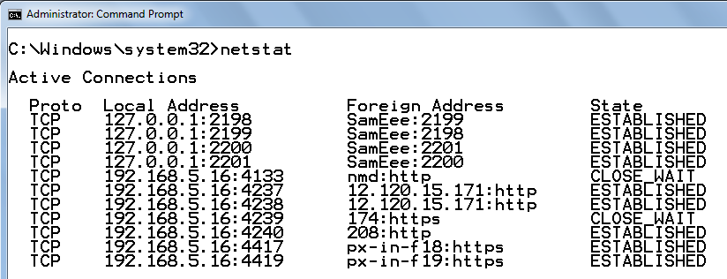
Displays TCP/IP statistics, component details, host connections

Used without switches

Displays active TCP/IP connections on machine

Can be used with switches

-a shows all connections including listening ones

-n display raw port numbers instead of letters like http

For help, use NETSTAT /?

Nbtstat

NetBIOS

Used on Windows LANs

Protocol runs in Session and Transport layers

Associates NetBIOS names with workstations

Not routable

Can be made routable by encapsulation

Nbtstat utility

Provides information about NetBIOS statistics

Resolves NetBIOS names to IP addresses

Limited use as TCP/IP diagnostic utility

Hostname and Nslookup

Hostname utility

Provides client’s host name

Administrator may change

Nslookup

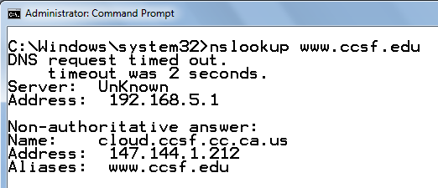
Query DNS database from any network computer

Find the device host name by specifying its IP address

Verify host configured correctly; troubleshoot DNS resolution problems

Dig

Domain information groper

Similar to nslookup

Query DNS database

Find specific IP address host name

Useful for diagnosing DNS problems

Dig utility provides more detailed information than nslookup

Flexible: two dozen switches

Included with UNIX, Linux operating systems

Windows system: must obtain third party code
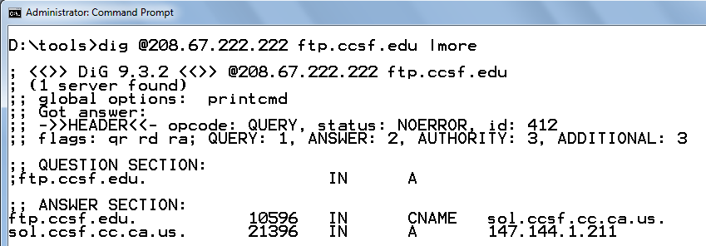

Whois

Query DNS registration database

Obtain domain information

Troubleshoot network problems

Syntax on Linux or Unix

whois xxx.yy

xxx.yy is second-level domain name

Windows system

Requires additional utilities

Web sites provide simple, Web-based interfaces

Traceroute

Windows-based systems: tracert

Linux systems: tracepath

ICMP ECHO requests

Trace path from one networked node to another

Identifying all intermediate hops between two nodes

Transmits UDP datagrams to specified destination

Using either IP address or host name

To identify destination

Command used a number of switches
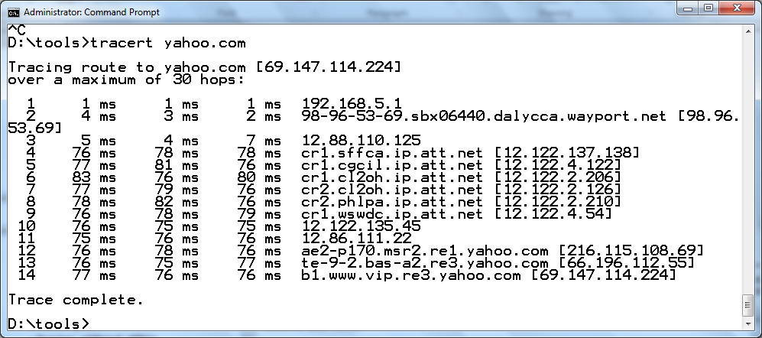

Mtr (my traceroute)

UNIX, Linux operating systems

Route discovery, analysis utility

Combines ping, traceroute functions

Output: easy-to-read chart

Simplest form

mtr ip_address or mtr host_name

Run continuously

Stop with Ctrl+C or add limiting option to command

Number of switches refine functioning, output

Results misleading

If devices prevented from responding to ICMP traffic

Windows XP, Vista, Server 2003, Server 2008

Pathping program as command-line utility

Similar switches as mtr

Pathping output differs slightly

Displays path first

Then issues hundreds of ICMP ECHO requests before revealing reply, packet loss statistics

Route

Route utility

Allows viewing of host’s routing table

UNIX or Linux system

Type route and press Enter

Windows-based system

Type route print and press Enter

Cisco-brand router

Type show ip route and press Enter

Route command

Add, delete, modify routes

Route command help

UNIX or Linux system

Type man route and press Enter

Windows system

Type route ? and press Enter

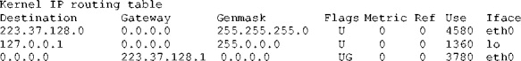
Figure 10-16 Example routing table

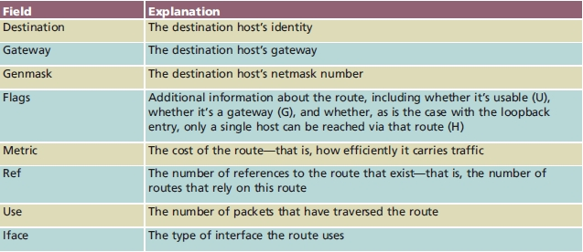
Table 10-6 Fields in routing table on a UNIX host

Last modified 10-28-09

