Objectives

Use terminology specific to converged networks

Explain VoIP (voice over IP) services and their user interfaces

Explain video-over-IP services and their user interfaces

Describe VoIP and video-over-IP signaling and transport protocols, including SIP, H.323, and RTP

Understand QoS (quality of service) assurance methods critical to converged networks, including RSVP and DiffServ
Terminology

IP Telephony

IP telephony (VoIP)

Any network carrying voice signals using TCP/IP

Public or private

Runs over any packet-switched network

VoATM (voice over ATM)

VoDSL (voice over DSL)

Data connection types carrying VoIP signals

T-carriers, ISDN, broadband cable, satellite connections, WiFi, WiMAX, cellular telephone networks

IP Telephony

Internet telephony

VoIP relies on Internet

Advantage: breadth and low cost

Private lines can also carry VoIP calls

Effective and economical

Network congestion control capabilities

Better sound quality

Non-Data Applications

Other non-data applications on converged networks

FoIP (Fax over IP)

IPTV (IP television)

Videoconferencing

Multiple participants communicate and collaborate via audiovisual means

Streaming video

Compressed video delivered in continuous stream

Hulu.com for free Internet TV shows

Webcasts

Streaming videos supplied via the Web

Terminology

Multicasting

One node transmits same content to every client in group

Video over IP

IPTV, videoconferencing, streaming video, IP multicasting

Unified communications (unified messaging) service

Several communication forms available from single user interface

VoIP (Voice over IP) Applications and Interfaces

VoIP (Voice over IP) Applications and Interfaces

Significant VoIP implementation reasons

Lower voice call costs (toll bypass)

New, enhanced features and applications

Centralize voice and data network management

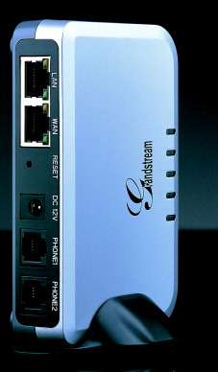
Voice and data configurations

Traditional telephone (sends, receives analog signals)

Telephone specially designed for TCP/IP transmission

Computer with microphone, speaker, VoIP client software

Mixture

Analog Telephones

Using traditional telephone, digital VoIP connection

Must convert voice signals into bits

Analog-to-digital conversion

Codec

Method to accomplish analog signal compressing, encoding

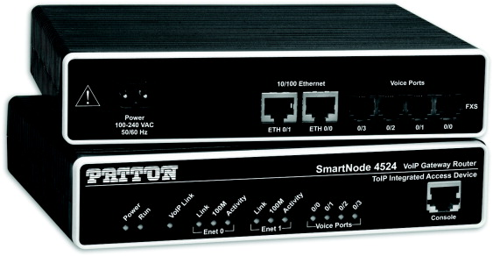
ATA (analog telephone adapter)

Card within computer workstation, externally attached device

Telephone line connects to RJ-11 adapter port

Converts analog voice signals to IP packets

VoIP-Enabled Router

Connect

Analog telephone line to VoIP-enabled device (switch, router, gateway)

Convert

Analog voice signals into packets

Digital PBX (IP-PBX)

PBX (private branch exchange): telephone switch connecting calls within a private organization

IP-PBX

Private switch

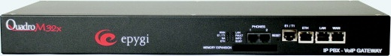
Accepts, interprets both analog and digital voice signals

Connects with traditional PSTN lines, data networks

Transmits, receives IP-based voice signals to and from other network connectivity devices

Packaged with sophisticated software

Analog PBX with Gateway

Traditional telephone connects to analog PBX

Then connects to voice-data gateway

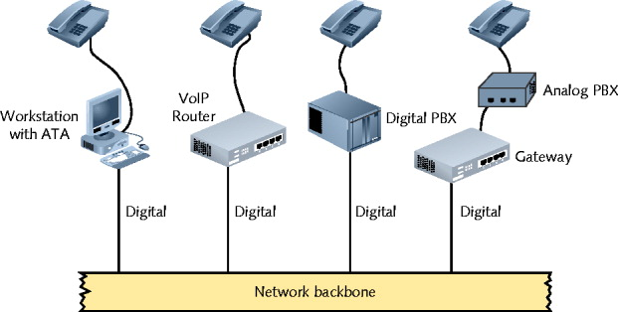
Gateway connects traditional telephone circuits with TCP/IP network

Internet or private WAN

Gateway

Digitizes incoming analog voice signal

Compresses data

Assembles data into packets

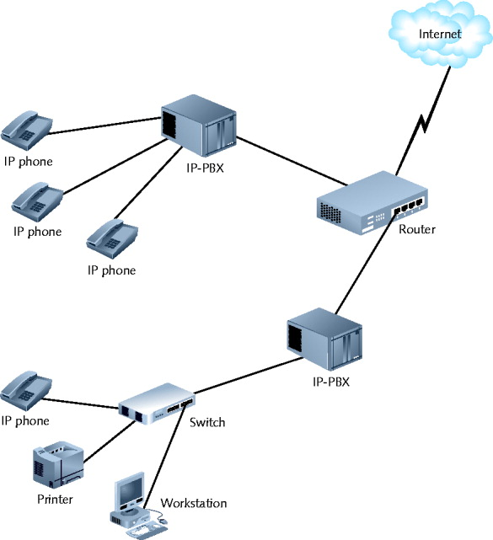
Issues packets to packet-switched network

IP Telephones

IP telephones (IP phones)

Transmit, receive only digital signals

Voice immediately digitized, issued to network in packet form

Requires unique IP address

Looks like traditional touch-tone phone

Connects to RJ-45 wall jack

Connection may pass through connectivity device before reaching IP-PBX

IP telephones: popular and unique features

Web browser screens

Connect to user’s PDA

Speech recognition capabilities

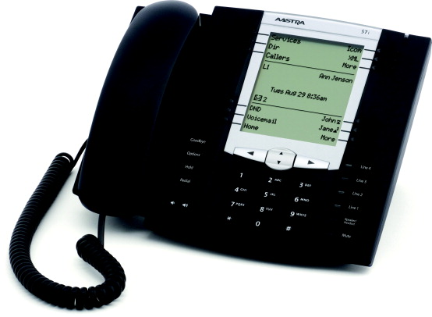
Busy line instant message option

Accept emergency messages

IP telephones: mobility

Move phone to new office; connect to wall jack; accept and make calls

Faster than traditional PBX extension reprogramming

Conventional analog telephone

Obtains current from local loop

Signaling (ring, dial tone)

IP telephones: issues

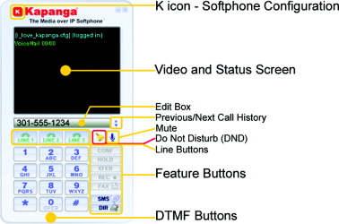
Need electric current

Not directly connected to local loop

Require separate power supply

Susceptible to power outages

Requires assured backup power sources

IP telephones may obtain current using PoE (power over Ethernet)

Softphones

Computer programmed to act like IP telephone

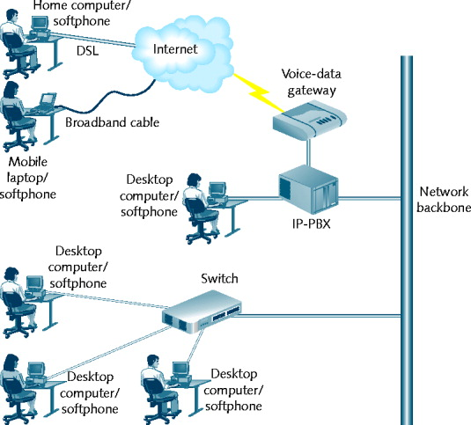
Softphones and IP telephones

Provide same calling functions

Connect to network; deliver services differently

Prerequisites

Computer minimum hardware requirements

IP telephony client installed

Digital telephone switch communication

Full-duplex sound card

Microphone, speakers

Example: Skype

Graphical interface

Presented after user starts softphone client software

Customizable

Difference between IP telephones and softphones

Softphones have versatile connectivity

VoIP solution for traveling employees and telecommuters

Softphones have convenient and localized call management

Call tracking: date, time, duration, originating number, caller names

Simplifies recordkeeping and billing

Video-over-IP Applications and Interfaces

Video-over-IP Applications and Interfaces

Cisco Systems estimate

By 2011, 60 percent of Internet traffic will be video traffic

Requirements for prediction to come true

Continual price drop in video-over-IP hardware

Networks must further augment capacities, reliability

Video-over-IP services categories

Streaming video, IPTV, videoconferencing

Video-over-IP transmission

Digitize audio, visual signals

Use video codecs

Streaming Video

Simplest among all video-over-IP applications

Basic computer hardware, software requirements

Video-on-demand

Files stored on video streaming server

Popular

Viewer chooses video when convenient: Web browser

Streaming video

Video issued live

Directly: source to user

Streaming video

Video issued live

Directly from source to user

Drawbacks

Content may not be edited before distribution

Viewers must connect with stream when issued

Video-on-demand benefits

Content viewed at user’s convenience

Viewers control viewing experience

Pausing, rewinding, fast-forwarding

Considerations

Number of clients receiving each service

Point-to-point video over IP

Point-to-multipoint video over IP (not necessarily multicast transmission)

Network type classification

Private

Public

Most streaming video

Takes place over public networks

IPTV (IP Television)

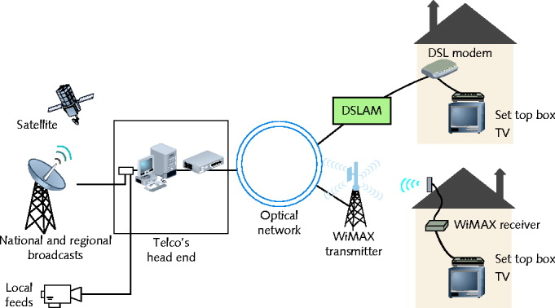
Telecommunications carriers, cable companies are upgrading networks to deliver high-bandwidth Internet connections

IPTV digital television signals is a valuable added service

Elements

Telco accepts video content at a head end

Telco’s CO (central office)

Servers provide management services

Video channel assigned to multicast group

Advantages of IPTV multicasting

Simple to manage content delivery

Issue one multicast transmission to entire group

Local loop capacity issues

Most rely on copper to home (limits throughput)

Sending all channels could overwhelming local loop

Solution: Telco transmits only content ordered

IGMP (Internet Group Management Protocol)

Manages multicasting

Routers communicate using multicast routing protocol

Compressed, digital video signal travels like data signal

Over technologies like DSL or WIMAX

Advantage

Telecommunications carrier, cable company

Control connection end to end

Better monitor and adjust QoS

Set top box

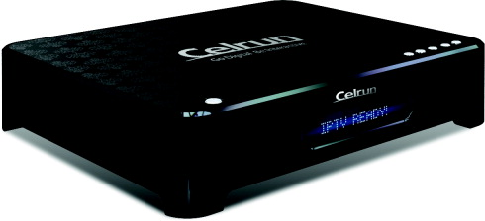
Decodes video signal, issues to television

Manages delivery

Communicating with content servers

Manage services

Pay per-view, video-on-demand programming

Videoconferencing

Unidirectional video-over-IP services

Video delivered to user who only watches content

Videoconferencing

Full-duplex connections

Participants send and receive audiovisual signals

Real time

Benefits

Cost savings, convenience

Replace face-to-face business meetings

Allows collaboration

Videoconferencing uses

Telemedicine

Tele-education

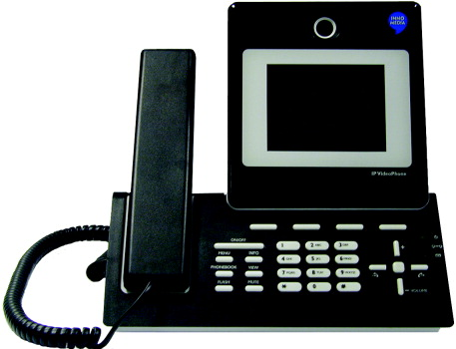
Judicial proceedings

Surveillance (usually unidirectional)

Hardware, software requirements

Computer workstation

Means to generate, send, receive audiovisual signals

Video terminal, video phone

Video Bridge

Video bridge

Manages multiple audiovisual sessions

Participants can see, hear each other

Conference server

Hardware or software

Leased Internet-accessible video bridging services

Occasional videoconference use

Video bridge depends on signaling protocols

Signaling Protocols

Signaling Protocols

Signaling

Information exchange

Between network components, system

Establishing, monitoring, releasing connections

Controlling system operations

Set up, manage client sessions

Perform several functions

Early VoIP

Proprietary signaling protocols

Today

Standardized signaling protocols

SS7 (not VoIP)

Signaling System 7

The protocol used to set up most of the world's PSTN calls (not VoIP calls)

Sets up connections between phone switches to route calls

Handles ringing, answering, billing, SMS, and other services

H.323 (used for VoIP)

Describes architecture and a group of protocols

Establishing, managing packet-switched network multimedia sessions

Supports voice, video-over-IP services

Terms

H.323 terminal -- a node, such as an IP Phone

H.323 gateway -- connects different signaling protocols, such as H.323 and SS7

H.323 gatekeeper -- nerve center, handles billing, accounting, bandwidth allocation, etc.

MCU (multipoint control unit) -- serves several H.323 terminals, like a video bridge

H.323 zone -- the devices managed by a single H.323 gatekeeper

H.323 Zone
(gatekeeper is not shown)
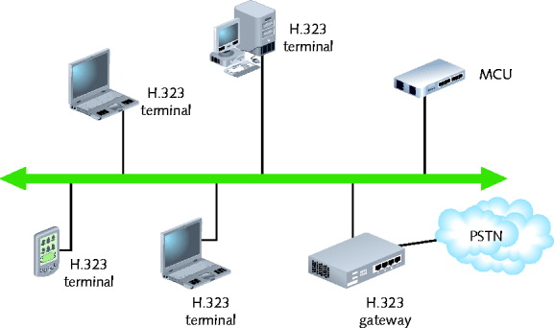

H.225 and H.245 signaling protocols

Specified in H.323 standard

Operate at Session layer

H.225 handles call or videoconference signaling

H.245 ensures correct information type formatting

Uses logical channels

H.323 standard specifies

Protocol interoperability

Presentation layer: coding, decoding signals

Transport layer

1996 ITU codified

Multiservice signaling open protocol

Early version

Suffered slow call setup

Second version (H.323.2)

VoIP networks popular call signaling protocol

Third version

Not widely accepted yet

SIP attracted network administrators attention

SIP (Session Initiation Protocol) (Used for VoIP)

Performs functions similar to H.323

Version 2.0 (RFC 2543)

Codified by the IETF in 1999

Application layer signaling, multiservice control protocol, packet-based networks

Goals

Modeled on HTTP protocol

Reuse existing TCP/IP protocols

Session management, enhanced services

Modular and specific

SIP Terms

User agent

Any node sending or receiving SIP messages

User agent client

End-user device, like an IP Phone

User agent server

Servers that provide SIP signals to many clients

Registrar server

Knows network addresses of its user agents

Proxy server

Makes connections within the SIP domain

Redirect server

Connects to external SIP domains

Common SIP Servers

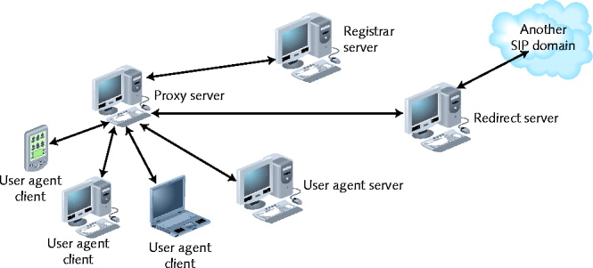
Asterisk -- open-source and free

Proprietary SIP systems available from

3Com

Avaya

Cisco

Nortel

others

SIP is Replacing H.323

VoIP vendors prefer SIP over H.323

Simplicity

Fewer instructions to control call

Consumes fewer processing resources

More flexible

SIP and H.323

Regulate call signaling, control for VoIP or video-over-IP clients and servers

Not used for communication between media gateways

MGCP (Media Gateway Control Protocol) and MEGACO (H.248)

Gateways

Integral to converged networks

Media gateway, fax gateway

“Payload” use

Different channels from control signals

Different logical and physical paths than signals

Expedites information handling

Use separate physical paths

Gateways still need to exchange and translate

Use signaling and control information

Media Gateway Controller

MGC (media gateway controller)

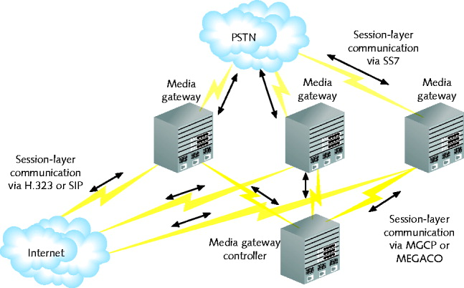
Computer managing multiple media gateways

Selects the gateway and physical media to use for payload and control packets

Also called a softswitch

Advantageous on large VoIP networks

MGCs can communicate with media gateways with either the MGCP or MEGACO protocols

MGCP (Media Gateway Control Protocol)

MGCP (Media Gateway Control Protocol): RFC 3435

Multiservice networks supporting many media gateways

Operate with H.323 or SIP

MEGACO

MEGACO

Newer than MGCP

Performs same functions as MGCP

Different commands and processes

Operates with H.323 or SIP

Superior to MGCP

Supports ATM

Developed by ITU and IETF
Transport Protocols

Transport Protocols

Signaling protocols like MEGACO, MGCP, H.323, and SIP only set up and tear down connections

Different protocols deliver voice or video payload

Review of Transport layer protocols

TCP: connection oriented

Delivery guaranteed, but slower

UDP: connectionless

No accountability; preferred in real-time applications

Packet loss tolerable if additional protocols overcome UDP shortcomings

RTP (Real-time Transport Protocol)

RFC 1889

Operates at Application layer

Relies on UDP

Applies sequence numbers to indicate:

Destination packet assembly order

Packet loss during transmission

Assigns packet timestamp

Receiving node

Compensates for network delay, synchronize signals

No mechanism to detect success--for that, it relies on RTCP

RTCP (Real-time Transport Control Protocol)

RFC 3550

Provides quality feedback to participants

Packets transmitted periodically

Measures # packets lost or delayed

Cannot correct those problems--QoS does that

RTCP is optional
QoS (Quality of Service) Assurance

QoS (Quality of Service) Assurance

QoS: measures network performance

High QoS: uninterrupted, accurate, faithful reproduction

Low (poor) QoS: distorted VoIP, video over IP

To ensure consistent QoS

Requires more dedicated bandwidth

Requires techniques ensuring high QoS

RSVP

DiffServ

MPLS

RSVP (Resource Reservation Protocol)

RFC 2205

Transport layer protocol

Before transmission

Reserves network resources

Creates a path between sender, receiver

Provides sufficient bandwidth

Signal arrives without delay

Issues PATH statement via RSVP to receiving node

Indicates required bandwidth, expected service level

Two service types

Guaranteed service

Controlled-load service

Router marks transmission’s path

Routers issue PATH message

Destination router issues Reservation Request (RESV) message

Follows same path in reverse

Reiterates information

Routers allocated requested bandwidth

Sending node transmits data

RSVP messaging

Separate from data transmission

Does not modify packets

Specifies and manages unidirectional transmission

Resource reservation process takes place in both directions

RSVP Emulates circuit-switched path

Provides excellent QoS

Drawback: high overhead--consumes a lot of network resources

Acceptable on small networks

Larger networks use DiffServ

DiffServ

Addresses traffic prioritization QoS issues

Differs from RSVP

Modifies actual IP datagrams that contain payload

Assigns priority to all network traffic

Time-sensitive voice and video services

Offers more protection

To prioritize traffic

IPv4 datagram: DiffServ field

IPv6 datagram: Traffic Class field

IP Header

From Wikipedia (link Ch 4c)

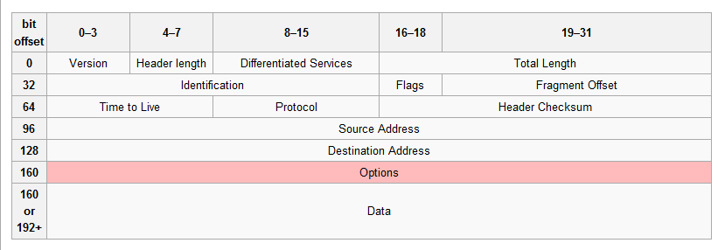

Two forwarding types

EF (Expedited Forwarding)

Data stream assigned minimum departure rate

Circumvents delays

AF (Assured Forwarding)

Data streams assigned different router resource levels

Prioritizes data handling

On time, in sequence packet arrival: no guarantee

MPLS (Multiprotocol Label Switching)

Modifies data streams at Network layer

A first router data stream encounters

Prefixes IP datagram header with label

Packet forwarding information

Router’s data stream path revises label

Indicates next hop

Considers network congestion

Very fast forwarding: no delay

Destination IP address compared to routing tables

Forward data to closest matching node

Last modified 11-4-09

