Objectives

Identify security risks in LANs and WANs and design security policies that minimize risks

Explain how physical security contributes to network security

Discuss hardware- and design-based security techniques

Understand methods of encryption, such as SSL and IPSec, that can secure data in storage and in transit

Describe how popular authentication protocols, such as RADIUS, TACACS, Kerberos, PAP, CHAP, and MS-CHAP, function

Use network operating system techniques to provide basic security

Understand wireless security protocols, such as WEP, WPA, and 802.11i

Security Audits

Examine network’s security risks

Consider effects

Different organization types

Different network security risk levels

Security audit

Thorough network examination

Determine possible compromise points

Performed in-house

By IT staff

Performed by third party
Security Risks

Security Risks

Recognize network threats

Breaches caused by:

Network technology manipulation

Careless or malicious insiders

Undeveloped security policies

Security threat considerations

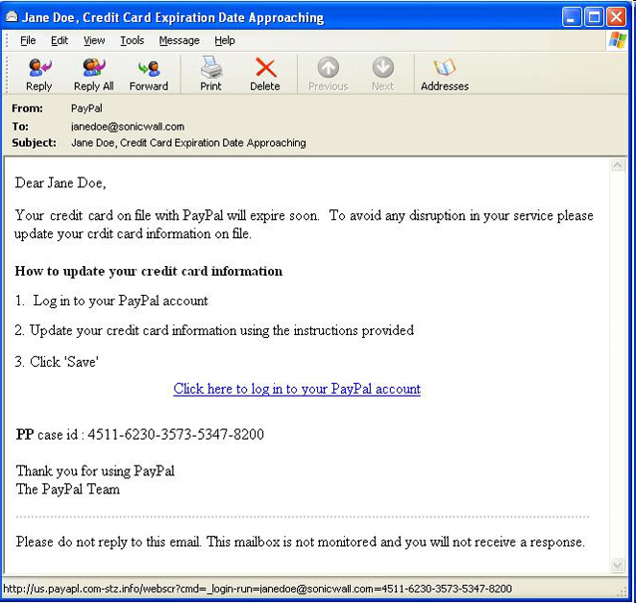
How to prevent

How it applies to your network

How it relates to other security threats

Risks Associated with People

Half of all security breaches

Human errors, ignorance, omissions

Social engineering

Strategy to gain password

Phishing

Getting access, authentication information

Pose as someone needing information

Usually with a deceptive email

Phishing IQ Test

Link Ch 12a

Risks Associated with People

Attackers using social engineering or snooping to obtain passwords

Administrator incorrectly assigning user IDs and rights

Administrators overlooking security flaws

Lack of proper documentation or communication of security policies

Dishonest or disgruntled employees

Unused computers left on and connected to the network

Users choosing easily-guessed passwords

Computer room doors left open or unlocked

Discarding disks, tapes, or manuals in public trash containers

Administrators neglecting to remove accounts for employees who have left the organizations

Users posting passwords in public places, like Post-it notes, or telling other users their passwords

Risks Associated with Transmission and Hardware

Physical, Data Link, Network layer security risks

Require more technical sophistication

Risks inherent in network hardware and design

Transmission interception

Man-in-the-middle attack

Eavesdropping

Networks connecting to Internet via leased public lines

Sniffing

Network hubs broadcasting traffic over entire segment

Unused hub, switch, router, server physical ports not secured

Software ports not secured, can be found with a port scanner like nmap

Router attack

Routers not configured to drop suspicious packets

Dial-in security holes

Modems accept incoming calls

Dial-in access servers not secured, monitored

General public computer access may be on same network as computers hosting sensitive data

Insecure passwords for routers, switches, and other network hardware

Easily guessable, default values

Risks Associated with Protocols and Software

This list includes Transport, Session, Presentation, and Application layers

Networking protocols and software risks

TCP/IP security flaws

Trust relationships between servers

NOS back doors, security flaws

NOS allows server operators to exit to command prompt

Administrators default security options

Transactions between applications interceptable

Risks Associated with Internet Access

Network security compromise

More often “from the inside”

Outside threats still very real

Web browsers permit scripts to access systems

Users providing information to sites

Common Internet-related security issues

Improperly configured firewall

Outsiders obtain internal IP addresses: IP spoofing

Telnets or FTP

Transmit user ID, password in plain text

Newsgroups, mailing lists, forms

Provide hackers user information

Chat session flashing

Denial-of-service attack

Floods a network with useless traffic
An Effective Security Policy

An Effective Security Policy

Minimizes break-in risk

Communicates with and manages users

Security policy

Identifies security goals, risks, authority levels, designated security coordinator, and team members

Team member and employee responsibilities

Specifies how to address security breaches

Not included in policy:

Hardware, software, architecture, and protocols

How hardware and software is installed and configured

Security Policy Goals

Ensure authorized users have appropriate resource access

Prevent unauthorized user access

Protect unauthorized sensitive data access

Inside and outside

Prevent accidental hardware and software damage

Prevent intentional hardware or software damage

Create secure environment

Withstand, respond to, and recover from threat

Communicate employee’s responsibilities

Strategy

Form committee

Involve as many decision makers as possible

Assign security coordinator to drive policy creation

Understand risks

Conduct security audit

Address threats

Security Policy Content

Password policy

Software installation policy

Confidential and sensitive data policy

Network access policy

Email use policy

Internet use policy

Modem and remote access policy

Policies for laptops and loaner machines

Computer room access policy

And more…

Security Policy Content

Explain to users:

What they can and cannot do

How measures protect network’s security

User communication

Security newsletter

User security policy section

Define what "confidential" means to the organization

Response Policy

Security breach occurrence

Provide planned response

Identify response team members

Understand security policy, risks, measures in place

Accept role with certain responsibilities

Regularly rehearse defense

Security threat drill

Suggested team roles

Dispatcher

Person on call, first notices, alerted to problem

Manager

Coordinates resources

Technical support specialist

One focus: solve problem quickly

Public relations specialist

Official spokesperson to public

After problem resolution

Review process
Physical Security

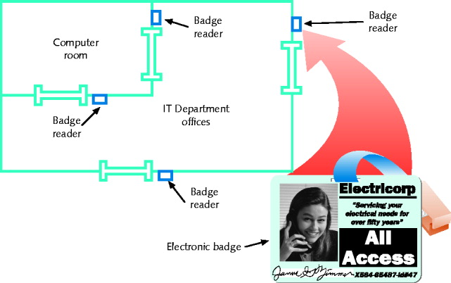
Physical Security

Restricting physical access network components

At minimum

Only authorized personnel can access computer room

Consider compromise points

Wiring closet switches, unattended workstation, equipment room, entrance facility, and storage room

Locks: physical, electronic

Electronic access badges

Locks requiring entrants to punch numeric code

Bio-recognition access--like iris pattern or fingerprint

Physical barriers

Gates, fences, walls, and landscaping

Closed-circuit TV systems monitor secured rooms

Surveillance cameras

Computer rooms, Telco rooms, supply rooms, data storage areas, and facility entrances

Central security office

Display several camera views at once

Switch from camera to camera

Video footage for investigation and prosecution

Security audit

Ask questions related to physical security checks

Consider losses from salvaged and discarded computers

Hard disk information stolen

Solution

Run specialized disk sanitizer program

Remove disk and use magnetic hard disk eraser

Pulverize or melt disk

Security in Network Design

Security in Network Design

Breaches may occur due to poor LAN or WAN design

Address though intelligent network design

Preventing external LAN security breaches

Optimal solution

Do not connect to outside world

Realistic solution

Restrict access at every point where LAN connects to outside world

Router Access Lists

Control traffic through routers

Routers main function

Examine packets, determine where to send

Based on Network layer addressing information

ACL (access control list)

Known as access list

Routers decline to forward certain packets

ACL instructs router

Permit or deny traffic according to variables:

Network layer protocol (IP, ICMP)

Transport layer protocol (TCP, UDP)

Source IP address

Destination IP address

TCP, UDP port number

Router receives packet, examines packet

Refers to ACL for permit, deny criteria

Drops packet if characteristics match

Flagged as deny

Access list statements

Deny all traffic from certain source addresses

Deny all traffic destined for TCP port 23

Separate ACL’s for:

Interfaces

Inbound and outbound traffic

Intrusion Detection and Prevention

Provides more proactive security measure

Detecting suspicious network activity

IDS (intrusion detection system)

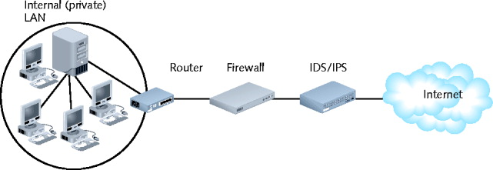
Software monitoring traffic

On dedicated IDS device

On another device performing other functions

Port mirroring

Detects many suspicious traffic patterns

Denial-of-service, smurf attacks

DMZ (demilitarized zone)

Network’s protective perimeter

IDS sensors installed at network edges

IDS at DMZ drawback

Number of false positives logged

IDS can only detect and log suspicious activity

IDS Example: Snort

IPS (intrusion-prevention system)

Reacts to suspicious activity

When alerted

Detect threat and prevent traffic from flowing to network

Based on originating IP address

Compared to firewalls

IPS originally designed as more comprehensive traffic analysis, protection tool

Differences now diminished

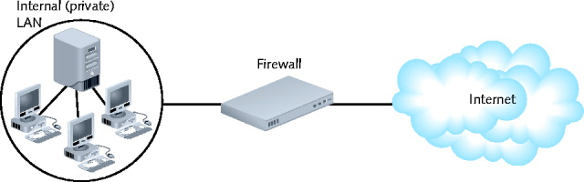
Firewalls

Specialized device and computer installed with specialized software

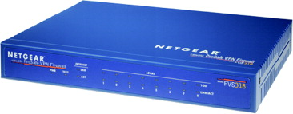
Selectively filters, blocks traffic between networks

Involves hardware, software combination

Resides

Between two interconnected private networks

Between private network and public network

Network-based firewall

Protects a whole network

Host-based firewall

Protects one computer

Packet-filtering firewall (screening firewall)

Simplest firewall

Blocks traffic into LAN

Examines header

Blocks traffic attempting to exit LAN

Stops spread of worms

Firewall default configuration

Block most common security threats

Preconfigured to accept, deny certain traffic types

Network administrators often customize settings

Common packet-filtering firewall criteria

Source, destination IP addresses

Source, destination ports

Flags set in the IP header

Transmissions using UDP or ICMP protocols

Packet’s status as first packet in new data stream, subsequent packet

Packet’s status as inbound to, outbound from private network

Port blocking

Prevents connection to and transmission completion through ports

Firewall may have more complex functions

Encryption

User authentication

Central management

Easy rule establishment

Filtering

Content-filtering firewalls, layer 7 firewalls, deep packet inspection

Logging, auditing capabilities

Protect internal LAN’s address identity

Monitor data stream from end to end

Yes: stateful firewall

If not: stateless firewall

Tailor firewall to needs

Consider traffic to filter (takes time)

Consider exceptions to rules

Cannot distinguish user trying to breach firewall and authorized user

Proxy Servers

Proxy service

Network host software application

Intermediary between external, internal networks

Screens all incoming and outgoing traffic

Proxy server

Network host running proxy service

Application layer gateway, application gateway, and proxy

Manages security at Application layer

Fundamental functions

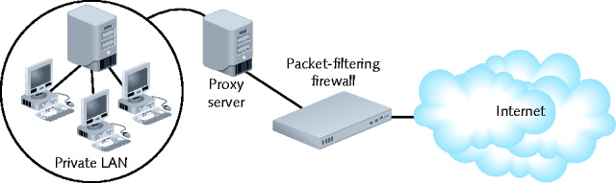
Prevent outside world from discovering internal network the addresses

Improves performance

Caching files

Examples

Squid on Linux

Microsoft Internet Security and Acceleration (ISA) Server
NOS (Network Operating System) Security

NOS (Network Operating System) Security

Restrict user authorization

Access to server files and directories

Public rights

Conferred to all users

Very limited

Group users according to security levels

Assign additional rights

Logon Restrictions

Additional restrictions

Time of day

Total time logged on

Source address

Unsuccessful logon attempts

Passwords

Choosing secure password

Guards against unauthorized access

Easy, inexpensive

Communicate password guidelines

Use security policy

Emphasize company financial, personnel data safety

Do not back down

Tips

Change system default passwords

Do not use familiar information or dictionary words

Dictionary attack

Use long passwords

Letters, numbers, special characters

Do not write down or share

Change frequently

Do not reuse

Use different passwords for different applications

Password Managers

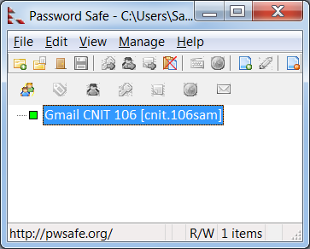
Save your passwords in an encrypted database

Much safer than reusing passwords, or remembering some series of passwords

Free password managers

KeePass

Password Safe
Encryption

Encryption

Use of algorithm to scramble and unscramble data

Purpose

Information privacy

Many encryption forms exist

Last means of defense against data theft

Provides three assurances

Data not modified after sender transmitted it

Before receiver picked it up

Data viewed only by intended recipient

All data received at intended destination:

Truly issued by stated sender

Not forged by intruder

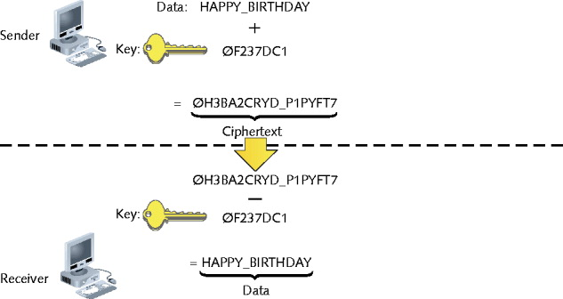
Key Encryption

Popular encryption

Weaves key into original data’s bits

Generates unique data block

Key

Random string of characters

Longer key is better

Ciphertext

Scrambled data block

Brute force attack

Attempt to discover key

Trying numerous possible character combinations

Private Key Encryption

Data encrypted using single key

Known by sender and receiver

Symmetric encryption

Same key used during both encryption and decryption

DES (Data Encryption Standard)

Most popular private key encryption

IBM developed (1970s)

56-bit key: secure at the time

Triple DES

Weaves 56-bit key three times

AES (Advanced Encryption Standard)

Weaves 128, 160, 192, 256 bit keys through data multiple times

Uses Rijndael algorithm

More secure than DES

Much faster than Triple DES

Replaced DES in high security level situations

Private key encryption drawback

Sender must somehow share key with recipient

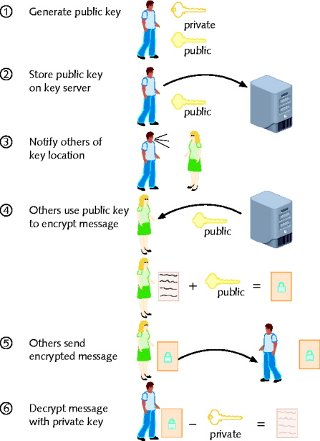
Public Key Encryption

Data encrypted using two keys

Private key: user knows

Public key: anyone may request

Public key server

Publicly accessible host

Freely provides users’ public keys

Key pair

Combination of public key and private key

Asymmetric encryption

Requires two different keys

Diffie-Hellman (1975)

First public key algorithm

RSA

Most popular

Key creation

Choose two large prime numbers, multiplying together

May be used in conjunction with RC4

Weaves key with data multiple times, as computer issues data stream

RC4

Key up to 2048 bits long

Highly secure, fast

E-mail, browser program use

Lotus Notes, Netscape

Digital certificate

Password-protected, encrypted file

Holds identification information

Public key

CA (certificate authority)

Issues, maintains digital certificates

Example: Verisign

PKI (public key infrastructure)

Use of certificate authorities to associate public keys with certain users

PGP (Pretty Good Privacy)

Secures e-mail transmissions

Developed by Phil Zimmerman (1990s)

Public key encryption system

Verifies e-mail sender authenticity

Encrypts e-mail data in transmission

Administered at MIT

Freely available

Open source and proprietary

Also used to encrypt storage device data

SSL (Secure Sockets Layer)

Encrypts TCP/IP transmissions

Web pages, Web form data entered into Web forms

En route between client and server

Using Public key encryption technology

Web pages using HTTPS

HTTP over Secure Sockets Layer, HTTP Secure

Data transferred from server to client (vice versa)

Using SSL encryption

HTTPS uses TCP port 443

SSL session

Association between client and server

Defined by agreement

Specific set of encryption techniques

Created by SSL handshake protocol

Handshake protocol

Allows client and server to authenticate

SSL

Netscape originally developed it

IETF attempted to standardize

TLS (Transport Layer Security) protocol

SSH (Secure Shell)

Collection of protocols

Provides Telnet capabilities with security

Guards against security threats

Unauthorized host access

IP spoofing

Interception of data in transit

DNS spoofing

Encryption algorithm (depends on version)

DES, Triple DES, RSA, Kerberos

Developed by SSH Communications Security

Version requires license fee

Open source versions available: OpenSSH

Secure connection requires SSH running on both machines

Requires public and private key generation

Highly configurable

Use one of several encryption types

Require client password

Perform port forwarding

SCP (Secure CoPy) and SFTP (Secure File Transfer Protocol)

SCP (Secure CoPy) utility

Extension to OpenSSH

Allows copying of files from one host to another securely

Replaces insecure file copy protocols (FTP)

Does not encrypt user names, passwords, data

UNIX, Linux, and Macintosh OS X operating systems

Include SCP utility

Freeware SSH programs available for Windows

May requires freeware SCP applications: WinSCP

SCP simple to use

Proprietary SSH version (SSH Communications Security)

Requires SFTP (Secure File Transfer Protocol) to copy files

Slightly different from SCP (does more than copy files)

IPSec (Internet Protocol Security)

Defines encryption, authentication, key management

For TCP/IP transmissions

Enhancement to IPv4

Native IPv6 standard

Difference from other methods

Encrypts data

By adding security information to all IP packet headers

Transforms data packets

Operates at Network layer (Layer 3)

Two phase authentication

First phase: key management

Way two nodes agree on common parameters for key use

IKE (Internet Key Exchange) runs on UDP port 500

Second phase: encryption

AH (authentication header)

ESP (Encapsulating Security Payload)

Used with any TCP/IP transmission

Most commonly

Routers, connectivity devices in VPN context

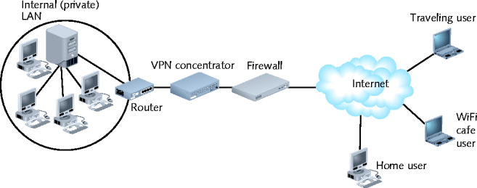
VPN concentrator

Specialized device

Positioned at the edge of the private network

Establishes VPN connections

Authenticates VPN clients

Establish tunnels for VPN connections
Authentication Protocols

Authentication Protocols

Authentication

Process of verifying a user’s credentials

Grant user access to secured resources

Authentication protocols

Rules computers follow to accomplish authentication

Several authentication protocol types

Vary by encryption scheme

Steps taken to verify credentials

RADIUS and TACACS

Used when many users are making simultaneous dial-up connections

Manages user IDs and passwords

Defined by IETF

Runs over UDP

Provides centralized network authentication, accounting for multiple users

RADIUS server

Does not replace functions performed by remote access server

RADIUS server

Does not replace functions performed by remote access server

Highly scalable

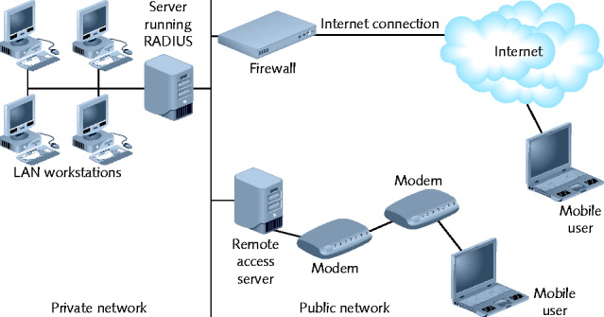
Used by Internet service providers

More secure than simple remote access solution

TACACS (Terminal Access Controller Access Control System)

Similar, earlier centralized authentication version

Radius and TACACS are AAA servers

Authentication, Authorization, and Accounting

PAP (Password Authentication Protocol)

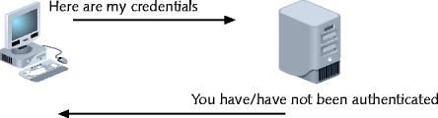
PPP does not secure connections

Requires an authentication protocol

PAP (Password Authentication Protocol)

Operates over PPP

Uses two-step authentication process

Simple

Not secure

Sends client’s credentials in clear text

CHAP and MS-CHAP

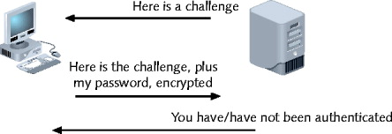
Another authentication protocol

Operates over PPP

Encrypts user names, passwords

Uses three-way handshake

Requires three steps to complete authentication process

Benefit over PAP

Password never transmitted alone

Password never transmitted in clear text

MS-CHAP (Microsoft Challenge Authentication Protocol)

Similar authentication protocol

Windows-based computers

Potential CHAP, MS-CHAP authentication flaw

Eavesdropping could capture character string encrypted with password, then decrypt

Because it used the weak LANMAN Hashes

Link Ch 12e

Solution to flaw

MS-CHAPv2 (Microsoft Challenge Authentication Protocol, version 2)

Uses stronger encryption

Does not use same encryption strings for transmission, reception

Requires mutual authentication

Mutual authentication

Both computers verify credentials of the other

Examples

Modify dial-up connection’s for XP and Vista

EAP (Extensible Authentication Protocol)

Another authentication protocol

Operates over PPP

Works with other encryption, authentication schemes

Verifies client, server credentials

Requires authenticator to initiate authentication process

Ask connected computer to verify itself

EAP’s advantages: flexibility

802.1x (EAPoL)

Codified by IEEE

Uses of one of many authentication methods plus EAP

Generates authentication keys

Grant access to a particular port

Primarily used with wireless networks

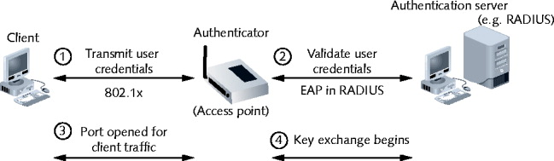
Originally designed for wired LAN

EAPoL (EAP over LAN)

Only defines process for authentication

Commonly used with RADIUS authentication

Distinguishing feature

Applies to communication with a particular port

Kerberos

Cross-platform authentication protocol

Uses key encryption

Verifies client identity

Securely exchanges information after client logs on

Private key encryption service

Provides significant security advantages over simple NOS authentication

Terms

KDC (Key Distribution Center)

AS (authentication service)

Ticket

Principal

Original process Kerberos requires for client/server communication

Problem

User request separate ticket for different service

Solution

TGS (Ticket-Granting Service)
Wireless Network Security

Wireless Network Security

Susceptible to eavesdropping

War driving

Driving while scanning for wireless networks

Effective for obtaining private information

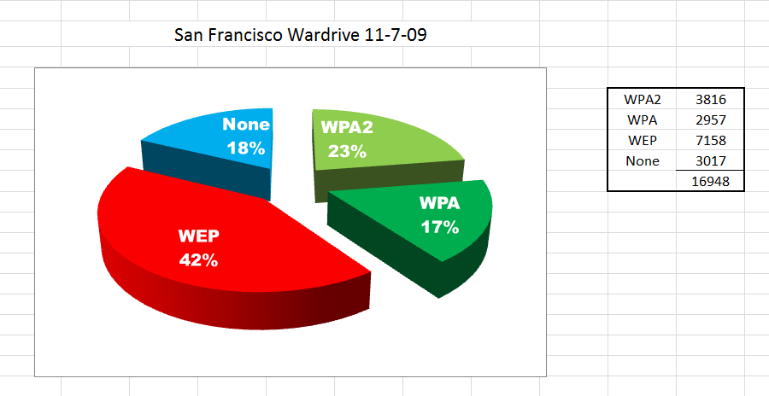

WEP (Wired Equivalent Privacy)

802.11 standard security

None by default

Access points

No client authentication required prior to communication

SSID: only item required

WEP

Uses keys

Authenticate network clients

Encrypt data in transit

Network key

Character string required to associate with access point

Example

Edit, add WEP key for wireless connection on Windows XP client

WEP implementations

First: 64-bit keys

Current: 128-bit, 256-bit keys

WEP is very insecure—it can be cracked in a few minutes

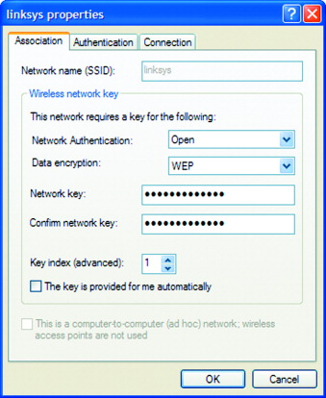
IEEE 802.11i and WPA (Wi-Fi Protected Access)

802.11i uses 802.1x (EAPoL)

Authenticate devices

Dynamically assign every transmission its own key

Relies on TKIP (Temporal Key Integrity Protocol)

Encryption key generation, management scheme

Uses AES encryption

WPA (Wi-Fi Protected Access)

Subset of 802.11i

Same authentication as 802.11i

Uses RC4 encryption

WPA and WPA-2 are reasonably secure to use

Last modified 11-11-09

