Objectives

Describe the steps involved in an effective troubleshooting methodology

Follow a systematic troubleshooting process to identify and resolve networking problems

Document symptoms, solutions, and results when troubleshooting network problems

Use a variety of software and hardware tools to diagnose problems
Troubleshooting Methodology

Troubleshooting Methodology

Proceed logically and methodically

Follow recommended steps

Use experience when necessary

Logical approach benefits

Prevents wasteful, time-consuming efforts

Unnecessary software, hardware replacements

Troubleshooting steps

Identify symptoms, problems

Identify affected area

Determine what has changed

Establish most probable cause

Determine if escalation necessary

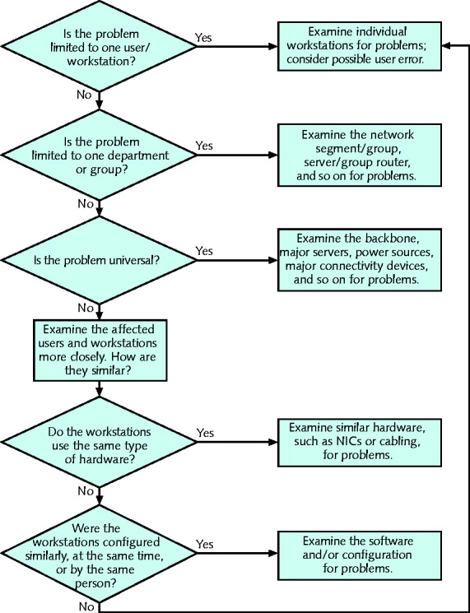
Create action plan, solution

Implement solution, test result

Identify results, effects

Document solution, process

Identify the Symptoms and Problems

Ask questions

Answers help identify network problem symptoms

Avoid jumping to conclusions about symptoms

Pay attention

Users, system and network behaviors, and error messages

Treat each symptom uniquely

Identify the Affected Area

Determine affected area and group

One user or workstation?

A workgroup?

A department?

One location within an organization?

An entire organization?

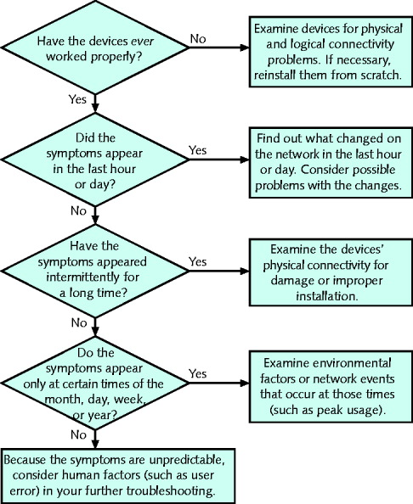
Narrow down time frame

When did the problem begin?

Has the network, server, or workstation ever worked properly?

Did the symptoms appear in the last hour or day?

Have the symptoms appeared intermittently for a long time?

Do the symptoms appear only at certain times of the day, week, month, or year?

Benefits

Eliminates some causes; points to other

Take time to troubleshoot correctly

Ask specific questions

Identify problem scope

Filter unrelated user information

Discover time and frequency of problem

May reveal more subtle network problems

Identify affected problem area

Leads to next troubleshooting steps

Determine What Has Changed

Become aware of recent network changes

Ask questions pinpointing problem resulting from network change

Possible actions if change generated problem

Correct problem

Reverse change

Less risky, less time consuming

Network change records

Track what has changed

Make records available to staff members

Establish the Most Probable Cause

Close to determining problem cause

Verify user competency

Ensure human error is not problem source

Verify user is performing network tasks correctly

Watch

Connect using remote desktop software

Talk over phone

Results

Catch user-generated mistakes

Gain clues for further troubleshooting

Re-create the problem

Learn more about problem causes

Reproduce symptoms

Log on as user; log on under privileged account

Follow same steps

Ask questions

Determine whether problem symptoms reproducible, to what extent

Ask user precisely what was done before error

Verify Physical layer connectivity

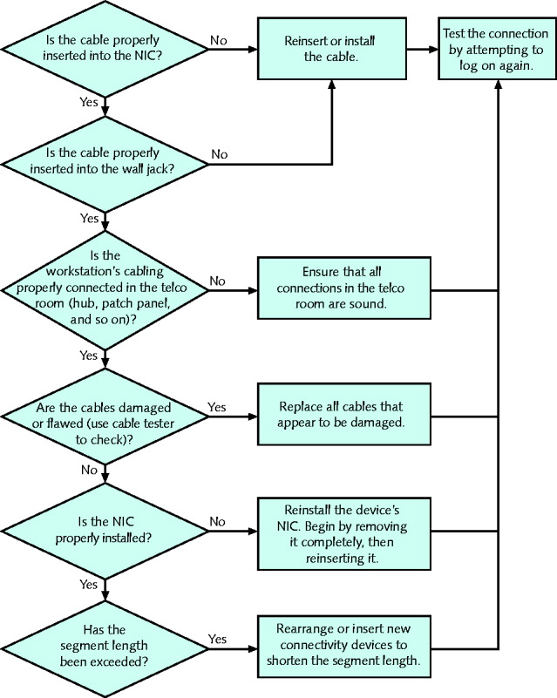
Half of all network problems occur at Physical layer

Symptoms of Physical layer problems

Segment, network lengths exceed standards

Noise

Improper terminations, faulty connectors, loose connectors, poorly crimped connections

Damaged cables

Faulty NICs

Software errors may point to physical connectivity problem

Diagnosing Physical layer Problems

Ask questions

Verify connections between devices

Verify soundness of connection hardware

Swapping equipment: tests theories

Exchange faulty component for functional one

Change patch cable

Better option: build in redundancy

Verify logical connectivity

Review questions identifying logical connectivity problem

Logical connectivity problems more difficult to isolate, resolve than physical connectivity problems

Software-based causes

Resource conflicts with NICs configuration

Improperly configured NIC

Improperly installed, configured client software

Improperly installed, configured network protocols, services

Determine Whether Escalation is Necessary

Help desks

Help desk analysts

Proficient in basic workstation, network troubleshooting

First-level support

Network specialist

Second-level support

Help desk coordinator

Third-level support personnel

Know when and how to escalate

Follow given procedure

Create an Action Plan and Solution Including Potential Effects

Consider how solution affects users, network functionality

Scope

Assess solution’s scope

Before implementing solution

Wait if not an emergency

Trade-offs

Restore functionality for one user group

May remove functionality for others

Security

Be aware of inadvertent security implications

Network access, resource privileges addition or removal consequences

Before upgrade, patch installation

Understand access changes for authorized, unauthorized users

Scalability

Solution types

Position network for future additions, enhancements

Temporary fix organization will outgrow

Cost

Weigh options carefully

Consider poor network performance identification

Address those areas separately

Use vendor information

Manufacturer documentation

Free online troubleshooting information

Searchable databases

Sophisticated web interfaces for troubleshooting their equipment

Vendor’s technical phone support

Consult with others, within, outside your organization

Implement and Test the Solution

Implement only after proposed solution’s effects researched

Implementation

Brief or long

Requires foresight, patience

Use methodical and logical approach

Leads to efficient correction process

Unless major problem – fix as quickly as possible

Follow series of steps

Implement a safe, reliable solution

Roll out solution in stages

Especially in large-scale fixes

After solution implementation

Verify problem solved properly

Testing dependencies

Solution itself

Area affected by problem

Inability to test immediately

Identify the Results and Effects of the Solution

After testing solution implementation

Determine how and why solution was successful

Determine solution’s effect on users and functionality

Avoid creating unintended, negative consequences

Communicate solution to colleagues

Document the Solution and Process

Always record:

Problem symptoms and cause (or causes)

Solution

Justification for recording

Impossible to remember each incident’s circumstances

Job changes

Use centrally located database

Accessible to all networking personnel

Call tracking system (help desk software)

User-friendly, graphical

Prompts for problem information

Assigns unique problem number

Highly customizable


If not available, use simple electronic form

Supported services list document

Lists all supported service, software and contacts

Follow-up with user

Help Desk Software Demo

Notify others of changes

Record resolution in call tracking system

Communication

Alerts others about problem, solution

Notifies others of network changes made

Many types of changes to record

Not necessary to record minor modifications

Help to Prevent Future Problems

Avert network problems with

Network maintenance

Documentation

Security

Upgrades
Troubleshooting Tools

Troubleshooting Tools

Utilities help troubleshoot network problems

Ping

Specialized tools

Specifically designed to analyze, isolate network problems

Simple continuity testers

Protocol analyzers

Tool selection dependencies

Problem being investigated

Network characteristics

Crossover Cable

Crossover cable

Reverses transmit and receive wire pairs in one connector

Directly interconnect two nodes without intervening connectivity device (hub or switch)

Use

Verify NIC transmitting, receiving signals properly

Tone Generator and Tone Locator

Ideal situation

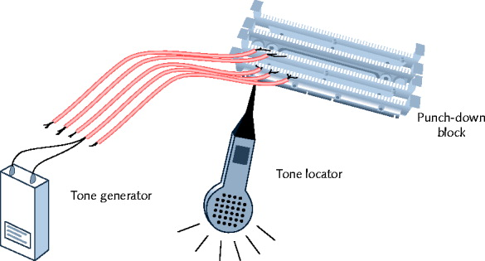
Telecommunications closet ports, wire terminations all labeled properly

Reality

Telecommunications closet disorganized, poorly documented

Tone generator (toner)

Issues signal on wire pair

Tone locator (probe)

Emits tone when electrical activity detected

Probe kit

Generator and locator combination

Fox and hound

Testing requires trial and error

Use

Determine where wire pair terminates

Not used to determine cable characteristics

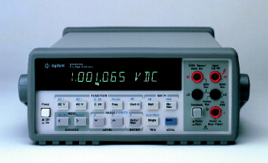
Multimeter

Tests cables for faults

Isolates problems with network cables

Multimeter

Measures electric circuit characteristics

Resistance and voltage

Voltmeter

Measures electric circuit pressure, voltage

Voltage creates signals over network wire

Resistance

Fundamental wire property

Dependent on wire’s molecular structure, size

Measured in ohms

Using ohmmeter

Impedance

Resistance contributing to controlling signal

Measured in ohms

Telltale factor for ascertaining where cable faults lie

Some required for proper signal transmission and interpretation

Multimeter

Separate instruments for measuring wires impedance, resistance, voltage

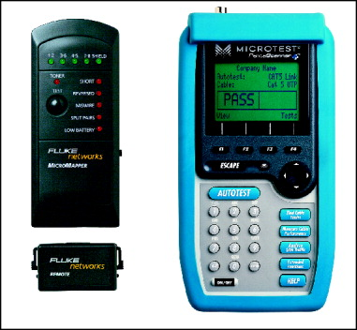
Has several uses

Sophistication, features, and costs vary

Cable Continuity Testers

Cable checkers (continuity testers, cable testers)

Tests whether cable carrying signal to destination

Tests cable continuity

Copper-based cable tester

Consists of two parts

Base unit generates voltage

Remote unit detects voltage

Series of lights, audible tone

Signal pass/fail

Verify UTP, STP wires paired correctly

Not shorted, exposed, crossed

Fiber optic continuity tester

Issues light pulses on fiber

Determines whether pulses reached other end

Tests the cable

Test all cables to ensure meeting network’s required standards

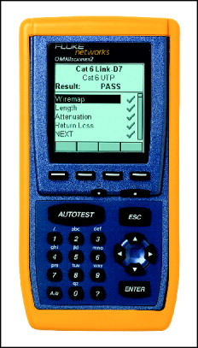
Homemade or purchased

Offer convenience: portable, lightweight, low cost

Cable Performance Testers

Determines if cable carrying current

Continuity testers versus performance testers

Sophistication and price

Performance tester accomplishes same continuity, fault tests

Continuity testers perform additional tasks

Sophisticated performance testers

Include TDR (time domain reflectometer)

Issue signal, measures signal bounce back

Indicate proper terminator installation, function, node distance

Fiber-optic connections testers

Use OTDRs (optical time domain reflectometers)

Transmit light-based signals of different wavelengths over fiber

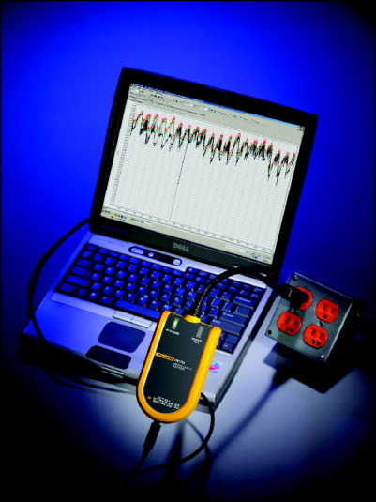
OTDRs

Measure fiber length

Determine faulty splice locations, breaks, connectors, bends

Measure attenuation over cable

Expensive

Voltage Event Recorders

Voltage event

Any condition where voltage exceeds or drops below predefined levels

Voltage event recorder

Collects data about power quality

Downloaded to workstation

Analyzed by software

Cost up to $5000

Butt Set

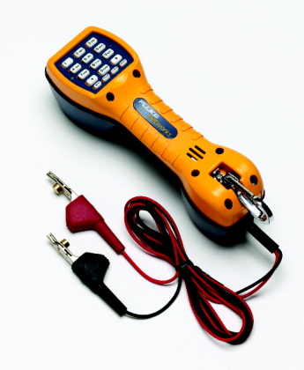
Lineman’s handset, telephone test set

Butt into telephone conversation

Rugged, sophisticated telephone

Uses

Determine if line functioning

Receiving signal, picking up noise affecting signal

Sophisticated butt sets

Perform rudimentary cable testing

Detecting dial tone on line

Network Monitors

Software-based tool

Continually monitors network traffic from server, workstation attached to network

Interprets up to Layer 3

Determine protocols passed by each frame

Cannot interpret frame data

Included in NOS

Microsoft’s Network Monitor

Purchase or free download tools developed by other software companies

All use similar graphical interfaces

Network adapter

Must support promiscuous mode

Common terms for abnormal data patterns, packets

Local collisions

Late collisions

Runts

Giants

Jabber

Negative frame sequence checks

Ghosts

Protocol Analyzers

Protocol analyzer (network analyzer)

Captures traffic, analyzes frames

Typically to Layer 7

Variety of protocol analyzer software available

Wireshark

Offers versatility in information type, depth

Could collect more information than can be reasonably processed

Set filters to avoid

Before using network monitor or protocol analyzer

Learn what network traffic normally looks like

Capture data for time period on regular basis

Wireless Network Testers

Tools containing wireless NICs, running wireless protocols

Workstation wireless network connection properties

Shows a little about wireless environment

Connection duration, signal speed and strength, number of packets exchanged

Only applies to one workstation

Programs scan for wireless signals

Discover access points, wireless stations transmitting

Free

InSSIDer
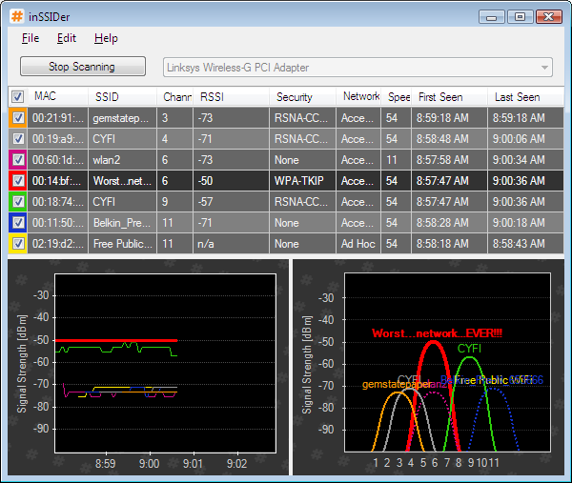

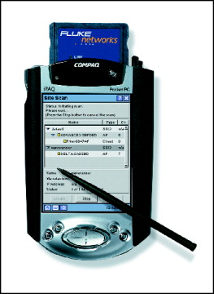

Commercial tools advantages

Portability

Installed with wireless network analysis tools

Contain more powerful antennas

Last modified 11-18-09

