Objectives

Identify the characteristics of a network that keep data safe from loss or damage

Protect an enterprise-wide network from viruses

Explain network- and system-level fault-tolerance techniques

Discuss issues related to network backup and recovery strategies

Describe the components of a useful disaster recovery plan and the options for disaster contingencies
What Are Integrity and Availability?

What Are Integrity and Availability?

Integrity

Network’s programs, data, services, devices, connections soundness

Availability

How consistently, reliably a file or system can be accessed

By authorized personnel

Both are compromised by:

Security breaches, natural disasters, malicious intruders, power flaws, human error

User error

Unintentional

Harm data, applications, software configurations, hardware

Intentional

Administrators must take precautionary measures to protect network

Cannot predict every vulnerability

Follow general guidelines for protecting network

General Guidelines for Protecting your Network

Allow only network administrators to change NOS and application system files

Monitor the network for unauthorized access or changes

Record authorized changes in a change management system

Install redundant components

Perform regular health checks

General Guidelines for Protecting your Network

Check system performance, error logs, and system log book

Keep backups, boot disks, and emergency repair disks current and available

Implement and enforce security and disaster recovery policies
Malware

Malware

Program or code

Designed to intrude upon or harm system and resources

Examples: viruses, Trojan horses, worms, bots

Virus

Replicating program intent to infect more computers

Through network connections, exchange of external storage devices

Many destructive programs often called viruses

Do not meet strict criteria of virus

Example: Trojan horse

Types of Malware

Boot sector viruses

Infects the boot sector of hard disks or floppies

Runs when the computer is started

Macro Virus

Infects Microsoft Office files

File-infector virus

Infects executable files

Worm

Runs independently, not attached to a file

Spreads through attachments to email, instant messages, or other file transfer

Types of Malware

Trojan horse

Claims to be something desirable, but hides something harmful

Network Virus

Propagates through network protocols, like FTP

Bot

Makes your computer a zombie--remotely controlled by a criminal, through IRC or some other network channel

A group of those computers form a botnet, controlled by a botmaster (link Ch 14a)

Malware Characteristics

Making malware harder to detect and eliminate

Encryption

Used by viruses, worms, Trojan horses

Thwart antivirus program’s attempts to detect it

Stealth

Malware hides itself to prevent detection

Disguise themselves as legitimate programs, code

Polymorphism

Change characteristics every time they transfer to new system

Use complicated algorithms, incorporate nonsensical commands

Time dependence

Programmed to activate on particular date

Can remain dormant, harmless until date arrives

Logic bombs: programs designed to start when certain conditions met

Malware can exhibit more than one of these characteristics

Malware Protection

Not just installing any virus-scanning program or anti-malware software

Requires:

Choosing appropriate anti-malware program

Monitoring network

Continually updating anti-malware program

Educating users

Anti-Malware Software

Malware leaves evidence

Some detectable only by anti-malware software

User viewable symptoms

Unexplained file size increases

Significant, unexplained system performance decline

Unusual error messages

Significant, unexpected system memory loss

Periodic, unexpected rebooting

Display quality fluctuations

Malware often discovered after damage done

Minimal anti-malware functions

Detect malware through signature scanning

Comparing file’s content with known malware signatures

Detect malware through integrity checking

Comparing current file characteristics against archived version

Detect malware by monitoring unexpected file changes

Receive regular updates and modifications

Consistently report only valid instances of malware--not false positives

Heuristic scanning: identifying malware by discovering “malware-like” behavior, is prone to false positives

Anti-Malware Policies

Dependent upon environment’s needs

Decide whether to install anti-malware software on

Every desktop

Servers

Policies provide rules for:

Using anti-malware software

Installing programs, sharing files, using external disks

Management should authorize and support policy

Anti-malware policy guidelines

Protect network from damage, downtime

Common Anti-Malware Software

Free products

Microsoft Security Essentials (probably the most logical choice for home users) (link Ch 14d)

Avira

Clamwin (no realtime protection, link Ch 14e)

AVG (link Ch 14f)

Commercial Products (for companies):

McAfee, Norton Antivirus, F-Secure, eTrust

Students get a free copy of McAfee Enterprise to use at home

Hoaxes

False alert email about:

Dangerous, new virus

Other malware causing workstation damage

Ignore

No realistic basis

Attempt to create panic

Do not pass on

Verification

Use reliable Web page listing virus hoaxes

Watch for attached files

Fault Tolerance

Fault Tolerance

Capacity for system to continue performing

Despite unexpected hardware, software malfunction

Failure

Deviation from specified system performance level

Given time period

Fault

Malfunction of one system component

Can result in failure

Fault-tolerant system goal

Prevent faults from progressing to failures

Levels of Fault Tolerance

How critical are the network services to the company?

Highest level of fault tolerance

System remains unaffected by most drastic problem

Power failure, flood, fire, etc.

Lower level of fault tolerance

System remains unaffected by more common problem

Failure of a NIC or hard drive

Environment

Protect devices from:

Excessive heat, moisture

Purchase temperature, humidity monitors

Break-ins

Natural disasters

Power

Blackout

Complete power loss

Brownout

Temporary dimming of lights

Causes

Forces of nature

Utility company maintenance, construction

Solution

Alternate power sources

Power Flaws

Not tolerated by networks

Types:

Surge

Momentary increase in voltage

Noise

Fluctuation in voltage levels

Brownout

Momentary voltage decrease

Blackout

Complete power loss

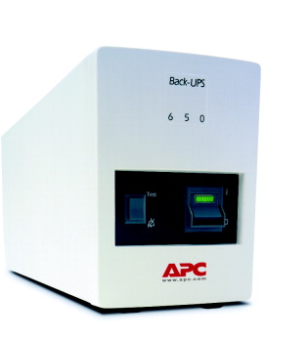
UPSs (Uninterruptible Power Supplies)

Battery-operated power source

Directly attached to one or more devices

Attached to a power supply

Prevents

Harm to device, service interruption

Variances

Power aberrations rectified

Time providing power

Number of supported devices

Price

Standby UPS (Offline UPS)

Switches quickly to battery upon power loss

Problems

Time to detect power loss

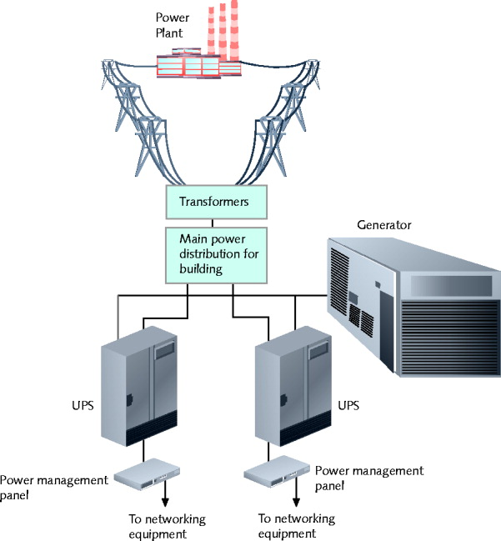
Does not provide continuous power

Online UPS

Devices are always powered by the battery

A/C power continuously charges battery

No momentary service loss risk

Handles noise, surges, sags

Before power reaches attached device

More expensive than standby UPSs

Cost depends on power capacity

Generators

Powered by diesel, liquid propane, gas, natural gas, or steam

Do not provide surge protection

Provide electricity free from noise

Used in highly available environments

Generator choice

Calculate organization’s crucial electrical demands

Determine generator’s optimal size

Topology and Connectivity

Before designing data links

Assess network’s needs

Fault tolerance in network design

Supply multiple paths for data

Avoid single points of failure

LAN: star topology and parallel backbone

WAN: full-mesh or partial-mesh topology

SONET technology

Relies on dual, fiber-optic ring

Redundant Internet Connections

Supply duplicate connection

Use different service carriers

Use two different routes

Critical data transactions must follow more than one possible path

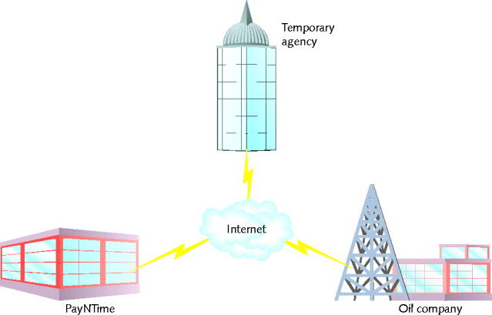
Network redundancy advantages

Reduces network fault risk

Lost functionality

Lost profits

Fault Tolerance at the WAN

Consider PayNTime, a company that needs to get data from two clients to print checks

One solution: lease two T1s to each client

Expensive

Better solution

Partner with ISP

Establishing secure VPNs

Outsources the network redundancy and design

Failures in the Data Room

Many single points of failure

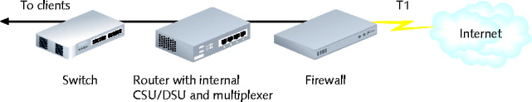
T1 connection could incur fault

Firewall, router, CSU/DSU, multiplexer, or switch might suffer faults in power supplies, NICs, or circuit boards

Fault Tolerance in the Data Room

Solution

Redundant devices with automatic failover

Immediately assume identical component duties

Use hot swappable devices

Desired for switches or routers supporting critical links

Adds to device cost

Does not address all faults occurring on connection

Faults might affect connecting links

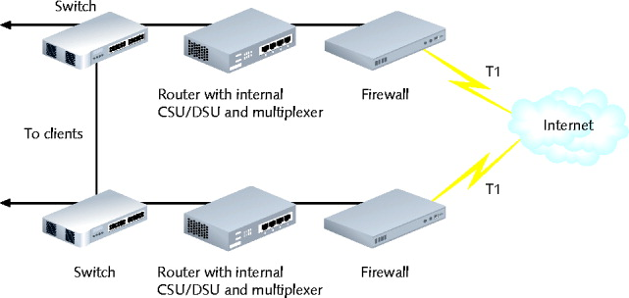
Load Balancing

Uses all redundant paths to move data faster

That way the fault tolerance is not just wasted money when nothing fails

Servers

Critical servers

Contain redundant components

Provide fault tolerance, load balancing

Server Mirroring

Mirroring

Fault-tolerance technique

One device, component duplicates another's activities

Server mirroring

One server continually duplicates another's transactions, data storage

Uses identical servers, components

High-speed link between servers

Synchronization software

Form of replication

Dynamic copying of data from one location to another

Advantage

Flexibility in server location

Disadvantages

Time delay for mirrored server to assume functionality

Toll on network as data copied between sites

Hardware and software costs

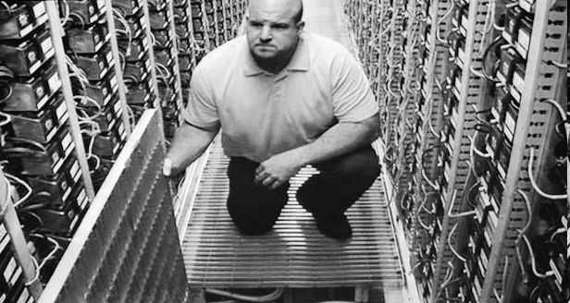
May be justifiable

Clustering

Links multiple servers together

Act as single server

Clustered servers share processing duties

Appear as single server to users

Failure of one server

Others take over

For large networks

More cost-effective than mirroring

Many advantages over mirroring

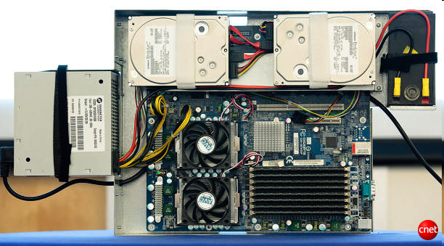
Each clustered server

Performs data processing

Always ready to take over

Reduces ownership costs

Improves performance

Google Server Cluster

Ch 14g

Storage

Data storage: also has issues of availability and fault tolerance

Different methods are available for making sure shared data and applications are never lost or irretrievable

RAID (Redundant Array of Independent [or Inexpensive] Disks)

Collection of disks

Provide shared data, application fault tolerance

Disk array (drive)

Group of hard disks

RAID drive (RAID array)

Collection of disks working in a RAID configuration

Single logical drive

Hardware RAID

Set of disks, separate disk controller

RAID array managed exclusively by RAID disk controller

Attached to server through server’s controller interface

Software RAID

Software implements, controls RAID techniques

Any hard disk type

Less expensive (no controller, disk array)

Performance rivals hardware RAID

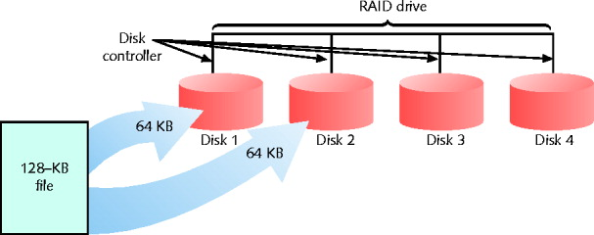
RAID Level 0 - Disk Striping

Simple RAID implementation

Data written in 64-KB blocks equally across all disks

Not fault-tolerant

Does not provide true redundancy

Best RAID performance (in this chapter)

Uses multiple disk controllers

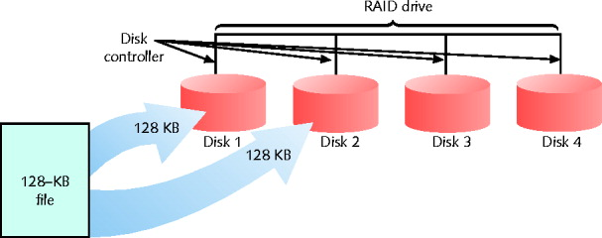
RAID Level 1- Disk Mirroring

Disk mirroring provides redundancy

Data from one disk copied automatically to another disk

Advantages

Simplicity, automatic and complete data redundancy

Disadvantages

Cost of two disks

CPU usage because software does the mirroring

Disk duplexing

Similar to disk mirroring

Data continually copied from one disk to another

Separate disk controller used for each disk

Provides added fault tolerance

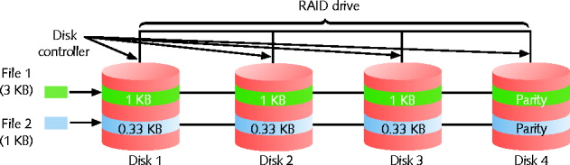
RAID Level 3 - Disk Striping with Parity ECC

ECC (error correction code)

Algorithm to detect, correct errors

Known as parity error correction code

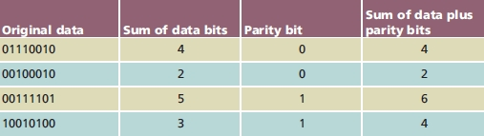
Parity

Mechanism to verify data integrity

Number of bits in byte sum to odd, even number

Use either even parity, odd parity, not both

Parity tracks data integrity

Not data type, protocol, transmission method, file size

Parity error checking

Process of comparing data parity

Advantage

High data transfer rate

Disadvantage

Parity information appears on single disk

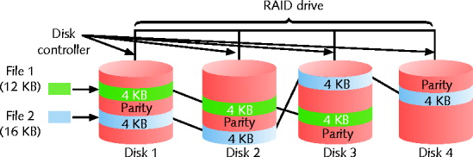
RAID Level 5 - Disk Striping with Distributed Parity

Most popular data storage technique

Data written in small blocks across several disks

Parity error checking information distributed among disks

Advantages over RAID level 3

Writes data more rapidly

Uses several disks for parity information

Disk replacement causes little interruption

Controlling software regenerates failed file parts

Hot spare (failover component)

Array disk, partition used only when one RAID disk fails

See link Ch 14i

Cold spare (hot swappable component)

Duplicate component

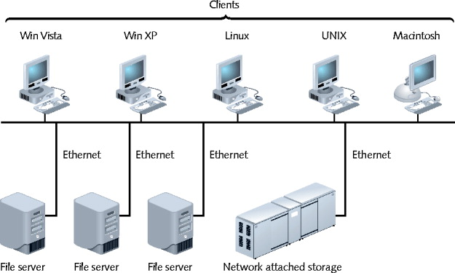
Not installed

NAS (Network Attached Storage)

Specialized storage device, storage device group

Provides centralized fault-tolerant data storage

Difference from RAID

Maintains own interface to LAN

Advantages

NAS device contains own file system

Optimized for saving, serving files

Reads, writes fast

Easily expandable

No service interruption

Disadvantage

No direct communication with network clients

Use

Enterprises requiring fault tolerance, fast data access

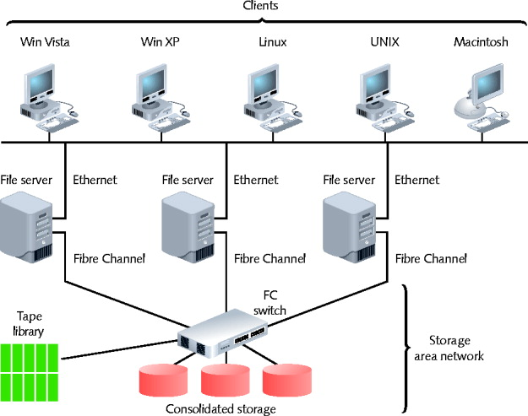
SANs (Storage Area Networks)

Distinct networks of storage devices

Communicate directly

With each other, other networks

Multiple storage devices

Connected to multiple, identical servers

Advantages

Fault tolerant

Fast

Special transmission method

Special protocols, like Fibre Channel

Despite the name, Fibre Channel can run over both copper and fiber media (link Ch 14k, 14l)

SAN can be installed in location separate from LAN served

Provides added fault tolerance

Highly scalable

Faster, more efficient method of writing data

Drawbacks

High cost

Small SAN: $100,000

Large SAN: several million dollars

More complex than NAS, RAID

Training, administration efforts required

Use

Environments with huge data quantities requiring quick availability
Data Backup

Data Backup

Backup

Copies of data or program files

Created for archiving, safekeeping

Store off site

Without backup

You risk losing everything

Many backup options available

Performed by different software and hardware

Use different storage media types

Can be controlled by NOS utilities, third-party software

Backup Media and Methods

Selecting backup media, methods

Several approaches

Each has advantages and disadvantages

Ask questions to select appropriate solution

Optical Media

Media storing digitized data

Uses laser to write data, read data

Examples

CDs, DVDs

Backup requirements

Recordable CD or DVD drive, software utility

CD-R (compact disc-recordable)

Written to once, stores 650 MB data

CD-RW (compact disc-rewriteable)

Used more than once, stores 650 MB data

CD backups

Simple to restore from

Standard format

Relatively low storage capacity

Recordable DVD

4.7 GB on one single-layered side

Double-layered, two-sided DVD

Store up to 17 GB of data

Several different formats

Disadvantage

Writing data takes longer than other media

Requires more human intervention

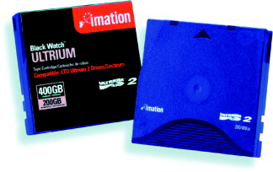
Tape Backups

Copying data to magnetic tape

Relatively simple

Stores very large data amounts

Requirements

Tape drive connected to network

Management software

Backup media

Small network

Stand-alone tape drives attached to each server

Large network

One large, centralized tape backup device

Manages all subsystems’ backups

Extremely large environments

Robots retrieve, circulate tapes from vault

Tape storage library

External Disk Drives

Removable disk drives

Attached temporarily to computer

USB, PCMCIA, FireWire, CompactFlash port

Simple to use

Save, share data

Temporary drive appears like any other drive

Large data capacity

Backup control features, higher storage capacity, faster read-write access

Example: Iomega REV drive

Network Backups

Save data to another place on network

Different server, another WAN location

SAN, NAS storage device

Online backup

Saves data across Internet

To another company’s storage array

Implement strict security measures

Automated backup, restoration processes

Online back up provider evaluation

Test speed, accuracy, security, recovery

Online Backup Examples

Iron Mountain

Normal online backup on their servers

Link Ch 14m

Symform

A cooperative service--your data is stored on other members' servers

$5 a month, no data storage limit

Ch 14n

Backup Strategy

Goal

Perform reliable backups providing maximum data protection

Documented in common area

Accessible by all IT staff

Address various questions

Archive bit

File attribute

Checked to set on or off

On indicates file must be archived

Backup Methods

Full backup

All data copied

Uncheck archive bits

Uses the most tape and time

Easiest restoration (play one tape)

Incremental backup

Copy data changed since last full or incremental backup

Uncheck archive bits

Uses the least tape and time

Most complex recovery--must play many tapes

Differential backup

Copy only data changed since last backup

All data marked for subsequent backup

Does not uncheck archive bits

Uses less tape and time than a Full Backup, but more than an Incremental Backup

Data recovery requires two tapes

Determine best backup rotation scheme

Plan specifying when and how often backups occur

Goal

Provide excellent data reliability without overtaxing network, requiring intervention

Grandfather-Father-Son

Uses backup sets

Daily (son)

Weekly (father)

Monthly (grandfather)

Three backup types performed each month:

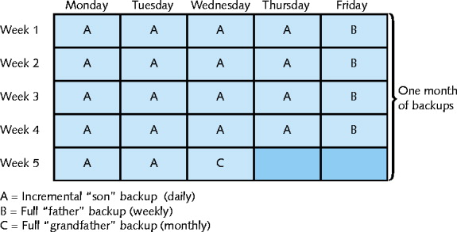
Daily incremental (every Monday through Thursday)

Weekly full (every Friday)

Monthly full (last day of the month)

Ensure backup activity recorded in backup log

Backup date

Tape identification

Type of data backed up,

Type of backup

Files backed up

Site where tape stored

Establish regular verification schedule
Disaster Recovery

Disaster Recovery

Disaster recovery

Restoring critical functionality, data

After enterprise-wide outage

Affecting more than single system, limited group

Consider possible extremes

Hurricane, fire, etc.

Not relatively minor outages, failures, security breaches, data corruption

Disaster Recovery Planning

Accounts for worst-case scenarios

Identifies disaster recovery team

Provides contingency plans

Restore and replace:

Computer systems

Power

Telephony systems

Paper-based files

Contains various sections

Related to computer systems

Lessens critical data loss risk

Disaster Recovery Contingencies

Cold site

Components necessary to rebuild network exist

Not appropriately configured, updated, or connected

Warm site

Components necessary to rebuild network exist

Some appropriately configured, updated, and connected

Hot site

Components necessary to rebuild network exist

All are appropriately configured, updated, and connected

Match network’s current state

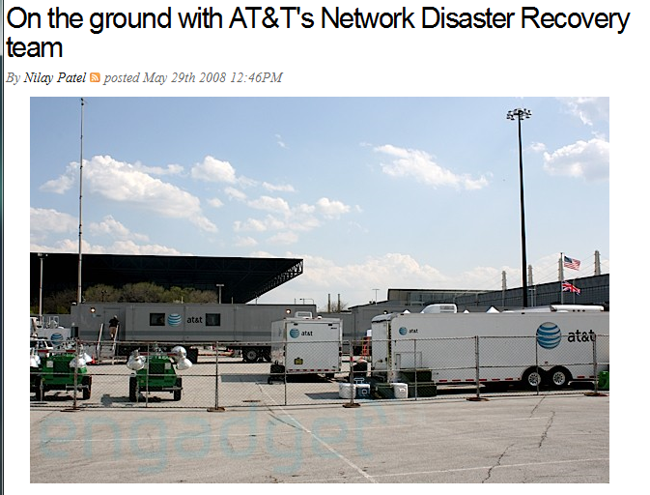

Link Ch 14o

Last modified 11-23-09

