Objectives

Understand network management and the importance of documentation, baseline measurements, policies, and regulations to assess and maintain a network’s health

Manage a network’s performance using SNMP-based network management software, system and event logs, and traffic-shaping techniques

Identify the reasons for and elements of an asset management system

Plan and follow regular hardware and software maintenance routines
Fundamentals of Network Management

Fundamentals of Network Management

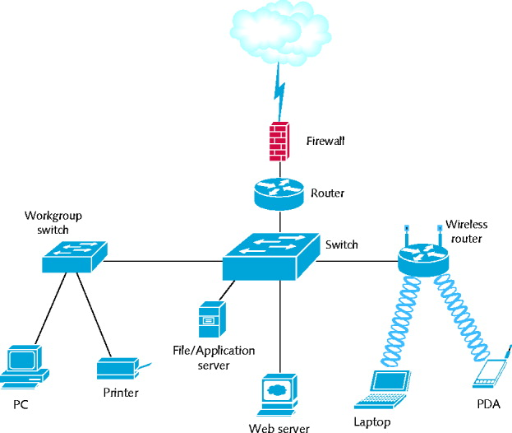
Network management

Assess, monitor, maintain all aspects of a network

Scope differs according to network’s size and importance

Several network management disciplines

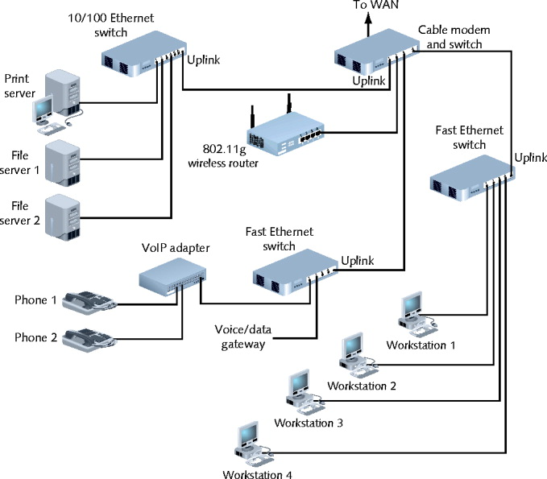
All share same goals

Enhance efficiency and performance

Prevent costly downtime and loss

Predict problems before they occur

Documentation

Network management documentation types

Physical topology

Access method

Protocols

Devices

Operating systems

Applications

Configurations

Configuration management

Collection, storage, assessment of configuration documentation

Documenting all network aspects

Saves future work

Network diagrams

Graphical representations of network’s devices, connections

Use popular Cisco icons

Provide broad snapshots of network’s physical or logical topology

Wiring schematic

Graphical representation of network’s wired infrastructure

Detailed form

Includes every wire necessary to interconnect network devices

Baseline Measurements

Baseline

Report of network’s current operation state

Baseline measurements

Network backbone utilization rate

Number of users logged on per day or per hour

Number of protocols running on network

Error statistics

Runts, collisions, jabbers, giants

Frequency of application use

Bandwidth usage
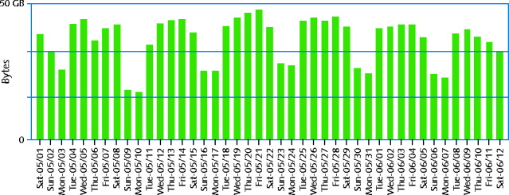

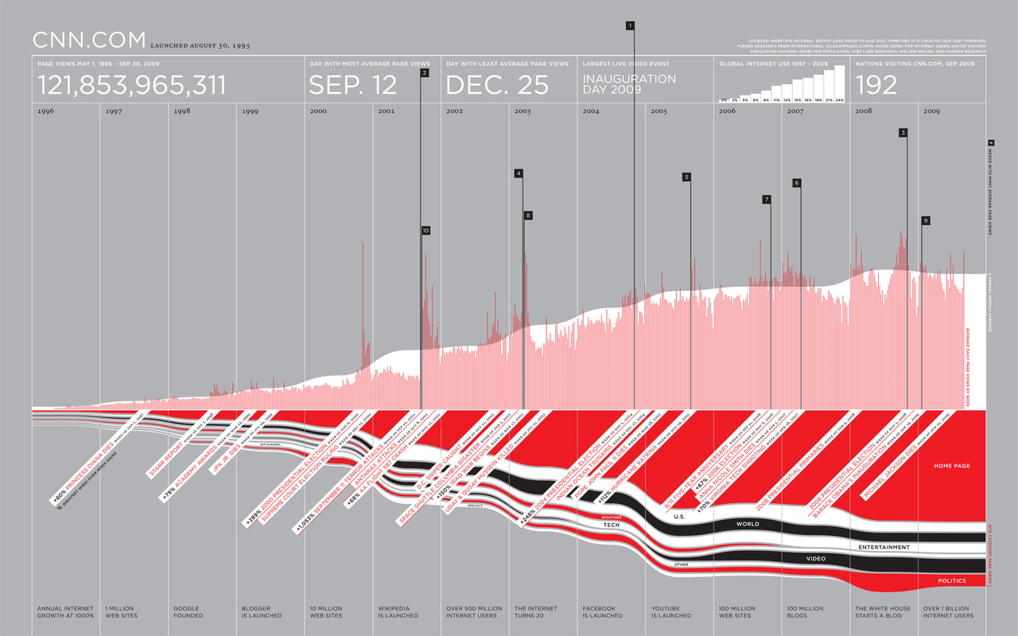

CNN.com Traffic for 13 Years (link Ch 15a)

Compare future and past performance

Most critical network, user functions

More data provides more accuracy

Forecasting network traffic patterns

Difficult to predict users’ habits, new technology effects, changes in resources demand

Gathering baseline data

Software applications

Freeware

Expensive, customizable hardware and software

Determine use before selecting

Policies, Procedures, and Regulations

Rules limit chaos, confusion, downtime

Sound network management internal policies

Media installation and management (cables)

Network addressing policies

Resource sharing and naming conventions

Security-related policies

Troubleshooting procedures

Backup and disaster recovery procedures

State and federal regulations

CALEA (Communications Assistance for Law Enforcement Act)


Telecommunications carriers, equipment manufacturers must provide for surveillance capabilities


HIPAA (Health Insurance Portability and Accountability Act)

Protect medical records security and privacy

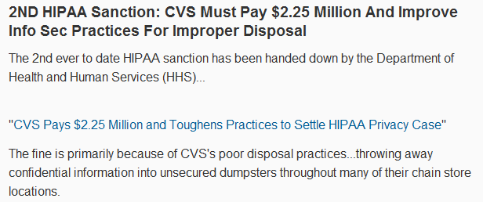
Many policies and procedures

Not laws


Best practices to prevent network problems

Cell Phone Surveillance

CVS HIPAA Sanction

For Schools: FERPA

Fault and Performance Management

Fault and Performance Management

Assess network’s status on an ongoing basis

Performance management

Monitoring

How well links, devices keeping up with demands

Fault management

Detection

Signaling of device, link, component faults

Network Management Software

Enterprise-wide network management software

Accomplish fault, performance management

All use similar architecture

Polling

Collecting data from multiple networked devices at regular intervals

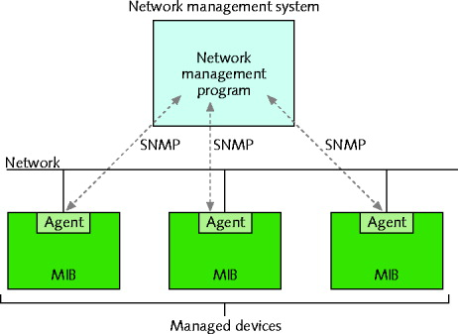
Agent

Software routine collecting information about device’s operation

Provides information to network management application

Managed device

Contains several objects to be managed

Processor, memory, hard disk, NIC, performance

MIB (Management Information Base)

Contains managed devices definition, data

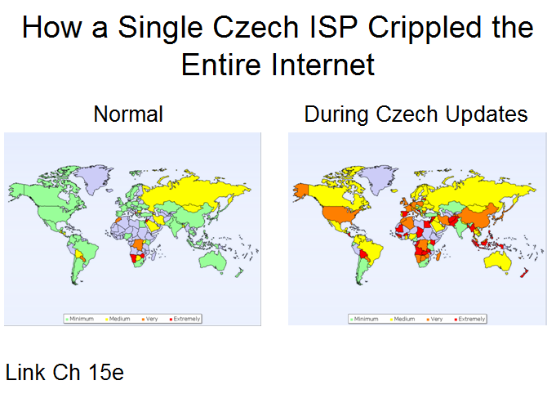
SNMP (Simple Network Management Protocol)

Agents used to communicate managed device information

Part of TCP/IP suite: runs over UDP port 161

Several ways to view and analyze data

Benefits

Flexible, sophisticated network management applications

Drawback

Challenging to configure and fine-tune

Be careful to collect only useful data

Common network management tool used on WANs

MRTG (Multi Router Traffic Grapher)

Command-line utility using SNMP to poll devices and collect data in log file; generates HTML-based views

Freely available
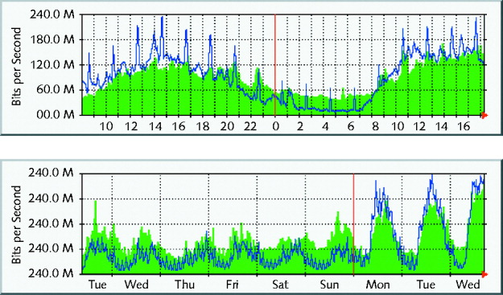

System and Event Logs

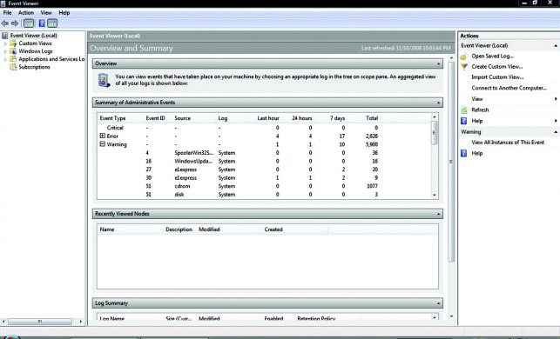
Log

Contains recorded conditions recognized by operating system

Event log

Windows-based computer log containing monitored device information

Event Viewer application

GUI to view Windows-based log information

System log

UNIX or Linux log

Using logs for fault management

Requires thoughtful data filtering, sorting

Information collected does not point to problem

Traffic Shaping

Traffic shaping

Manipulating packet, data stream, connection characteristics

Manage type, amount of traffic traversing network

Goals

Assure timely delivery of most important traffic

Offer best possible performance for all users

Techniques

Delay less important traffic

Increasing priority of more important traffic

Traffic policing

Limit traffic volume flowing in, out of interface during specified time period

Limit momentary throughput rate for an interface

Not without controversy

Comcast discriminated against certain traffic types

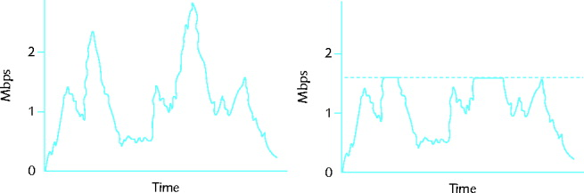
Figure 15-8 Traffic volume before and after applying limits

Comcast's Traffic Shaping


Phorm: Deep Packet Inspection


Traffic prioritization

Treating more important traffic preferentially

Based on characteristics

Protocol

IP address

User group

DiffServ (Differentiated Services) flag or TOS (type of service) field in IP datagram

VLAN tag in Data Link layer frame

Service or application

Caching

Caching

Local storage of frequently needed files

Allows quick access

Web caching

Most common caching type, highly customizable

Web pages stored locally

On host or network, then delivered to requesters

ISP cache engine

Network device devoted to storage, frequently requested files delivery

Saves money, lowers WAN traffic
Asset Management

Asset Management

Identifying and tracking hardware and software

First step

Inventory each network node

Organization needs

Determine asset management tool selected

Benefits

Simplifies maintaining and upgrading network

Provides information about hardware and software costs and benefits

Change Management

Managing change while maintaining network efficiency, availability

Requires good planning

Common software and hardware changes

Installing patches to replacing network backbone

Several ways to approach changes

Software Changes

Keeping a system running optimally

Requires software upgrades

Software change types

Patches

Improvements, enhancements to particular software application code

Upgrades

Major changes to existing code

Revisions

Minor or major changes to existing code

Software Change Process

Patches

Correction, improvement, and enhancement to particular piece of software application

Changes part of application

Most code untouched

Vendors distribute at no charge

Often fix bugs

Not a software package replacement

Installed on top of existing software

Installation is similar to new software

Perform off-hours; test

Stay apprised of patches

Check vendor’s technical support Web site regularly

Subscribe to vendor mailing list

Patches may be bundled

Significant patches

Vendor notifications sent

Reported in trade journals

Client upgrades

Software upgrade

Major change to software package’s existing code

Free

May substitute for vendors original code

Designed to add functionality and fix bugs

Client upgrades scope, purpose

Varies widely

Before applying upgrade

Read documentation

May be transparent to users

May completely change appearance

Test on single workstation before general distribution

Prepare a reverse process

Installation methods

Workstation-by-workstation

Software distribution application

Plan carefully; inform users

Shared application upgrades

Modifications to all or part of an application

Designed to enhance functionality; fix problems

Applied to software shared by network clients

Affects all users at once

Use same installation and planning principles as other software upgrades

Upgrades tend to enhance functionality

Weigh time, cost, and effort versus upgrade necessity

Provide user training for significant upgrades

NOS (Network Operating System) upgrades

Most critical upgrade type

Involves significant and potentially drastic changes to the way servers and clients operate

Before upgrade

Requires plenty of forethought and product research; rigorous testing

Ask and answer significant questions

May produce complex and far-reaching change

Have appropriate money, staff, and time available

Have backout plan

Methodical process considerations

Research

Project plan

Proposal

Evaluation

Testing

Training

Preimplementation--warn users

Implementation

Postimplementation--test, review help desk calls

Reversing a software upgrade

Be prepared to reverse an update

Software change may create problems

Backleveling

Process of reverting to previous version of software after attempting upgrade

No hard-and-fast rules for backleveling

Always refer to software vendor’s documentation to reverse an upgrade

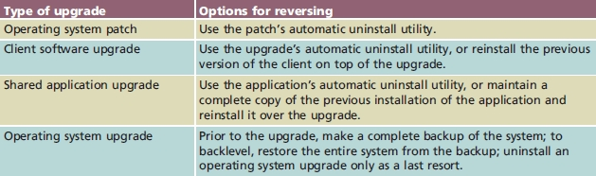
For NOS: consult other professionals as well

Hardware and Physical Plant Changes

Required when network component fails or malfunctions

More commonly performed as upgrade

Increase capacity, improve performance, add network functionality

Face same issues as software changes

Proper planning is key

Consider guided steps

Adding or upgrading equipment

Difficulty determined by past use; experience with hardware or the vendor

Take time to research, evaluate, test unfamiliar equipment

Rapid hardware industry changes

May affect consistency of installed products

If consistency is a concern

Purchase as much hardware as possible in single order

Purchase from same vendor

Different preparation, implementation requirements

For each device type

Read reading manufacturer’s instructions

Gain experience with networking equipment

Follow general guidelines for each device type:

Workstations and printers are simplest

Servers, routers, and switches are most disruptive and complex to add or upgrade

Most difficult to remove or backlevel

Keep safety in mind when upgrading and installing network hardware

Cabling upgrades

Can require significant implementation planning and time

Dependent upon network size

Troubleshooting cabling problems

Easier with current and accurate wiring schematics

Carefully document existing cable

Before making any upgrades

Upgrade cabling in phases

Change affects all users

Weigh upgrade importance against disruption potential

Small organization

Upgrade on their own

Larger organizations

Rely on contractors

Backbone upgrades

Most comprehensive and complex upgrade

Backbone represents main data conduit

Requirements

Extensive planning, personnel efforts, money

Upgrading entire backbone changes the whole network

Reversing hardware changes

Provide way to reverse hardware upgrade

Reinstall old hardware

If old component is faulty, reinstall is not possible

Keep upgraded components safe and nearby

May need to reinstall

Refer to it for information

Last modified 12-7-09

