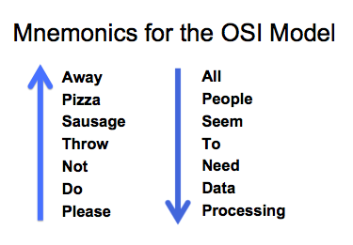
Objectives
Application
Presentation
Session
Transport
Network
Data Link
Physical

What is the purpose of a Network model?

What are the layers of the OSI model?

What are the characteristics of each layer of the OSI model?

How does the TCP/IP stack compare to the OSI model?

What are the well-known TCP and/or UDP port numbers for a given collection of common applications

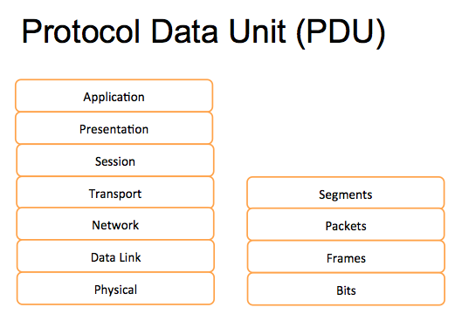
The Purpose of Reference Models

It breaks network communication into smaller, simpler parts that are easier to develop.

It facilitates standardization of network components to allow multiple-vendor development and support.

It allows different types of network hardware and software to communicate with each other.

It prevents changes in one layer from affecting the other layers so that they can develop more quickly.

It breaks network communication into smaller parts to make learning it easier to understand.

Warriors of the Net video
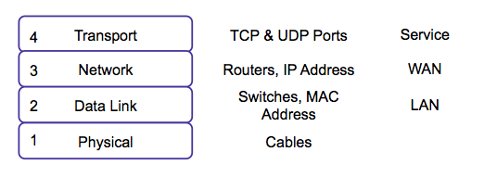

\Quick Summary of Layers 1-4

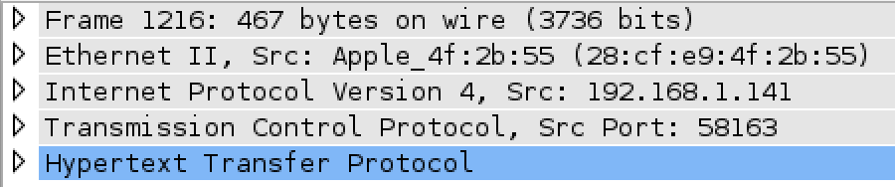

OSI Layers in Wireshark

1. Physical Layer

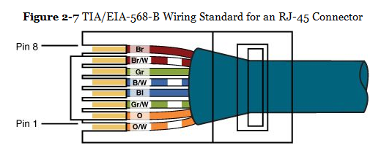
Wiring Standards

Asynchronous and Synchronous Communications

Synchronizing Bits

Two devices must agree on when one bit stops and another bit starts

Asynchronous

Uses start and stop bits

Synchronous

Internal clocks are synchronized at each end of the cable

Bandwidth Usage

Broadband

Multiple channels share the same medium

Ex: cable TV uses frequency division multiplexing (each channel uses a different frequency range)

Baseband

The whole medium is used for one transmission

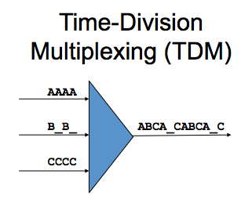
Example: Ethernet

Time-Division Multiplexing (TDM)

Each channel gets the same amount of time on the wire

Statistical Time-Division Multiplexing (StatTDM)

Busy channels get more time on the wire

Frequency Division Multiplexing (FDM)

Example: signals sent with different colors through the same fiber optic cable

Layer 1 Devices

Cables

Wireless access points

Hubs

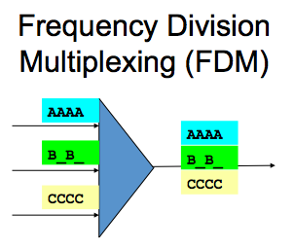
Because they don’t pay any attention to addresses, they just deliver signals to every connected device like a crossover cable
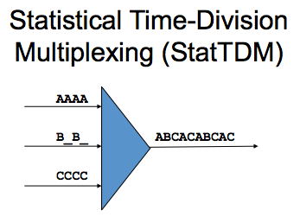

2. Data Link Layer
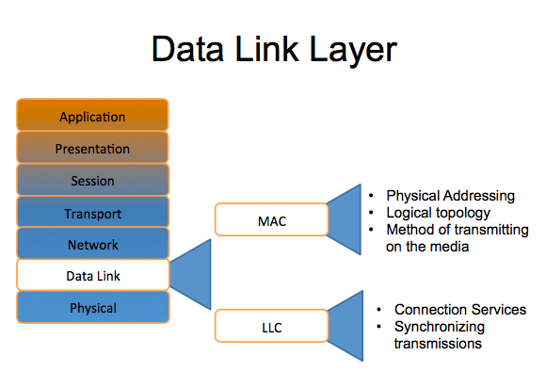

MAC Addresses

IPCONFIG /ALL

Physical Address

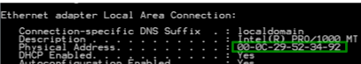
Built into the network interface

Connection Services

Flow control

Prevents sender from sending data faster than the client can accept it

Error control

When a frame is received, a checksum is used to detect errors

Usually a Cyclic Redundancy Check (CRC)

If the receiver's checksum does not match the sender's checksum, the frame is discarded and resent

Layer 2 Devices

Switches

Bridges

Network Interface Cards (NICs)
3. Network Layer

IP Address

Logical address

Changes when the device is moved

Switching

Packet switching

Data is broken into packets

Many packets travel along network connections like cars on a freeway

Circuit switching

A physical line is dedicated to each connection

Ex: old copper landline phone systems

Message switching

Store-and-forward, like email

Layer 3 Devices

Routers

Multilayer Switches
4. Transport Layer

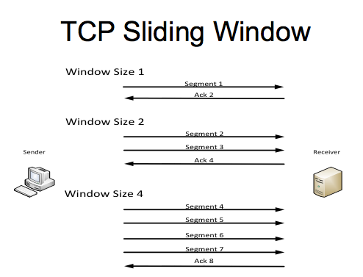
TCP and UDP

Transmission Control Protocol (TCP)

Connection-oriented and reliable

Handshake makes sure both ends are ready

Segments are acknowledged and resent if necessary

User Datagram Protocol (UDP)

Connectionless and unreliable

No handshake

Best-effort delivery, no acknowledgements

ICMP (Internet Control Message Protocol)

At layer 4

Used by ping and traceroute, and to indicate errors such as dropped packets
5. Session Layer

Example of a Session

User logs in with a username & password

All data now has a special significance until that user logs off, or the session times out, or is terminated some other way

Layer 6 Protocol

H.323 (voice or video)

NetBIOS (file sharing)

6. Presentation Layer

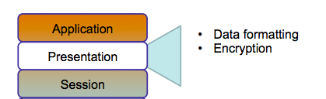

7. Application Layer

Application Layer

Closest to the user

Hands data to an application in the format it expects, with no addresses or other transmission artifacts

Examples: a downloaded file, an email message
The TCP/IP Stack

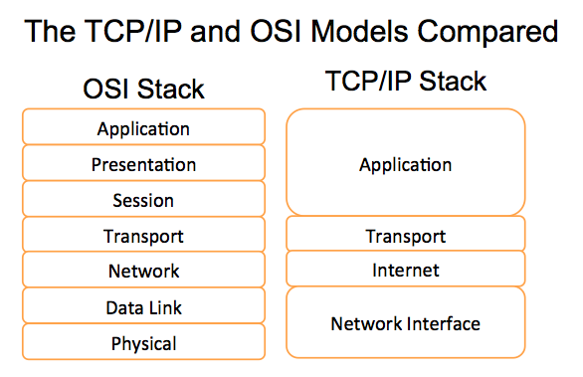
The TCP/IP and OSI Models Compared

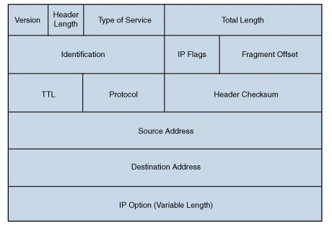

IP Ver4 Header

TTL (Time-to-Live)

TTL decreases by one each time the packet is forwarded by a router

If TTL reaches zero, the packet is discarded

This eliminates packets trapped in routing loops

Demo: Routing Loop

TCP Header

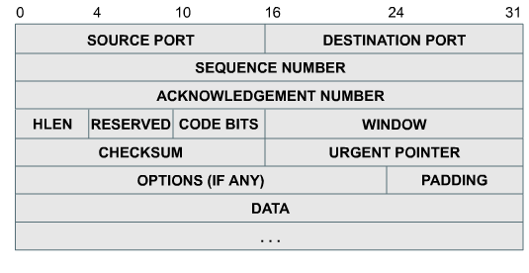
TCP Header Fields

Port numbers

Indicate which program on the end device should receive the data

Examples: Port 25 for email, 80 for HTTP

Window size

Number of bytes that can be sent before waiting for an ACK

TCP Header Fields

Sequence and Acknowledgement numbers

Used to put packets in order to reassemble files and other large messages

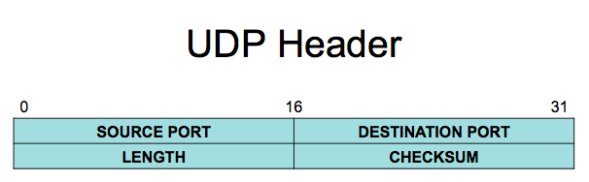
Flags like SYN and ACK are used for the TCP handshake and to acknowledge data received

UDP Header

No handshake, acknowledgements, sequencing, or flow control

Common Port Numbers
DNS (Domain Name System) | TCP/UDP 53
HTTP (Hypertext Transfer Protocol) | TCP 80
SMTP (Simple Mail Transfer Protocol) | TCP 25
POP (Post Office Protocol) | TCP 110
Telnet (DHCP) | TCP 23
DHCP (Dynamic Host Configuration Protocol) | UDP 67(IPv4 client) and 68(IPv4 server);
FTP (File Transfer Protocol) | TCP 20(data) and 21(control)
TFTP (Trivial File Transfer Protocol) | UDP 69
NBNS (NetBIOS Name Service) | UDP/TCP 137
IMAP4 (Internet Message Access Protocol) | TCP 143
SNMP (Simple Network Management Protocol) | TCP/UDP 161
HTTPS (Hypertext Transfer Protocol Secure) | TCP 443
NTP (Network Time Protocol) | UDP 123
SSL (Secure Sockets Layer) | TCP 443
SSH (Secure Shell) | TCP 22

Link Ch 2d for flash cards

Port Types

Port numbers are assigned in various ways, based on three ranges:

System Ports (0-1023), System Ports are assigned by IETF process for standards-track protocols, as per RFC6335. Also known as well-known-ports

User Ports (1024-49151) ,User Ports are assigned by IANA using the "Expert Review" process, as per RFC6335

Dynamic and/or Private Ports (49152-65535), Dynamic Ports are not assigned, they are dynamically created as your computer need them. Also known as ephemeral ports.

Communication Between Two Systems

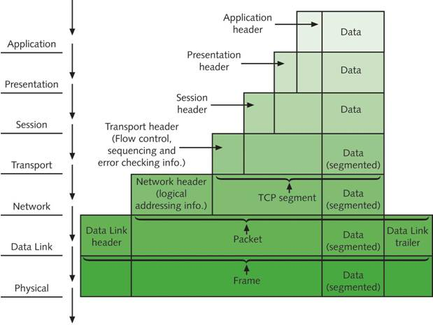

Last modified 4-21-13

