Installing the Gogo6 Tunnel
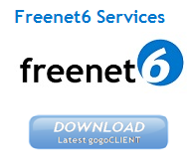
- Since you probably only have IPv4 Internet service, the easiest way to get on IPv6 is to use a Tunnel Broker--a service that converts IPv4 traffic to IPv6. The easiest one is Gogo6.
- In a Web browser. go to http://gogo6.com/. At the upper right of the page, click "Freenet6". On the next page, click Sign Up. Fill in the form to create an account. You will have to read your email and click a link to verify your account, and also fill out a profile form.
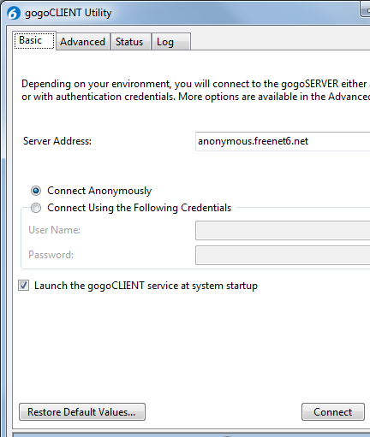
- In a Web browser. go to http://gogo6.com/ and, at the top of the page, click "Freenet6". Your name should appear at the upper right of the page--Freenet has recorded your ID with a cookie. In the 'Freenet Services" section, click the Download button, as shown to the right on this page.
- The next page offers several versions to download. In the "gogoCLIENT - Basic version" section, click the "gogoCLIENT 1.2 Windows Installer 32-bit" link. Install it with the default options.
- When the gogoCLIENT launches, as shown to the right on this page, click the Connect button.

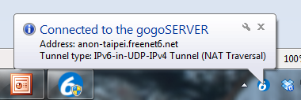
- After a few seconds, you should see a message saying "Connected to the gogoSERVER", as shown to the right on this page.

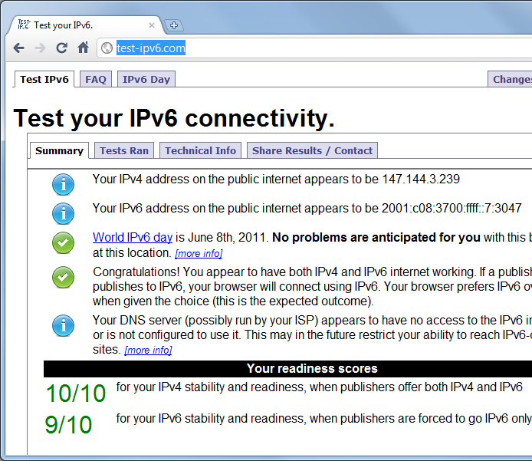
Testing your IPv6 Connectivity
- In a Web browser. go to http://test-ipv6.com
- The test runs automatically. You should now have an IPv6 address on the public Internet, as shown below on this page. The numerical score is usually 10, but when I did it I got a 9. However, all you need for this project is an IPv6 address showing in the second line of the test results.

Saving the Screen Image
- Make sure you have an IPv6 address showing in the test results--it will usually start with 2001:.
- Press the PrntScn key to copy whole screen to the clipboard.
- Open Paint and paste in the image. Save it as a PNG or JPEG, with the filename Your Name Proj 6x.
Turning in your Project
- Email the image to me as an email attachment. Send the message to: cnit.106sam@gmail.com with a subject line of Proj 6x From Your Name, replacing Your Name with your own first and last name. Send a Cc to yourself.

Last modified 2-1-11

