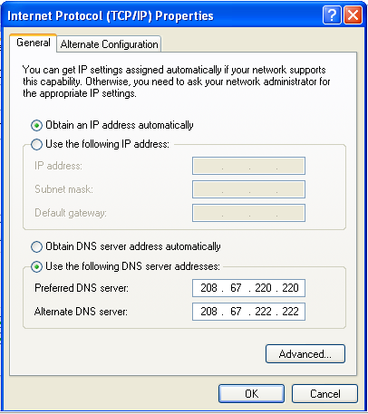
If your VM can't connect to the Internet, try these troubleshooting tips:
  - Make sure the host OS can reach the Internet
  - Ensure that the network adapter in your VM is set to automatic addressing (DHCP). To do that in Windows XP, click Start, "Control Panel", "Network Connections". Right-click "Local Area Connection", click Properties, double-click "Internet Protocol (TCP/IP)", and ensure that the settings are as shown to the right on this page.
  - In the VM, click Start, Run, type in CMD and press Enter. In the Command Prompt window, enter these two commands, pressing the Enter key after each one:
IPCONFIG /RELEASE
IPCONFIG /RENEW
  - In VMware Workstation, click VM, Settings. In the "Virtual Machine Settings" box, click "Network Adapter". Make sure the "Connected" box is checked, as shown below on this page. If it still won't connect, try all the "Network Connection" options--usually the best choice is NAT, but just try them all.
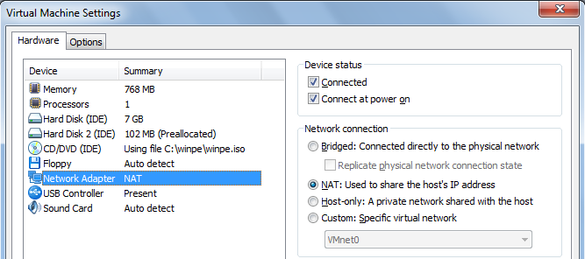
  - If all these steps fail, which is a common event, make a fresh copy of the VM from your original source.

