If you do your homework in the S214 lab, VMware Workstation is already installed for you, on the Vista partitions. But if you want to work at home, or if you want to use a fresh Windows 7 installation in the S214 lab, you will need to install it there.

What You Need
- A computer running Windows XP, Vista, or Windows 7 with at least 512 MB of RAM and several GB of storage available. Each virtual machine is 2-4 GB, or even larger if you install a lot of software on the virtual machine
- A broadband Internet connection so you can download large files.

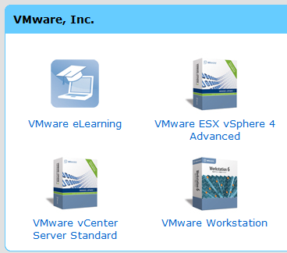
Downloading VMware Workstation
- You should have received an email with a subject line "An account has been created for you" telling you how to get your VMware Workstation software. Click the link in that email and fill out the form to log into the e5onthehub.com VMware site.
- You should see a group of icons, , as shown to the right on this page. Click "VMware Workstation".
- In the next screen, click "Add to cart".
- In the next screen, click "Check out".
- Scroll to the bottom of the next page and click "I Accept".
- In the next screen, click "Proceed With Order".
- The next page shows your Serial Number. Save this number! I recommend that you email it to yourself, or write it down carefully.
- Click "Download Options".
- In the next screen, click the blue "VMware Workstation 6.5 for Windows" link. Download the file and save it on your desktop.

Installing VMware Workstation
- On your desktop, double-click the VMware-workstation-6.5.1-126130.exe file. Install the software with the default choices. You will need to copy and paste in the Serial Number. Note: If you are working in S214, don't use your own personal serial number. Use the ones posted on the noteboard,

Last Modified: 8-19-09

