What You Need for This Project
Warning! "Ethical Hacking and Network Defense" students will capturing passwords in room S214. Don't do online shopping, personal e-mailing, or any other private computer work in that lab. Make up a new password just for that lab. Nothing you do in that lab is private!
- A computer with VMware Workstation
- The instructions below assume you are working in the S214 lab. If you are working at home, you will have to adapt the steps to match your situation. A DVD containing useful virtual machines was handed out in class, labeled VMs.

Start Your Host Machine
- Select a machine to be your primary machine for the semester. You'll want to keep using the same machine as much as possible, because your virtual machines will be there.
- Power on your computer. Boot to Vista. Log on as Student with no password.

Making Your VM (Virtual Machines) Folder
- Click Start, Computer. Find the VMs drive and double-click it to open it.
- In the VMs window, right-click the empty space and click New, Folder. Name the folder YOUR NAME VMs replacing YOUR NAME with your own name.

Copying the Virtual Machine into Your VM Folder
- Insert the VMs DVD into your machine. It should contain these three items:
  - A folder named WinXPSP3—this is your Virtual Machine which you will use for many projects
  - A file named 7z465.exe—this is for a different class, just ignore it
  - A file named WinXP_TARGET.7z—this is for a different class, just ignore it
- Copy the WinXPSP3 folder into the YOUR NAME VMs folder.

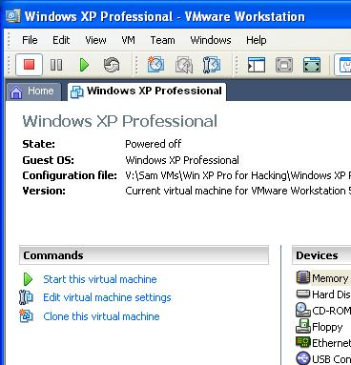
Starting VMware
- Double-click the VMware Workstation icon on the desktop. In the VMware Workstation window, from the menu bar, click View, Go to Home Tab.
- On the Home tab, click the Open Existing VM or Team icon. Navigate to the VMs: drive, open your folder, open the Win XP SP3 folder, and double-click the Windows XP Professional.vmx file. You should see a Windows XP Professional VM in the Powered Off state, as shown to the right on this page.

Starting Your Virtual Machine
- In the Windows XP Professional – VMware Workstation window, on the left side, click the "Power on this virtual machine" link.
- If you see a message saying “The location of this virtual machine’s configuration file has changed…,” accept the default selection of Create and click OK.
- If you see a long message about Windows XP product activation, click OK.

Changing Your Virtual Machine’s Name
- All the virtual machines now have the same name. This will cause warning messages to appear on the desktops, and it’s confusing. So you should change your machine’s name to contain the station number and your name, with the following steps:
- Click the Start button on your virtual machine’s desktop, right-click My Computer, and click Properties. Click the Computer Name tab. Click the Change button. Enter the name of your station followed by your name, which will be something like this S214-01-YOURNAME. Click OK. When a Computer Name Changes box appears saying “You must restart…”, click OK. In the System Properties box, click OK. In the System Settings Change box, click Yes. Wait while your virtual computer restarts. Log in as you did before.
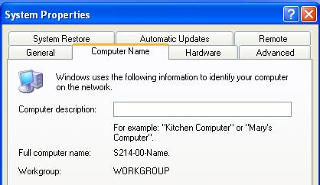
- Click the Start button on your virtual machine’s desktop, right-click My Computer, and click Properties. Click the Computer Name tab. The "Full computer name:" should contain your station number and your name, as shown to the right on this page.

Saving a Screen Image
- You have now completed Project 1. The only thing that remains is to turn it in. To do that, you need to make a JPEG image of the screen and email it to me, as explained below. Note the hand symbol just below this text: that indicates screen images that you must capture and turn in.
- Click the taskbar at the bottom of your host Windows XP desktop, to make the host machine listen to the keyboard, instead of the virtual machine.
- Press the PrintScrn key in the upper-right portion of the keyboard. That will copy the whole desktop to the clipboard.
- On the host machine, not the virtual machine, click Start, "All Programs", Accessories, Paint. In the untitled - Paint window, select Edit, Paste from the menu bar. The desktop appears in the Paint window (only a corner of it will be visible).
- In the untitled - Paint window, click File, Save. Save the document in the My Pictures folder (or any other place you wish, such as a floppy disk) with the filename Your Name Proj 1. Select a Save as type of JPEG.
- Email the JPEG image to me as an attachment to an e-mail message. Send it to: cnit.106sam@gmail.com with a subject line of Proj 1 From Your Name, replacing Your Name with your own first and last name. Send a Cc to yourself.
Last Modified: 8-19-09

