What You Need for This Project
- A host machine with VMware Workstation
- A Windows XP virtual machine,

Start Your Vista Host Machine
- Log in as Student.

Starting Your Target Virtual Machine
- Double-click the VMware Workstation icon on the desktop. In the VMware Workstation window, from the menu bar, click View, Go to Home Tab.
- On the Home tab, click the Open Existing VM or Team icon. Navigate to the VMs drive, open your folder, open the WinXPSP3 folder, and double-click the WinXPSP3.vmx file. On the left side, click the Start this virtual machine link.
- If you see a long message about Windows XP product activation, click OK.

Setting the Virtual Network to "Bridged"
- In the "Windows XP Professional – VMware Workstation" window, in the menu bar, click VM, Settings.
- In the "Virtual Machine Settings" box, in the left pane, click "Network Adapter". In the right pane, make sure both the Connected and "Connect at power on" boxes are checked, as shown below on this page. In the "Network Connection" section, click the Bridged button. Click OK.
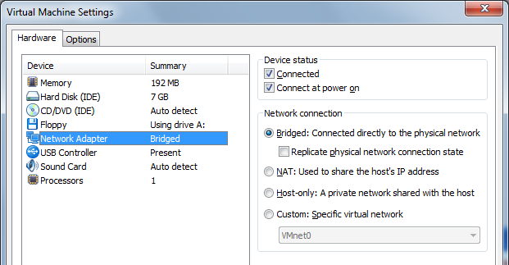
- In this mode, the VMware software acts like a Bridge—allowing both the host and virtual machines to share a single network interface card. We will discuss bridges in detail later in the course.

Testing Your Internet Connection
- If there is a Clamwin box open in your virtual Windows XP machine, close it.
- In the virtual machine, double-click the Firefox icon to open it. Go to www.ccsf.edu. If it connects, you will see the CCSF Web page, as shown below on this page. However, it may fail to connect, and show an error message instead—this is because the VMware software is somewhat buggy and unreliable. VMware is so useful that it's worth putting up with its annoying defects, however. And it will give you a lot of practice debugging network problems, which is good in this class!

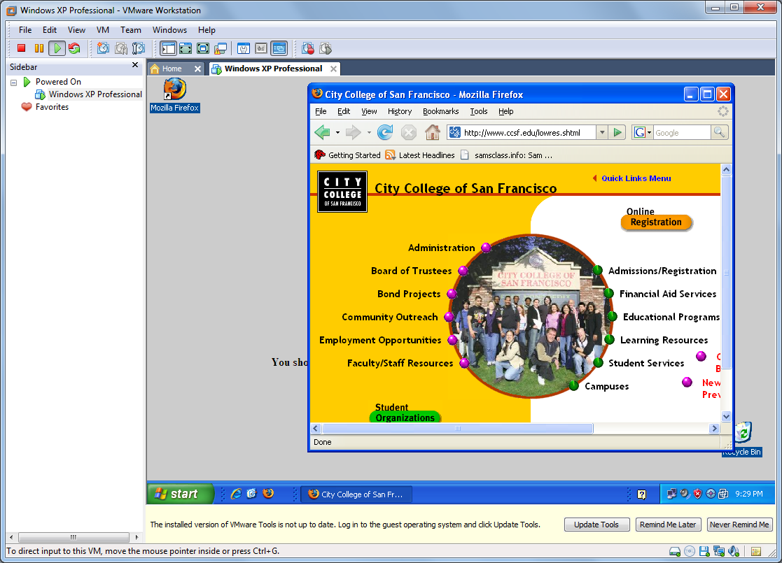

Repairing Your Internet Connection
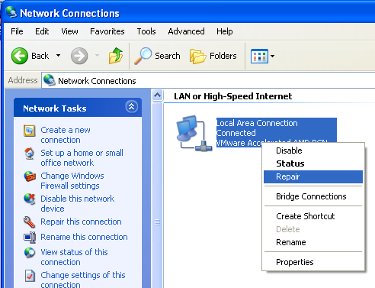
- In the virtual machine, click Start, "Control Panel". Double-click "Network Connections".
- In the "Network Connections" window, right-click "Local Area Connection" and click Repair, as shown to the right on this page. This performs a series of tests on the connection, and checks to see if a new IP address is available. We will cover IP addresses in detail later

Finding the Virtual Machine's IP Address
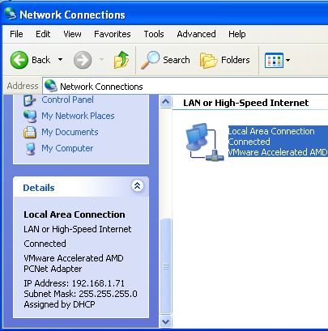
- In the "Network Connections" window, left-click "Local Area Connection". In the left pane, scroll down to the Details section. This shows your IP Address, as shown to the right on this page. We will cover IP addresses in detail later, but for now just make a note of the number so you can see that it changes later in this project.

Saving a Screen Image
- Make sure the "Network Connections" window is visible, showing the IP Address.
- Click on the host machine's desktop, outside the virtual machine to make the host machine’s desktop active.
- Press the PrintScrn key to copy the whole desktop to the clipboard.
- In the host machine, click Start, "All Programs", Accessories, Paint. In the untitled - Paint window, select Edit, Paste from the menu bar. The desktop appears in the Paint window, with only a corner of it visible.
- In the untitled - Paint window, click File, Save. Save the document in the My Pictures folder (or any other place you wish, such as a floppy disk) with the filename Your Name Proj 2. Select a Save as type of JPEG.

Setting the Virtual Network to "NAT"
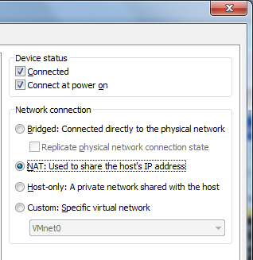
- In the "Windows XP Professional – VMware Workstation" window, in the menu bar, click VM, Settings.
- In the "Virtual Machine Settings" box, in the left pane, click "Network Adapter". In the right pane, in the "Network Connection" section, click the NAT button, as shown to the right on this page. Click OK.
- In this mode, the VMware software acts like a router performing Network Address Translation. It takes data packets sent from the virtual machine and re-addresses them before sending them out onto the network. This is generally considered the most reliable type of virtual networking.

Repairing Your Internet Connection
- In the virtual machine, click Start, "Control Panel". Double-click "Network Connections".
- In the "Network Connections" window, right-click "Local Area Connection" and click Repair. This performs a series of tests on the connection, and checks to see if a new IP address is available. We will cover IP addresses in detail later

Finding the Virtual Machine's IP Address
- In the "Network Connections" window, left-click "Local Area Connection". In the left pane, scroll down to the Details section. The IP address should be different now.

Turning in Your Project
- Email the JPEG image to me as an attachment to an e-mail message. Send it to: cnit.106sam@gmail.com with a subject line of Proj 2 From Your Name, replacing Your Name with your own first and last name. Send a Cc to yourself.

Last Modified: 8-16-09

