What You Need for This Project
- A computer with WireShark installed. You should do project 3 first. The instructions below assume you are using Windows 7 in the S214 lab.

Start Your Computer
- Boot to Windows 7. Log in as Student with no password. If you can't log on, try using Vista, or another machine. If that doesn't work, do project 2x to hack into the machine.

Downloading the Packet Capture File
- Open Firefox and go to samsclass.info
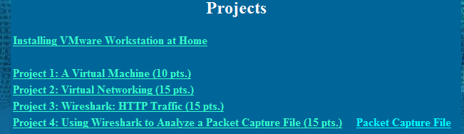
- Click “CNIT 106”. On the next page, click "Projects". A list of projects appears, as shown below on this page.

- Point to "Packet Capture File" and right-click. Save the file on your desktop.
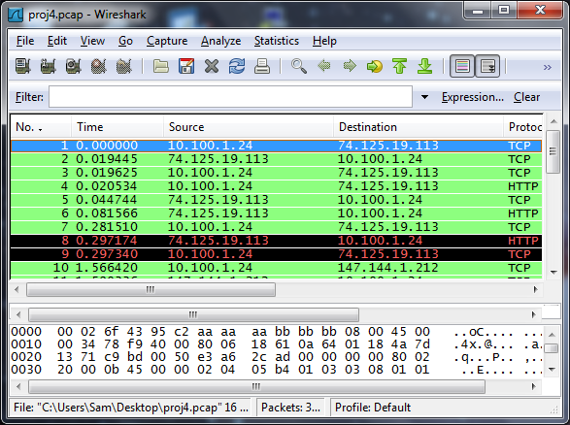
- On your desktop, double-click the proj4.pcap file. The file opens in Wireshark, as shown below on this page.

Analyzing the Packet Capture File
- Examine the wireshark window and find answers to the following questions:

- Three packets in this capture perform a TCP Handshake. Find the packet numbers of those packets (the column labeled "No.". Write those numbers here:

- In this session, a client machine initiated a connection to a server and then downloaded a file. What is the client's IP address?

- How many HTTP GET request packets are there?

- Find the first HTTP GET request packet. What was the server's IP address? (The server is the Destination).

- Examine the first packet. Look at the bottom pane in Wireshark. How many bytes were sent on the wire to form this packet?

Turning in Your Project
- Email the answers to those questions to: cnit.106sam@gmail.com with a subject line of Proj 4 From Your Name, replacing Your Name with your own first and last name. Send a Cc to yourself.

Last Modified: 9-3-09

