What You Need for This Project
- A computer with Windows XP, Vista, Windows 7, or any other Windows version. The instructions below assume you are using Windows 7 in the S214 lab.

Start Your Computer
- Boot to Windows 7. Log in as Student with no password. If you can't log on, try using Vista, or another machine. If that doesn't work, do project 2x to hack into the machine.

Use Automatic Addressing
- Click the Start button. In the Search box, type NET
- In the menu, a "Network and Sharing Center" item appears. Click it.
- In the "Network and Sharing Center" box, click "Change adapter settings".
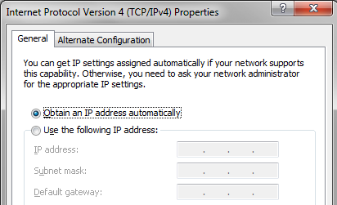
- In "Network Connections", right-click "Local Area Connection" and click Properties.
- In "Local Area Connection Properties", double-click "Internet Protocol Version 4 (TCP/IPv4)".
- In the "Internet Protocol Version 4 (TCP/IPv4) Properties" box, verify that the "Obtain an IP address automatically" item is selected. If it is not checked, write down all the numbers in this box carefully so you can put them back later. Then select the "Obtain an IP address automatically" item.
- Click OK twice.

Open a Command Prompt
- Click the Start button. In the Search box, type CMD
- Press the Enter key. A Command Prompt box opens.
  - If you are using Vista, press Shift+Ctrl+Enter instead of Enter to open an Administrator Command Prompt. You don't need an Administrator Command Prompt in Windows 7 or Windows XP.

Renewing your IP Address
- In the Command Prompt window, type the following command, and then press the Enter key:
IPCONFIG /RELEASE
- In the Command Prompt window, type the following command, and then press the Enter key:
IPCONFIG /RENEW

- These two commands cause your computer to request a new IP address from your DHCP server. You should see your new IP address in the window, as shown below on this page. The process might time out and give an error, ending with an IP address starting with 169.254—that's OK for this project.
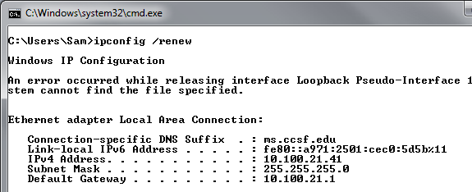

Starting Wireshark
- Wireshark should already be installed. If it isn't, see project 3 for instructions to install it.
- Click the Start button. In the Search box, type WIRE
- At the top of the menu, a Wireshark item appears. Right-click Wireshark and click "Run as Administrator". If a User Account Control box appears, allow the program to run.
- From the Wireshark menu bar, click Capture, Interfaces. If your computer has several network cards, you may see several items here. Just look to see which one shows an increasing number of packers. In the example shown below on this page, it's the NVIDIA interface. On the line showing the increasing number of packets, click Options.
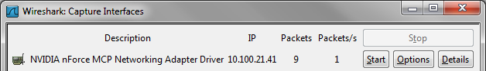

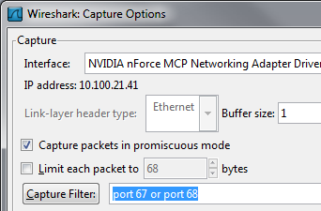

- In the "Wireshark: Capture Options" box, type this into the "Capture Filter" box, as shown to the right on this page:
port 67 or port 68
- Click Start. This filter will show only DHCP traffic—packets used to obtain an IP address automatically.

Renewing your IP Address
- In the Command Prompt window, type the following command, and then press the Enter key:
IPCONFIG /RELEASE
- In the Command Prompt window, type the following command, and then press the Enter key:
IPCONFIG /RENEW

Examining the Wireshark Capture of the DHCP Process
- From the Wireshark menu bar, click Capture, Stop.
- From the Wireshark menu bar, click View, "Colorize Packet List", so it is unchecked. That makes it easier to read the display.
- If DHCP is working correctly on your system, you should see the whole process, as shown below on this page. Examine the output and look for these items in the Info column:
  - DHCP Release – sent from your machine's original IP address, to the IP address of the DHCP Server. This packet informs the server that your machine no longer wants that address and is freeing it up for some other machine to use.
  - DHCP Discover – sent from your machine, with a Source IP address of 0.0.0.0 to the Broadcast address of 255.255.255.255. This is a packet requesting an IP address. It has a Source IP of 0.0.0.0 because your computer doesn't have an IP address at this point, and the Destination is 255.255.255.255 because your machine does not know where the DHCP server is. This packet is a call to every machine that is nearby, asking for any available DHCP server to send a response.
  - DHCP Offer – sent from the DHCP server to the Broadcast address of 255.255.255.255. This is the server offering an IP address—but it cannot be targeted at your computer specifically because your computer still has no IP address.
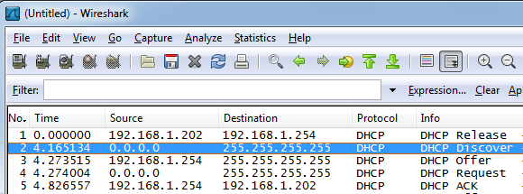
  - DHCP Request, DHCP ACK – These packets complete the DHCP process—your computer accepts the IP address

- If DHCP is not working on your network, you will just see a series of DHCP Discover packets. That's OK for this project—just keep going.

Examining a UDP Packet
- In the top pane of the Wireshark window, click a DHCP Discover packet.
- In the center pane of the Wireshark window, click the + symbol next to User Datagram Protocol to show the UDP header fields, as shown below on this page. If necessary, resize the center pane of the Wireshark window to make it taller.
- Find these items in the User Datagram Protocol section:
  - Source Port – UDP port 68 on your computer
  - Destination Port – UDP port 67 on the DHCP server
  - Length – size of the packet (may vary)
  - Checksum – used to correct errors. It may be flagged as incorrect--don't worry about that—it's a limitation of Wireshark. Some outgoing packets are captured by Wireshark before the NIC adds the checksum, so they appear incorrect even when they will actually be transmitted on the network correctly (see link Ch 4a).
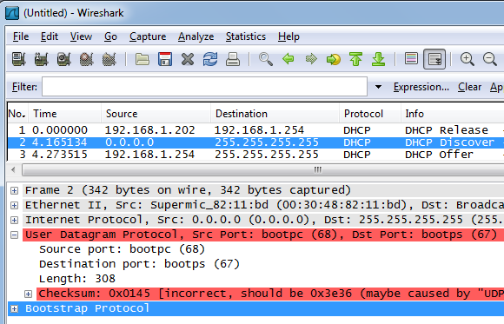

Saving a Screen Image
- Make sure the four features listed above are visible: Source Port, Destination Port, Length, and Checksum.
- Click Start, "All Programs", Accessories, Paint. In the untitled - Paint window, select Edit, Paste from the menu bar. The desktop appears in the Paint window.
- In the untitled - Paint window, click File, Save. Save the document in the My Pictures folder (or any other place you wish, such as a floppy disk) with the filename Your Name Proj 5. Select a Save as type of JPEG or PNG.

Starting a New Packet Capture
- From the Wireshark menu bar, click Capture, Interfaces. On the line showing the increasing number of packets, click Options.

- In the "Wireshark: Capture Options" box, type this into the "Capture Filter" box:
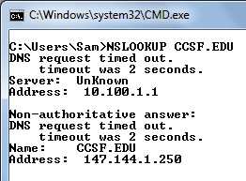
port 53
- Click Start. This filter will show only DNS traffic—packets used to convert domain names to IP Addresses.

Performing a DNS Lookup
- In the Command Prompt window, type the following command, and then press the Enter key:
NSLOOKUP CCSF.EDU
- The domain name is resolved to the IP address 147.144.1.250, as shown to the right on this page:

Examining the Wireshark Capture of the DNS Process
- From the Wireshark menu bar, click Capture, Stop.
- You should see several packets, including a Standard query A CCSF.EDU and a "Standard query response A", as shown below on this page. Examine the lower pane and see that DNS uses UDP, just like DHCP.
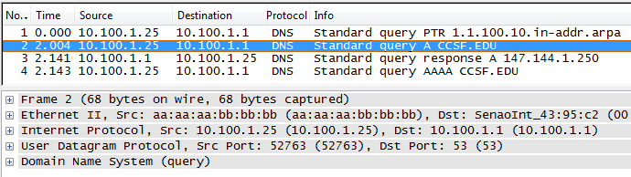

Turning in Your Project
- Email the JPEG image to me as an attachment to an e-mail message. Send it to: cnit.106sam@gmail.com with a subject line of Proj 5 From Your Name, replacing Your Name with your own first and last name. Send a Cc to yourself.

Last Modified: 2-25-10

