What You Need for This Project
- Two computers with Windows XP or Vista, but NOT Windows 7. The instructions below assume you are using Vista in the S214 lab.

Select Your Computers
- Find two computers. Boot them both Vista. Log in as Student with no password. If you can't log on, do project 2x to hack into the machine.
- Pick one computer to be Computer A. The other one will be Computer B.

Using Automatic Addressing—Do This on Computer A
- On Computer A, click the Start button. In the Search box, type NET
- In the menu, a "Network and Sharing Center" item appears. Click it.
- In the "Network and Sharing Center" box, click "Manage network connections".
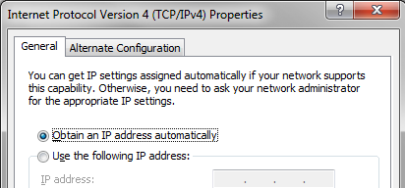
- In "Network Connections", right-click "Local Area Connection" and click Properties. If a “User Account Control” box pops up, approve the action.
- In "Local Area Connection Properties", double-click "Internet Protocol Version 4 (TCP/IPv4)".
- In the "Internet Protocol Version 4 (TCP/IPv4) Properties" box, verify that the "Obtain an IP address automatically" item is selected.
- Click OK twice.

Open a Command Prompt—Do This on Computer A
- On Computer A, click the Start button. In the Search box, type CMD
- Press Enter. A Command Prompt box opens.

Finding your IP Address—Do This on Computer A
- On Computer A, in the Command Prompt window, type the following command, and then press the Enter key:
IPCONFIG
- Find your IP Address settings, as shown below on this page, and write them in the box below on this page. There may be several adapters. In S214, use the one with an IP address starting with 192.168.1.
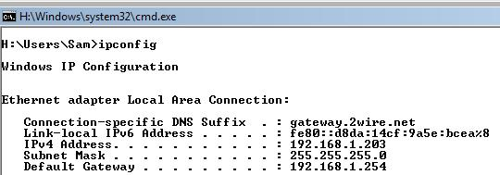

IPv4 Address: ____________________________________

Subnet Mask: ____________________________________

Default Gateway: ____________________________________

Using Manual Addressing—Do This on Computer A
- On Computer A, click the Start button. In the Search box, type NET
- In the menu, a "Network and Sharing Center" item appears. Click it.
- In the "Network and Sharing Center" box, click "Manage network connections".
- In "Network Connections", right-click "Local Area Connection" and click Properties. If a “User Account Control” box pops up, approve the action.
- In "Local Area Connection Properties", double-click "Internet Protocol Version 4 (TCP/IPv4)".

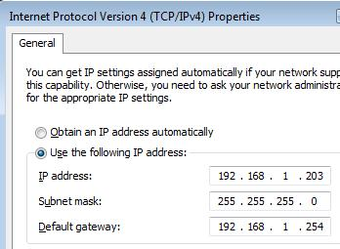
- In the "Internet Protocol Version 4 (TCP/IPv4) Properties" box, click the "Use the following IP address" button. Fill in the three values you wrote in the box on the previous page of these instructions.
- Click OK twice.

Disabling the Network Adapter—Do This on Computer A
- On Computer A, in "Network Connections", right-click "Local Area Connection" and click Disable. If a “User Account Control” box pops up, approve the action.

Using Manual Addressing—Do This on Computer B
- On Computer B, click the Start button. In the Search box, type NET
- In the menu, a "Network and Sharing Center" item appears. Click it.
- In the "Network and Sharing Center" box, click "Manage network connections".
- In "Network Connections", right-click "Local Area Connection" and click Properties. If a “User Account Control” box pops up, approve the action.
- In "Local Area Connection Properties", double-click "Internet Protocol Version 4 (TCP/IPv4)".
- In the "Internet Protocol Version 4 (TCP/IPv4) Properties" box, click the "Use the following IP address" button. Fill in the three values you wrote in the box on the previous page of these instructions.
- Click OK twice.

Enabling the Network Adapter—Do This on Computer A
- On Computer A, in "Network Connections", right-click "Local Area Connection" and click Enable. If a “User Account Control” box pops up, approve the action.
- An error box should pop up, as shown below on this page. If it does not, see the Troubleshooting steps on the next page.
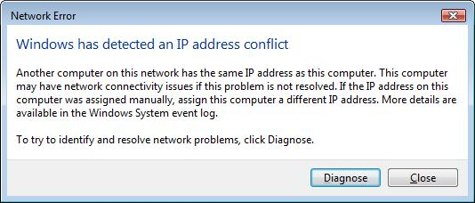

Troubleshooting
- If the “IP Address Conflict” message does not appear, disconnect both computers from the room's LAN and connect them to the numbered ports in a router from the closet with two patch cables. The message should pop up immediately.

Saving a Screen Image
- Make sure “IP Address Conflict” message is visible.
- Press the Print Scrn key.
- Click Start, "All Programs", Accessories, Paint. In the untitled - Paint window, select Edit, Paste from the menu bar. The desktop appears in the Paint window.
- In the untitled - Paint window, click File, Save. Save the document in the My Pictures folder (or any other place you wish, such as a floppy disk) with the filename Your Name Proj 6. Select a Save as type of JPEG or PNG.

Using Automatic Addressing—Do This on Computer A
- On Computer A, in "Network Connections", right-click "Local Area Connection" and click Properties. If a “User Account Control” box pops up, approve the action.
- In "Local Area Connection Properties", double-click "Internet Protocol Version 4 (TCP/IPv4)".
- In the "Internet Protocol Version 4 (TCP/IPv4) Properties" box, click the "Obtain an IP address automatically" button. Also click the “Obtain DNS server address automatically” button. Click OK twice.

Using Automatic Addressing—Do This on Computer B
- On Computer B, in "Network Connections", right-click "Local Area Connection" and click Properties. If a “User Account Control” box pops up, approve the action.
- In "Local Area Connection Properties", double-click "Internet Protocol Version 4 (TCP/IPv4)".
- In the "Internet Protocol Version 4 (TCP/IPv4) Properties" box, click the "Obtain an IP address automatically" button. Also click the “Obtain DNS server address automatically” button. Click OK twice.

Turning in Your Project
- Email the JPEG image to me as an attachment to an e-mail message. Send it to: cnit.106sam@gmail.com with a subject line of Proj 6 From Your Name, replacing Your Name with your own first and last name. Send a Cc to yourself.
Last Modified: 10-4-09

