What You Will Need
- Two computers running any version of Windows, both connected to the Internet, or to a LAN. They may be real or virtual machines. The instructions below assume you are using Windows 7 in S214.
Selecting Two Machines
- Choose one machone to be the Server. The other one is the Client.
Downloading Team Viewer--Do This on Both Machines
- On the Server machine, open a browser and go to teamviewer.com
- Click the "Download Now" button. Save the TeamViewer_Setup.exe file to your desktop. Double-click the installer and install the software with the default options. On the Environment page, select "personal / non-commercial use".
- Repeat the installation on the Client machine.
Waiting for a Session--Do This on the Server
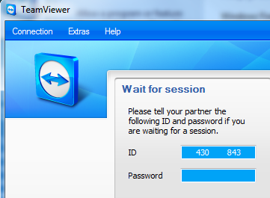
- On the Server machine, TeamViewer should have started automatically after the installation completed. If it did not, click Start, type in TEAM, and click TeamViewer 4. If a "Windows Firewall" box opens warning you that the firewall has blocked a connection, click "Allow Access".
- You should see a TeamViewer box with an ID and Password, as shown to the right on this page. Note that I have erased the password and part of the ID in this example.

Creating a Session--Do This on the Client
- On the Client machine, TeamViewer should have started automatically after the installation completed. If it did not, click Start, type in TEAM, and click TeamViewer 4. If a "Windows Firewall" box opens warning you that the firewall has blocked a connection, click "Allow Access".
- In the "Create session" section of the TeamViewer box, type in the ID shown on the Server's screen. Click the "Connect to partner" button.
- When a box pops up asking for a password, type in the Password shown on the Server's screen. Click the "Log in" button.
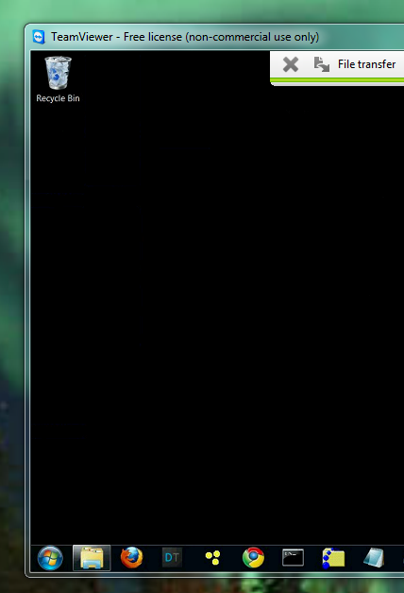
- On the Client, you should see a "TeamViewer" window with the Server's desktop inside it, as shown to the right on this page.

Capturing the Screen Image
- Make sure that the Server's desktop is visible inside the "Remote Desktop Connection" window.
- Press the PrntScn key to copy whole screen to the clipboard. If an Information box opens in the TeamViewer window, click OK. Open Paint and paste in the image. Save it as a JPEG, with the filename Your Name Proj 10.
Testing TeamViewer
- Use the Server from the Client a bit. Open a Web page, try moving and resizing windows, etc. See how it feels--the graphics are more primitive and the response is slower, but it should be usable.
Turning in your Project
- Send the image as an email attachment cnit.106sam@gmail.com with a subject line of Proj 10 From Your Name. Send a Cc to yourself.

Last modified 10-12-09

