Getting the Ubuntu Linux 9.10 ISO File
- You can download the Ubuntu-9.10 ISO file directly from ubuntu.com. It's faster and friendlier to use the torrent download, but direct download links are available also. You can also copy the ISO file from the VMs\Install folder in the S214 lab.

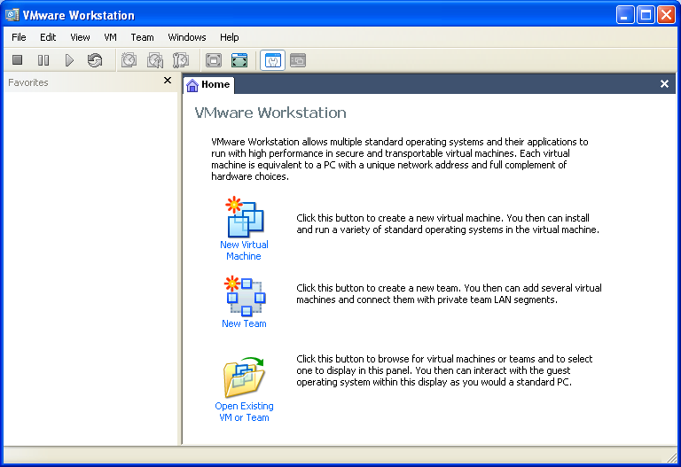
Using VMWare Workstation to Create a New Virtual Machine
- If you are working at home, install your free copy of VMware Workstation before starting this project.
- Double-click the VMWare Workstation icon on the desktop.
- A VMWare Workstation window opens as shown to the right on this page. From the menu bar, click View, "Go to Home Tab". Click the New Virtual Machine icon.
- A "Welcome to the New Virtual Machine Wizard" screen appears. Select "Typical (recommended)" and click Next.
- In the "Guest Operating System Installation" screen, click the "Installer disc image file (iso)" button. Click the Browse button and navigate to the VMs drive. Double-click the ubuntu-9.10-rc-desktop-i386.iso file and click Next.
- At the Name the Virtual Machine screen, enter a Virtual machine name of Your Name Ubuntu. Click the Browse button to choose the drive and folder to save the VM in. Navigate to VMs:\YOURNAME_VMs. Create a new subfolder named Ubuntu and click it to select it. DO NOT SAVE VIRTUAL MACHINES IN THE MY DOCUMENTS FOLDER OR ELSEWHERE ON THE C: DRIVE! Click Next.
- At the Specify Disk Capacity screen, accept the default size of 8 GB. Click the "Split virtual disk into 2 GB files" button. Click Next.
- At the Ready to Create Virtual Machine screen, click Finish.

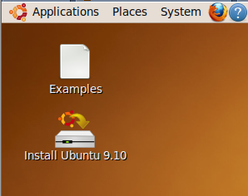
Installing Linux
- The virtual machine should boot from the CD. After 30 seconds or so, you should see a brown desktop with an Install Ubuntu 9.10 icon on it, as shown to the right on this page.
- At this point, Ubuntu is running from the virtual CD. This “Live CD” mode is intended to let people try Linux on a Windows machine without changing the hard disk. The problem with it is that you cannot install software, save files, or customize it. Besides, we are using VMware, which protects the Windows host system anyway—we don’t need the Live CD feature. So we will install Ubuntu onto the virtual hard disk.

Installing Ubuntu Linux on the Virtual Hard Disk
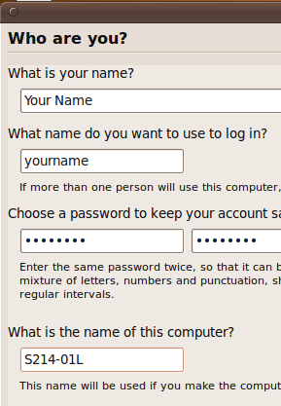
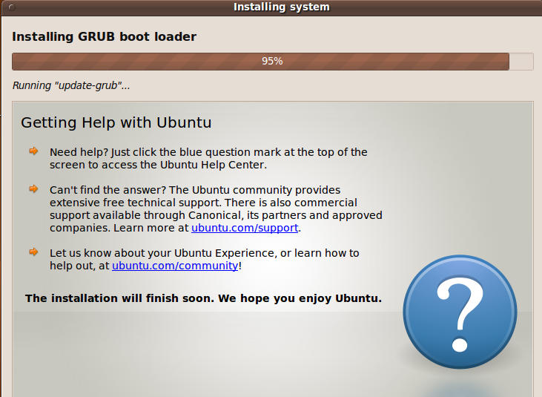
- Double-click the Install icon.
- In the first Linux install screen, labeled "Step 1 of 6" in the lower left corner, accept the default selection of English and click the Forward button.
- In "Step 2 of 6", click on the map to select Los Angeles for a time zone, and click the Forward button.
- In "Step 3 of 6", accept the default keyboard layout selection of "USA" and click the Forward button.
- Step 4 of 6 is preparing the disk space. Accept the default selection of "Erase and use the entire disk" and click the Forward button.
- Step 5 of 6 is the Who are you? Screen. Type in your name and a logon name of your choice. Enter a password you can remember – I recommend P@ssw0rd. Name your computer after the station number on the front panel, adding an L (for Linux) to the end, as shown to the right on this page. Scroll down to see one of the new features in Ubuntu 9.0-4--there is an option to encrypt your home folder. Don't do that--just click the Forward button.
- Step 6 of 6 is the "Ready to install" screen. Click the Install button.
- Wait while Linux installs – it will take about 15 minutes. When you see an Installation Complete box, click Restart now.
- A VMware Workstation box pops up, asking whether it should "Disconnect anyway (and override the lock)?". Click Yes.
- At the bottom of your VMware window, click the "I Finished Installing" button.
- The virtual machine stops with text on the screen, saying "BUG: soft lockup". From the VMware menu bar, click VM, Power, Reset. In the box that pops up, click OK.

Starting the Installed Virtual Machine
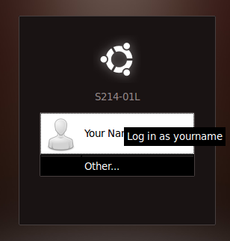
- When Ubuntu boots up, you will see the login screen shown to the right on this page. Click your name. Then type in your password and press the Enter key.
- If an "Incomplete Language Support" box appears, click Close.

Choosing a Background
- Right-click the desktop and click "Choose Background". Try a few of the images and pick one you like.

Increasing the Screen Resolution
- From the menu bar, click System. Preferences, Display. In the Resolution drop-down list box, select 1024 x 768 (4:3). Click Apply. Click "Keep This Configuration". Click Close.

Using Software Center
- From the menu bar, click Applications, "Ubuntu Software Center".
- In the Ubuntu Software Center box, click Internet.
- Scroll to the bottom and click Zenmap, as shown below on this page.

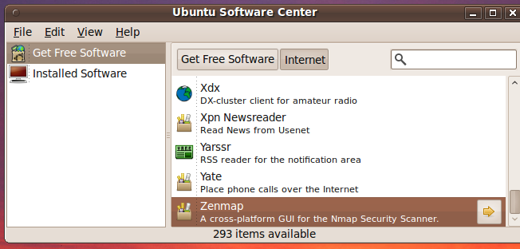
- To the right of the word Zenmap, click the yellow right-arrow. If you can install it, do that. I just got a message saying "Not available in the current data", which I suppose means the Ubuntu repositories are overloaded and unavailable, which is to be expected in the first few days of a new version.

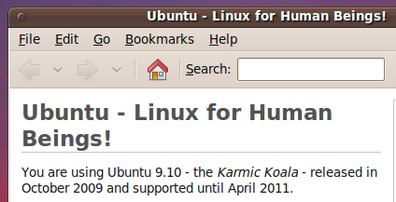
Showing the Version
- From the menu bar, click System, "About Ubuntu". A box appears saying that you are using Ubuntu 9.10, as shown to the right on this page.

Saving the Screen Image
- Click on the host Windows desktop taskbar. Press the PrntScn key to copy whole screen to the clipboard.
- On the host Windows machine, open Paint and paste in the image. Save it as a PNG or JPEG, with the filename Your Name Proj 13.

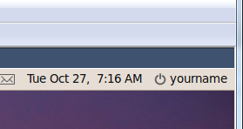
Shutting Down the Ubuntu Machine
- At the upper right of the Ubuntu desktop, click your name, as shown to the right on this page. Click the "Shut Down…".
Turning in your Project
- Email the JPEG image to me as an attachment. Send the message to cnit.106sam@gmail.com with a subject line of Proj 13 From Your Name. Send a Cc to yourself.
Last modified 10-27-09

