Linux Commands
General System Information

date shows the current date and time

cal shows a calendar of the current month
cal 2003 shows a calendar of the year 2003
cal 12 2003 shows a calendar of December 2003
cal 2003 | more shows a calendar of 2003 pausing between pages. Press the spacebar to see the next page.
cal 2003 > calfile sends the calendar of 2003 to a file named calfile. If calfile does not exist, it is created. If calfile exists, it is emptied and then the calendar is placed into it. The > symbol is called the output redirection operator.
cal 2004 >> calfile appends a calendar of 2004 to a file named calfile. If calfile does not exist, it is created. If calfile exists, its contents are preserved and a calendar of 2004 is added to its end. The >> symbol is called the append operator.

who shows information about the current users of the UNIX system
who | more pipelines the list to more so it pauses between pages

finger username displays information about users

Exit, Abort, and Echo

exit logs out of UNIX and terminates the connection

CTRL + C aborts a command and returns you to the prompt

echo "text" writes text to the standard output
echo "foo" > echofile makes a file named echofile and puts the characters foo in the file

File Management Commands
ls lists the files and directories in the working directory.

more filename shows the contents of the file filename one screen at a time. Press the spacebar to move to the next page, or press b to move back to the previous page.

cat filename shows the contents of the file filename on the screen without pausing between pages like more. cat stands for concatenate and it can be used to combine two or more files together.

rm filename removes (deletes) the file filename

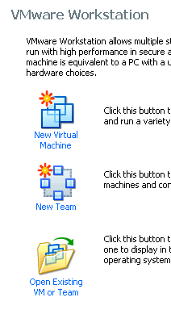
Launching your Ubuntu Linux Virtual Machine
- You should have made an Ubuntu Linux virtual machine in the previous project. If you haven't, go do that project first.
- Double-click the VMWare Workstation icon on the desktop.
- A VMWare Workstation window opens as shown to the right on this page. From the menu bar, click View, "Go to Home Tab". Click the "Open Existing VM or Team" icon.
- In the Open box, navigate to VMs:\YOURNAME_VMs. Double-click the folder named Ubuntu. Double-click the "Ubuntu Linux.vmx" file.
- Click "Start this virtual machine".
- Log in with the account you created in the previous project. Your password should be P@ssw0rd
Using Terminal Commands
- From the Ubuntu menu bar, click Applications, Accessories, Terminal.
- Enter the following command to create a file named foo with the current date and time in it.
date > foo
- Then enter the command cat foo to observe the contents of the foo file. An example of the file you are trying to create is on the next page.
- Use the echo command again to add your name to the file named foo
echo “Your Name” >> foo replace Your Name with your own name
Then enter the command cat foo to observe the contents of the foo file.
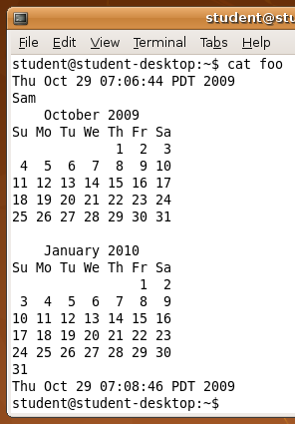
- Enter the following command to add a calendar of December 2003 to the foo file.
cal 10 2009 >> foo
Then enter the command cat foo to observe the contents of the foo file.
- Use the cal command again to add a calendar of January 20102010 to the file named foo, and then enter the command cat foo to observe the contents of the foo file.
- Use the date command again to add the date and time you finished the assignment to the end of the file named foo. Be careful: you need to use the append operator >>, not the output redirection operator >. If you use output redirection as you did in step 2, you will erase your file and need to start over.
- Then enter the command cat foo to observe the contents of the foo file. It should look like the example to the right on this page.
Saving the Screen Image
- Click on the host Windows desktop taskbar. Press the PrntScn key to copy whole screen to the clipboard.
- On the host Windows machine, open Paint and paste in the image. Save it as a PNG or JPEG, with the filename Your Name Proj 14.

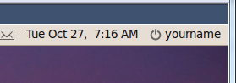
Shutting Down the Ubuntu Machine
- At the upper right of the Ubuntu desktop, click your name, as shown to the right on this page. Click the "Shut Down…".
Turning in your Project
- Email the JPEG image to me as an attachment. Send the message to cnit.106sam@gmail.com with a subject line of Proj 14 From Your Name. Send a Cc to yourself.
Last modified 10-29-09

