Requirements: You need a Windows machine connected to the Internet. I assume you are using Windows 7 in S214 in the instructions, but any other version should be fine too.
Start your Computer in Windows 7
- Boot your machine to Windows 7 (any version). Log in with any account that has Administrative privileges, such as the Student account.
Using NETSTAT
- If there are any Web browsers open on your computer, close them.
- Click Start. Type in CMD and press the Enter key.
- In the Command Prompt window, type this command, and then press the Enter key:
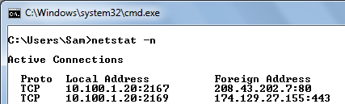
netstat -n
- You may see some connections, as shown to the right on this page. If there are no connections at this point, that's fine too.
- In the Command Prompt window, press the Up-Arrow key on the keyboard so the netstat –n command appears again. Don't press the Enter key yet.
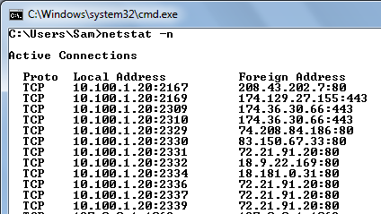
Loading a Web Page
- Open Firefox and go to samsclass.info
- Press Shift+Ctrl+R to reload the page.
- In the Command Prompt window, press Enter.
- In the netstat output, you should see connections to these Foreign Addresses, as shown to the right on this page:
  - 74.208.84.186:80 samsclass.info
  - 72.21.91.20:80 cdn.widgetsetver.com
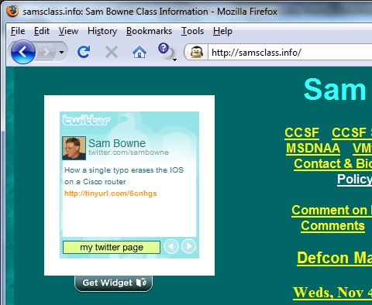
- These two connections load different portions of the page, as noted above. In particular, note that the Twitter widget at the top left corner of the page loads from cdn.widgetserver.com.
Creating a Restore Point
- You will be changing hosts file, which is somewhat dangerous. To make sure you can restore your machine to its original condition at the end of the project, you should make a Restore point.
- Click Start, and type RESTORE into the Search box.
- Click "Create a Restore Point".
- In the "System Properties" box, click "Create".
- In the "Create a restore point" box, enter a name of "Your Name - Before ad-blocking" and click the Create button. Wait while the restore point is created.
- A box appears saying "The restore point was created successfully". Click Close.
- Close "System Properties".
Blocking the Widget with the Hosts file
- Click Start. Type in NOTEPAD and press Shift+Ctrl+Enter key. In the User Account Control box, click Yes.
- In the Notepad window, click File, Open. Navigate to the C:\Windows\System32\Drivers \etc and open it.
- In the lower right portion of the Open box, set the file type to "All files (*.*)", as shown below on this page.
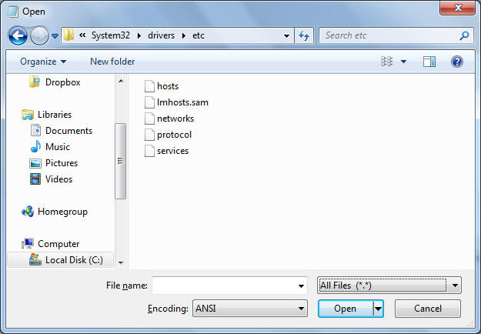

- Double-click the hosts file.
- Add this line to the end of the hosts file, as shown below on this page:
      - cdn.widgetserver.com
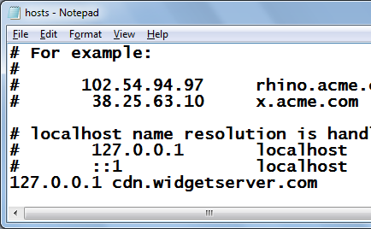
- Press Ctrl+S to save the file.
- Close Notepad.
- This entry will redirect cdn.widgetserver.com to the localhost, which is not a Web server, and won't provide the Widget. As far as your machine is concerned, that Web site has vanished.
Clearing the DNS Cache
- Click Start. Type in CMD and then press Shift+Ctrl+Enter. In the User Account Control box, click Yes.
- In the Administrator Command Prompt window, type this command, and then press the Enter key:
ipconfig /flushdns
Reloading the Web Page
- You should have a Firefox window open, showing samsclass.info
- In the Firefox window, press Shift+Ctrl+R to reload the page.
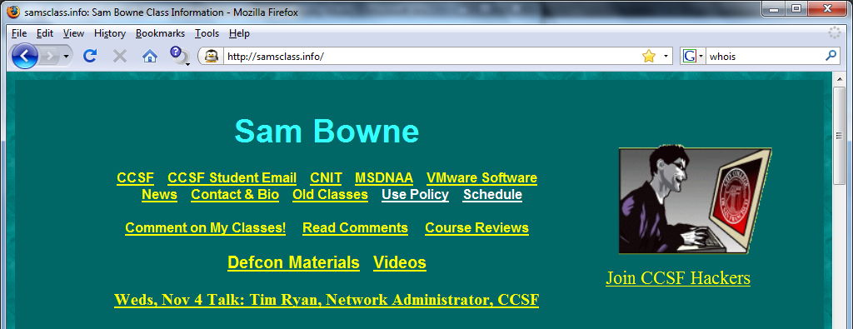
- The Widget shoulld be gone, as shown to the right on this page.

Saving the Screen Image
- Make sure the samsclass.info page is open with the Twitter widget gone.
- Press the PrntScn key to copy whole screen to the clipboard.
- Open Paint and paste in the image. Save it as a PNG or JPEG, with the filename Your Name Proj 15a.
Using System Restore to Undo Registry Changes
- Press the Windows logo key, next to the Ctrl key at the lower left of your keyboard. Don't touch the mouse. Type this into the Search box:
rest
- "System Restore" should appear in the Programs list. If it's not already highlighted, press the down-arrow as needed to highlight it. Then press the Enter key.
- In the "Restore system files and settings" box, click Next.
- In the "Restore system files and settings" box, make sure that the restore point with your name on it is highlighted.
Completing the System Restore
- Close all other windows. The System Restore will reboot your system rudely, and could cause you to lose data if you are editing documents.
- In the "System Restore" box, click Next.
- In the "Confirm your restore point" box, click Finish.
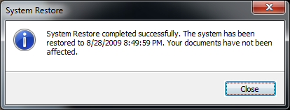
- Another box pops up, saying "System Restore cannot be interrupted". Click Yes.
- The restore completes, and your machine restarts. Log in as before. You should see a message saying "System Restore completed successfully", as shown to the right on this page.
Saving a Screen Image
- Make sure the "System Restore completed successfully" line is visible.
- Press PrintScrn to copy the whole desktop to the clipboard.
- Open Paint and paste in the image. Save it as a PNG or JPEG, with the filename Your Name Proj 15b.
Turning in your Project
- Email the images to me as attachments to one e-mail message. Send the message to: cnit.106sam@gmail.com with a subject line of Proj 15 From Your Name, replacing Your Name with your own first and last name. Send a Cc to yourself.

Last modified 11-3-09 4 pm

