Requirements: You need a Windows machine (any version) connected to the Internet. I assume you are using Windows 7 in S214 in the instructions, but any other version should be fine too. This project should be harmless.
Start your Computer in Windows 7
- Boot your machine to Windows 7 (any version). Log in with any account that has Administrative privileges, such as the Student account.
Downloading Password Safe
- Open a Web browser and go to passwordsafe.sourceforge.net
- At the top center of the screen, click the "[click here for latest version]" link.
- Save the pwsafe-3.19.exe file on your desktop.
Installing Password Safe
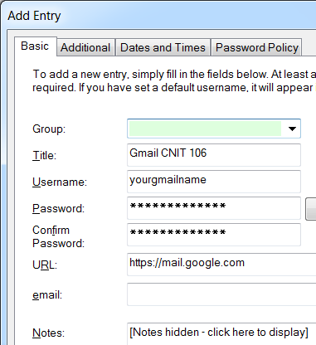
- On your desktop, double-click the pwsafe-3.19.exe file. Install the software with the default options.
- Click Start, "Password Safe".
- In the "Safe Combination Entry" box, click the "New Database" button.
- In the "Please choose a name for the new database" box, enter your name. Click Save.
- In the "Safe Combination Setup" box, type a passphrase you can remember in both boxes. It should be long and complex, like a whole sentence. Click OK.
Creating a New Password Entry
- In the "Password Safe" box, click Edit, "Add Entry…".
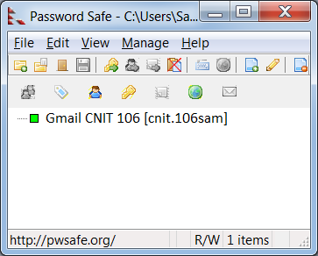
- In the "Add Entry" box, enter a Title of "Gmail CNIT 106", as shown to the right on this page. Put your Gmail user name and password in the appriate boxes. In the URL box, put https://mail.google.com and then click OK.
- In the "Set Default Username" box, click No.
- You should now see an entry in the Password Safe box, as shown to the right on this page. Your account name will be different.
Using Autotype
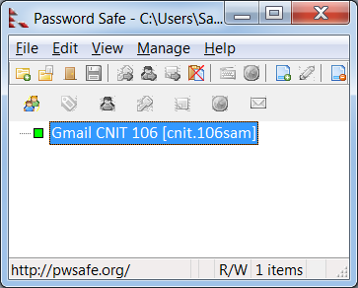
- Password Safe has an AutoType feature that makes it very handy to use.
- Open a Web browser and go to https://mail.google.com
- In the Gmail logon page, click in the Username field, so the blinking insertion point appears there.
- In the "Password Safe" box, and click on your Gmail entry to highlight it, as shown to the right on this page.
- Press Ctrl+T. Your name and password are automatically sent to the Gmail window, and it logs in to your email.
Saving the Screen Image
- Make sure the "Password Safe" box is open, showing at least one entry.
- Press the PrntScn key to copy whole screen to the clipboard.
- Open Paint and paste in the image. Save it as a PNG or JPEG, with the filename Your Name Proj 16.
Turning in your Project
- Email the images to me as attachments to one e-mail message. Send the message to: cnit.106sam@gmail.com with a subject line of Proj 16 From Your Name, replacing Your Name with your own first and last name. Send a Cc to yourself.

Last modified 11-11-09 11 am

