What You Need for This Project
- Three Windows machines on a LAN. They can be real or virtual machines. Select one machine to the PBX Server. The other machines will be VoIP Clients. The instructions below assume you are using three Windows 7 computers in S214, with several students working together.
- A headset with a microphone would be nice, but not strictly necessary (I have some you can borrow)
Downloading the PBX Server (Do this on your PBX Server computer)
- Open a Web browser and go to 3cx.com
- At the top right, click DOWNLOAD. In the center of the next page, click "FREE edition".
- On the next page, fill out the form and click the "Submit & download" button.
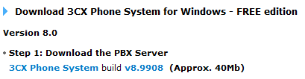
- On the next page, in the "Step 1: Download the Server" section, click the "3CX Phone System" link, as shown to the right on this page. Save the 3CXPhoneSystem8.exe file on your desktop.
- Don't bother with "Step 2: Download the 3CX VOIP client". We'll use a different client.
Installing the PBX Server (Do this on your PBX Server computer)
- On your desktop, double-click the 3CXPhoneSystem8.exe file.
- If a "Windows Security Alert" box pops up, saying Windows Firewall has blocked some features of this program", click "Allow access"
- Click through the installer, accepting the default options.
Configuring the PBX Server (Do this on your PBX Server computer)
- A box appears, titled "Welcome to the 3CX User Settings Wizard". Accept the default language of English and click Next.
- Accept the default Setup option of "Create New PBX" and click Next.
- In the "Extension Digits" section, accept the default option of "3 digits" and click Next.
- In the "SIP Domain" section, enter a domain of sip.mydomain.com and click Next. This fake value is OK because it will not be used in this project.
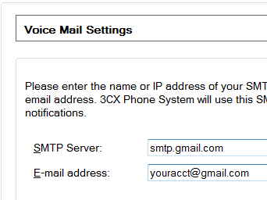
- In the "Voice Mail Settings" page, use an "SMTP Server" of smtp.gmail.com and put youracct@gmail.com in the "E-mail address" field, as shown to the right on this page. This fake value is OK because it will not be used in this project. Click Next.
- In the "Administrator Logon" page, type a password of P@ssw0rd in both boxes and click Next.

- In the "Extensions" section, click the Add button.
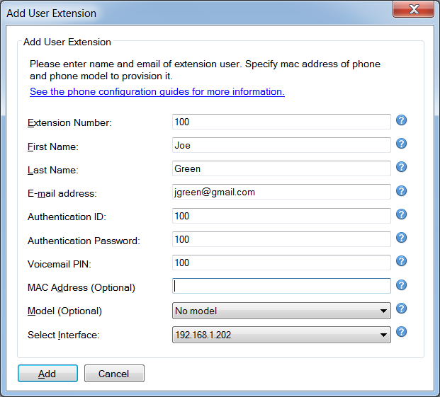
- In the "Add User Extension" box, put anything into the empty boxes just so they look good, as shown to the right on this page. Leave all the values of 100 unchanged. Make sure the "Select Interface" value is the IP address that really goes to the other computers in your LAN. In S214, it must start with 192.168.1. Click the Add button.
- In the "Extensions" section, click the Add button again.
- In the "Add User Extension" box, put anything into the empty boxes just so they look good. Leave all the values of 101 unchanged. Make sure the "Select Interface" value is the IP address that really goes to the other computers in your LAN. In S214, it must start with 192.168.1. Write the IP address in the box to the right on this page. Click the Add button.

PBX IP: ______________________________
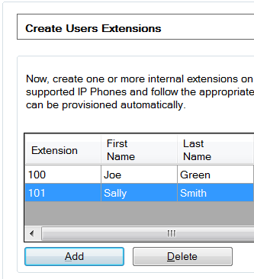
- You should now have two extensions made, extensions 100 and 101, as shown to the right on this page. Click Next.
- In the "Operator Extensions" section, click Next.
- In the "VoIP Gateway" section, click Skip>>. Wait while the configuration database is created.

Turning the Firewall Off on your PBX Server
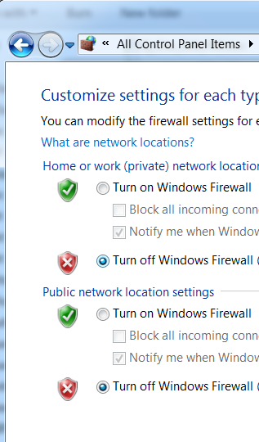
- On your PBX Server computer, click Start. Type in Fire. Click "Windows Firewall".
- In the "Windows Firewall" box, on the left side, click "Turn Windows Firewall on or off".
- In the "Customize Settings" box, click both of the "Turn off Windows Firewall (not recommended)" boxes, as shown to the right on this page.

Installing the X-Lite VoIP Client (do this on both client computers)
- Open a Web browser and go to counterpath.com

- On the lower right of this page, find the X-Lite section as shown below on this page, and click the arrow.

- On the next page, scroll to the bottom, and click the "Download X-Lite 3.0 for Windows" link.
- Save the installer file and install the software with the default options.
- X-Lite launches. When a "Call Quality Information" box appears, click No.
- In the "SIP Accounts" box, click the Add… button.

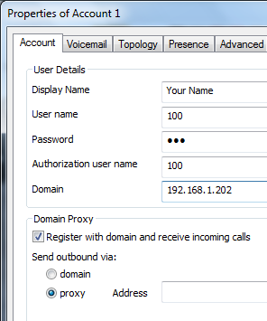
- In the "Properties of Account1" box, enter these values, as shown to the right on this page:
  - Display name: Your name
  - User Name: 100 for the first client, and 101 for the second client
  - Password: 100 for the first client, and 101 for the second client
  - Authorization user name: 100 for the first client, and 101 for the second client
  - Domain: The PBX IP you wrote on a previous page of these instructions
- In the "Properties of Account1" box, click the OK button.
- In the "SIP Accounts" box, click the Close button.
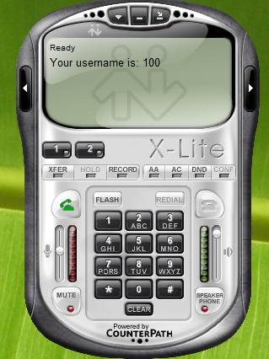
- The X-Lite client launches, as shown to the right on this page. If you see a "Firewall" alert telling you that some features of the program have been blocked, click "Unblock".
- You should see a message in the top portion of the X-Lite panel saying "Ready Your Username is 100" (or some other extension number). If you see an error message, some part of the configuration is wrong—try these troubleshooting ideas:
Troubleshooting
Turn off all firewalls
PING from one computer to another
Use nmap from the client machines and do a port scan—you should find port 5060 open on the PBX server.

Capturing a Screen Image
- Make sure the X-Lite panel is visible, showing "Ready Your Username is 100" (or some other extension number).
- Press the PrintScrn key in the upper-right portion of the keyboard.
- On the host Windows system, Click Start, Programs, Accessories, Paint. In the untitled - Paint window, select Edit, Paste from the menu bar.
- In the untitled - Paint window, click File, Save. Select a Save as type of JPEG. Save the document with the filename Your Name Proj 2xa.
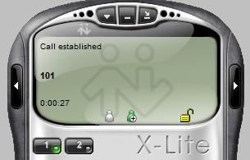
Calling from One Client to Another
- On a client, click the green "Dial" button, on the left side (it looks like a telephone handset being lifted up). Dial the extension number of another client, such as 101, and press the Enter key on the keyboard.
- The other client should show a status of "Incoming Call". On that client, click the green "Dial" button. You should see a status of "Call established", as shown to the right on this page.
- Click the red "Hang Up" button.

Turning in Your Project
- Email the JPEG image to me as an e-mail attachment. Send it to: cnit.106sam@gmail.com with a subject line of Proj 2x From Your Name, replacing Your Name with your own first and last name. Send a Cc to yourself.

Sources

Last Modified: 11-18-09

