What You Need for This Project
- Two computers with Windows 7 (Vista did not detect the address conflict when students tried it). The instructions below assume you are using Windows 7 in the S214 lab.

Select Your Computers
- Find two computers. Boot them both Windows 7. Log in as Student with no password. If you can't log on, do project 2x to hack into the machine.
- Pick one computer to be Computer A. The other one will be Computer B.

Finding your IPv6 Address—Do This on Computer A
- On Computer A, in the Command Prompt window, type the following command, and then press the Enter key:
IPCONFIG
- Find your IPv6 Address , as shown below on this page, and write it in the box below on this page. The IPv6 address should be labeled "Link-Local IPv6 Address" and should start with fe80::. There may be several adapters. In S214, use the one with an IPv4 address starting with 192.168.1.
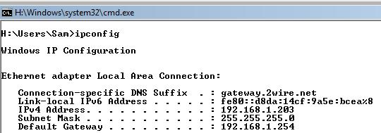

IPv6 Address: ____________________________________

Manual Addressing—Do This on Computer B
- On Computer B, click the Start button. In the Search box, type NET
- In the menu, a "Network and Sharing Center" item appears. Click it.
- In the "Network and Sharing Center" box, click "Manage network connections".
- In "Network Connections", right-click "Local Area Connection" and click Properties. If a “User Account Control” box pops up, approve the action.
- In "Local Area Connection Properties", double-click "Internet Protocol Version 6 (TCP/IPv6)".

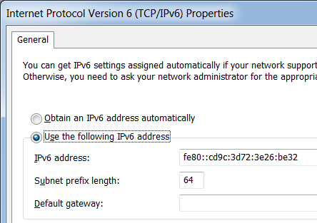
- In the "Internet Protocol Version 6 (TCP/IPv6) Properties" box, click the "Use the following IPv6 address" button. Fill in the IPv6 address you wrote in the box on the previous page of these instructions. Enter a "Subnet prefix length" of 64.
- Click OK twice.

IP Address Conflict Message
- On Computer A, in "Network Connections", right-click "Local Area Connection" and click Enable. If a “User Account Control” box pops up, approve the action.
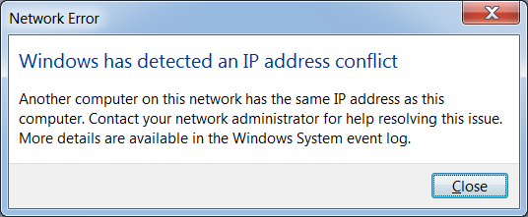
- An error box should pop up, as shown to the right on this page.

Saving a Screen Image
- Make sure the “IP Address Conflict” message is visible.
- Press the Print Scrn key.
- Click Start, "All Programs", Accessories, Paint. In the untitled - Paint window, select Edit, Paste from the menu bar. The desktop appears in the Paint window.
- In the untitled - Paint window, click File, Save. Save the document in the My Pictures folder (or any other place you wish, such as a floppy disk) with the filename Your Name Proj 3x. Select a Save as type of JPEG or PNG.

Using Automatic Addressing—Do This on Computer B
- On Computer B, in "Network Connections", right-click "Local Area Connection" and click Properties. If a “User Account Control” box pops up, approve the action.
- In "Local Area Connection Properties", double-click "Internet Protocol Version 6 (TCP/IPv6)".
- In the "Internet Protocol Version 6 (TCP/IPv6) Properties" box, click the "Obtain an IP address automatically" button. Also click the “Obtain DNS server address automatically” button. Click OK twice.

Turning in Your Project
- Email the JPEG image to me as an attachment to an e-mail message. Send it to: cnit.106sam@gmail.com with a subject line of Proj 3x From Your Name, replacing Your Name with your own first and last name. Send a Cc to yourself.
Last Modified: 10-4-09

