Purpose: WOT (Web of Trust) is a Firefox extension that warns you about sites that are known to be dangerous. Sites have a reputation, assigned by other WOT users. This protects you from scams, phishing sites, sites hosting malware, pornography, and other Internet nasties.
Requirements: You need a Windows or MAC computer (any version) connected to the Internet. I assume you are using Windows 7 in S214 in the instructions, but any other version should be fine too. This project should be harmless.
Start your Computer in Windows 7
- Boot your machine to Windows 7 (any version). Log in with any account that has Administrative privileges, such as the Student account.
Installing WOT
- Open Firefox. If you don't have Firefox, use Internet Explorer (or Safari), go to getfirefox.com, and download it.
- From the Firefox menu bar, click Tools, Add-ons. If WOT is already installed, remove it and restart Firefox.
- In the Add-ons box, in the search field, type WOT as shown below on this page. Press the Enter key.
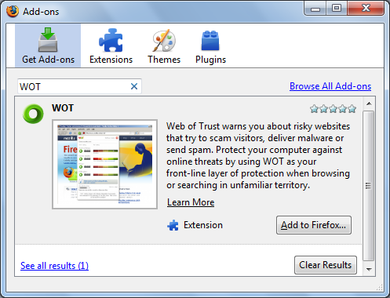

- In the Add-ons box, click the "Add to Firefox…" button.
- In the "Software Installation" box, click the "Install Now" button.
- In the Add-ons box, click the "Restart Firefox" button.
Identifying Risky Websites
- In Firefox, go to google.com
- In the Google page, search for WAREZ
- "Warez" are illegal, modified versions of copyrighted software products. As you might expect, many warez sites are harmful to visit. WOT has flagged many of the search results with little round icons, as shown belown on this page. The red icons indicate dangerous sites, and the green ones indicate safe sites. Hover over an icon to see its detailed rating.
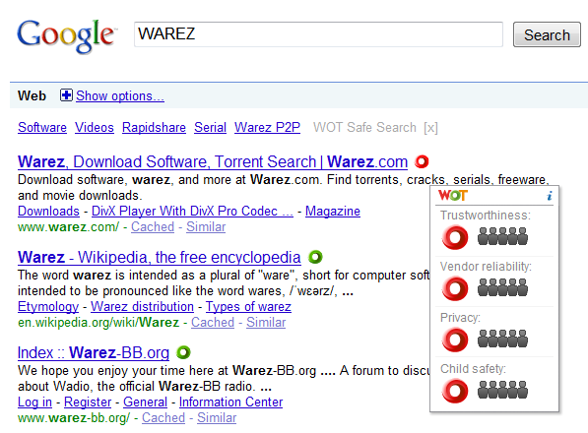

Saving the Screen Image
- Make sure at least one WOT rating icon is visible.
- Press the PrntScn key to copy whole screen to the clipboard.
- Open Paint and paste in the image. Save it as a PNG or JPEG, with the filename Your Name Proj 3x.
Turning in your Project
- Email the image to me as an email attachment. Send the message to: cnit.106sam@gmail.com with a subject line of Proj 3x From Your Name, replacing Your Name with your own first and last name. Send a Cc to yourself.

Last modified 12-1-09 8 am

