What You Need for This Project
- A computers with Windows XP, Vista, or Windows 7. The instructions below assume you are using Windows 7 in the S214 lab.

Removing Other Antivirus Software
- If you have some other Antivirus, like McAfee or Norton, you have to remove it first. If you don't want to do that on your home machine, use a machine in S214.

Downloading Microsoft Security Essentials
- Open Internet Explorer (Firefox does not work) and go to microsoft.com/Security_essentials
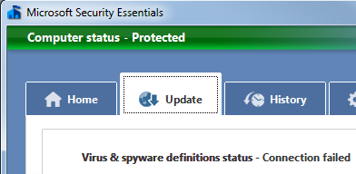
- Click "Download Now".
- Run the installer and accept the default options. It will automatically update. When I did it, the update failed, but it still changed the title bar to green and my Computer Status to "Protected", as shown to the right on this page.

Downloading the EICAR Test Virus
- Open a Web browser and go to eicar.com
- On the upper right, click "Anti-Malware Testfile".
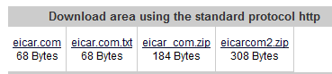
- Scan the explanation on the next page so you understand what this file is--it is harmless, but it is detected by anti-malware products as a virus.
- Scroll to the bottom of the page and click the eicar.com link, as shown to the right on this page.

Detecting the EICAR Test Virus
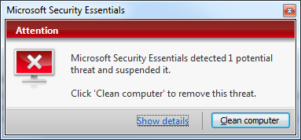
- A red Attention box should pop up, as shown to the right on this page. In that box, click "Show Details".

- You should see a box identifying the threat as Virus:DOS/EICAR_Test_File, as shown below on this page.

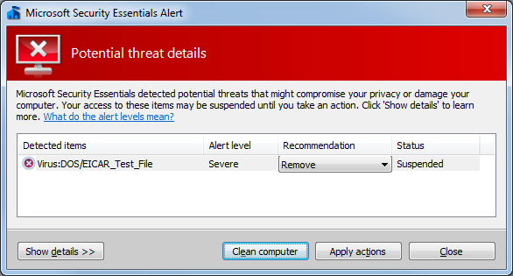

Saving a Screen Image
- Make sure the box showing your antivirus detecting EICAR is visible.
- Press the Print Scrn key.
- Click Start, "All Programs", Accessories, Paint. In the untitled - Paint window, select Edit, Paste from the menu bar. The desktop appears in the Paint window.
- In the untitled - Paint window, click File, Save. Save the document in the My Pictures folder (or any other place you wish, such as a floppy disk) with the filename Your Name Proj 4x. Select a Save as type of JPEG or PNG.

Turning in Your Project
- Email the JPEG image to me as an attachment to an e-mail message. Send it to: cnit.106sam@gmail.com with a subject line of Proj 4x From Your Name, replacing Your Name with your own first and last name. Send a Cc to yourself.
Last Modified: 10-4-09

