Purpose: We all have many Web sites to log in to. But how do you remember the names and passwords? Most people re-use the same password for many sites, which is very dangerous. RoboForm makes it easy to use different passwords for every site. It also protects you from keylogger attacks.
Requirements: You need a Windows machine (any version) connected to the Internet. I assume you are using Windows 7 in S214 in the instructions, but any other version should be fine too. This project should be harmless.
Start your Computer in Windows 7

- Boot your machine to Windows 7 (any version). Log in with any account that has Administrative privileges, such as the Student account.
Downloading RoboForm
- Open a Web browser and go to roboform.com
- At the top left of the screen, click DOWNLOAD, as shown to the right on this page.
- At the lower right of the screen, click the yellow "Download RoboForm!" button.
- Save the AiRibiForm.exe file on your desktop.
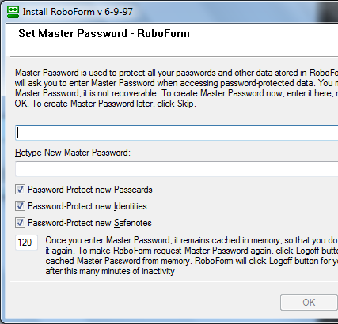
Installing RoboForm
- On your desktop, double-click the AiRibiForm.exe file. Install the software with the default options. When the installer asks you whether to close your browser window, click Yes.
- In the "Set Master Password" box, as shown to the right on this page, choose a strong password you can remember. If you are just trying RoboForm out in the S214 lab and don't intendto use it for your real passwords, enter P@ssw0rd in both boxes. Click OK.
- A browser window opens showing the message "CONGRATULATIONS! Your RoboForm installation is complete."
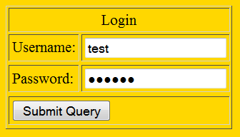
Saving Your Login Information into a Passcard
- In the browser, go to tinyurl.com/fakelogin
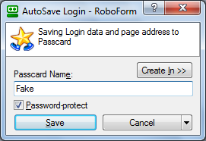
- Enter anything you like in the Username and Password fields and click the "Submit Query" button.
- In the "AutoSave Login - RoboForm" box, enter a Passcard Name of Fake, as shown to the left on this page. Click Save.
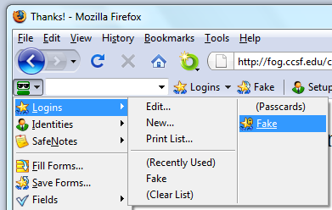

Filling in a Form with RoboForm
- In the browser, in the RoboForm Toolbar, click.the leftmost icon, as shown to the right on this page. Point to Login and click Fake.
- RoboForm opens the page, fills it in, and logs in, all automatically. This is why people love RoboForm--it 's easy and secure.
Saving the Screen Image
- In the browser, in the RoboForm Toolbar, click.the leftmost icon, and point to Login. Make sure the Fake item is visible.
- Press the PrntScn key to copy whole screen to the clipboard.
- Open Paint and paste in the image. Save it as a PNG or JPEG, with the filename Your Name Proj 7x.
Turning in your Project
- Email the image to me as an email attachment. Send the message to: cnit.106sam@gmail.com with a subject line of Proj 7x From Your Name, replacing Your Name with your own first and last name. Send a Cc to yourself.

Last modified 12-1-09 8 am

