What You Will Need
- Any computer connected to the Internet. The instructions below assume you are using Windows 7 in S214.

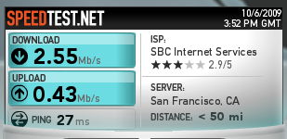
Testing Internet Speed with Speedtest.net
- Open a browser and go to speedtest.net
- Click the "Begin Test" button. You should get two answers, one for Download speed, and one for Upload speed, as shown to the right on this page. Your values may be different.

Capturing the Screen Image
- Make sure that the Download speed and for Upload speed values are visible.
- Press the PrntScn key to copy whole screen to the clipboard. Open Paint and paste in the image. Save it as a JPEG, with the filename Your Name Proj 8a.
Creating a 1 MB Test File
- Click Start. In the Search Bar, type NOTEPAD. Press the Enter key.
- In the Notepad window, type 1234567890
- In the Notepad window, press Ctrl+A to select all the text. Then press Ctrl+C to copy it to the clipboard. Then press Ctrl+V ten times to paste it ten times into the file. Your file is now 100 bytes in size.
- In the Notepad window, press Ctrl+A to select all the text. Then press Ctrl+C to copy it to the clipboard. Then press Ctrl+V ten times to paste it ten times into the file. Your file is now 1000 bytes in size.
- In the Notepad window, press Ctrl+A to select all the text. Then press Ctrl+C to copy it to the clipboard. Then press Ctrl+V ten times to paste it ten times into the file. Your file is now 10 KB in size.
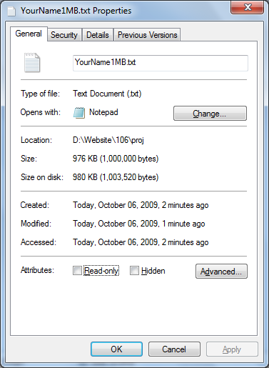
- In the Notepad window, press Ctrl+A to select all the text. Then press Ctrl+C to copy it to the clipboard. Then press Ctrl+V ten times to paste it ten times into the file. Your file is now 100 KB in size.
- In the Notepad window, press Ctrl+A to select all the text. Then press Ctrl+C to copy it to the clipboard. Then press Ctrl+V ten times to paste it ten times into the file. Your file is now 1 MB in size.
- In the Notepad window, press Ctrl+S to save the file. Save it on your desktop with the filename YourName1MB. Close Notepad.
- On your desktop, right-click the YourName1MB file and click Properties. Your file should have a Size of 1,000,000 bytes as shown to the right on this page.

Capturing the Screen Image
- Make sure that the Size is visible, showing 1,000,000 bytes.
- Press the PrntScn key to copy whole screen to the clipboard. Open Paint and paste in the image. Save it as a JPEG, with the filename Your Name Proj 8b.
Timing a File Upload
- Open a browser and open your email account. Any kind of email will do, such as your CCSF student email.
- Compose a message to yourself. Any subject line is fine.
- Find a timing device, such as a watch with a second hand. If no such device is available, open a second browser window to time.gov
- In the email message composition screen, click "Attach a file". Navigate to your YourName1MB file and point to itt.
- Check the clock. Wait till a new minute begins. When you see :00 on the time, double click the YourName1MB file to start the upload. When the upload is done, look at the clock to see how long it took.

Upload time: _____________________________

Download time: _____________________________

- Write the upload time in the box to the right on this page.
- Send the email message.
Timing a File Download
- In your Email inbox, click the message you just sent. If it's not in the Inbox, look in the Sent Mail folder.
- Check the clock. Wait till a new minute begins. When you see :00 on the time, click the Download button to download the YourName1MB file. When the download is done, look at the clock to see how long it took.
- Write the download time in the box to the right on this page.
Calculating the Speed
- Use this formula to calculate the speeds from your measured times. The file you sent contained 1 million bytes, which is 8 million bits, or 8 Mb:
Speed = 8 Mbps / (TIME in seconds)

Upload speed: _____________________________

Download speed: _____________________________

- Write your speeds in the box to the right on this page.

Reflection
- How to the speeds you measured compare to the values from speedtest.net? They should be approximately in agreement. If they are not, check your calculation and try to understand why not.
Turning in your Project
- Include these things in your email:
  - Your measured times and speeds for both upload and download
  - The two images you captured above, as attachments
- Send the email message to cnit.106sam@gmail.com with a subject line of Proj 8 From Your Name. Send a Cc to yourself.

Last modified 10-6-09

