What You Will Need
- Any computer connected to the Internet. The instructions below assume you are using Windows 7 in S214.

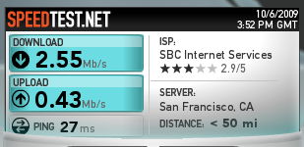
Testing Internet Speed with Speedtest.net
- Open a browser and go to speedtest.net
- Click the "Begin Test" button. You should get two answers, one for Download speed, and one for Upload speed, as shown to the right on this page. Your values may be different.

Capturing the Screen Image
- Make sure that the Download speed and for Upload speed values are visible.
- Press the PrntScn key to copy whole screen to the clipboard. Open Paint and paste in the image. Save it as a JPEG, with the filename Your Name Proj 8a.
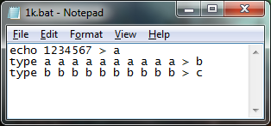
Creating a 1 KB Test File
- If these files are on your desktop: a, b, c, 1.bat, or 10M.bat, delete them.
- Click Start. In the Search Bar, type NOTEPAD. Press the Enter key.
- In the Notepad window, type the three lines shown to the right. This is a batch file that will create a file 1 KB in size by adding together a small file many times.
- In the Notepad window, click File, Save. Save the file on your desktop with the name 1k.bat
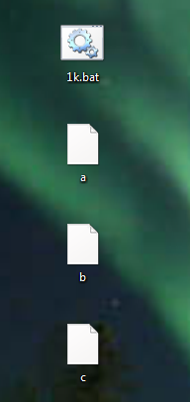
- On your desktop, double-click the 1k.bat file. Three new files should appear on your desktop, named a, b, and c, as shown to the right on this page.
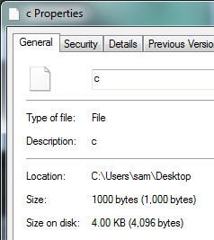
- Right click the icon for the c file and click Properties. The Size should be 1000 bytes, as shown below on this page. If it isn't, delete the a, b, and c files, correct your 1k.bat script, and run it again.
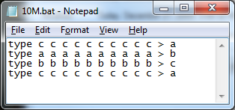
Creating a 10 MB Test File
- Click Start. In the Search Bar, type NOTEPAD. Press the Enter key.
- In the Notepad window, type the three lines shown to the right. This batch file will create a file 10 MB in size by adding together the 1 KB file many times.
- In the Notepad window, click File, Save. Save the file on your desktop with the name 10M.bat
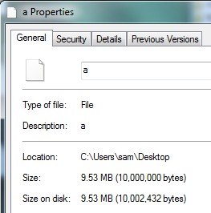
- On your desktop, double-click the 10M.bat file.
- Right click the icon for the a file and click Properties. The Size should be 10,000,000 bytes, as shown to the right on this page.

Capturing the Screen Image
- Make sure that the Size is visible, showing 10,000,000 bytes.
- Press the PrntScn key to copy whole screen to the clipboard. Open Paint and paste in the image. Save it as a JPEG, with the filename Your Name Proj 8b.
Timing a File Upload
- Open a browser and open your email account. Any kind of email will do, such as your CCSF student email.
- Compose a message to yourself. Any subject line is fine.
- Find a timing device, such as a watch with a second hand. If no such device is available, open a second browser window to time.gov
- In the email message composition screen, click "Attach a file". Navigate to your a file and point to it.
- Check the clock. Wait till a new minute begins. When you see :00 on the time, double click the YourName1MB file to start the upload. When the upload is done, look at the clock to see how long it took.

Upload time: _____________________________

Download time: _____________________________

- Write the upload time in the box to the right on this page.
- Send the email message.
Timing a File Download
- In your Email inbox, click the message you just sent. If it's not in the Inbox, look in the Sent Mail folder.
- Check the clock. Wait till a new minute begins. When you see :00 on the time, click the Download button to download the a file. When the download is done, look at the clock to see how long it took.
- Write the download time in the box to the right on this page.
Calculating the Speed
- Use this formula to calculate the speeds from your measured times. The file you sent contained 10 million bytes, which is 80 million bits, or 80 Mb:
Speed = 80 Mbps / (TIME in seconds)

Upload speed: _____________________________

Download speed: _____________________________

- Write your speeds in the box to the right on this page.

Reflection
- How to the speeds you measured compare to the values from speedtest.net? They should be approximately in agreement. If they are not, check your calculation and try to understand why not.
Turning in your Project
- Include these things in your email:
  - Your measured times and speeds for both upload and download
  - The two images you captured above, as attachments
- Send the email message to cnit.106sam@gmail.com with a subject line of Proj 8 From Your Name. Send a Cc to yourself.

Last modified 3-9-10

