What You Will Need
- Two computers connected to a LAN. The instructions below assume you are using Windows 7 in S214.
Creating a 1 KB Test File
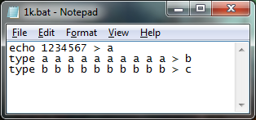
- If these files are on your desktop: a, b, c, 1.bat, or 10M.bat, delete them. DO NOT SKIP THIS STEP. If you leave the old files from Project 8 there, the script below will never stop, and will fill the whole hard drive.
- Click Start. In the Search Bar, type NOTEPAD. Press the Enter key.
- In the Notepad window, type the three lines shown to the right. This is a batch file that will create a file 1 KB in size by adding together a small file many times.
- In the Notepad window, click File, Save. Save the file on your desktop with the name 1k.bat
- On your desktop, double-click the 1k.bat file. Three new files should appear on your desktop, named a, b, and c.
- Right click the icon for the c file and click Properties. The Size should be 1000 bytes. If it isn't, delete the a, b, and c files, correct your 1k.bat script, and run it again.
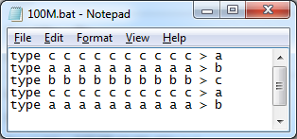
Creating a 100 MB Test File
- Click Start. In the Search Bar, type NOTEPAD. Press the Enter key.
- In the Notepad window, type the three lines shown to the right. This batch file will create a file 100 MB in size by adding together the 1 KB file many times.
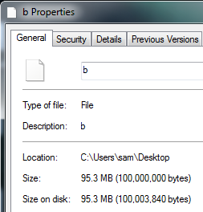
- In the Notepad window, click File, Save. Save the file on your desktop with the name 100M.bat
- On your desktop, double-click the 100M.bat file. Wait until the script finishes and the C:\Windows\system32\cmd.exe window closes.
- Right click the icon for the b file and click Properties. The Size should be 100,000,000 bytes, as shown to the right on this page.

Capturing the Screen Image
- Make sure that the Size is visible, showing 100,000,000 bytes.
- Press the PrntScn key to copy whole screen to the clipboard. Open Paint and paste in the image. Save it as a JPEG, with the filename Your Name Proj 9a.
Setting the Network Type
- Caution: sharing a folder on a public network is unsafe. I don't recommend doing this project on a public wireless network. Use a private wireless network, or a wired network. Otherwise strangers may access your shared folders and/or attack your computer.
- Click Start. Type in NET. In the search results, click "Network and Sharing Center".
- In the center section of the "Network and Sharing Center" window, find the network labeled "Local Area Connection" on the right. On the left the name of the network is shown in black letters, and the network type is shown in blue letters, as shown below on this page. If the network type is "Home network" or "Work network", it's OK and doesn't require any change. If the network type is "Public network", click the blue "Public network" link and change it to "Work network".
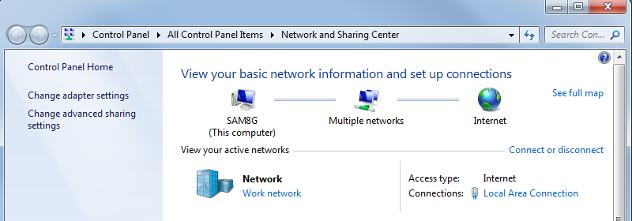

Sharing a Folder
- In "Network and Sharing Center", click "Advanced Sharing Settings". Expand the "Home or Work" section. Make sure these two items are selected, as shown below on this page:
  - Turn on file and printer sharing
  - Turn on sharing so anyone with network access can read and write files in the Public folders
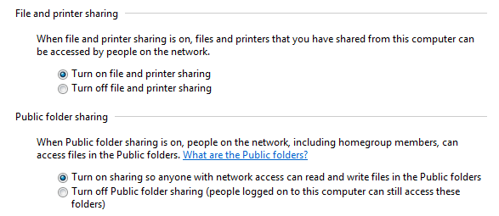

- If you made any change, click the "Save Changes" button.

Timing a File Transfer
- Go to the other computer.
- Click Start, Computer. In the left pane, scroll to the bottom and click Network. Find the machine you shared the 100MB file on in the right pane and double-click it. In S214, that machine should have a name like S214-01 to help you find it.
- Double-click Users. Double-click Public. Double-click "Public Documents". Right-click the YourName100MB file and click Copy.
- Check the clock. Wait till a new minute begins. When you see :00 on the time, right click a blank portion of your desktop and click Paste. When the transfer is done, look at the clock to see how long it took.

Transfer time: _________________

Transfer speed: _________________
- Write the upload time in the box to the right on this page.
Calculating the Speed
- Use this formula to calculate the speed from your measured time. The file you sent contained 100 million bytes, which is 800 million bits, or 800 Mb:
Speed = 800 Mbps / (TIME in seconds)
- Write your speed in the box to the right on this page.
Finding the NIC's Speed Rating
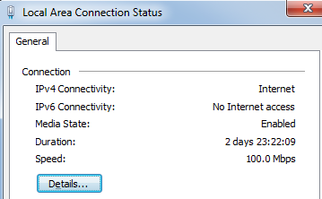
- Click Start. Type in CONNECTION. In the search results, click "View network connections".
- In the "Network Connections" window, right click "Local Area Connection" and click Status. You should see the Speed, as shown to the right on this page. For most computers, the speed is 100 Mbps.

Capturing the Screen Image
- Make sure that the Speed is visible.
- Press the PrntScn key to copy whole screen to the clipboard. Open Paint and paste in the image. Save it as a JPEG, with the filename Your Name Proj 9b.

Reflection
- Microsoft claims that Windows 7 has faster file transfers than any previous version of Windows. What do you think? Is the observed speed as fast as it should be?
Turning in your Project
- Include these things in your email:
  - Your measured time and speed for both upload and download
  - The two images you captured above, as attachments
- Send the email message to cnit.106sam@gmail.com with a subject line of Proj 9 From Your Name. Send a Cc to yourself.

Last modified 12-27-09

