Purpose: NoScript is a Firefox extension that blocks all Flash animations and other scripts, unless you explicitly allow them. This stops many ads, makes your browser run much faster, and protects you from many Internet attacks. But it is inconvenient--you often have to click several extra times when launching a new page.
Requirements: You need a Windows or MAC computer (any version) connected to the Internet. I assume you are using Windows 7 in S214 in the instructions, but any other version should be fine too. This project should be harmless.
Start your Computer in Windows 7
- Boot your machine to Windows 7 (any version). Log in with any account that has Administrative privileges, such as the Student account.
Installing NoScript
- Open Firefox. If you don't have Firefox, use Internet Explorer (or Safari), go to getfirefox.com, and download it.
- From the Firefox menu bar, click Tools, Add-ons. If NoScript is already installed, remove it and restart Firefox.
- In the Add-ons box, in the search field, type NOSCRIPT as shown below on this page. Press the Enter key.
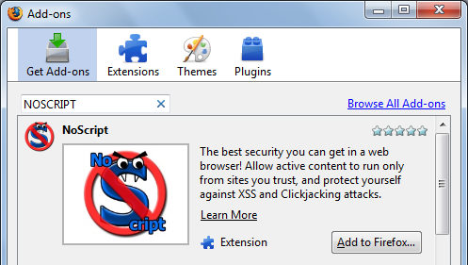

- In the Add-ons box, click the "Add to Firefox…" button.
- In the "Software Installation" box, click the "Install Now" button.
- In the Add-ons box, click the "Restart Firefox" button.
Using NoScript
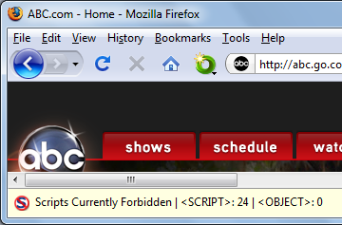
- In Firefox, go to abc.tv
- A bar opens at the bottom of the window, telling you how many scripts have been blocked, as shown to the right on this page. When I did it, 24 scripts were blocked.
Allowing Scripts
- At the bottom of the browser, click the Options button. Click "Allow abc.com".
- At the bottom of the browser, click the Options button. Click "Allow go.com".
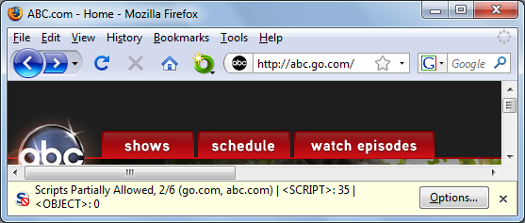
- The bar at the bottom should now show the message "Scripts Partially Allowed", as shown below on this page. This is usually what you want to see--only the essential scripts allowed, and the ads and other trash blocked.

Saving the Screen Image
- Make sure the "Scripts Partially Allowed" message is visible.
- Press the PrntScn key to copy whole screen to the clipboard.
- Open Paint and paste in the image. Save it as a PNG or JPEG, with the filename Your Name Proj 9x.
Turning in your Project
- Email the image to me as an email attachment. Send the message to: cnit.106sam@gmail.com with a subject line of Proj 9x From Your Name, replacing Your Name with your own first and last name. Send a Cc to yourself.

Last modified 12-1-09 8 am

