Security Training at CCSF

Certificate in Network Security
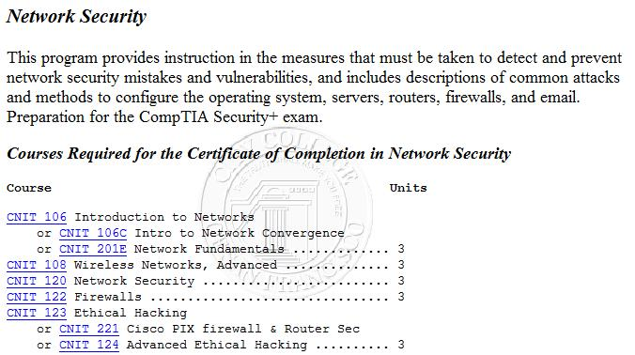

Associate of Science Degree

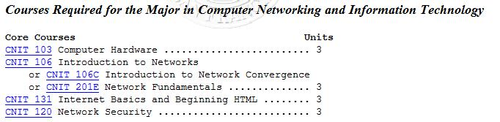
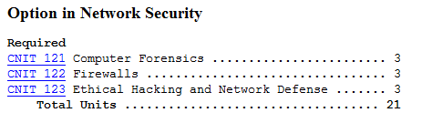

CNIT 120: Network Security

Fundamentals of Network Security

Preparation for Security+ Certification

Essential for any Information Technology professional

Two Hacking Classes

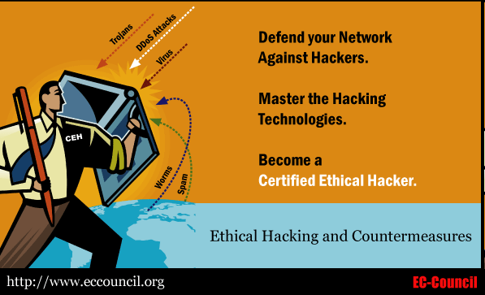
CNIT 123: Ethical Hacking and Network Defense

Has been taught since Spring 2007 (four times)

Face-to-face and Online sections available Fall 2008

CNIT 124: Advanced Ethical Hacking

Taught for the first time in Spring 2008

Supplemental Materials

Projects from recent research

Students get extra credit by attending conferences

Certified Ethical Hacker

CNIT 123 and 124 prepare students for CEH Certification
Security+ Guide to Network Security Fundamentals, Third Edition

Objectives

Describe the challenges of securing information

Define information security and explain why it is important

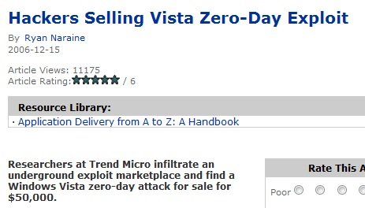
Identify the types of attackers that are common today

List the basic steps of an attack

Describe the five steps in a defense

Explain the different types of information security careers and how the Security+ certification can enhance a security career

Security Vulnerabilities for Sale

Anyone can buy attack tools to take over computers

See links Ch 1a, 1b on my Web page

samsclass.info, click CNIT 120, Links

Challenges of Securing Information

There is no simple solution to securing information

This can be seen through the different types of attacks that users face today

As well as the difficulties in defending against these attacks

Today’s Security Attacks

A malicious program was introduced at some point in the manufacturing process of a popular brand of digital photo frames

Nigerian e-mail scam claimed to be sent from the U.N.

“Booby-trapped” Web pages are growing at an increasing rate (link Ch 1c)

A new worm disables Microsoft Windows Automatic Updating and the Task Manager (link Ch 1d)

Apple has issued an update to address 25 security flaws in its operating system OS X

Researchers at the University of Maryland attached four computers equipped with weak passwords to the Internet for 24 days to see what would happen

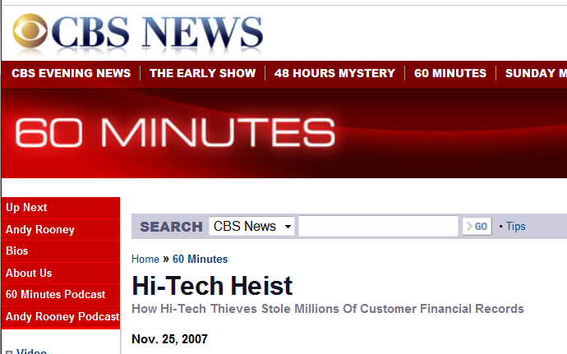
These computers were hit by an intrusion attempt on average once every 39 seconds (link Ch 1e)

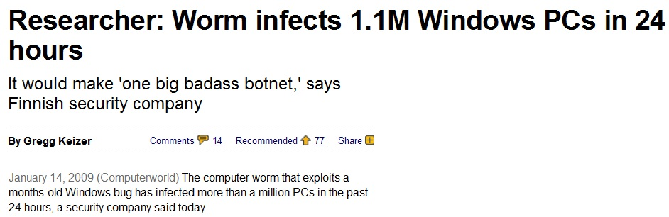
TJX Companies

had 45 million customer credit card and debit card numbers stolen because they used poor wireless security (WEP) (link Ch 1f)

Worm infects 1.1 million PCs in 24 hours

“On Tuesday there were 2.5 million, on Wednesday 3.5 million and today [Friday], eight million”

See links Ch 1g, 1l

The total average cost of a data breach in 2007 was $197 per record compromised

A recent report revealed that of 24 federal government agencies, the overall grade was only “C−”

Difficulties in Defending against Attacks
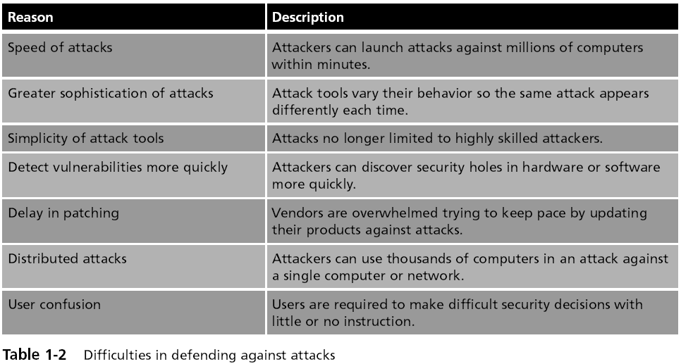
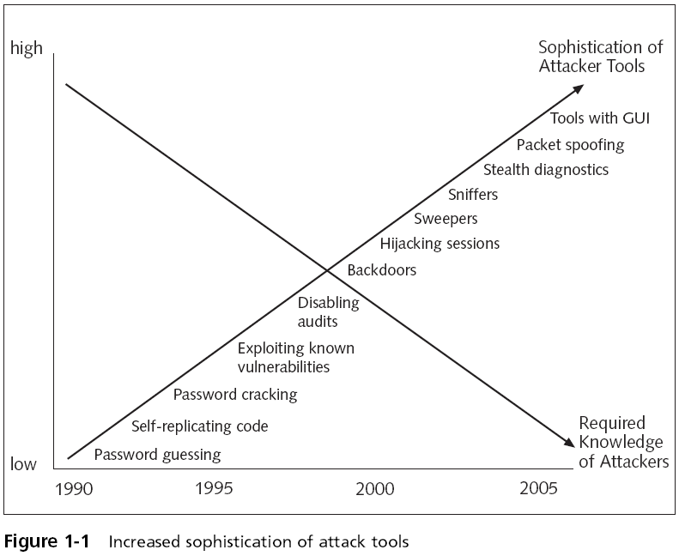

What Is Information Security?

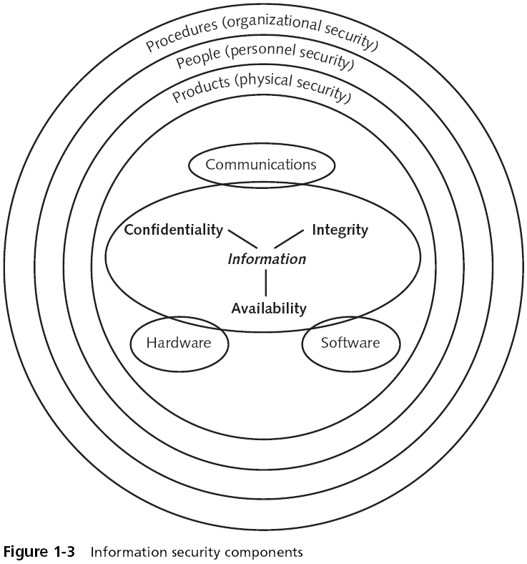
Defining Information Security

Security is a state of freedom from a danger or risk

Freedom exists because protective measures are established and maintained

Information security

The tasks of guarding information that is in a digital format

Ensures that protective measures are properly implemented

Cannot completely prevent attacks or guarantee that a system is totally secure

Defining Information Security

Information security protects information that has value, protecting “CIA”:

Confidentiality

Integrity

Availability

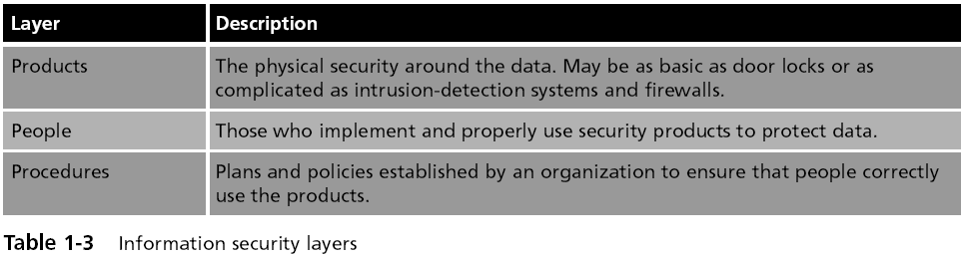
Information Security Layers

Formal Definition of Information Security

Information Security

protects the confidentiality, integrity, and availability of information on the devices that store, manipulate, and transmit the information through products, people, and procedures

Information Security Terminology

Asset

Something that has a value

Threat

An event or object that may defeat the security measures in place and result in a loss

Threat agent

A person or thing that has the power to carry out a threat

Information Security Terminology

Vulnerability

Weakness that allows a threat agent to bypass security

Exploit

Takes advantage of a vulnerability

Risk

The likelihood that a threat agent will exploit a vulnerability

Realistically, risk cannot ever be entirely eliminated

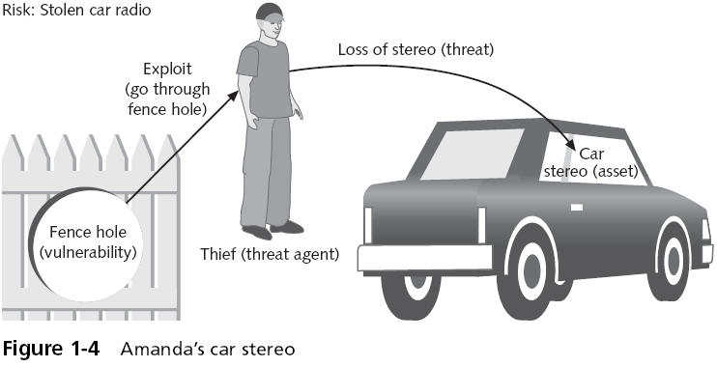

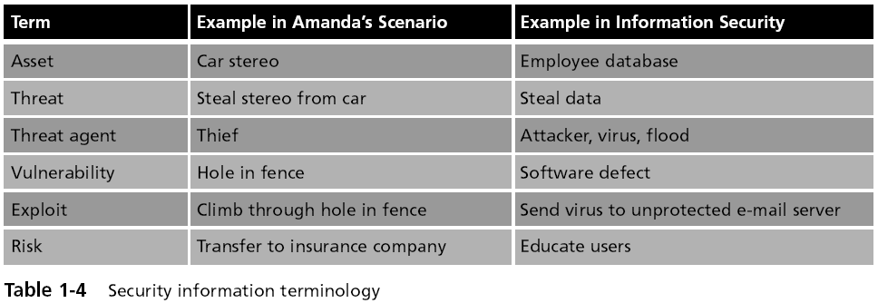

Understanding the Importance of Information Security

Data Theft and Identity Theft

Preventing data theft

The theft of data is one of the largest causes of financial loss due to an attack

Thwarting identity theft

Identity theft involves using someone’s personal information to establish bank or credit card accounts

Cards are then left unpaid, leaving the victim with the debts and ruining their credit rating

Avoiding Legal Consequences

A number of federal and state laws have been enacted to protect the privacy of electronic data

The Health Insurance Portability and Accountability Act of 1996 (HIPAA)

The Sarbanes-Oxley Act of 2002 (Sarbox)

The Gramm-Leach-Bliley Act (GLBA)

USA Patriot Act (2001)

The California Database Security Breach Act (2003)

Children’s Online Privacy Protection Act of 1998 (COPPA)

Maintaining Productivity

Cleaning up after an attack diverts resources such as time and money away from normal activities


Foiling Cyberterrorism

Attacks by terrorist groups using computer technology and the Internet

Utility, telecommunications, and financial services companies are considered prime targets of cyberterrorists

The NSA Hacker

Gary McKinnon hacked into NASA and the US Military

He was looking for evidence about UFOs

Link Ch 1i
Who Are the Attackers?

The types of people behind computer attacks are generally divided into several categories

Hackers

Script kiddies

Spies

Employees

Cybercriminals

Cyberterrorists

Hacker

Anyone who illegally breaks into or attempts to break into a computer system

Although breaking into another person’s computer system is illegal

Some hackers believe it is ethical as long as they do not commit theft, vandalism, or breach any confidentiality

Ethical Hacker

Has permission from the owner to test security of computers by attacking them

Script kiddies

Unskilled users

Download automated hacking software (scripts) from Web sites and use it to break into computers

Spies

Computer spy

A person who has been hired to break into a computer and steal information

Excellent computer skills

Employees

The largest information security threat

Motives

An employee might want to show the company a weakness in their security

Disgruntled employees may be intent on retaliating against the company

Industrial espionage

Blackmailing

Cybercriminals

A loose-knit network of attackers, identity thieves, and financial fraudsters


More highly motivated, less risk-averse, better funded, and more tenacious than hackers

Many security experts believe that cybercriminals belong to organized gangs of young and mostly Eastern European attackers

Cybercriminals have a more focused goal that can be summed up in a single word: money

Max Butler

Took over the world’s market in stolen credit cards in 2006

From a San Francisco apartment in the Tenderloin

Link Ch 1h

Cybercriminals

Cybercrime

Targeted attacks against financial networks, unauthorized access to information, and the theft of personal information

Financial cybercrime is often divided into two categories

Trafficking in stolen credit card numbers and financial information

Using spam to commit fraud

Cyberterrorists

Their motivation may be defined as ideology, or attacking for the sake of their principles or beliefs

Goals of a cyberattack:

To deface electronic information and spread misinformation and propaganda

To deny service to legitimate computer users

To commit unauthorized intrusions into systems and networks that result in critical infrastructure outages and corruption of vital data

Attacks and Defenses

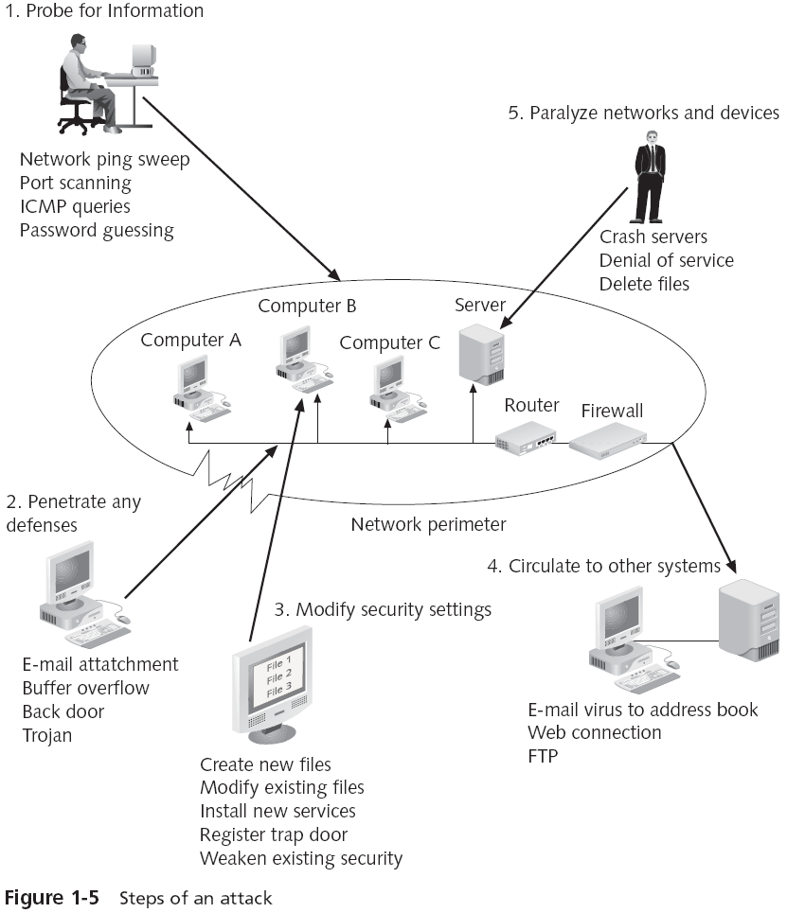
Steps of an Attack

The five steps that make up an attack

Probe for information

Penetrate any defenses

Modify security settings

Circulate to other systems

Paralyze networks and devices

Defenses against Attacks

Although multiple defenses may be necessary to withstand an attack

These defenses should be based on five fundamental security principles:

Layering

Limiting

Diversity

Obscurity

Simplicity

Layering

Information security must be created in layers

One defense mechanism may be relatively easy for an attacker to circumvent

Instead, a security system must have layers, making it unlikely that an attacker has the tools and skills to break through all the layers of defenses

A layered approach can also be useful in resisting a variety of attacks

Layered security provides the most comprehensive protection

Limiting

Limiting access to information reduces the threat against it

Only those who must use data should have access to it

In addition, the amount of access granted to someone should be limited to what that person needs to know

Some ways to limit access are technology-based, while others are procedural

Diversity

Layers must be different (diverse)

If attackers penetrate one layer, they cannot use the same techniques to break through all other layers

Using diverse layers of defense means that breaching one security layer does not compromise the whole system

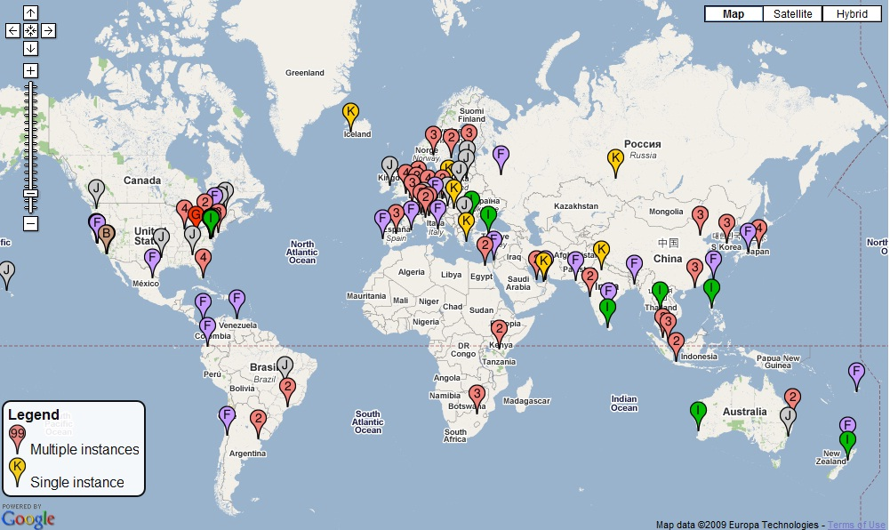
Diversity: Root DNS Servers

The whole Internet depends on these servers, so they are diversified geographically and in other ways

They have withstood severe attacks (links Ch 1j, 1k)

Obscurity

An example of obscurity would be not revealing the type of computer, operating system, software, and network connection a computer uses

An attacker who knows that information can more easily determine the weaknesses of the system to attack it

Obscuring information can be an important way to protect information

Simplicity

Information security is by its very nature complex

Complex security systems can be hard to understand, troubleshoot, and feel secure about

As much as possible, a secure system should be simple for those on the inside to understand and use

Complex security schemes are often compromised to make them easier for trusted users to work with

Keeping a system simple from the inside but complex on the outside can sometimes be difficult but reaps a major benefit
Information Security Careers and the Security+ Certification

Surveying Information Security Careers and the Security+ Certification

Today, businesses and organizations require employees and even prospective applicants

To demonstrate that they are familiar with computer security practices

Many organizations use the CompTIA Security+ certification to verify security competency

Types of Information Security Jobs

Information assurance (IA)

A superset of information security including security issues that do not involve computers

Covers a broader area than just basic technology defense tools and tactics

Also includes reliability, strategic risk management, and corporate governance issues such as privacy, compliance, audits, business continuity, and disaster recovery

Is interdisciplinary; individuals who are employed in it may come from different fields of study

Types of Information Security Jobs

Information security, also called computer security

Involves the tools and tactics to defend against computer attacks

Does not include security issues that do not involve computers

Two broad categories of information security positions

Information security managerial position

Information security technical position
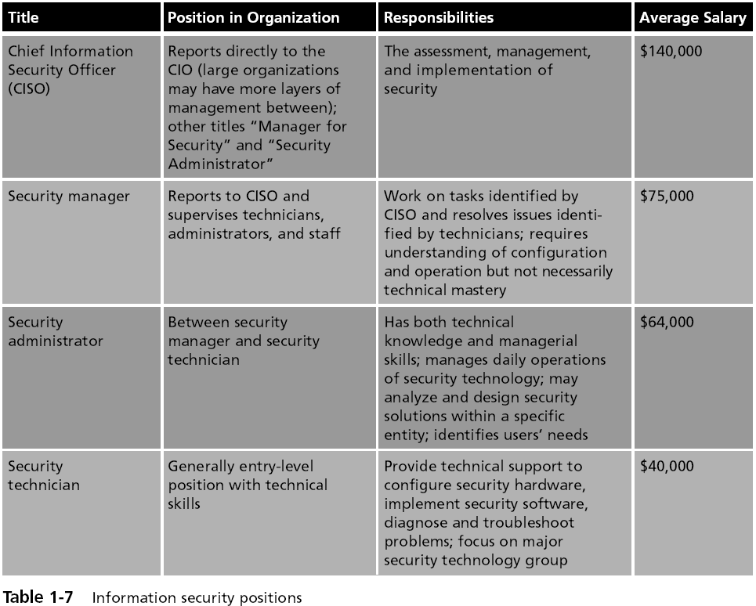

CompTIA Security+ Certification

The CompTIA Security+ (2008 Edition) Certification is the premiere vendor-neutral credential

The Security+ exam is an internationally recognized validation of foundation-level security skills and knowledge

Used by organizations and security professionals around the world

The skills and knowledge measured by the Security+ exam are derived from an industry-wide Job Task Analysis (JTA)

The six domains covered by the Security+ exam:

Systems Security, Network Infrastructure, Access Control, Assessments and Audits, Cryptography, and Organizational Security

Last modified 1-16-08

