Objectives

Describe the different types of software-based attacks

List types of hardware attacks

Define virtualization and explain how attackers are targeting virtual systems
Software-Based Attacks

Malware (Malicious software

Software that enters a computer system without the owner’s knowledge or consent

The three primary objectives of malware

To infect a computer system

Conceal the malware’s malicious actions

Bring profit from the actions that it performs

Viruses

Programs that secretly attach to file and execute when that file is opened

Once a virus infects a computer, it performs two separate tasks

Replicates itself by spreading to other computers

Activates its malicious payload

Payload examples

Encrypt data and charge money to decrypt it

Reformat the hard drive

Use your computer to send spam

Many others

Types of computer viruses

File infector virus – attached to EXE or COM file

Resident virus – lives in RAM

Boot virus – Infects the boot sector of a floppy disk

Companion virus – second file with similar name users execute by mistake, like cmd.bat

Macro virus – lives inside a Microsoft Office document

Metamorphic viruses

Avoid detection by altering how they appear

Polymorphic viruses

Also encrypt their content differently each time

Worms

Program designed to take advantage of a vulnerability in an application or an operating system in order to enter a system

Worms are different from viruses in two regards:

A worm can travel by itself (over a network)

A worm does not require any user action to begin its execution

Actions that worms have performed: deleting files on the computer; allowing the computer to be remote-controlled by an attacker

Trojans

Trojan Horse (or just Trojan)

Program advertised as performing one activity that but actually does something else

User is tricked into installing the software

Rootkits

System files are replaced by counterfeits

Hides files and processes from the operating system

Intruder gains remote control of the computer

VERY hard to detect and remove

Usually reformatting the drive and restoring from read-only backup is recommended

SONY Rootkit

Secretly installed on PCs that played SONY music CDs in 2005

Exposed those machines to remote control by SONY and others

This led to a massive product recall, and numerous lawsuits

Links Ch 2a, 2b, 2c
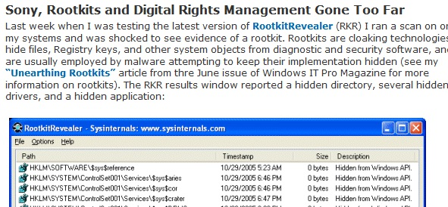

Logic bomb

Program waits for a trigger event such as a date, or the programmer being fired

Once triggered, the payload executes, deleting files or causing other damage

Logic bombs are extremely difficult to detect before they are triggered

Famous Logic Bombs
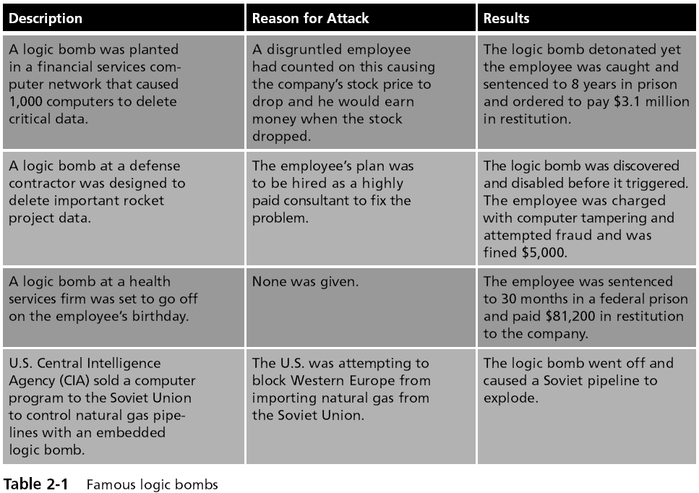

Privilege Escalation

Gaining rights that the user should not have

Types of privilege escalation

Gain higher system rights, usually Administrator

Gain another user’s rights

Spam

Unsolicited e-mail

Text-based spam messages can easily by trapped by special filters

Image spam uses graphical images of text in order to circumvent text-based filters

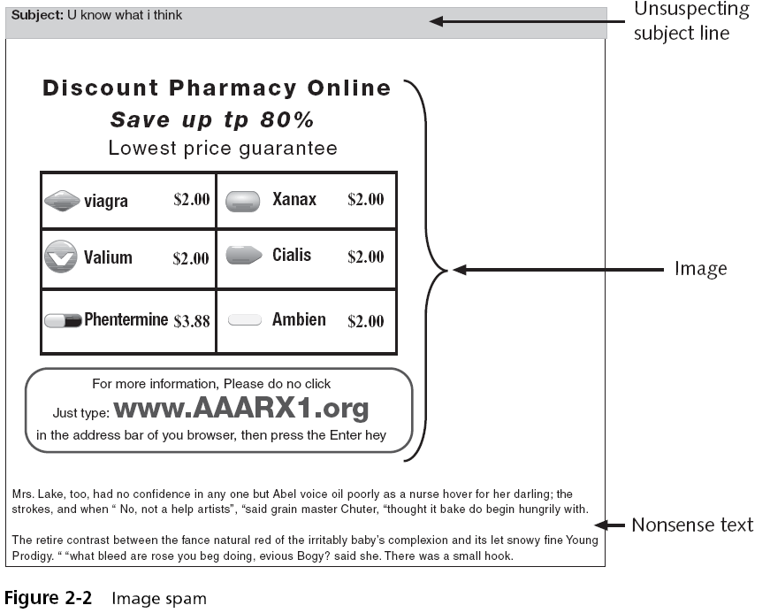

Evading Spam Filters

Techniques

GIF layering

Word splitting

Geometric variance

See link Ch 2d

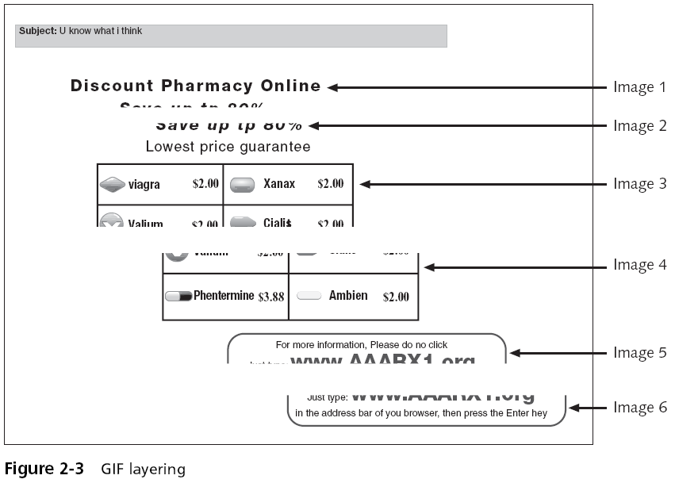

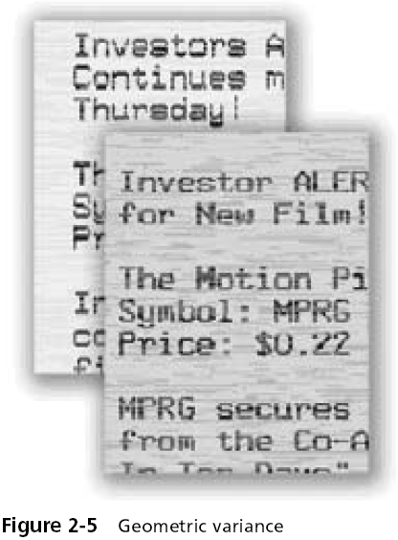

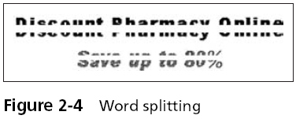

Blocking Spam

Image spam cannot be easily filtered based on the content of the message

To detect image spam, one approach is to examine the context of the message and create a profile, asking questions such as:

Who sent the message?

What is known about the sender?

Where does the user go if she responds to this e-mail?

What is the nature of the message content?

How is the message technically constructed?

Spyware

Software that violates a user’s privacy

Antispyware Coalition defines spyware as:

Technologies that are deployed without the user’s consent and impair the user’s control over:

Use of their system resources, including what programs are installed on their computers

Collection, use, and distribution of their personal or other sensitive information

Material changes that affect their user experience, privacy, or system security

Spyware creators are motivated by profit

Spyware is often more intrusive than viruses, harder to detect, and more difficult to remove

Spyware is very widespread

Almost every computer has some spyware on it

Most common types of spyware

Adware

Keyloggers

Effects of Spyware

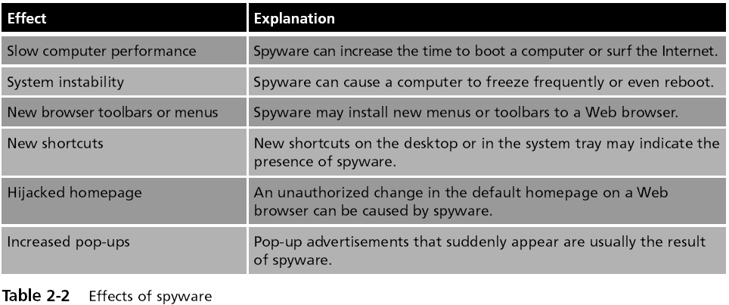

Adware

Delivers advertising content, often as pop-up windows

Can slow or crash a computer

Can monitor or track your activities

Hardware Keylogger

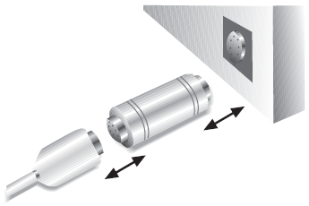
A small device inserted between the keyboard connector and computer keyboard port

Records each keystroke a user types on the computer’s keyboard

Used by a high school student to steal a final exam from a teacher (link Ch 2f)

Software Keyloggers

Programs that silently capture all keystrokes, including passwords and sensitive information

Hide themselves so that they cannot be easily detected even if a user is searching for them

Botnets

Hundreds or thousandsof zombie computers are under the control of an attacker

Zombie

An infected computer with a program that will allow the attacker to remotely control it

Attackers use Internet Relay Chat (IRC) to remotely control the zombies

Attacker is knows as a bot herder

Uses of Botnets

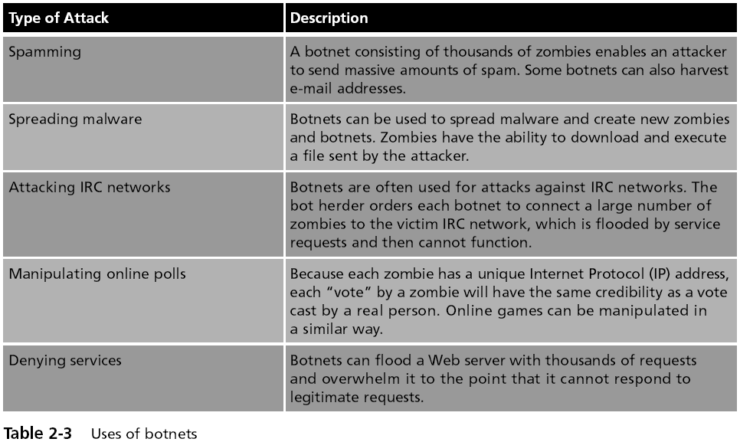

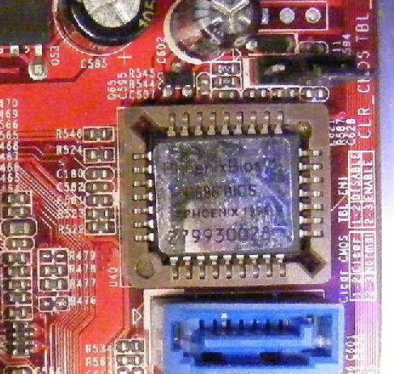
Hardware-Based Attacks

BIOS

Basic Input/Output System (BIOS)

A program embedded on a chip

Recognizes and controls different devices on the computer system

Executed when the computer system is first turned on

On older computer systems the BIOS was a Read Only Memory (ROM) chip

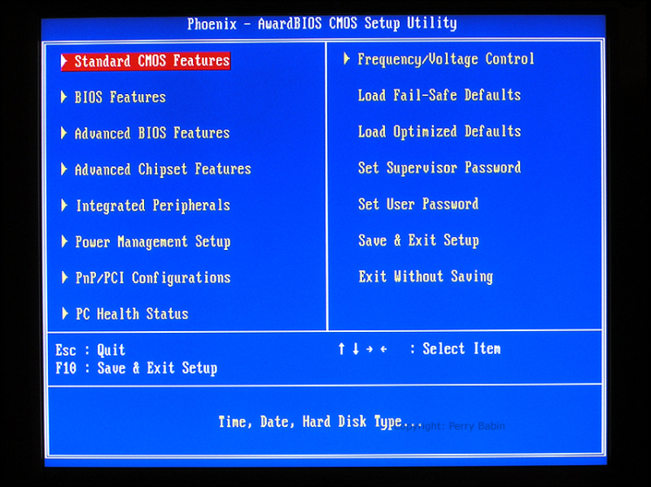
Today’s computer systems have a PROM (Programmable Read Only Memory) chip

Images from link Ch 2g, Ch 2h

BIOS Attacks

One virus overwrites the contents of the BIOS and the first part of the hard disk drive, rendering the computer completely dead

A BIOS virus or rootkit won’t be removed even by reformatting or replacing the hard drive

One defense is to block BIOS flashing on the motherboard
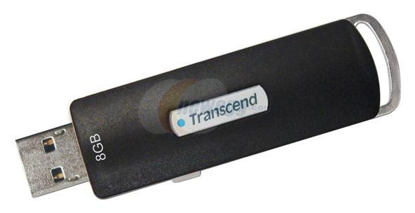

USB Devices

USB devices use flash memory

Flash memory is a type of EEPROM, nonvolatile computer memory that can be electrically erased and rewritten repeatedly

USB devices are widely used to spread malware

Also, USB devices allow spies or disgruntled employees to copy and steal sensitive corporate data

In addition, data stored on USB devices can be lost or fall into the wrong hands
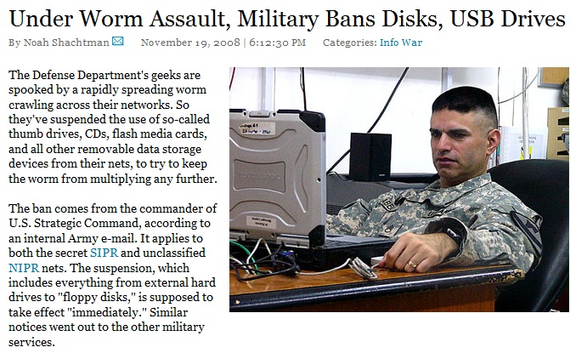

Link Ch 2i

USB PocketKnife

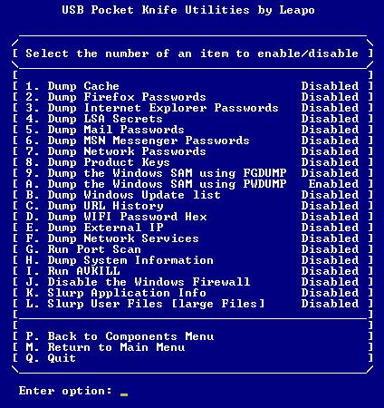
As soon as it is plugged into a computer, it steals passwords, files, installs a trojan, etc.

We do this as a project in CNIT 124

Links Ch 2j, 2k

USB Devices

To reduce the risk introduced by USB devices:

Disable the USB in hardware

Disable the USB through the operating system

Use third-party software

Better Solution: IEEE 1667

Standard Protocol for Authentication in Host Attachments of Transient Storage Devices

USB devices can be signed and authenticated, so only authorized devices are allowed

Will be implemented in Windows 7

Link Ch 2l

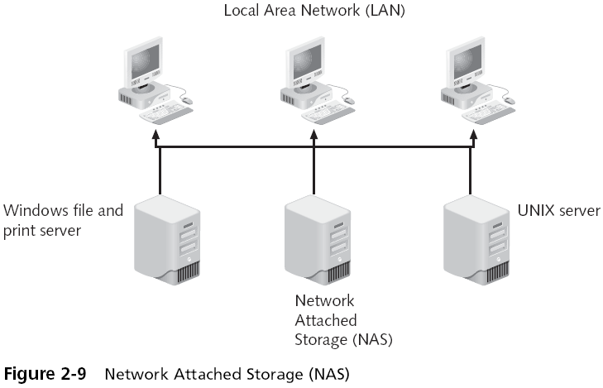
Network Attached Storage (NAS)

Single, dedicated hard disk-based file storage device that provides centralized and consolidated disk storage available to LAN users through a standard network connection

Link Ch 2m

Storage Area Network (SAN)

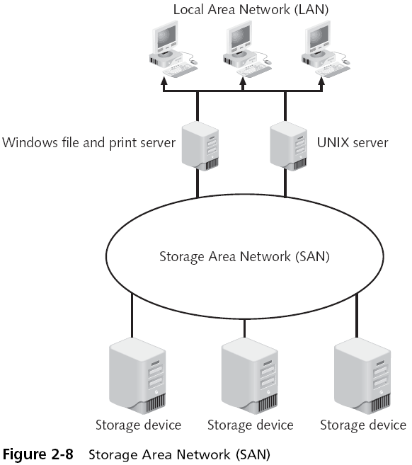
Specialized high-speed network for attaching servers to storage devices

Larger and more expensive than NAS

Link Ch 2n

NAS and SAN Security

They can be attacked just like other servers

NAS security is implemented through the standard operating system security features

The operating system on NAS devices can be either a standard operating system, a proprietary operating system, or a “stripped-down” operating system with many of the standard features omitted

Cell Phone Attacks

Lure users to malicious Web sites

Cell Phone Viruses (link Ch 2o)

Access account information

Abuse the cell phone service
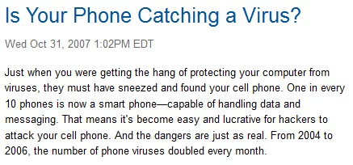

Attacks on Virtualized Systems

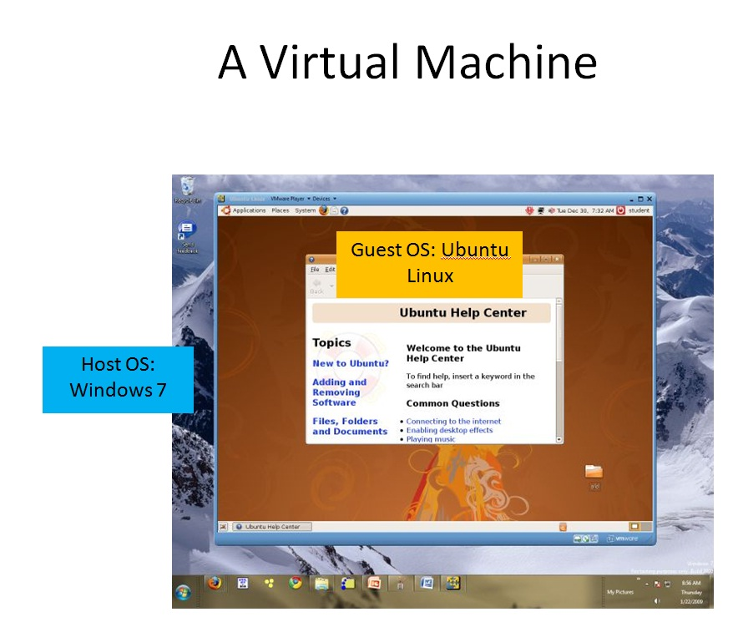
What Is Virtualization?

Virtualization

Simulating hardware (or other things) on a computer

Operating system virtualization

A virtual machine is a whole simulated computer running as a program on another computer

Virtual Servers

Virtual servers are

Easier to set up and repair

More reliable

Cheaper – because many virtual servers can run on a single physical computer

Use less energy

100% of the Fortune 100 companies use VMware

Link Ch 2p

Attackers Use Virtual Machines

A single computer can use both Windows and Linux tools

Security of Virtual Machines

Security for virtualized environments can be a concern for two reasons

Existing security tools were designed for single physical servers and do not always adapt well to multiple virtual machines

Virtual machines not only need to be protected from the outside world, but they also need to be protected from other virtual machines on the same physical computer

Virtual Machines can be used as security devices

running security software, such as a firewall and intrusion detection system

Last modified 1-22-09

