Cyberwar and Cyberterrorism

"Titan Rain" - Attacks on US gov't and military computers from China breached hundreds of systems in 2005 (link Ch 4a)

In 2007, Estonia was attacked by Russian computers as a political statement

Using DDoS (Distributed Denial of Service) with botnets (Ch 4b)

Objectives

Explain the types of network vulnerabilities

List categories of network attacks

Define different methods of network attacks
Network Vulnerabilities

Media-Based Vulnerabilities

Monitoring network traffic

Helps to identify and troubleshoot network problems

Monitoring traffic can be done in two ways

Use a switch with port mirroring

Copies all traffic to a designated monitoring port on the switch

Install a network tap (test access point)

A device that installed between two network devices, such as a switch, router, or firewall, to monitor traffic

Port Mirroring

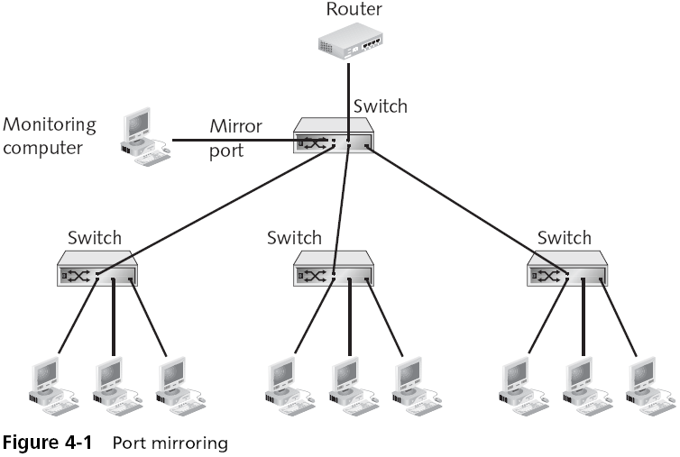

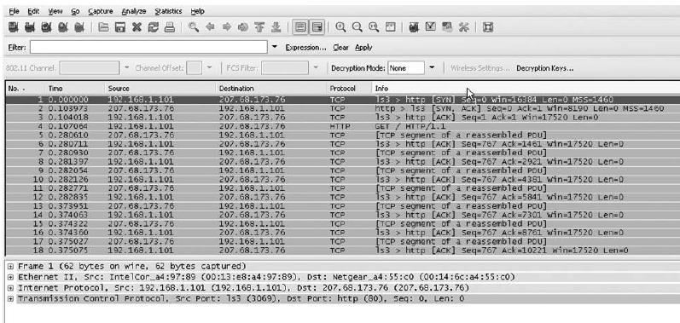
Sniffer

Network Tap
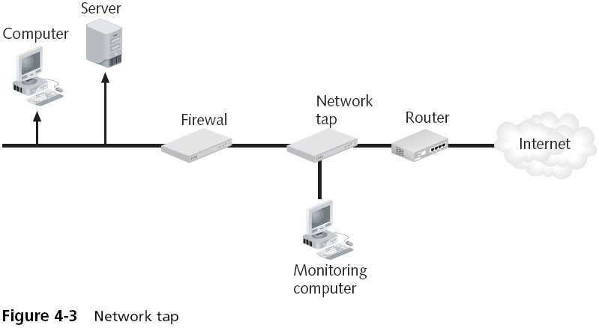

Sniffing Attacks

Just as network taps and protocol analyzers can be used for legitimate purposes

They also can be used by attackers to intercept and view network traffic

Attackers can access the wired network in the following ways:

False ceilings

Exposed wiring

Unprotected RJ-45 jacks

Ways to Redirect Switched Traffic

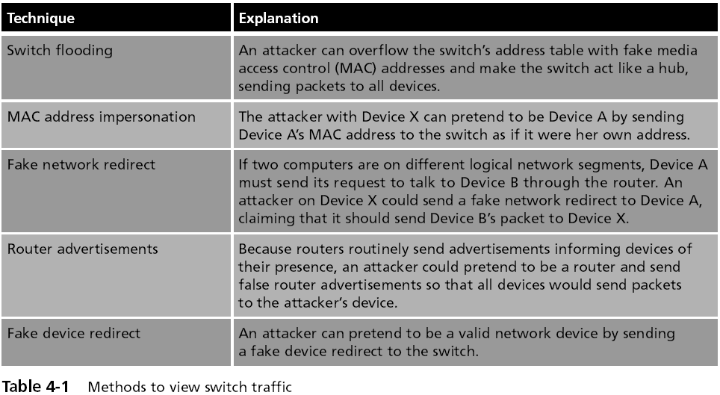

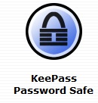
Network Device Vulnerabilities

Passwords

Passwords should be long and complex

Should be changed frequently

Should not be written down

But that is a difficult task

Solution: Password Manager Software (link Ch 4d)

Characteristics of Weak Passwords

A common word used as a password

Not changing passwords unless forced to do so

Passwords that are short

Personal information in a password

Using the same password for all accounts

Writing the password down

Network Device Vulnerabilities

Default account

A user account on a device that is created automatically by the device instead of by an administrator

Used to make the initial setup and installation of the device (often by outside personnel) easier

Although default accounts are intended to be deleted after the installation is completed, often they are not

Default accounts are often the first targets that attackers seek

ATM Passwords



In 2008, these men used default passwords to reprogram ATM machines to hand out $20 bills like they were $1 bills

Link Ch 4e
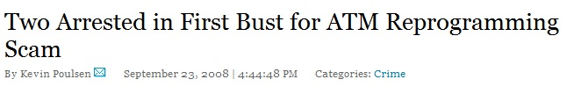

Network Device Vulnerabilities

Back door

An account that is secretly set up without the administrator’s knowledge or permission, that cannot be easily detected, and that allows for remote access to the device

Back doors can be created:

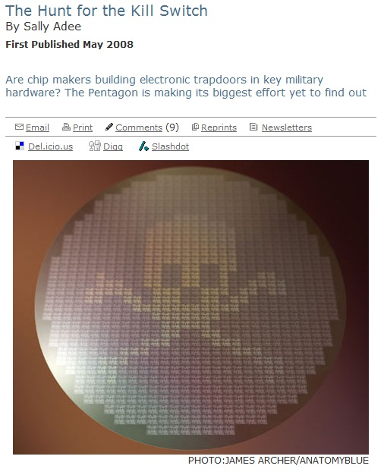
By a virus, worm, or Trojan horse

By a programmer of the software on the device

Built into the hardware chips

Hardware Trojans

Military equipment contains chips from foreign countries

Those chips can contain backdoors or kill switches

Link Ch 4e

Privilege escalation

Changing a limited user to an Administrator

Link Ch 4g
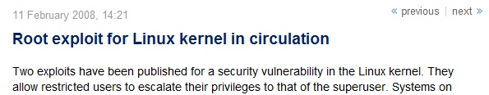

Categories of Attacks

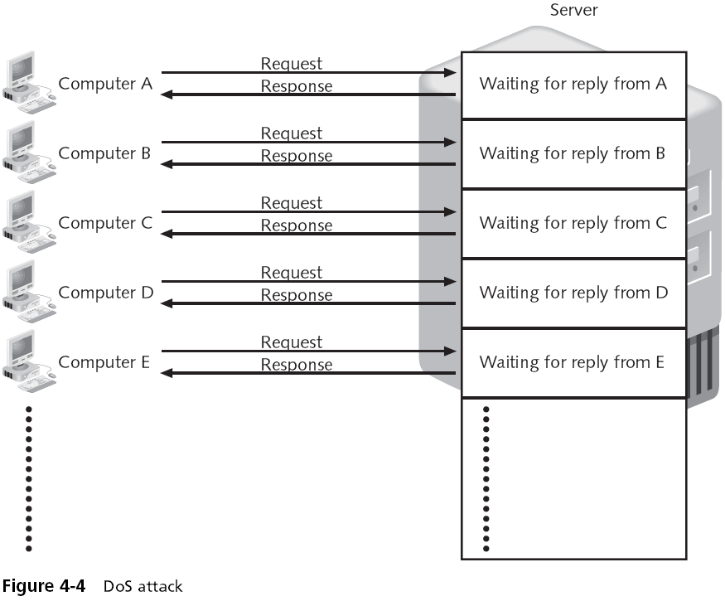
Denial of Service (DoS)

Attempts to consume network resources so that the network or its devices cannot respond to legitimate requests

Example: SYN flood attack

Distributed denial of service (DDoS) attack

A variant of the DoS

May use hundreds or thousands of zombie computers in a botnet to flood a device with requests

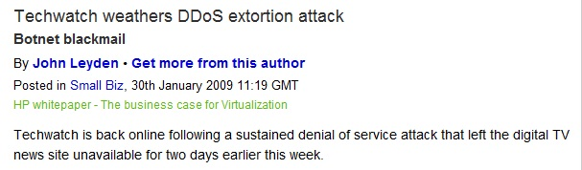

Real DDoS Attack

Link Ch 4i

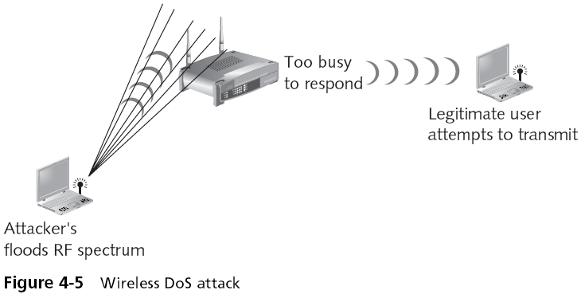

Wireless DoS

Requires a powerful transmitter

An Easier Wireless DoS
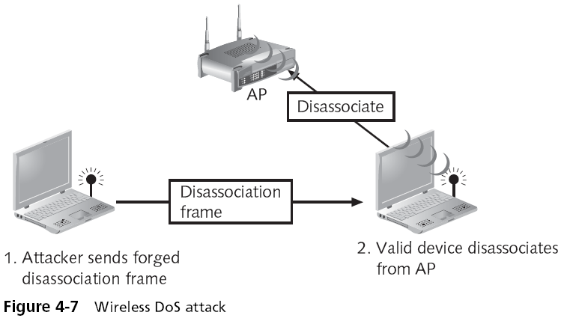

Spoofing

Spoofing is impersonation

Attacker pretends to be someone else

Malicious actions would be attributed to another user

Spoof the network address of a known and trusted host

Spoof a wireless router to intercept traffic

Man-in-the-Middle Attack

Passive--attacker reads traffic

Active--attacker changes traffic

Common on networks
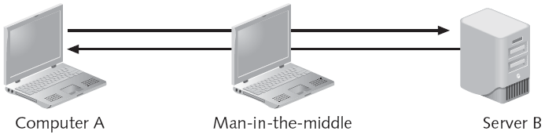

Replay Attack

Attacker captures data

Resends the same data later

A simple attack: capture passwords and save them

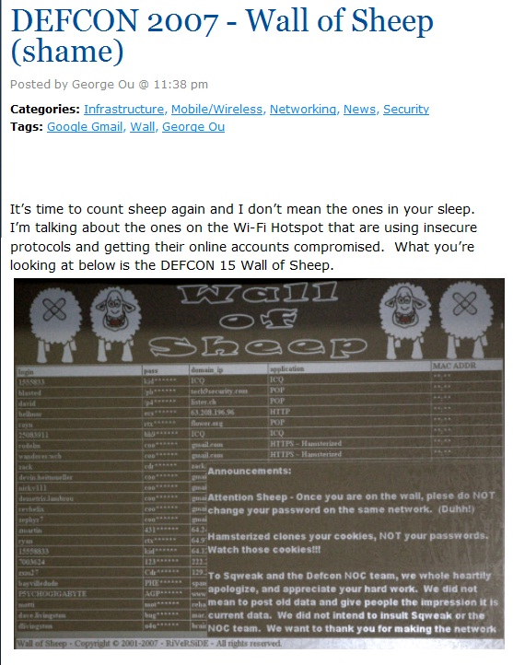
Wall of Sheep

Captured passwords projected on the wall at DEFCON

Link Ch 4j

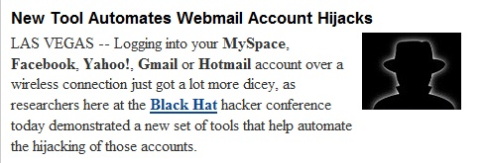
Sidejacking

Records cookies and replays them (link Ch 4k)

This technique breaks into Gmail accounts

Technical name: Cross Site Request Forgery

Almost all social networking sites are vulnerable to this attack

Facebook, MySpace, Yahoo, etc.

Methods of Network Attacks

SNMP (Simple Network Management Protocol)

Used to manage switches, routers, and other network devices

Early versions did not encrypt passwords, and had other security flaws

But the old versions are still commonly used

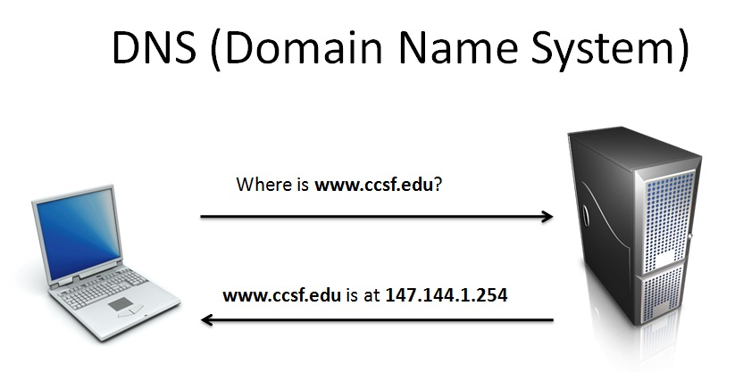
DNS (Domain Name System)

DNS is used to resolve domain names like www.ccsf.edu to IP addresses like 147.144.1.254

DNS has many vulnerabilities

It was never designed to be secure

DNS Poisoning

Local DNS Poisoning

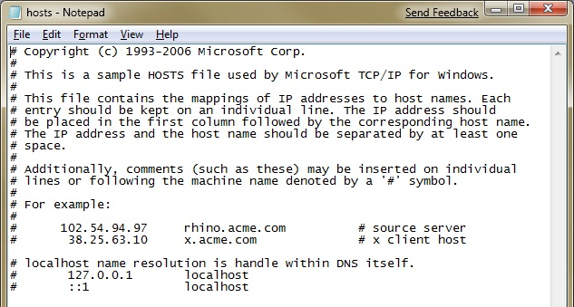
Put false entries into the Hosts file

C:\Windows\System32\Drivers\etc\hosts

DNS Cache Poisoning

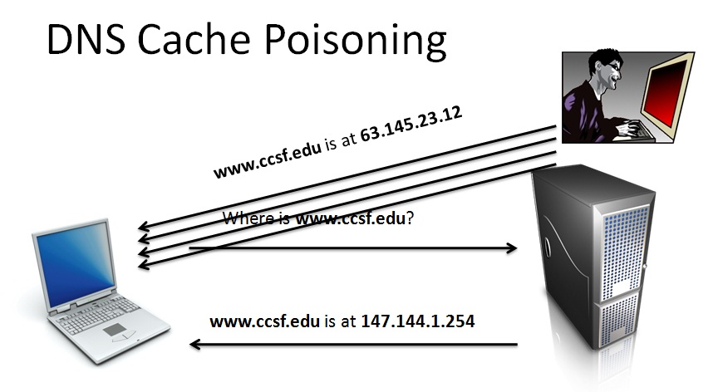
Attacker sends many spoofed DNS responses

Target just accepts the first one it gets

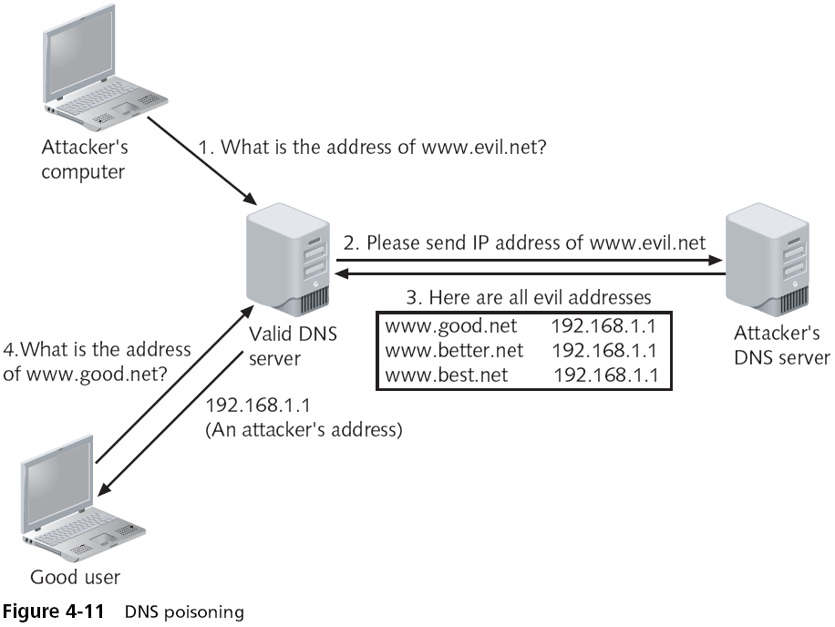
Sending Extra DNS Records

DNS Transfers

Intended to let a new DNS server copy the records from an existing one

Can be used by attackers to get a list of all the machines in a company, like a network diagram

Usually blocked by modern DNS servers

Protection from DNS Attacks

Antispyware software will warn you when the hosts file is modified

Using updated versions of DNS server software prevents older DNS attacks against the server

But many DNS flaws cannot be patched

Eventually: Switch to DNSSEC (Domain Name System Security Extensions)

But DNSSEC is not widely deployed yet, and it has its own problems

Link Ch 4l

ARP (Address Resolution Protocol)

ARP is used to convert IP addresses like 147.144.1.254 into MAC addresses like 00-30-48-82-11-34

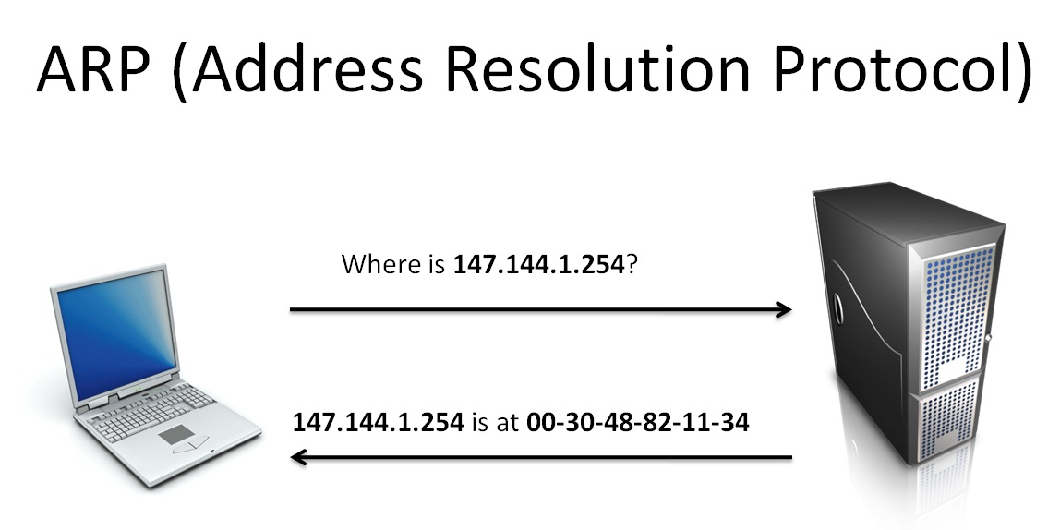

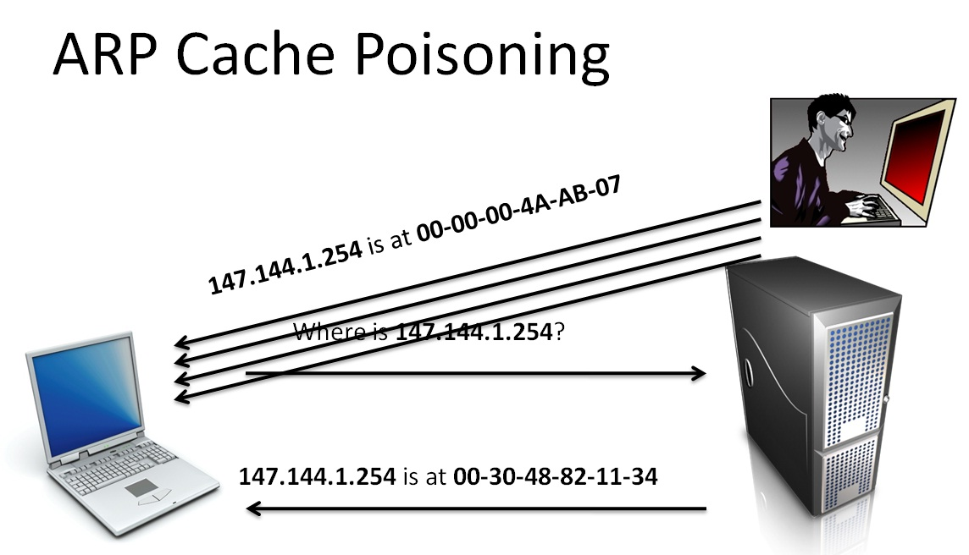
ARP Cache Poisoning

Attacker sends many spoofed ARP responses

Target just accepts the first one it gets

Results of ARP Poisoning Attacks

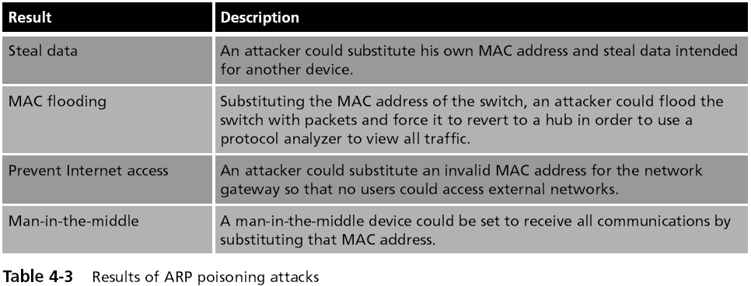

TCP/IP Hijacking

Takes advantage of a weakness in the TCP/IP protocol

The TCP header contains of two 32-bit fields that are used as packet counters

Sequence and Acknowledgement numbers

Packets may arrive out of order

Receiver uses the Sequence numbers to put the packets back in order

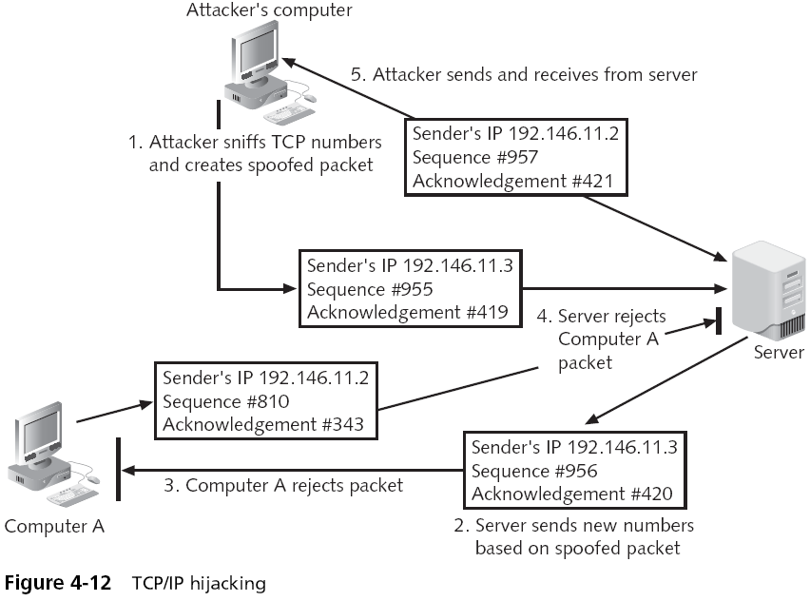

Wireless Attacks

Rogue access points

Employees often set up home wireless routers for convenience at work

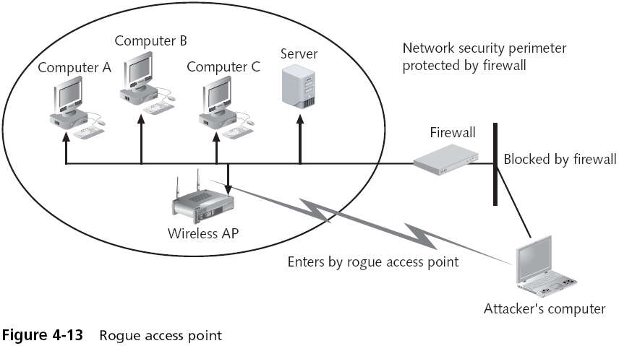
This allows attackers to bypass all of the network security and opens the entire network and all users to direct attacks

An attacker who can access the network through a rogue access point is behind the company's firewall

Can directly attack all devices on the network

War driving

Beaconing

At regular intervals, a wireless AP sends a beacon frame to announce its presence and to provide the necessary information for devices that want to join the network

Scanning

Each wireless device looks for those beacon frames

Unapproved wireless devices can likewise pick up the beaconing RF transmission

Formally known as wireless location mapping

War driving technically involves using an automobile to search for wireless signals over a large area

Tools for conducting war driving:

Mobile computing device

Wireless NIC adapters

Antennas

Global positioning system receiver

Software

Bluetooth

A wireless technology that uses short-range RF transmissions

Provides for rapid “on the fly” and ad hoc connections between devices

Bluesnarfing

Stealing data through a Bluetooth connection

E-mails, calendars, contact lists, and cell phone pictures and videos, …

Other Attacks and Frauds

Null Sessions

Connections to a Microsoft Windows 2000 or Windows NT computer with a blank username and password

Attacker can collect a lot of data from a vulnerable system

Cannot be fixed by patches to the operating systems

Much less of a problem with modern Windows versions, Win XP SP2, Vista, or Windows 7

Domain Name Kiting

Check kiting

A type of fraud that involves the unlawful use of checking accounts to gain additional time before the fraud is detected

Domain Name Kiting

Registrars are organizations that are approved by ICANN to sell and register Internet domain names

A five-day Add Grade Period (AGP) permits registrars to delete any newly registered Internet domain names and receive a full refund of the registration fee

Domain Name Kiting

Unscrupulous registrars register thousands of Internet domain names and then delete them

Recently expired domain names are indexed by search engines

Visitors are directed to a re-registered site

Which is usually a single page Web with paid advertisement links

Visitors who click on these links generate money for the registrar

Last modified 2-5-09

