Objectives

Explain how to enhance security through network design

Define network address translation and network access control

List the different types of network security devices and explain how they can be used
Crafting a Secure Network

Security through Network Design

Subnetting

IP addresses are actually two addresses: one part is a network address and one part is a host address

Subnetting or subnet addressing

Splits a large block of IP addresses into smaller groups
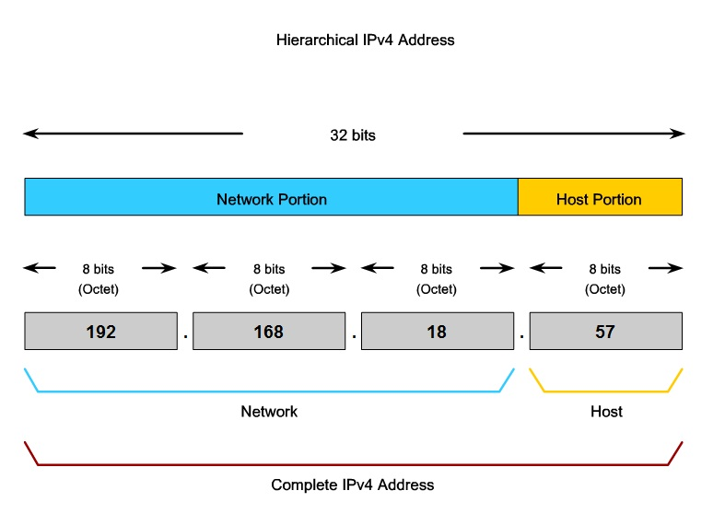

Image from Cisco CCNA Class 1

Subnets Improve Security

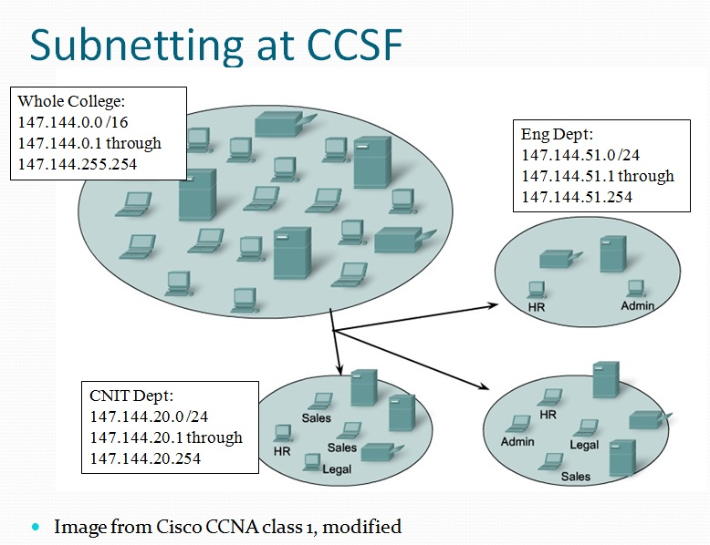
Each subnet can be isolated from the rest of the network

Traffic between subnets can be monitored and restricted at the routers

Subnets also allow network administrators to hide the internal network layout

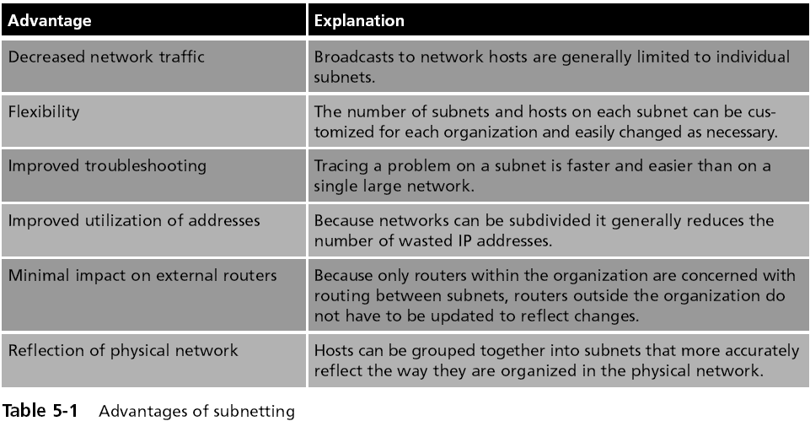
Outsiders only see your public servers, not your private subnets

Virtual Local Area Network (VLAN)

VLANs segment a network with switches, not routers

A VLAN allows scattered users to be logically grouped together even though they may be attached to different switches

Can reduce network traffic and provide a degree of security similar to subnetting:

VLANs can be isolated so that sensitive data is transmitted only to members of the VLAN

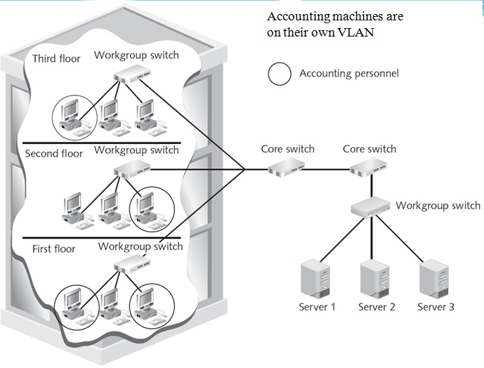

VLAN Security

VLAN communication can take place in two ways

All devices are connected to the same switch

Traffic is handled by the switch itself

Devices are connected to different switches

A special “tagging” protocol must be used, such as the IEEE 802.1Q-2005

A VLAN is heavily dependent upon the switch for correctly directing packets

Attackers could take control of the switch itself, if it has a default or weak password

Specially crafted traffic can also "hop" from one VLAN to another

Network Convergence

Telephone, data, and video all using the same IP network

Voice over IP, Video over IP

Advantages

Cost savings

Management

Application development

Infrastructure requirements

Reduced regulatory requirements

Increased user productivity

Vulnerabilities in Converged Networks

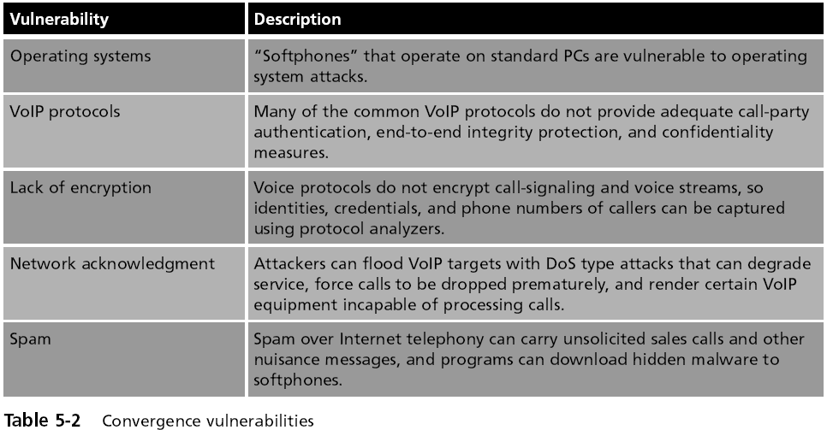

Demilitarized Zone (DMZ)

A separate network that sits outside the secure network perimeter

Outside users can access the DMZ but cannot enter the secure network
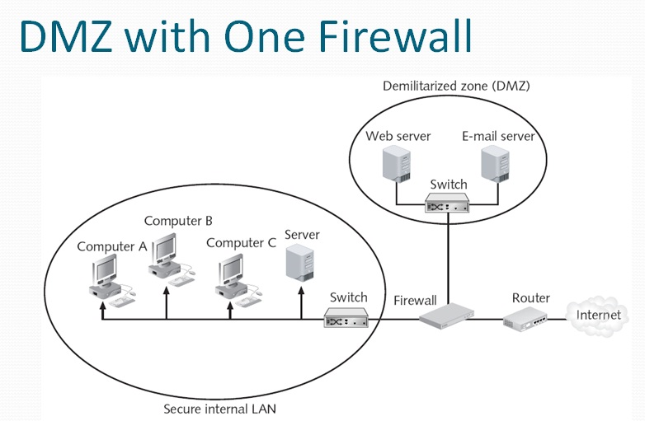

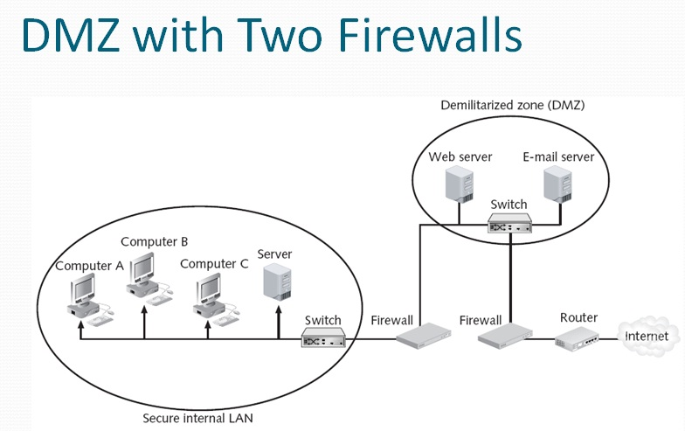

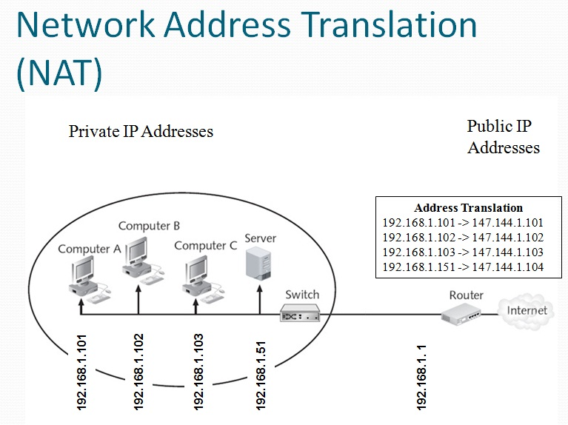

Network Address Translation (NAT)

Hides the IP addresses of network devices from attackers

Private addresses

IP addresses not assigned to any specific user or organization

Function as regular IP addresses on an internal network

Non-routable addresses--traffic addressed to private addresses is discarded by Internet routers

NAT removes the private IP address from the sender’s packet

And replaces it with an alias IP address

When a packet is returned to NAT, the process is reversed

An attacker who captures the packet on the Internet cannot determine the actual IP address of the sender

Port Address Translation (PAT)

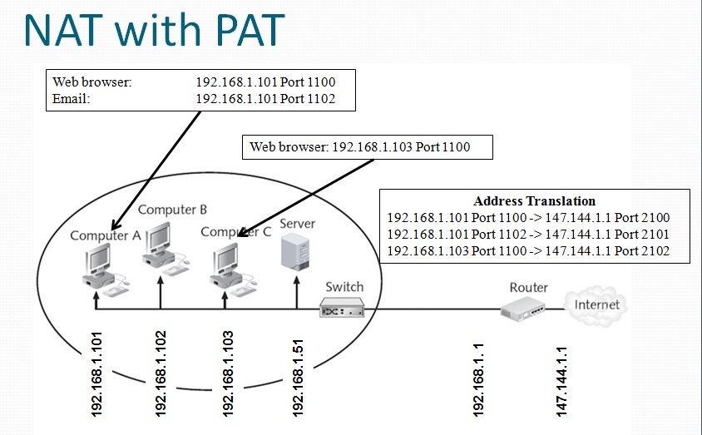
Normally performed along with NAT

Each packet is given the same IP address but a different TCP port number

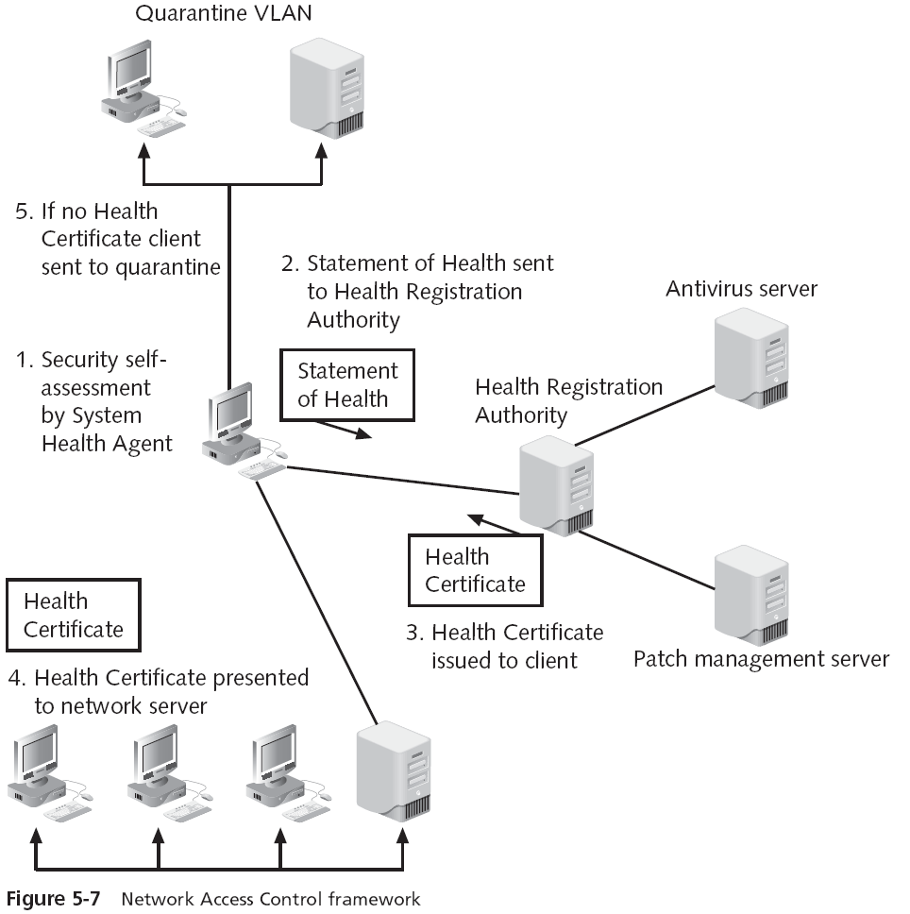
Allows many machines to share the same public IP address

Network Access Control (NAC)

Examines a computer before it is allowed to connect to the network

Each computer must meet security policy first, such as

Windows patches up to date

Antivirus software

Antispyware software

Etc.

Any device that does not meet the policy is only allowed to connect to a “quarantine” network where the security deficiencies are corrected

Applying Network Security Devices

Network Security Devices

Firewalls

Proxy servers

Honeypots

Network intrusion detection systems

Host and network intrusion prevention systems

Protocol analyzers

Internet content filters

Integrated network security hardware

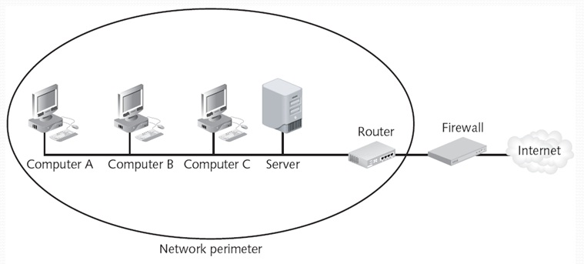
Firewall

Typically used to filter packets

Sometimes called a packet filter

Designed to prevent malicious packets from entering the network

A firewall can be software-based or hardware-based

Hardware firewalls usually are located outside the network security perimeter

As the first line of defense

The basis of a firewall is a rule base

Establishes what action the firewall should take when it receives a packet (allow, block, and prompt)

Stateless packet filtering

Looks at the incoming packet and permits or denies it based strictly on the rule base
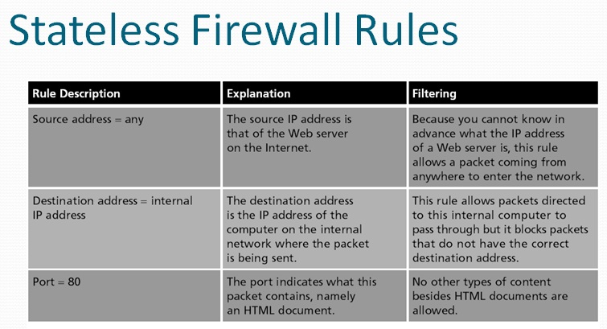

Stateful packet filtering

Keeps a record of the state of a connection between an internal computer and an external server

Then makes decisions based on the connection as well as the rule base

Stateless Firewall Rules

This rule is added to the Stateless Firewall Rules

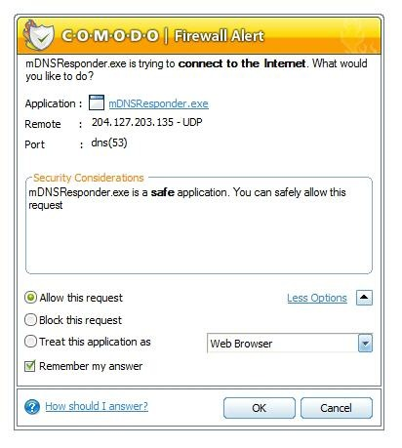
Note error in textbook in left column, 3rd row

Inbound and Outbound Traffic Filtering

Most personal software firewalls today also filter outbound traffic as well as inbound traffic

Filtering outbound traffic protects users by preventing malware from connecting to other computers and spreading

But it annoys them with these alerts

Proxy Server

Clients never directly connect to the Internet

This saves bandwidth, because one copy of a popular Web page can be used many times

Allows a company to block forbidden Web sites

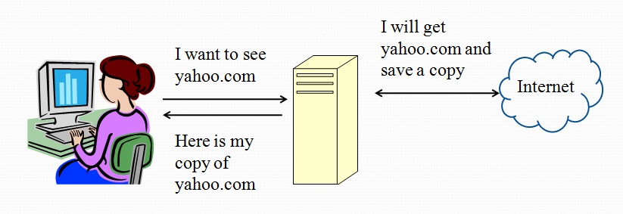
It also prevents many attacks the same way NAT does

Clients never directly connect to the Internet

This saves bandwidth, because one copy of a popular Web page can be used many times

Allows a company to block forbidden Web sites

It also prevents many attacks the same way NAT does

Reverse proxy

Does not serve clients but instead routes incoming requests to the correct server

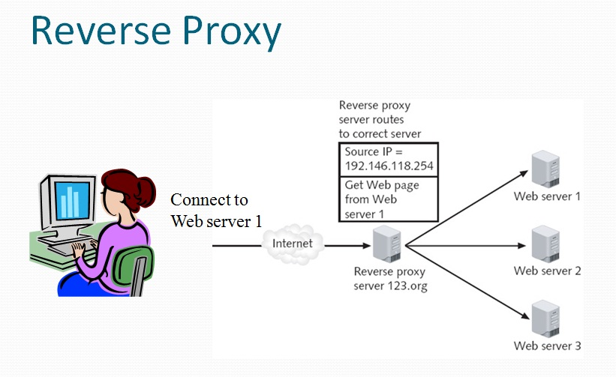

Honeypot

Intended to trap or trick attackers

A computer typically located in a DMZ that is loaded with software and data files that appear to be authentic

Yet they are actually imitations of real data files

Three primary purposes of a honeypot:

Deflect attention

Early warnings of new attacks

Examine attacker techniques

Network Intrusion Detection Systems (NIDS)

Network intrusion detection system (NIDS)

Watches for attempts to penetrate a network

NIDS work on the principle of comparing new behavior against normal or acceptable behavior

A NIDS looks for suspicious patterns

Passive intrusion detection just logs the traffic and sends alerts
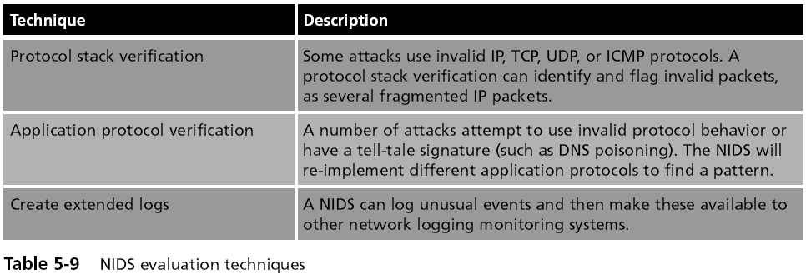

Intrusion Prevention Systems

Finds malicious traffic and deals with it immediately

Also called Active Intrusion Detection

A typical IPS response may be to block all incoming traffic on a specific port

Host Intrusion Prevention Systems (HIPS)

Installed on each system that needs to be protected

Rely on agents installed directly on the system being protected

Work closely with the operating system, monitoring and intercepting requests in order to prevent attacks

Most HIPS monitor the following desktop functions:

System calls

File system access

System Registry settings

Host input/output

HIPS are designed to integrate with existing antivirus, anti-spyware, and firewalls

HIPS provide an additional level of security that is proactive instead of reactive

Network Intrusion Prevention Systems (NIPS)

Work to protect the entire network and all devices that are connected to it

By monitoring network traffic NIPS can immediately react to block a malicious attack

NIPS are special-purpose hardware platforms that analyze, detect, and react to security-related events

Can drop malicious traffic based on their configuration or security policy

Protocol Analyzers

Three ways for detecting a potential intrusion

Detecting statistical anomalies (unusual traffic)

Examine network traffic and look for well-known patterns of attack

Use protocol analyzer technology

Protocol analyzers

Can fully decode application-layer network protocols

Parts of the protocol can be analyzed for any suspicious behavior

Such as an overly long User-Agent field in an HTTP GET request

Internet Content Filters

Internet content filters

Monitor Internet traffic and block access to preselected Web sites and files

A requested Web page is only displayed if it complies with the specified filters

Unapproved Web sites can be restricted based on the Uniform Resource Locator (URL) or by matching keywords
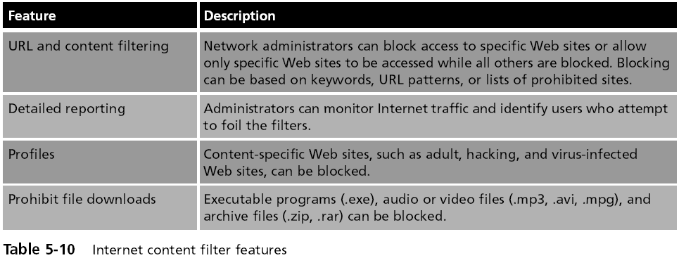

Integrated Network Security Hardware

Types of hardware security appliances:

Dedicated security appliances provide a single security service

Multipurpose security appliances that provide multiple security functions

Integrated network security hardware

Combines or integrates multipurpose security appliances with a traditional network device such as a switch or router

Particularly attractive for networks that use IDS

Last modified 2-20-09

