
TJX Data Breach

TJX used WEP security

They lost 45 million customer records

They settled the lawsuits for $40.9 million

Link Ch 6a

Objectives

Describe the basic IEEE 802.11 wireless security protections

Define the vulnerabilities of open system authentication, WEP, and device authentication

Describe the WPA and WPA2 personal security models

Explain how enterprises can implement wireless security
IEEE 802.11 Wireless Security Protections

Institute of Electrical and Electronics Engineers (IEEE)

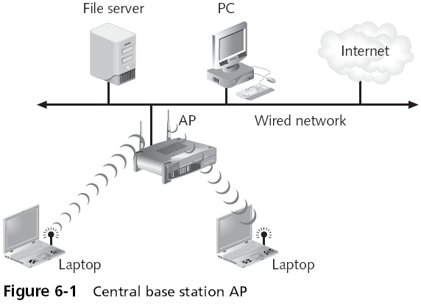
In the early 1980s, the IEEE began work on developing computer network architecture standards

This work was called Project 802

In 1990, the IEEE formed a committee to develop a standard for WLANs (Wireless Local Area Networks)

At that time WLANs operated at a speed of 1 to 2 million bits per second (Mbps)

IEEE 802.11 WLAN Standard

In 1997, the IEEE approved the IEEE 802.11 WLAN standard

Revisions

IEEE 802.11a

IEEE 802.11b

IEEE 802.11g

IEEE 802.11n

Controlling Access to a WLAN

Access is controlled by limiting a device’s access to the access point (AP)

Only devices that are authorized can connect to the AP

One way: Media Access Control (MAC) address filtering

CCSF uses this technique (unfortunately)

See www.ccsf.edu/wifi

MAC Address Filtering
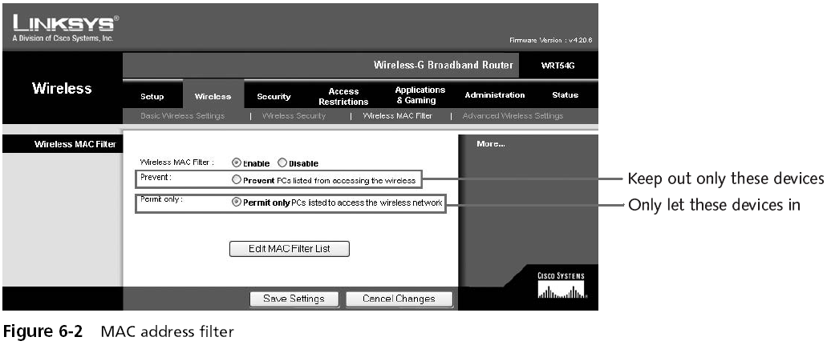

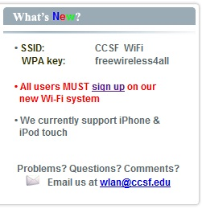

MAC Address Filtering

Usually implemented by permitting instead of preventing

CCSF does this

www.ccsf.edu/wifi

Wired Equivalent Privacy (WEP)

Designed to ensure that only authorized parties can view transmitted wireless information

Uses encryption to protect traffic

WEP was designed to be:

Efficient and reasonably strong

WEP Keys

WEP secret keys can be 64 or 128 bits long

The AP and devices can hold up to four shared secret keys

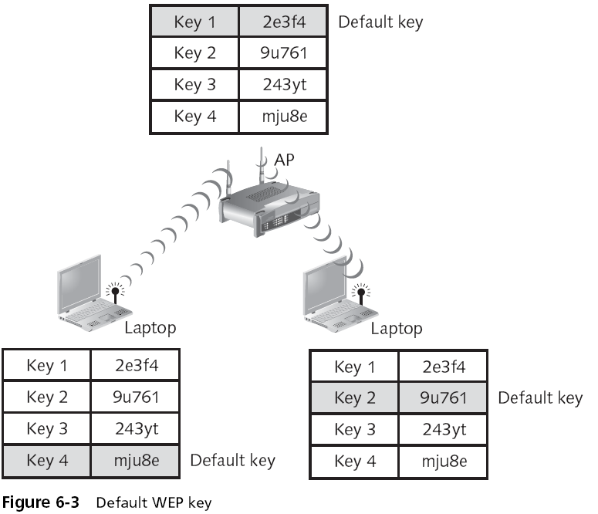
One of which must be designated as the default key

WEP Encryption Process
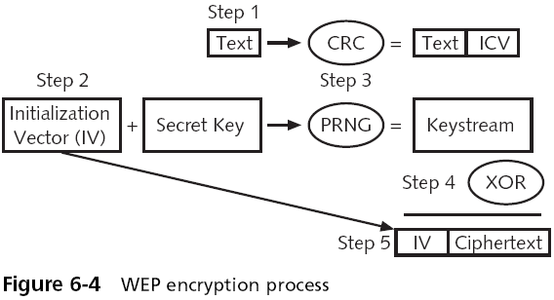

Transmitting with WEP
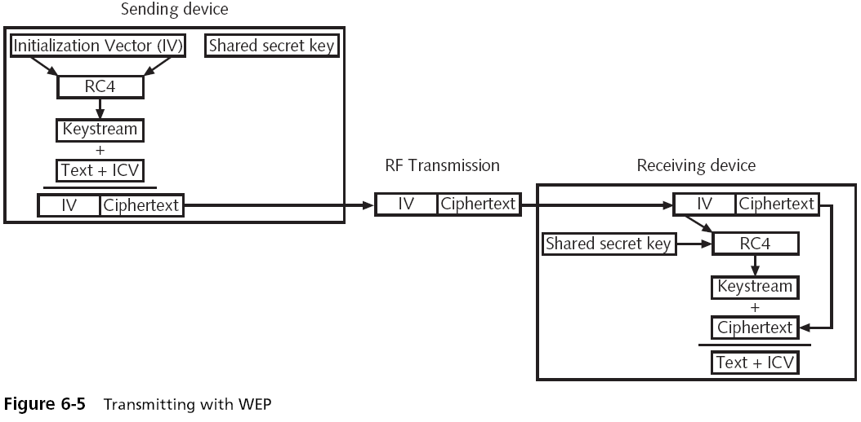

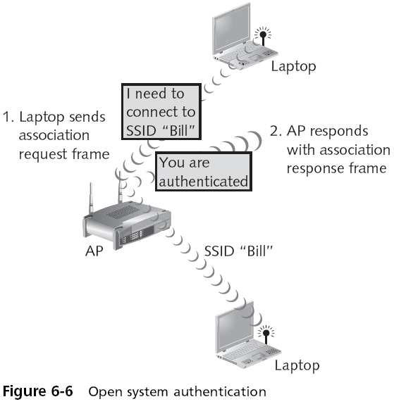

Device Authentication

Before a computer can connect to a WLAN, it must be authenticated

Types of authentication in 802.11

Open system authentication

Lets everyone in

Shared key authentication

Only lets computers in if they know the shared key

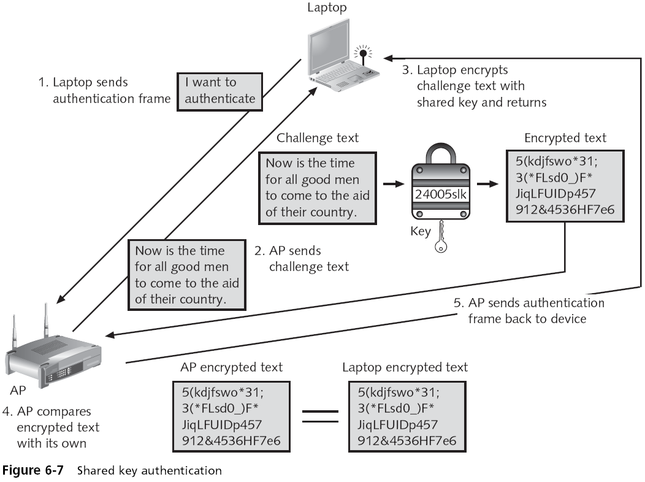

Vulnerabilities of IEEE 802.11 Security

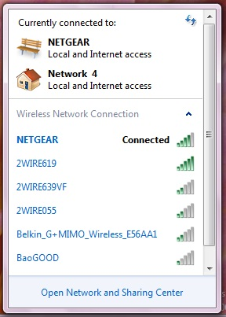
Open system authentication

MAC address filtering

WEP

Open System Authentication

To connect, a computer needs the SSID (network name)

Routers normally send out beacon frames announcing the SSID

Passive scanning

A wireless device listens for a beacon frame

Turning Off Beaconing

For "security" some people turn off beacons

This annoys your legitimate users, who must now type in the SSID to connect

It doesn't stop intruders, because the SSID is sent out in management frames anyway

It can also affect roaming

Windows XP prefers networks that broadcast

MAC Address Filtering Weaknesses

MAC addresses are transmitted in the clear

An attacker can just sniff for MACs

Managing a large number of MAC addresses is difficult

MAC address filtering does not provide a means to temporarily allow a guest user to access the network

Other than manually entering the user’s MAC address into the access point

WEP

To encrypt packets WEP can use only a 64-bit or 128-bit number

Which is made up of a 24-bit initialization vector (IV) and a 40-bit or 104-bit default key

The 24-bit IV is too short, and repeats before long

In addition, packets can be replayed to force the access point to pump out IVs

Cracking WEP

With the right equipment, WEP can be cracked in just a few minutes

You need a special wireless card

We do it in CNIT 123: Ethical Hacking and Network Defense
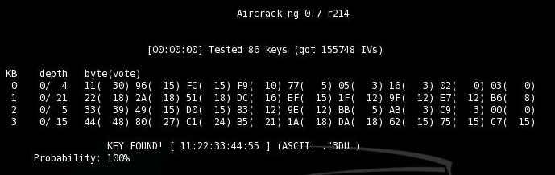

Personal Wireless Security

WPA Personal Security

WPA2 Personal Security

WPA Personal Security

Wireless Ethernet Compatibility Alliance (WECA)

A consortium of wireless equipment manufacturers and software providers

WECA goals:

To encourage wireless manufacturers to use the IEEE 802.11 technologies

To promote and market these technologies

To test and certify that wireless products adhere to the IEEE 802.11 standards to ensure product interoperability

In 2002, the WECA organization changed its name to Wi-Fi (Wireless Fidelity) Alliance

In October 2003 the Wi-Fi Alliance introduced Wi-Fi Protected Access (WPA)

WPA had the design goal to protect both present and future wireless devices, addresses both wireless authentication and encryption

PSK addresses authentication and TKIP addresses encryption

Preshared key (PSK) authentication

Uses a passphrase to generate the encryption key

Key must be entered into both the access point and all wireless devices

Prior to the devices communicating with the AP

The PSK is not used for encryption

Instead, it serves as the starting point (seed) for mathematically generating the encryption keys

Temporal Key Integrity Protocol (TKIP)

WPA replaces WEP with TKIP

TKIP advantages:

TKIP uses a longer 128-bit key

TKIP uses a new key for each packet

Message Integrity Check (MIC)

WPA also replaces the (CRC) function in WEP with the Message Integrity Check (MIC)

Designed to prevent an attacker from capturing, altering, and resending data packets

See link Ch 6b

WPA2 Personal Security

Wi-Fi Protected Access 2 (WPA2)

Introduced by the Wi-Fi Alliance in September 2004

The second generation of WPA security

Still uses PSK (Pre-Shared Key) authentication

But instead of TKIP encryption it uses a stronger data encryption method called AES-CCMP

PSK Authentication

Intended for personal and small office home office users who do not have advanced server capabilities

PSK keys are automatically changed and authenticated between devices after a specified period of time known as the rekey interval

PSK Key Management Weaknesses

People may send the key by e-mail or another insecure method

Changing the PSK key is difficult

Must type new key on every wireless device and on all access points

In order to allow a guest user to have access to a PSK WLAN, the key must be given to that guest

Pre-Shared Key Weakness

A PSK is a 64-bit hexadecimal number

Usually generated from a passphrase

Consisting of letters, digits, punctuation, etc. that is between 8 and 63 characters in length

If the passphrase is a common word, it can be found with a dictionary attack

Cracking WPA
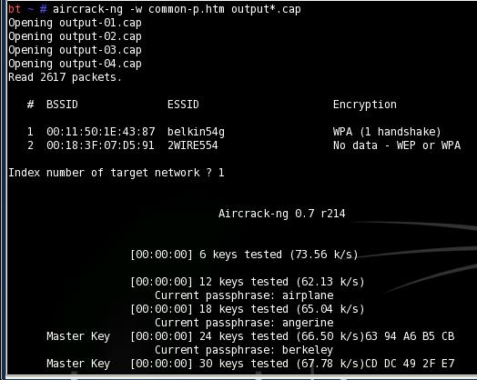

WPA2 Personal Security (continued)

AES-CCMP Encryption

Encryption under the WPA2 personal security model is accomplished by AES-CCMP

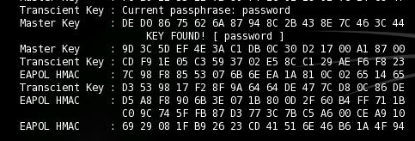
This encryption is so complex that it requires special hardware to be added to the access points to perform it

WPA and WPA2 Compared
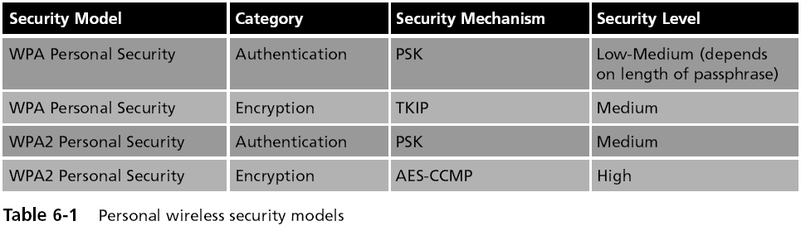

Enterprise Wireless Security

Two models:

IEEE 802.11i

WPA and WPA2 models

IEEE 802.11i

Improves encryption and authentication

Encryption

Replaces WEP’s original PRNG RC4 algorithm

With a stronger cipher that performs three steps on every block (128 bits) of plaintext

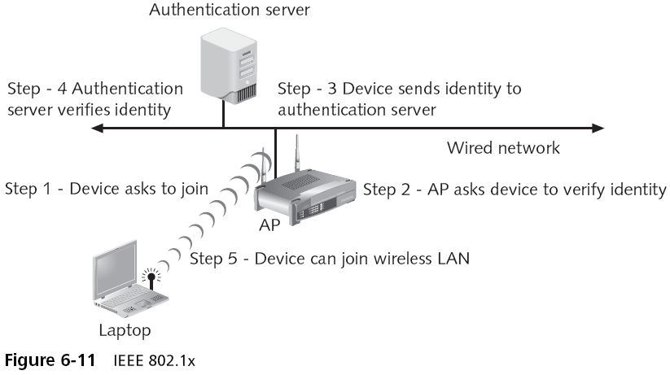
IEEE 802.11i

IEEE 802.11i authentication and key management is accomplished by the IEEE 802.1x standard

802.1x Authentication

IEEE 802.11i (continued)

Key-caching

Remembers a client, so if a user roams away from a wireless access point and later returns, she does not need to re-enter her credentials

Pre-authentication

Allows a device to become authenticated to an AP before moving into range of the AP

Authentication packet is sent ahead

WPA Enterprise Security

Designed for medium to large-size organizations

Improved authentication and encryption

The authentication used is IEEE 802.1x and the encryption is TKIP

WPA Enterprise Security (continued)

IEEE 802.1x Authentication

Provides an authentication framework for all IEEE 802-based LANs

Does not perform any encryption

TKIP Encryption

An improvement on WEP encryption

Designed to fit into the existing WEP procedure

WPA2 Enterprise Security

The most secure method

Authentication uses IEEE 802.1x

Encryption is AES-CCMP

Enterprise Wireless Security Models
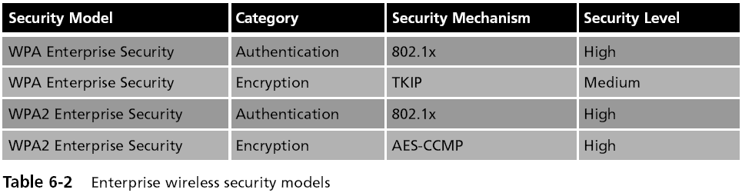

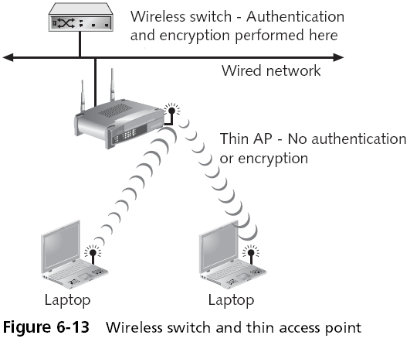
Enterprise Wireless Security Devices

Thin Access Point

An access point without the authentication and encryption functions

These features reside on the wireless switch

Advantages

The APs can be managed from one central location

All authentication is performed in the wireless switch

Wireless VLANs

Can segment traffic and increase security

The flexibility of a wireless VLAN depends on which device separates the packets and directs them to different networks
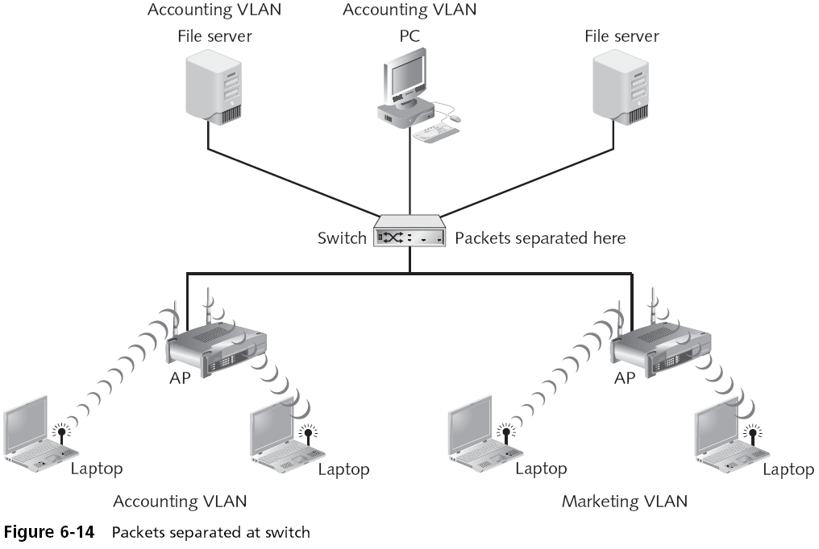

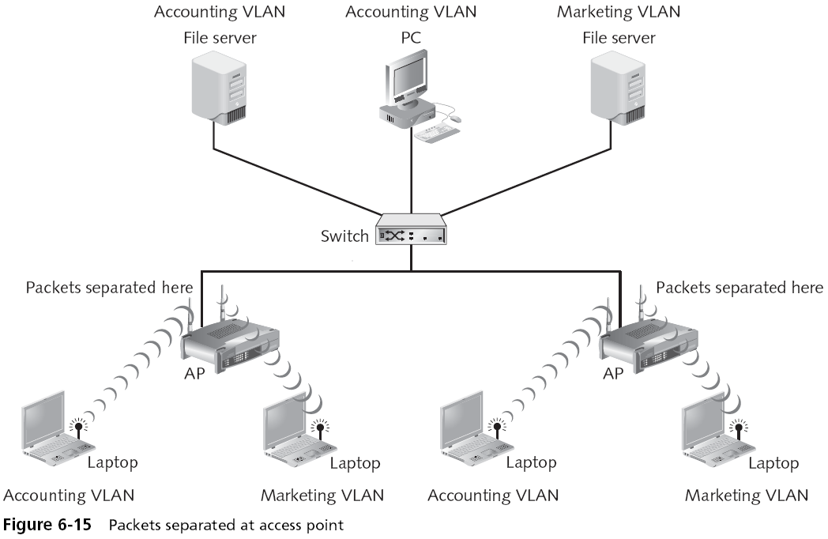

Enterprise Wireless Security Devices (continued)

For enhanced security, set up two wireless VLANs

One for employee access

One for guest access

Rogue Access Point Discovery Tools

Wireless protocol analyzer

Auditors carry it around sniffing for rogue access points

For more security, set up wireless probes to monitor the RF frequency

Types of Wireless Probes

Wireless device probe

Desktop probe

Access point probe

Dedicated probe

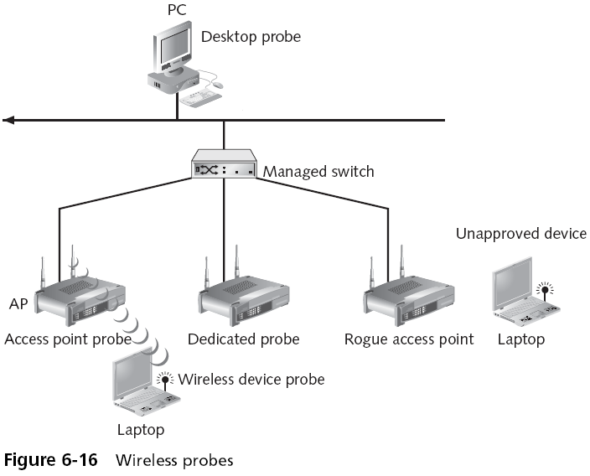

Last modified 2-27-09

