Jérôme Kerviel

Rogue trader, lost €4.9 billion

Largest fraud in banking history at that time

Worked in the compliance department of a French bank

Defeated security at his bank by concealing transactions with other transactions

Arrested in Jan 2008, out and working at a computer consulting firm in April 2008

Links Ch7a, 7b

Objectives

Define access control and list the four access control models

Describe logical access control methods

Explain the different types of physical access control

What Is Access Control?

Access Control

The process by which resources or services are granted or denied on a computer system or network

There are four standard access control models as well as specific practices used to enforce access control

Access Control Terminology

Identification

A user accessing a computer system would present credentials or identification, such as a username

Authentication

Checking the user’s credentials to be sure that they are authentic and not fabricated, usually using a password

Authorization

Granting permission to take the action

A computer user is granted access

To only certain services or applications in order to perform their duties

Custodian

The person who reviews security settings

Also called Administrator

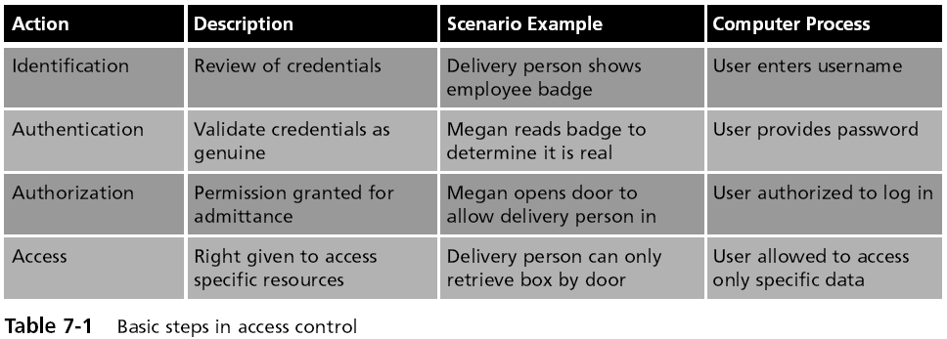

Computer access control can be accomplished by one of three entities: hardware, software, or a policy

Access control can take different forms depending on the resources that are being protected

Other terminology is used to describe how computer systems impose access control:

Object – resource to be protected

Subject – user trying to access the object

Operation – action being attempted

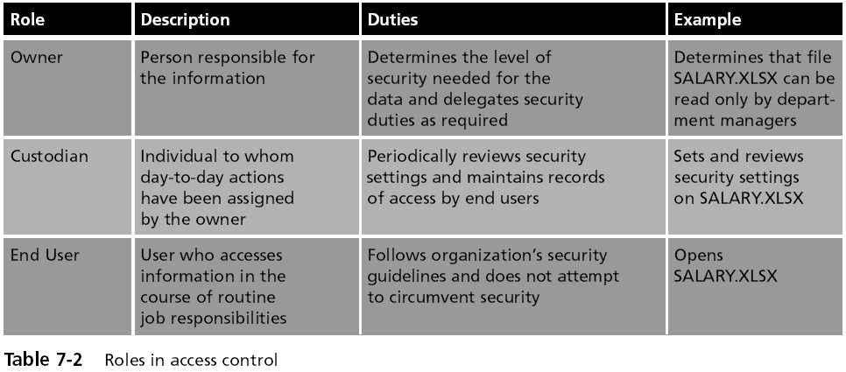

Access Control Models

Mandatory Access Control

Discretionary Access Control

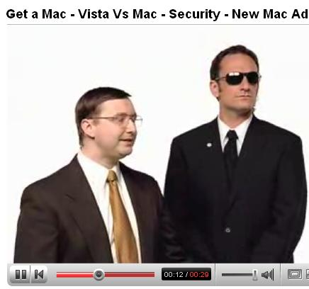
Role-Based Access Control

Rule-Based Access Control

Mandatory Access Control (MAC) model

Most restrictive model—used by the military

Objects and subjects are assigned access levels

Unclassified, Classified, Secret, Top Secret

The end user cannot implement, modify, or transfer any controls

Discretionary Access Control (DAC) model

The least restrictive--used by Windows computers in small networks

A subject has total control over any objects that he or she owns

Along with the programs that are associated with those objects

In the DAC model, a subject can also change the permissions for other subjects over objects

DAC Has Two Significant Weaknesses

It relies on the end-user subject to set the proper level of security

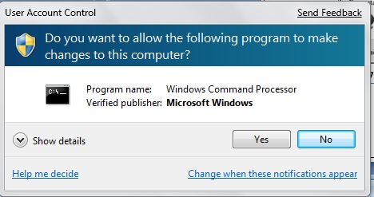
A subject’s permissions will be “inherited” by any programs that the subject executes

User Account Control--Cruel Mac Video

Link Ch 7c

User Account Control (UAC)

Asks the user for permission when installing software

Principle of least privilege

Users run with limited privileges by default

Applications run in standard user accounts

Standard users can perform common tasks

Role Based Access Control (RBAC) model

Sometimes called Non-Discretionary Access Control

Used in Windows corporate domains

Considered a more “real world” approach than the other models

Assigns permissions to particular roles in the organization, such as “Manager” and then assigns users to that role

Objects are set to be a certain type, to which subjects with that particular role have access

Rule Based Access Control (RBAC) model

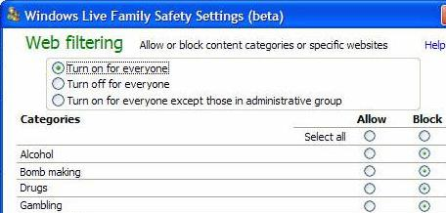
Also called the Rule-Based Role-Based Access Control (RB-RBAC) model or automated provisioning

Controls access with rules defined by a custodian

Example: Windows Live Family Safety

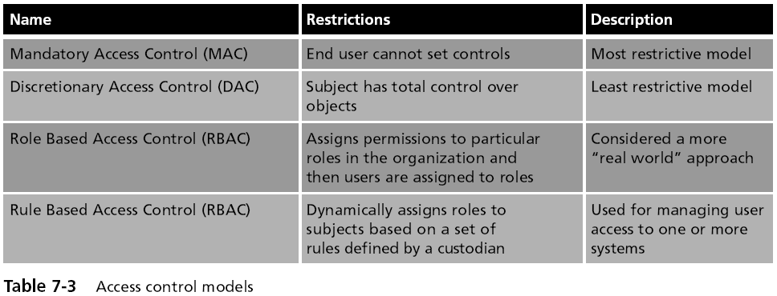

Best Practices for Access Control

Separation of duties

No one person should control money or other essential resources alone

Network administrators often have too much power and responsibility

Job rotation

Individuals are periodically moved from one job responsibility to another

Least privilege

Each user should be given only the minimal amount of privileges necessary to perform his or her job function

Implicit deny

If a condition is not explicitly met, access is denied

For example, Web filters typically block unrated sites

Logical Access Control Methods

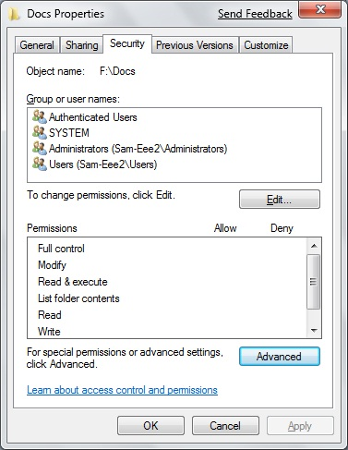
Access Control Methods

The methods to implement access control are divided into two broad categories

Physical access control and

Logical access control

Logical access control includes

Access control lists (ACLs)

Group policies

Account restrictions

Passwords

Access Control List (ACL)

A set of permissions attached to an object

Specifies which subjects are allowed to access the object

And what operations they can perform on it

Every file and folder has an ACL

Access control entry (ACE)

Each entry in the ACL table in the Microsoft Windows, Linux, and Mac OS X operating systems

Windows Access Control Entries (ACEs)

In Windows, the ACE includes

Security identifier (SID) for the user or group

Access mask that specifies the access rights controlled by the ACE

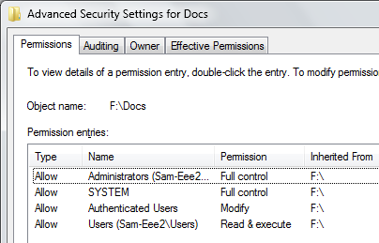
A flag that indicates the type of ACE

A set of flags that determine whether objects can inherit permissions

Advanced Security Settings in Windows 7 Beta

Group Policy

A Microsoft Windows feature that provides centralized management and configuration of computers and remote users

Using the Microsoft directory services known as Active Directory (AD)

Group Policy is used in corporate domains to restrict user actions that may pose a security risk

Group Policy settings are stored in Group Policy Objects (GPOs)

Account Restrictions

Time of day restrictions

Limit when a user can log on to a system

These restrictions can be set through a Group Policy

Can also be set on individual systems

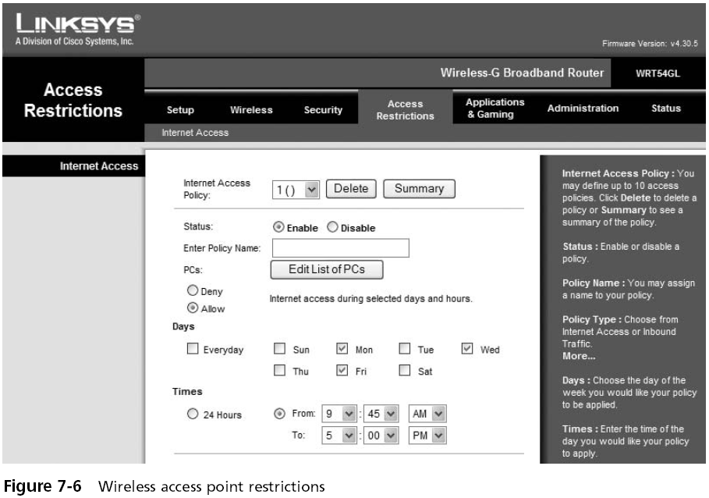

Account expiration

The process of setting a user’s account to expire

Orphaned accounts are user accounts that remain active after an employee has left an organization

Can be controlled using account expiration

Passwords

The most common logical access control

Sometimes referred to as a logical token

A secret combination of letters and numbers that only the user knows

A password should never be written down

Must also be of a sufficient length and complexity so that an attacker cannot easily guess it (password paradox)

Passwords Myths

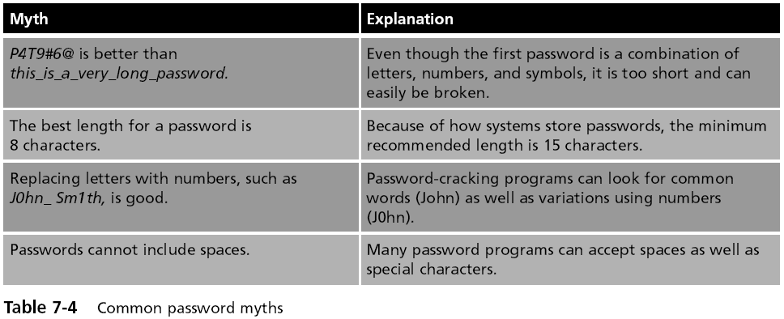

Attacks on Passwords

Brute force attack

Simply trying to guess a password through combining a random combination of characters

Passwords typically are stored in an encrypted form called a “hash”

Attackers try to steal the file of hashed passwords and then break the hashed passwords offline

How to Get the Hashes

Easy way: Just use Cain, Cracker tab, right-click, "Add to List"

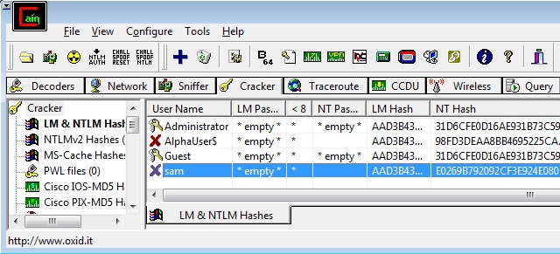

Attacks on Passwords

Dictionary attack

Guess passwords from a dictionary

Works if the password is a known common password

Rainbow tables

Make password attacks faster by creating a large pregenerated data set of hashes from nearly every possible password combination

Works well against Windows passwords because Microsoft doesn't use the salting technique when computing hashes

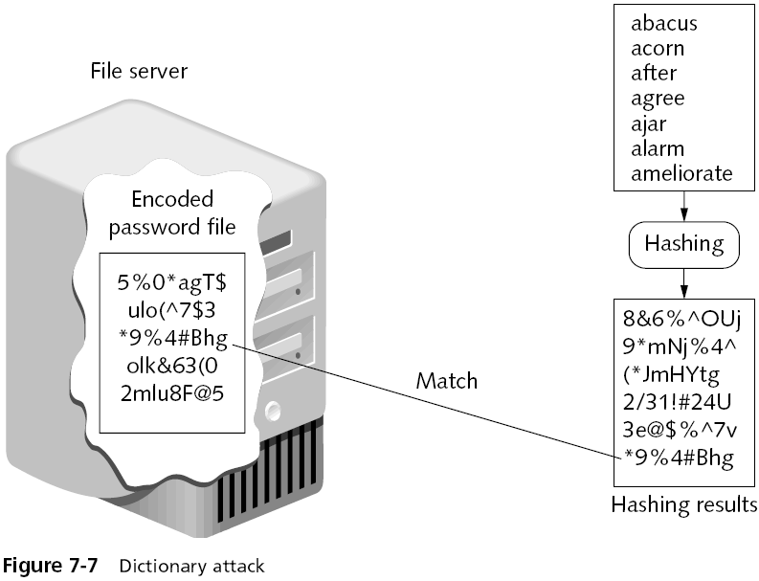

Rainbow Tables

Generating a rainbow table requires a significant amount of time

Rainbow table advantages

Can be used repeatedly for attacks on other passwords

Rainbow tables are much faster than dictionary attacks

The amount of time needed on the attacking machine is greatly reduced

Rainbow Table Attack

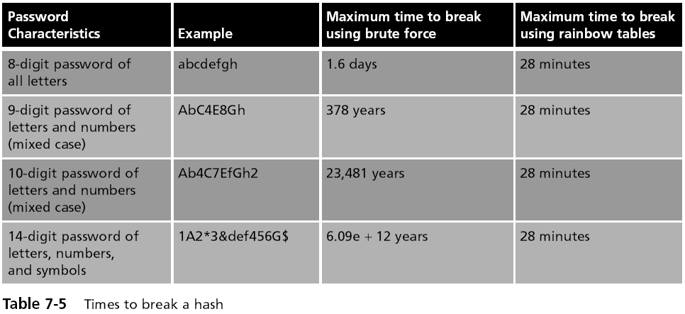

Passwords (continued)

One reason for the success of rainbow tables is how older Microsoft Windows operating systems hash passwords

A defense against breaking encrypted passwords with rainbow tables

Hashing algorithm should include a random sequence of bits as input along with the user-created password

These random bits are known as a salt

Make brute force, dictionary, and rainbow table attacks much more difficult

No Salt!

To make hashing stronger, add a random "Salt" to a password before hashing it

Windows doesn't salt its hash!

Two accounts with the same password hash to the same result, even in Windows 7 Beta!

This makes it possible to speed up password cracking with precomputed Rainbow Tables

Demonstration

Here are two accounts on a Windows 7 Beta machine with the password 'password'

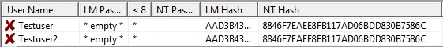

This hash is from a different Windows 7 Beta machine

Linux Salts its Hashes

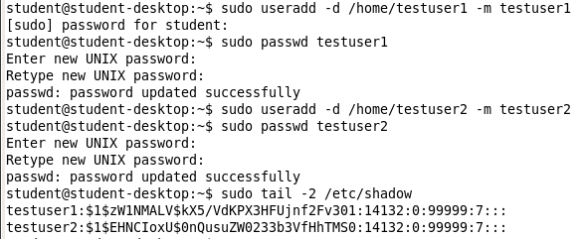

Password Policy

A strong password policy can provide several defenses against password attacks

The first password policy is to create and use strong passwords

One of the best defenses against rainbow tables is to prevent the attacker from capturing the password hashes

A final defense is to use another program to help keep track of passwords

Domain Password Policy

Setting password restrictions for a Windows domain can be accomplished through the Windows Domain password policy

There are six common domain password policy settings, called password setting objects

Used to build a domain password policy

Physical Access Control

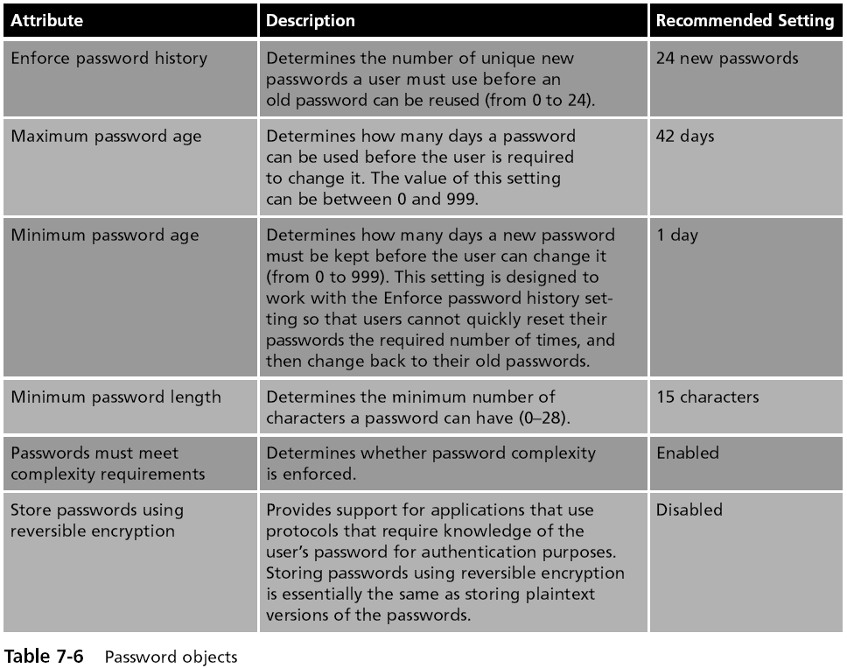
Physical Access Control

Physical access control primarily protects computer equipment

Designed to prevent unauthorized users from gaining physical access to equipment in order to use, steal, or vandalize it

Physical access control includes computer security, door security, mantraps, video surveillance, and physical access logs

Physical Computer Security

Physically securing network servers in an organization is essential

Rack-mounted servers

4.45 centimeters (1.75 inches) tall

Can be stacked with up to 50 other servers in a closely confined area

KVM (Keyboard, Video, Mouse) Switch

Needed to connect to the servers

Can be password-protected

KVM Switch

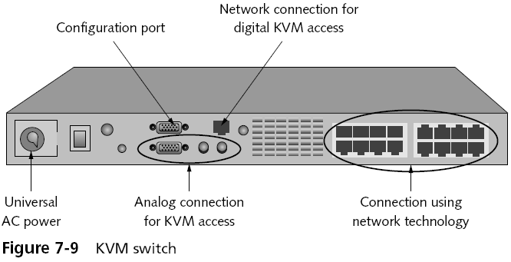
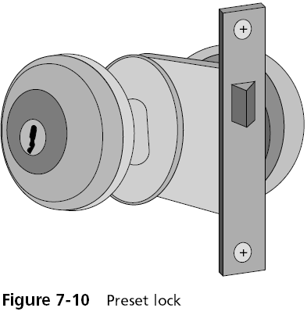

Door Security

Hardware locks

Preset lock

Also known as the key-in-knob lock

The easiest to use because it requires only a key for unlocking the door from the outside

Automatically locks behind the person, unless it has been set to remain unlocked

Security provided by a preset lock is minimal

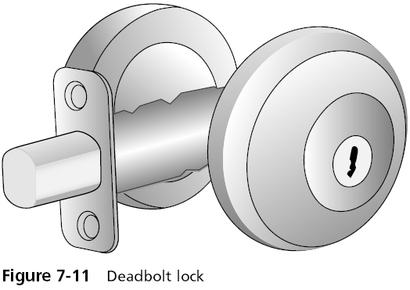
Deadbolt lock

Extends a solid metal bar into the door frame

Much more difficult to defeat than preset locks

Requires that the key be used to both open and lock the door

Lock Best Practices

Change locks immediately upon loss or theft of keys

Inspect all locks on a regular basis

Issue keys only to authorized persons

Keep records of who uses and turns in keys

Keep track of keys issued, with their number and identification

Master keys should not have any marks identifying them as masters

Lock Best Practices

Secure unused keys in a locked safe

Set up a procedure to monitor the use of all locks and keys and update the procedure as necessary

When making duplicates of master keys, mark them “Do Not Duplicate,” and wipe out the manufacturer’s serial numbers to keep duplicates from being ordered

Lockpicking at DEFCON

See links Ch 7e, 7f

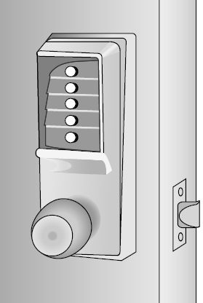
Cipher Lock

Combination locks that use buttons that must be pushed in the proper sequence to open the door

Can be programmed to allow only the code of certain individuals to be valid on specific dates and times

Cipher locks also keep a record of when the door was opened and by which code

Cipher locks are typically connected to a networked computer system

Can be monitored and controlled from one central location

Cipher Lock Disadvantages

Basic models can cost several hundred dollars while advanced models can be even more expensive

Users must be careful to conceal which buttons they push to avoid someone seeing or photographing the combination

Tailgate Sensor

Uses infrared beams that are aimed across a doorway

Can detect if a second person walks through the beam array immediately behind (“tailgates”) the first person

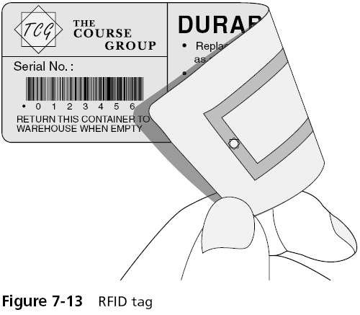
Without presenting credentials

Physical Tokens

Objects to identify users

ID Badge

The most common types of physical tokens

ID badges originally were visually screened by security guards

Today, ID badges can be fitted with tiny radio frequency identification (RFID) tags

Can be read by an RFID transceiver as the user walks through the door with the badge in her pocket

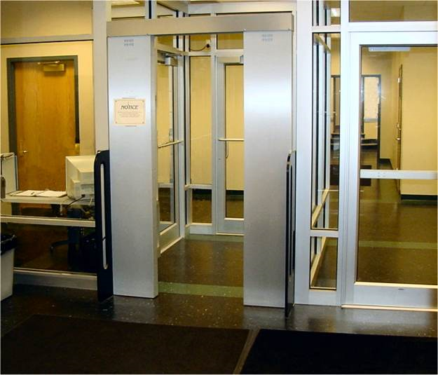
Mantrap

Before entering a secure area, a person must enter the mantrap

A small room like an elevator

If their ID is not valid, they are trapped there until the police arrive

Mantraps are used at high-security areas where only authorized persons are allowed to enter

Such as sensitive data processing areas, cash handling areas, critical research labs, security control rooms, and automated airline passenger entry portals

Video Surveillance

Closed circuit television (CCTV)

Using video cameras to transmit a signal to a specific and limited set of receivers

Some CCTV cameras are fixed in a single position pointed at a door or a hallway

Other cameras resemble a small dome and allow the security technician to move the camera 360 degrees for a full panoramic view

Physical Access Log

A record or list of individuals who entered a secure area, the time that they entered, and the time they left the area

Can also identify if unauthorized personnel have accessed a secure area

Physical access logs originally were paper documents

Today, door access systems and physical tokens can generate electronic log documents

Last modified 3-7-09

