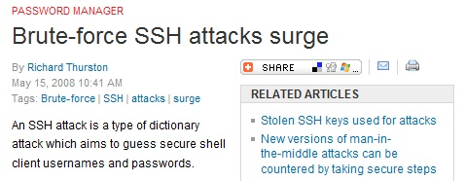
Objectives

Define authentication

Authentication credentials

Authentication models

Authentication servers

Extended authentication protocols

Virtual Private Network (VPN)

Password-Guessing Attacks Surge

Slow guessing and botnets conceal the attacks

Countermeasures

Strong password policy, restricting access to server by source IP, two-factor authentication

Link Ch 8a
Definition of Authentication

Definition of Authentication

Authentication can be defined in two contexts

The first is viewing authentication as it relates to access control

The second is to look at it as one of the three key elements of security:

Authentication

Authorization

Accounting

Authentication and Access Control Terminology

Access control is the process by which resources or services are granted or denied

Identification

The presentation of credentials or identification

Authentication

The verification of the credentials to ensure that they are genuine and not fabricated

Authorization

Granting permission for admittance

Access is the right to use specific resources

Authentication, Authorization, and Accounting (AAA)

Authentication in AAA provides a way of identifying a user

Typically with a password

Authorization determines whether the user has the authority to carry out certain tasks

The process of enforcing policies

Accounting measures the resources a user “consumes” during each network session

Uses of Accounting DATA

To find evidence of problems

For billing

For planning

AAA servers

Servers dedicated to performing AAA functions

Can provide significant advantages in a network

Authentication Credentials

Authentication Credentials

Credentials are something you have, something you are, or something you know

Types of authentication credentials

Passwords

One-time passwords

Standard biometrics

Behavioral biometrics

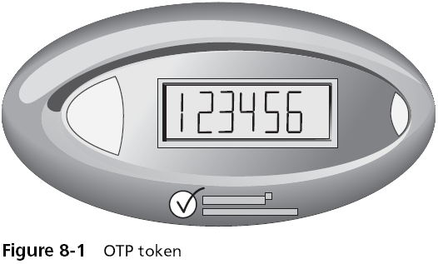
Cognitive biometrics

One-Time Passwords

Standard passwords are typically static in nature

One-time passwords (OTP)

Dynamic passwords that change frequently

Systems using OTPs generate a unique password on demand that is not reusable

The most common type is a time-synchronized OTP

Used in conjunction with a token

The token and a corresponding authentication server share the same algorithm

Each algorithm is different for each user’s token

Challenge-Based OTPs

Authentication server displays a challenge (a random number) to the user

User then enters the challenge number into the token

Which then executes a special algorithm to generate a password

Because the authentication server has this same algorithm, it can also generate the password and compare it against that entered by the user
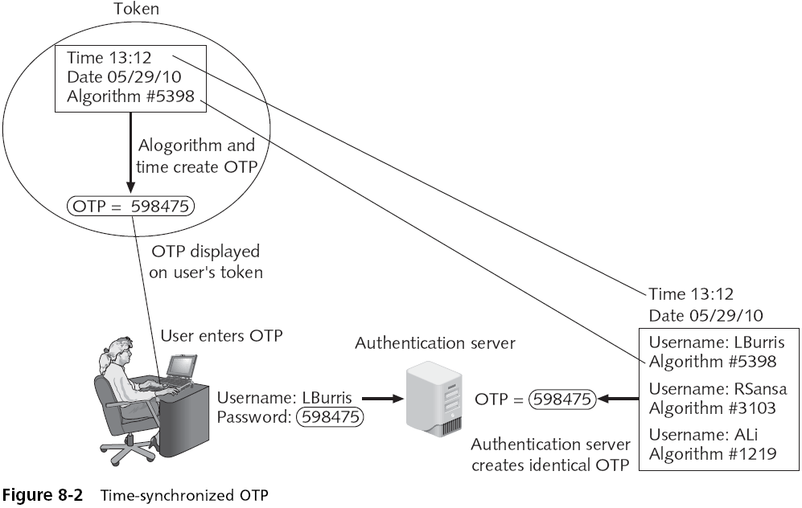

Standard Biometrics

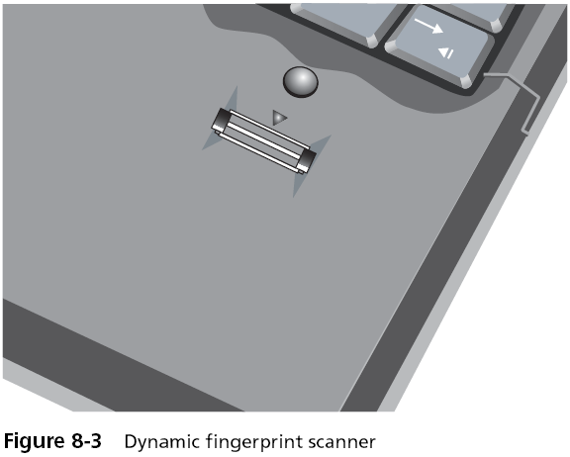
Uses a person’s unique characteristics for authentication (what he is)

Examples: fingerprints, faces, hands, irises, retinas

Types of fingerprint scanners

Static fingerprint scanner

Dynamic fingerprint scanner (more secure)

Disadvantages

Costs

Readers are not always foolproof

How can you change your password it it's your fingerprint?

Dynamic Fingerprint Scanner

Behavioral Biometrics

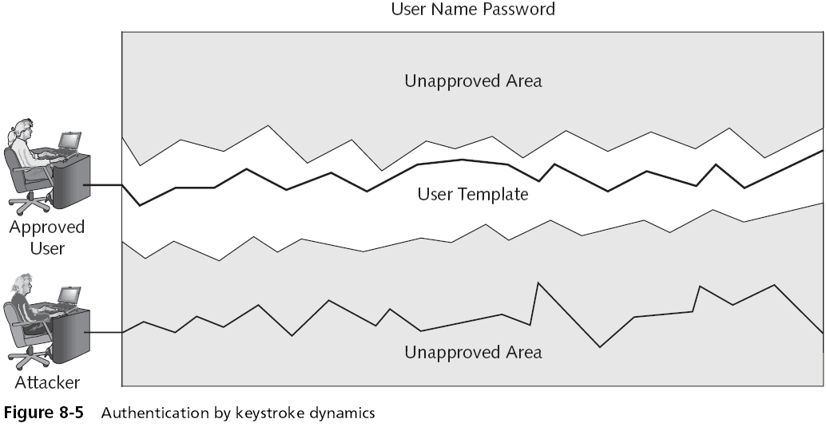
Authenticates by normal actions that the user performs

Keystroke dynamics

Attempt to recognize a user’s unique typing rhythm

Keystroke dynamics uses two unique typing variables

Dwell time

Flight time

Voice recognition

Uses unique characteristics of a person’s voice

Phonetic cadence

Speaking two words together in a way that one word “bleeds” into the next word

Becomes part of each user’s speech pattern

Computer footprint

When and from where a user normally accesses a system

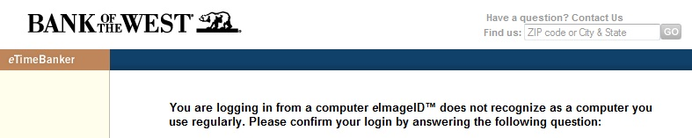
Computer Footprinting in Online Banking

A simple form of two-factor authentication

Required by the US now

Links Ch 8b, c, d

Cognitive Biometrics

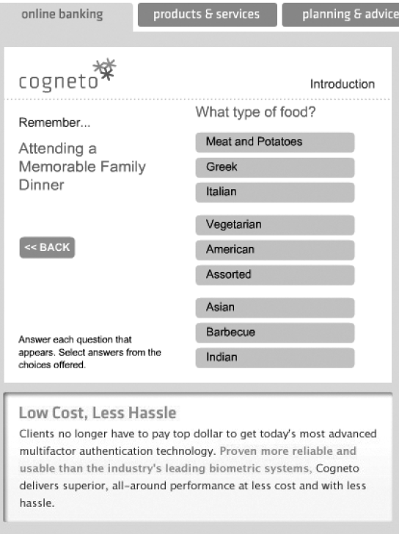
Related to the perception, thought process, and understanding of the user

Easier for the user to remember because it is based on the user’s life experiences

One example of cognitive biometrics is based on a life experience that the user remembers

Another example of cognitive biometrics requires the user to identify specific faces
Authentication Models

Single and multi-factor authentication

One-factor authentication

Using only one authentication credential, such as a password

Two-factor authentication

Enhances security, particularly if different types of authentication methods are used (password and token)

Three-factor authentication

Requires that a user present three different types of authentication credentials

Single sign-on

Identity management

Using a single authenticated ID to be shared across multiple networks

Federated identity management (FIM)

When those networks are owned by different organizations

One application of FIM is called single sign-on (SSO)

Using one authentication to access multiple accounts or applications

Windows Live ID

Originally introduced in 1999 as .NET Passport

When the user wants to log into a Web site that supports Windows Live ID

The user will first be redirected to the nearest authentication server

Once authenticated, the user is given an encrypted time-limited “global” cookie

Never became widely used

Windows CardSpace

New Windows feature

Users control digital identities with digital ID cards

Types of cards

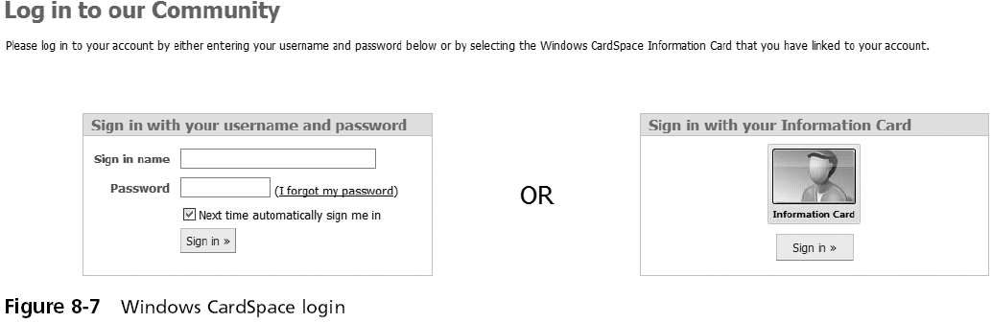
Managed cards

Personal cards

OpenID

A decentralized open source FIM

Does not require specific software to be installed on the desktop

An OpenID identity is only a URL backed up by a username and password

OpenID provides a means to prove that the user owns that specific URL

Not very secure--dependent on DNS
Authentication Servers

Authentication Servers

Authentication can be provided on a network by a dedicated AAA or authentication server

The most common type of authentication and AAA servers are

RADIUS

Kerberos

TACACS+

Generic servers built on the Lightweight Directory Access Protocol (LDAP)

RADIUS (Remote Authentication Dial in User Service)

Developed in 1992

The industry standard with widespread support

Suitable for what are called “high-volume service control applications”

With the development of IEEE 802.1x port security for both wired and wireless LANs

RADIUS has recently seen even greater usage

RADIUS

A RADIUS client is typically a device such as a dial-up server or wireless access point (AP)

Responsible for sending user credentials and connection parameters in the form of a RADIUS message to a RADIUS server

The RADIUS server authenticates and authorizes the RADIUS client request

Sends back a RADIUS message response

RADIUS clients also send RADIUS accounting messages to RADIUS servers
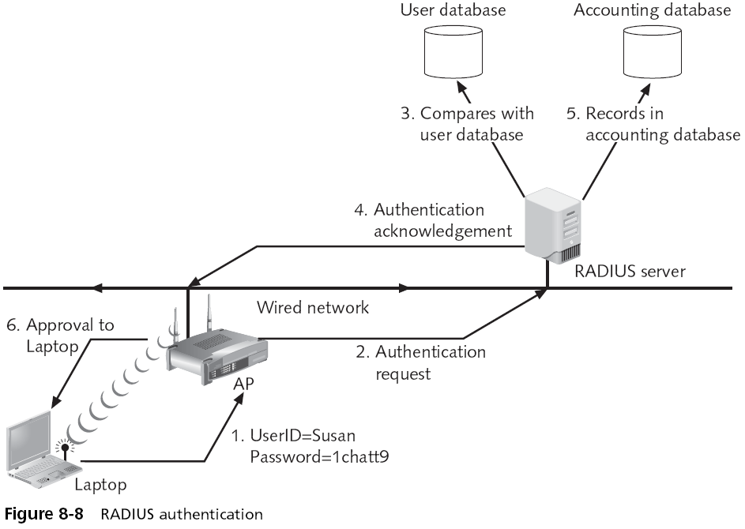

Kerberos

An authentication system developed by the Massachusetts Institute of Technology (MIT)

Used to verify the identity of networked users

Kerberos authentication server issues a ticket to the user

The user presents this ticket to the network for a service

The service then examines the ticket to verify the identity of the user

Terminal Access Control Access Control System (TACACS+)

Developed by Cisco to replace RADIUS

More secure and reliable than RADIUS

The centralized server can either be a TACACS+ database

Or a database such as a Linux or UNIX password file with TACACS protocol support

Lightweight Directory Access Protocol (LDAP)

Directory service

A database stored on the network itself that contains information about users and network devices

Can be used with RADIUS

X.500

A standard for directory services

Created by ISO

White-pages service

Capability to look up information by name

Yellow-pages service

Browse and search for information by category

Lightweight Directory Access Protocol (LDAP)

The information is held in a directory information base (DIB)

Entries in the DIB are arranged in a tree structure called the directory information tree (DIT)

Directory Access Protocol (DAP)

Protocol for a client application to access an X.500 directory

DAP is too large to run on a personal computer

Lightweight Directory Access Protocol (LDAP)

Sometimes called X.500 Lite

A simpler subset of DAP

Primary differences

LDAP was designed to run over TCP/IP

LDAP has simpler functions

LDAP encodes its protocol elements in a less complex way than X.500

LDAP is an open protocol
Extended Authentication Protocols (EAP)

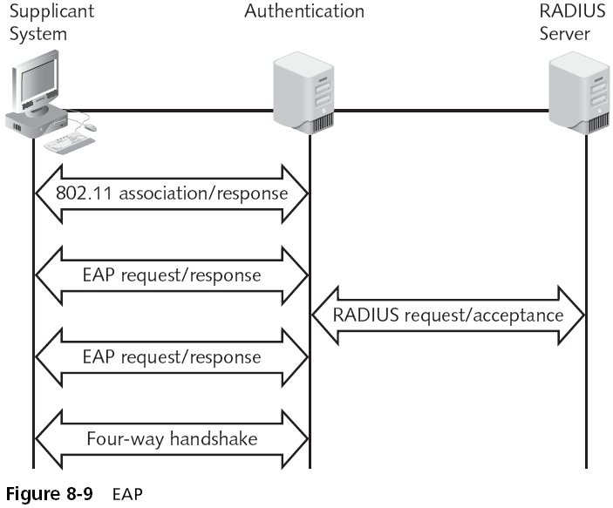
In IEEE 802.1x, EAP is the "envelope" that carries data used for authentication

Three EAP protocol categories:

Authentication legacy protocols

EAP weak protocols

EAP strong protocols

Authentication Legacy Protocols

No longer extensively used for authentication

Password Authentication Protocol (PAP)

Sends passwords in the clear

Challenge-Handshake Authentication Protocol (CHAP)

Safer than PAP, but vulnerable (link Ch 8g)

Microsoft Challenge-Handshake Authentication Protocol (MS-CHAP)

EAP Weak Protocols

Still used but have security vulnerabilities

Extended Authentication Protocol–MD5 (EAP-MD5)

Vulnerable to offline dictionary attacks

Lightweight EAP (LEAP)

Also vulnerable to offline dictionary attacks

Can be cracked faster than WEP

Link Ch 8h

EAP Strong Protocols

EAP with Transport Layer Security (EAP-TLS)

Uses certificates for both client and server

Used in large Windows networks

EAP with Tunneled TLS (EAP-TTLS) and Protected EAP (PEAP)

No client-side certificate

Easier to implement than EAP-TLS
Remote Authentication and Security

Remote Authentication and Security

Important to maintain strong security for remote communications

Transmissions are routed through networks or devices that the organization does not manage and secure

Managing remote authentication and security usually includes:

Using remote access services

Installing a virtual private network

Maintaining a consistent remote access policy

Remote Access Services (RAS)

Any combination of hardware and software that enables access to remote users to a local internal network

Provides remote users with the same access and functionality as local users

Virtual Private Networks (VPNs)

One of the most common types of RAS

Uses an unsecured public network, such as the Internet, as if it were a secure private network

Encrypts all data that is transmitted between the remote device and the network
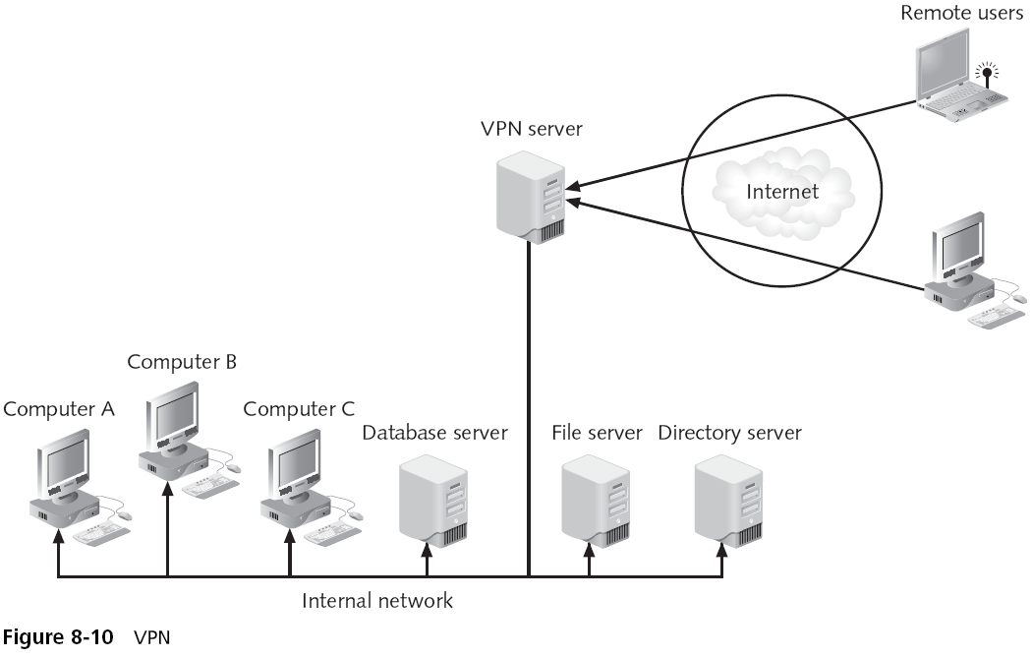

Common types of VPNs

Remote-access VPN or virtual private dial-up network (VPDN)

Site-to-site VPN

VPN transmissions are achieved through communicating with endpoints

Endpoint

End of the tunnel between VPN devices

VPN concentrator

Aggregates hundreds or thousands of multiple connections

Depending upon the type of endpoint that is being used, client software may be required on the devices that are connecting to the VPN

VPNs can be software-based or hardware-based

Software-based VPNs offer the most flexibility in how network traffic is managed

Hardware-based VPNs generally tunnel all traffic they handle regardless of the protocol

Generally, software based VPNs do not have as good performance or security as a hardware-based VPN

VPN Advantages

Cost savings (no long-distance phone call)

Scalability (easy to add more users)

Full protection (all traffic is encrypted)

Speed (faster than direct dial-up)

Transparency (invisible to the user)

Authentication (only authorized users can connect)

Industry standards

VPN Disadvantages

Management

Availability and performance

Interoperability

Additional protocols

Performance impact

Expense

Remote Access Policies

Establishing strong remote access policies is important

Some recommendations for remote access policies:

Remote access policies should be consistent for all users

Remote access should be the responsibility of the IT department

Form a working group and create a standard that all departments will agree to

Last modified 2-5-09

