Objectives

Define risk and risk management

Describe the components of risk management

List and describe vulnerability scanning tools

Define penetration testing
Risk Management, Assessment, and Mitigation

One of the most important assets any organization possesses is its data

Unfortunately, the importance of data is generally underestimated

The first steps in data protection actually begin with understanding risks and risk management

What Is Risk?

In information security, a risk is the likelihood that a threat agent will exploit a vulnerability

More generally, a risk can be defined as an event or condition that could occur

And if it does occur, then it has a negative impact

Risk generally denotes a potential negative impact to an asset

Definition of Risk Management

Realistically, risk cannot ever be entirely eliminated

Would cost too much or take too long

Rather, some degree of risk must always be assumed

Risk management

A systematic and structured approach to managing the potential for loss that is related to a threat

Steps in Risk Management

The first step or task in risk management is to determine the assets that need to be protected

Asset identification

The process of inventorying and managing these items

Types of assets:

Data

Hardware

Personnel

Physical assets

Software

Attributes of Assets

Along with the assets, the attributes of the assets need to be compiled

Attributes are details

Important to determine each item’s relative value (see chart on next page)

Determining Relative Value

Factors that should be considered in determining the relative value are:

How critical is this asset to the goals of the organization?

How difficult would it be to replace it?

How much does it cost to protect it?

How much revenue does it generate?

Determining Relative Value

Factors that should be considered in determining the relative value are: (continued)

How quickly can it be replaced?

What is the cost to replace it?

What is the impact to the organization if this asset is unavailable?

What is the security implication if this asset is unavailable?

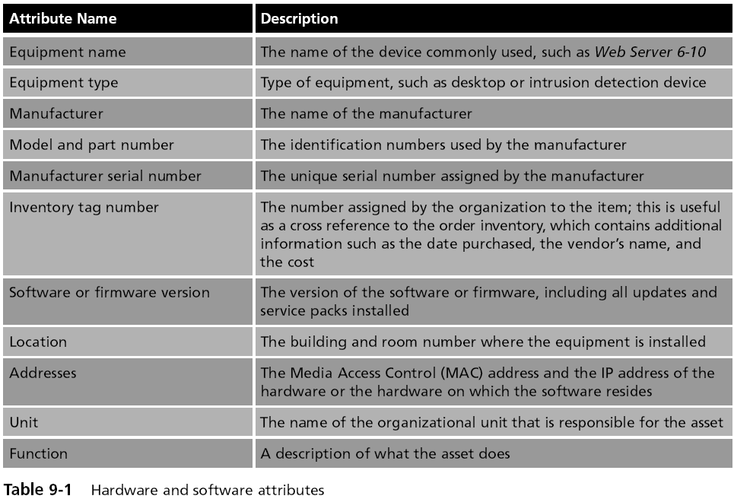
Threat Identification

The next step is to determine the threats from threat agents

Threat agent

Any person or thing with the power to carry out a threat against an asset
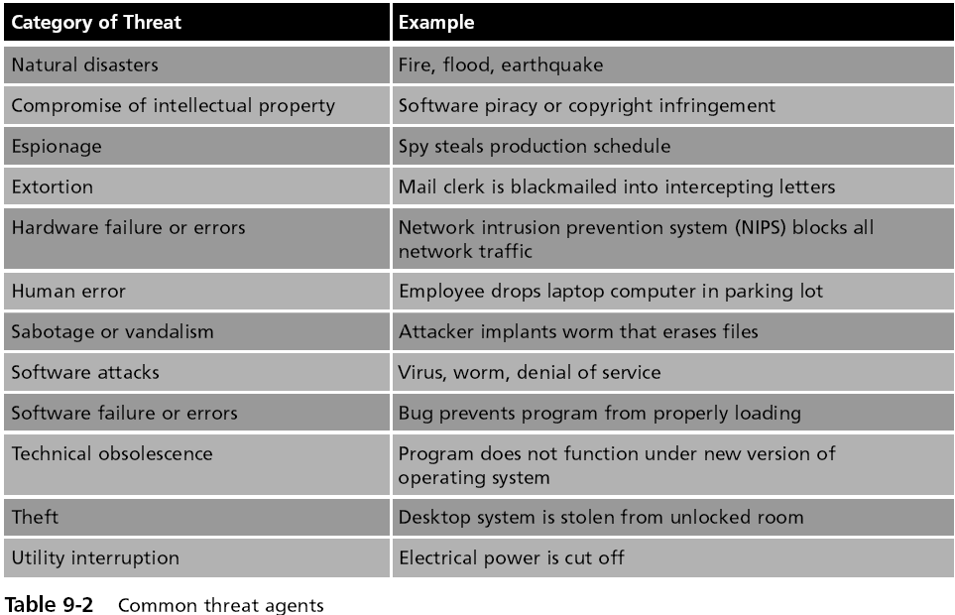

Threat modeling

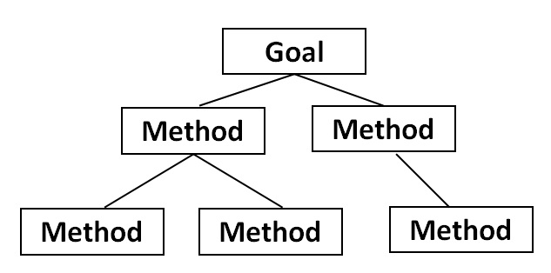
Constructs scenarios of the types of threats that assets can face

Helps to understand who the attackers are, why they attack, and what types of attacks might occur

Attack Tree

Provides a visual image of the attacks that may occur against an asset
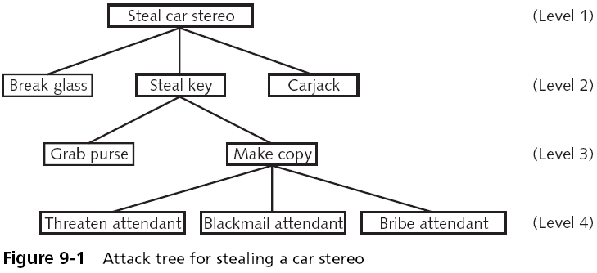
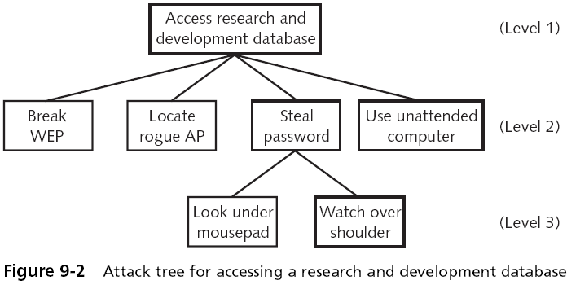
Vulnerability Appraisal

Finding security weaknesses that expose assets to threats

Takes a snapshot of the security of the organization as it now stands

Every asset must be viewed in light of each threat

Determining vulnerabilities often depends upon the background and experience of the assessor

Risk Assessment

Determining:

The damage that would result from an attack, and

The likelihood that the vulnerability is a risk to the organization

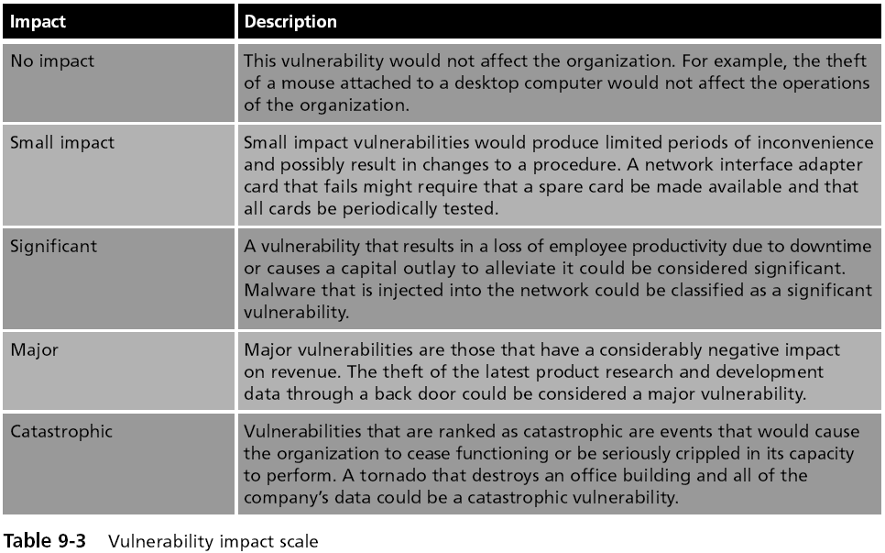

Anticipated Losses

Single Loss Expectancy (SLE)

The expected monetary loss every time a risk occurs

Annualized Loss Expectancy (ALE)

The expected monetary loss that can be expected for an asset due to a risk over a one-year period

Risk Mitigation

The final step--determine what to do about the risks

Options when confronted with a risk:

Diminish the risk

Transfer the risk

Outsourcing or insurance

Accept the risk

Steps in Risk Management
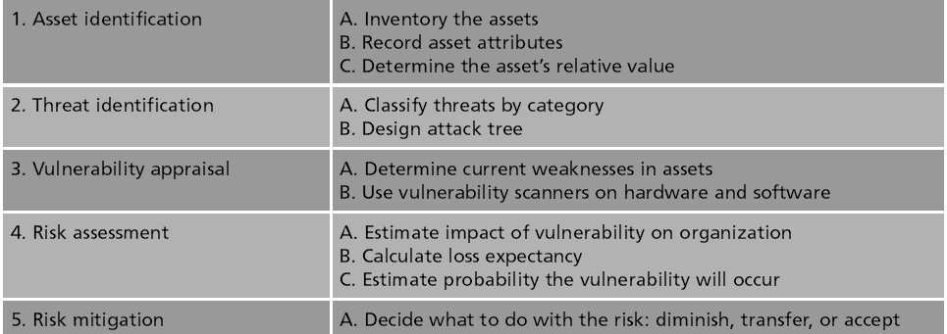

Identifying Vulnerabilities

Identifying vulnerabilities through a vulnerability appraisal

Determines the current security weaknesses that could expose assets to threats

Two categories of software and hardware tools

Vulnerability scanning

Penetration testing

Vulnerability Scanning

Vulnerability scanning is typically used by an organization to identify weaknesses in the system

That need to be addressed in order to increase the level of security

Tools include port scanners, network mappers, protocol analyzers, vulnerability scanners, the Open Vulnerability and Assessment Language, and password crackers

IP Addresses and Ports

Internet protocol (IP) addresses

The primary form of address identification on a TCP/IP network

Used to uniquely identify each network device

Port number

TCP/IP uses a numeric value as an identifier to applications and services on the systems

Each datagram (packet) contains not only the source and destination IP addresses

But also the source port and destination port

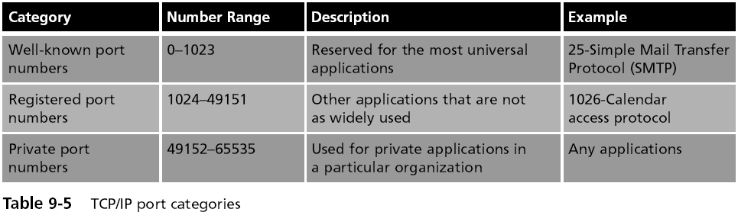
TCP/IP Ports

Port Scanners

Port scanner

Sends probes to interesting ports on a target system

Determines the state of a port to know what applications are running and could be exploited

Three port states:

Open, closed, and blocked
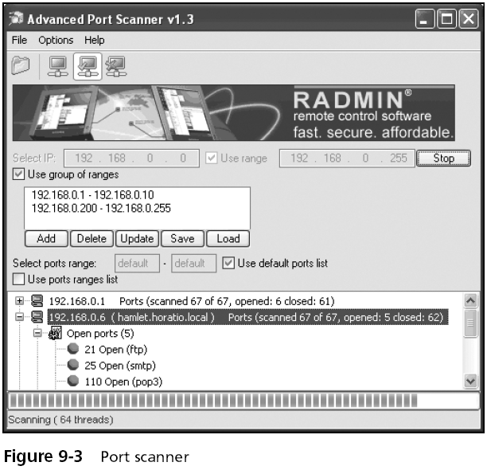

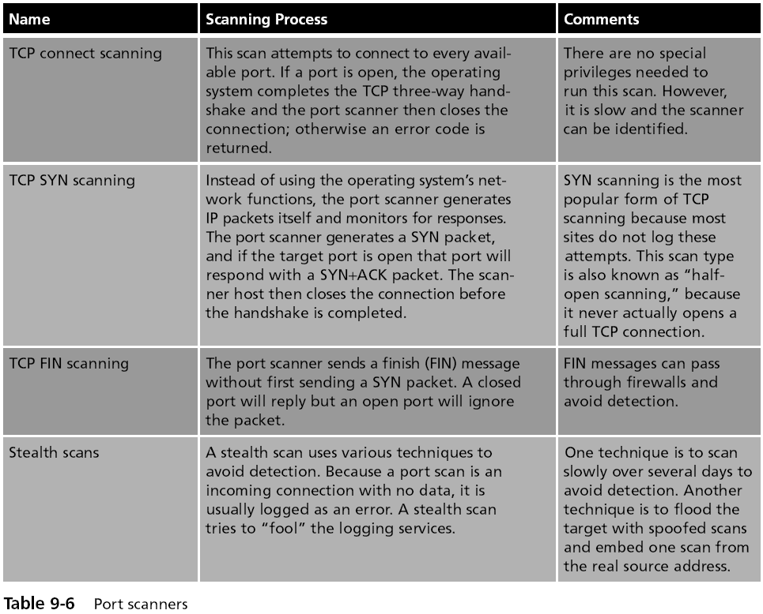

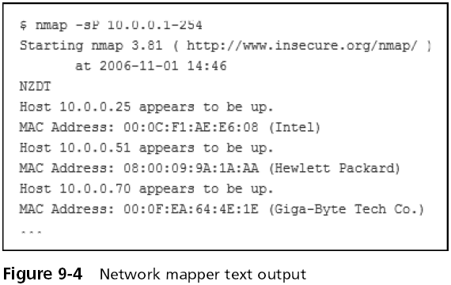
Network Mappers

Software tools that can identify all the systems connected to a network

Most network mappers utilize the TCP/IP protocol ICMP

Internet Control Message Protocol (ICMP)

Used by PING to identify devices

Less useful for modern versions of Windows

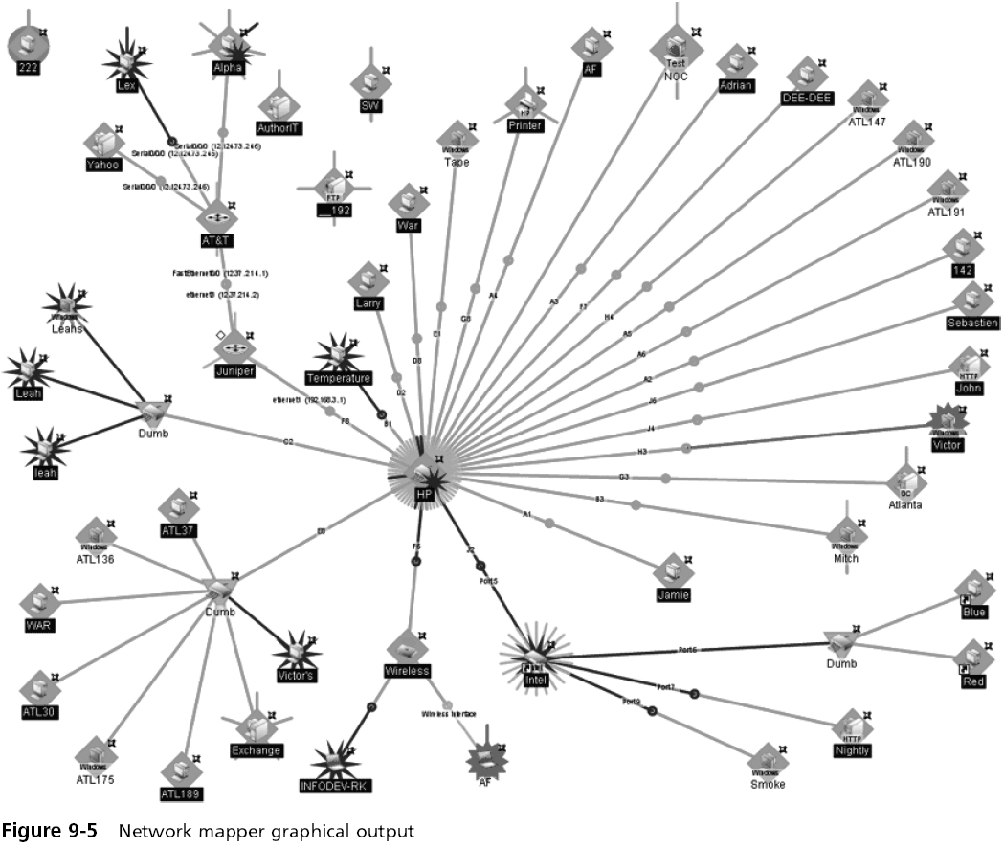

Protocol Analyzers

Also called a sniffer

Captures each packet to decode and analyze its contents

Can fully decode application-layer network protocols

Common uses include:

Network troubleshooting

Network traffic characterization

Security analysis
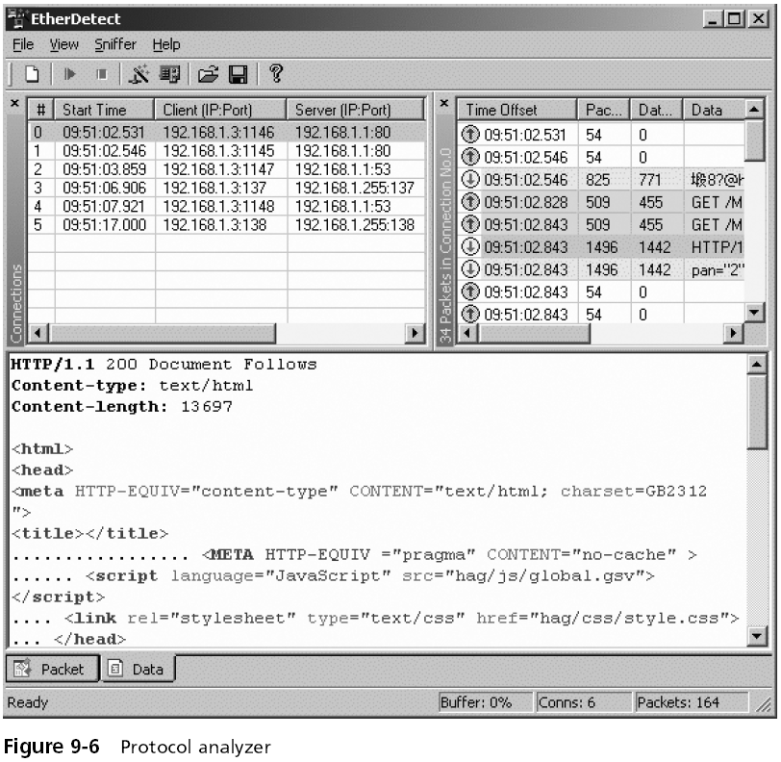

Vulnerability Scanners

Products that look for vulnerabilities in networks or systems

Help network administrators find security problems

Most vulnerability scanners maintain a database that categorizes and describes the vulnerabilities that it can detect

Other types of vulnerability scanners combine the features of a port scanner and network mapper
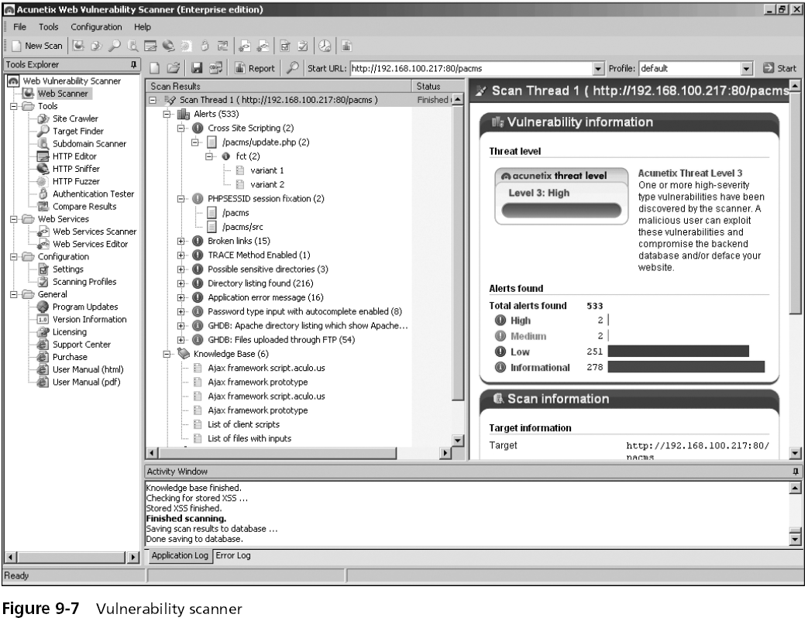

Open Vulnerability and Assessment Language (OVAL)

Designed to promote open and publicly available security content

Standardizes the transfer of information across different security tools and services

A “common language” for the exchange of information regarding security vulnerabilities

These vulnerabilities are identified using industry-standard tools

Open Vulnerability and Assessment Language (OVAL) (continued)

OVAL vulnerability definitions are recorded in Extensible Markup Language (XML)

Queries are accessed using the database Structured Query Language (SQL)

OVAL supports Windows, Linux, and UNIX platforms

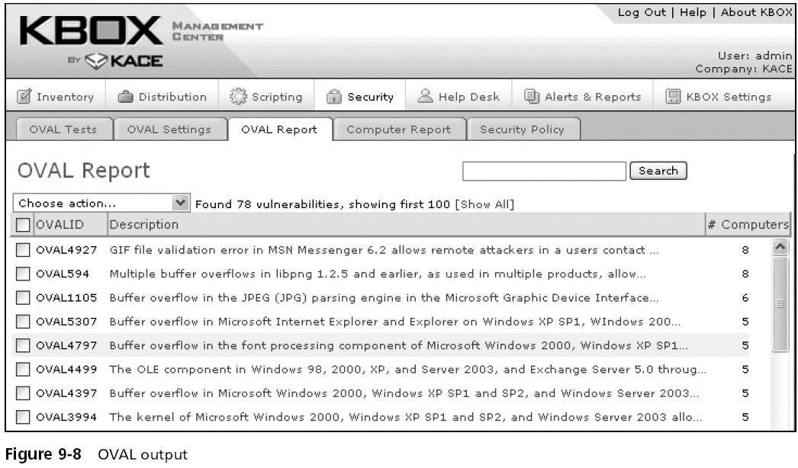

Password Crackers

Password

A secret combination of letters and numbers that only the user knows

Because passwords are common yet provide weak security, they are a frequent focus of attacks

Password cracker programs

Use the file of hashed passwords and then attempts to break the hashed passwords offline

The most common offline password cracker programs are based on dictionary attacks or rainbow tables
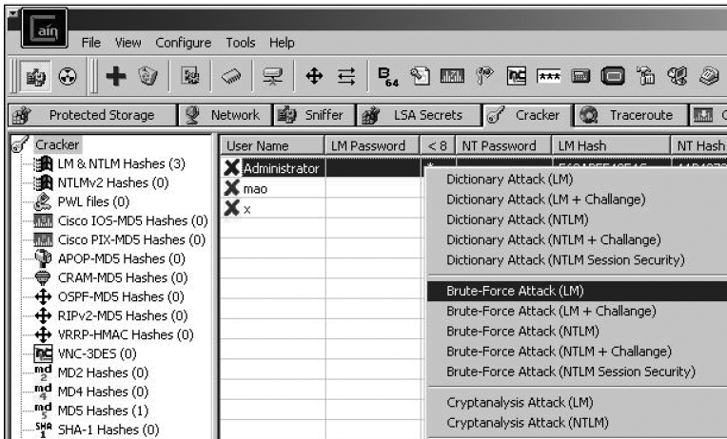

Shadow File

A defense against password cracker programs for UNIX and Linux systems

On a system without a shadow fiile

The passwd file that contains the hashed passwords and other user information is visible to all users

The shadow file can only be accessed at the highest level and contains only the hashed passwords

Penetration Testing

Method of evaluating the security of a computer system or network

By simulating a malicious attack instead of just scanning for vulnerabilities

Involves a more active analysis of a system for vulnerabilities

One of the first tools that was widely used for penetration testing as well as by attackers was SATAN

SATAN

SATAN could improve the security of a network by performing penetration testing

To determine the strength of the security for the network and what vulnerabilities may still have existed

SATAN would:

Recognize several common networking-related security problems

Report the problems without actually exploiting them

Offer a tutorial that explained the problem, what its impact could be, and how to resolve the problem

Last modified 3-20-09

