Objectives

Define privilege audits

Describe how usage audits can protect security

List the methodologies used for monitoring to detect security-related anomalies

Describe the different monitoring tools
Privilege Auditing

Privilege Auditing

A privilege can be considered a subject’s access level over an object

Principle of least privilege

Users should be given only the minimal amount of privileges necessary to perform his or her job function

Privilege auditing

Reviewing a subject’s privileges over an object

Requires knowledge of privilege management, how privileges are assigned, and how to audit these security settings

Privilege Management

The process of assigning and revoking privileges to objects

The roles of owners and custodians are generally well-established

The responsibility for privilege management can be either centralized or decentralized

Centralized and Decentralized Structures

In a centralized structure

One unit is responsible for all aspects of assigning or revoking privileges

All custodians are part of that unit

Promotes uniform security policies

Slows response, frustrates users

A decentralized organizational structure for privilege management

Delegates the authority for assigning or revoking privileges more closely to the geographic location or end user

Requires IT staff at each location to manage privileges

Assigning Privileges

The foundation for assigning privileges

The existing access control model for the hardware or software being used

Recall that there are four major access control models:

Mandatory Access Control (MAC)

Discretionary Access Control (DAC)

Role Based Access Control (RBAC)

Rule Based Access Control (RBAC)

Auditing System Security Settings

Auditing system security settings for user privileges involves:

A regular review of user access and rights

Using group policies

Implementing storage and retention policies

User access and rights review

It is important to periodically review user access privileges and rights

Most organizations have a written policy that mandates regular reviews

Reviewing user access rights for logging into the network can be performed on the network server

Reviewing user permissions over objects can be viewed on the network server
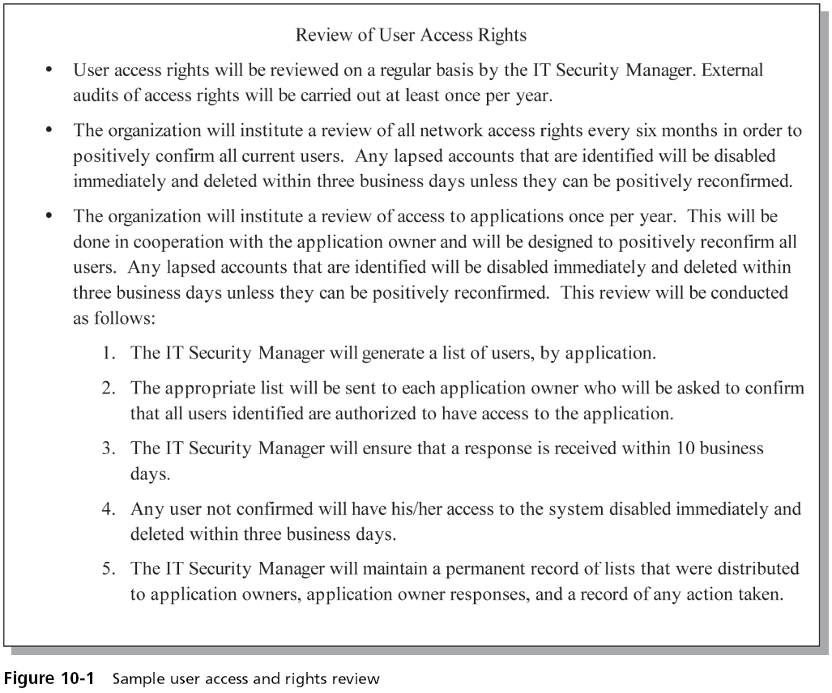

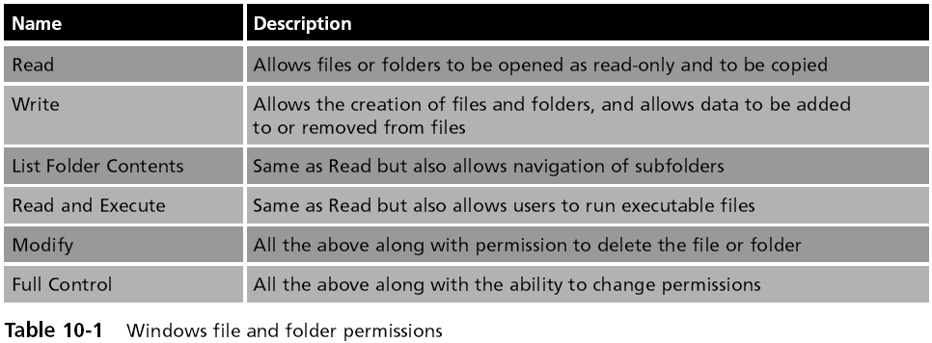
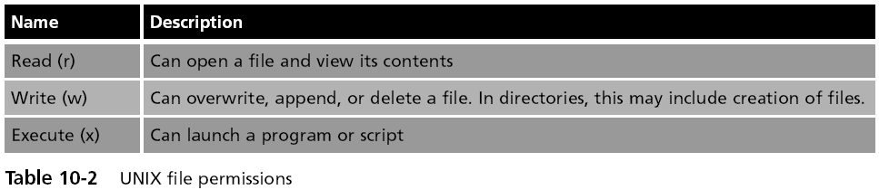

Group Policies

Instead of setting the same configuration baseline on each computer, a security template can be created

Security template

A method to configure a suite of baseline security settings

On a Microsoft Windows computer, one method to deploy security templates is to use Group Policies

A feature that provides centralized management and configuration of computers and remote users who are using Active Directory (AD)

Group Policy Objects (GPOs).

The individual elements or settings within group policies are known as Group Policy Objects (GPOs).

GPOs are a defined collection of available settings that can be applied to user objects or AD computers

Settings are manipulated using administrative template files that are included within the GPO

Image from franciosi.org
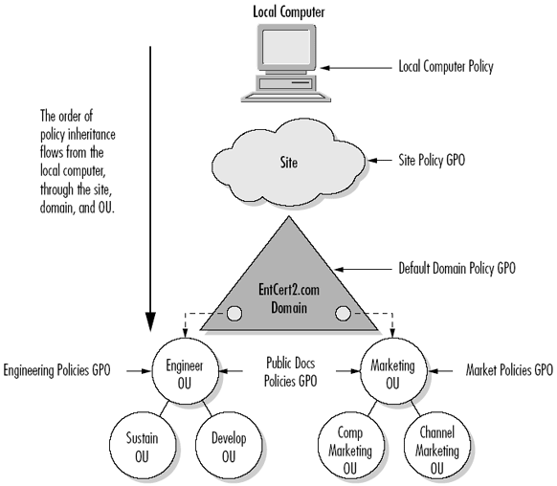

Storage and Retention Policies

Health Insurance Portability and Accountability Act (HIPPA)

Sarbanes-Oxley Act

Require organizations to store data for specified time periods

Require data to be stored securely

HIPPA Sanction for Unlocked Dumpsters

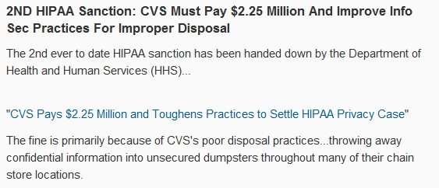
Link Ch 10a

Information Lifecycle Management (ILM)

A set of strategies for administering, maintaining, and managing computer storage systems in order to retain data

ILM strategies are typically recorded in storage and retention policies

Which outline the requirements for data storage

Data classification

Assigns a level of business importance, availability, sensitivity, security and regulation requirements to data
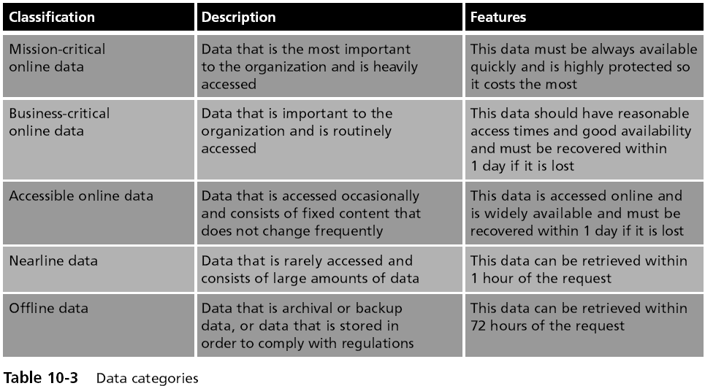

Data Categories

Grouping data into categories often requires the assistance of the users who save and retrieve the data on a regular basis

The next step is to assign the data to different levels or “tiers” of storage and accessibility
Usage Auditing

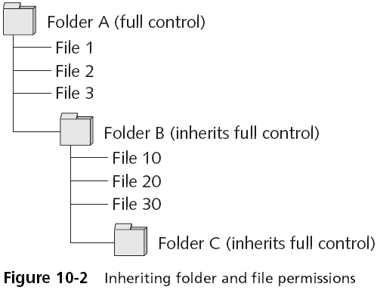
Usage Auditing

Audits what objects a user has actually accessed

Involves an examination of which subjects are accessing specific objects and how frequently

Sometimes access privileges can be very complex

Usage auditing can help reveal incorrect permissions

Inheritance

Permissions given to a higher level “parent” will also be inherited by a lower level “child”

Inheritance becomes more complicated with GPOs

GPO Inheritance

Allows administrators to set a base security policy that applies to all users in the Microsoft AD

Other administrators can apply more specific policies at a lower level

That apply only to subsets of users or computers

GPOs that are inherited from parent containers are processed first

Followed by the order that policies were linked to a container object

Log Management

A log is a record of events that occur

Logs are composed of log entries

Each entry contains information related to a specific event that has occurred

Logs have been used primarily for troubleshooting problems

Log management

The process for generating, transmitting, storing, analyzing, and disposing of computer security log data

Application and Hardware Logs

Security application logs

Antivirus software

Remote Access Software

Automated patch update service

Security hardware logs

Network intrusion detection systems and host and network intrusion prevention systems

Domain Name System (DNS)

Authentication servers

Proxy servers

Firewalls

Antivirus Logs
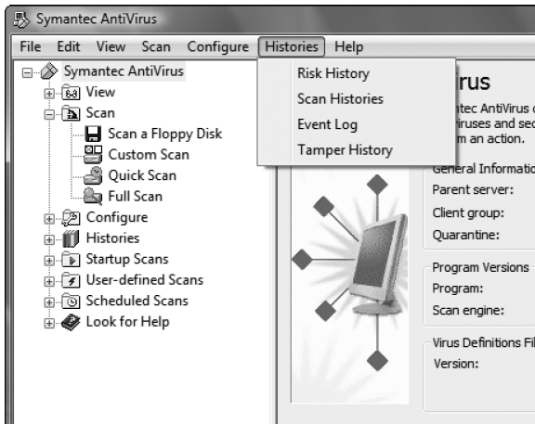

DNS Logs

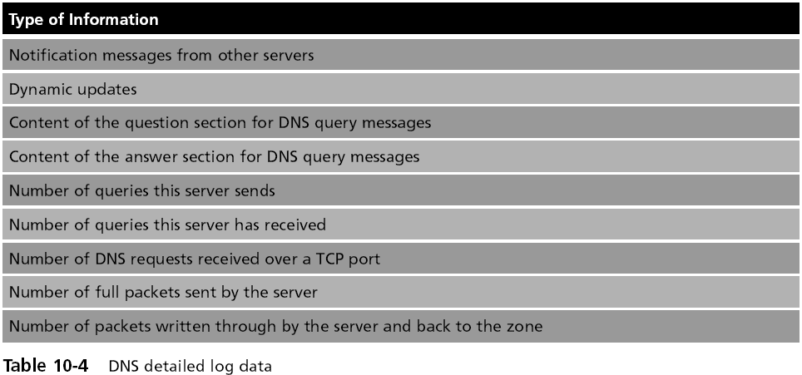
Firewall Logs

Types of items that should be examined in a firewall log include:

IP addresses that are being rejected and dropped

Probes to ports that have no application services running on them

Source-routed packets

Packets from outside with false internal source addresses

Suspicious outbound connections

Unsuccessful logins
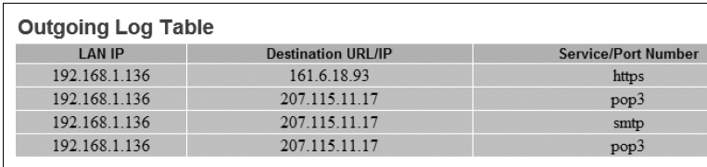

Operating System Logs

System events

Significant actions performed by the operating system

Shutting down the system

Starting a service

System events that are commonly recorded include:

Client requests and server responses

Usage information

Logs based on audit records

The second common type of security-related operating system logs

Audit records that are commonly recorded include:

Account activity, such as escalating privileges

Operational information, such as application startup and shutdown

Windows 7 Event Logs

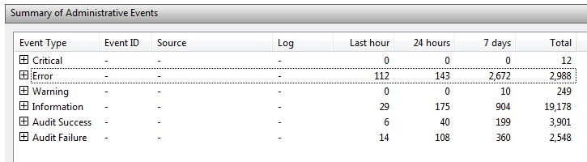

Log Management Benefits

A routine review and analysis of logs helps identify

Security incidents

Policy violations

Fraudulent activity

Operational problems

Logs can also help resolve problems

Log Management Benefits

Logs help

Perform auditing analysis

The organization’s internal investigations

Identify operational trends and long-term problems

Demonstrate compliance with laws and regulatory requirements
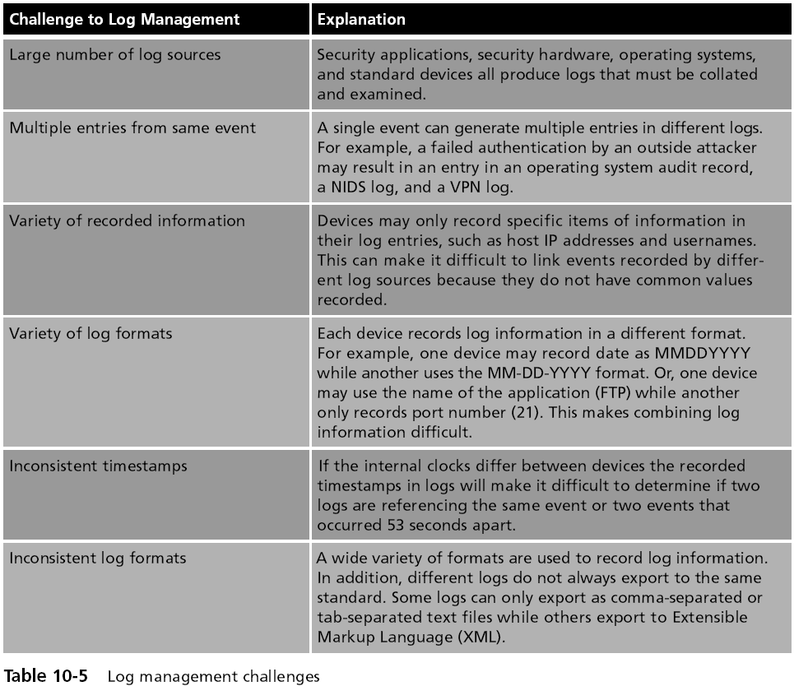

Log Management Solutions

Enact periodic audits

Establish policies and procedures for log management

Maintain a secure log management infrastructure

Prioritize log management throughout the organization

Use log aggregators

Provide adequate support

Change Management

A methodology for making changes and keeping track of those changes

Two major types of changes

Any change in system architecture

New servers, routers, etc.

Data classification

Documents moving from Confidential to Standard, or Top Secret to Secret

Change Management Team (CMT)

Created to oversee changes

Any proposed change must first be approved by the CMT

The team typically has:

Representatives from all areas of IT (servers, network, enterprise server, etc.)

Network security

Upper-level management

Change Management Team (CMT)Duties

Review proposed changes

Ensure that the risk and impact of the planned change is clearly understood

Recommend approval, disapproval, deferral, or withdrawal of a requested change

Communicate proposed and approved changes to co-workers
Monitoring Methodologies and Tools

Anomaly-based Monitoring

Detecting abnormal traffic

Baseline

A reference set of data against which operational data is compared

Whenever there is a significant deviation from this baseline, an alarm is raised

Advantage

Detect the anomalies quickly

Anomaly-based Monitoring

Disadvantages

False positives

Alarms that are raised when there is no actual abnormal behavior

Normal behavior can change easily and even quickly

Anomaly-based monitoring is subject to false positives

Signature-based Monitoring

Compares activities against signatures

Requires access to an updated database of signatures

Weaknesses

The signature databases must be constantly updated

As the number of signatures grows the behaviors must be compared against an increasingly large number of signatures

New attacks will be missed, because there is no signature for them

Behavior-based Monitoring

Adaptive and proactive instead of reactive

Uses the “normal” processes and actions as the standard

Continuously analyzes the behavior of processes and programs on a system

Alerts the user if it detects any abnormal actions

Advantage

Not necessary to update signature files or compile a baseline of statistical behavior

Behavior-based Monitoring
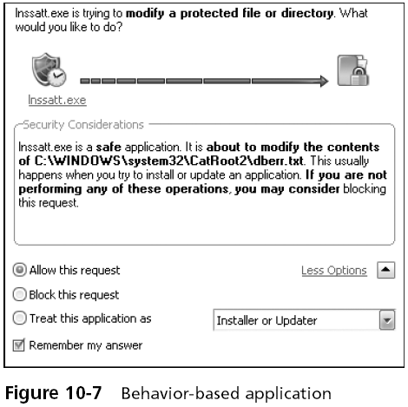

Monitoring Tools

Performance baselines and monitors

Performance baseline

A reference set of data established to create the “norm” of performance for a system or systems

Data is accumulated through the normal operations of the systems and networks through performance monitors

Operational data is compared with the baseline data to determine how closely the norm is being met and if any adjustments need to be made

System Monitor

A low-level system program

Monitors hidden activity on a device

Some system monitors have a Web-based interface

System monitors generally have a fully customizable notification system

That lets the owner design the information that is collected and made available

Protocol Analyzer

Also called a sniffer

Captures each packet to decode and analyze its contents

Can fully decode application-layer network protocols

The different parts of the protocol can be analyzed for any suspicious behavior

Last modified 3-27-09

