Defining Cryptography

Objectives

Define cryptography

Describe hashing

List the basic symmetric cryptographic algorithms

Describe how asymmetric cryptography works

List types of file and file system cryptography

Explain how whole disk encryption works

What Is Cryptography?

Cryptography - scrambles data

The science of transforming information into an unintelligible form while it is being transmitted or stored so that unauthorized users cannot access it

Steganography - hides data

Hides the existence of the data

What appears to be a harmless image can contain hidden data embedded within the image

Can use image files, audio files, or even video files to contain hidden information

Steganography

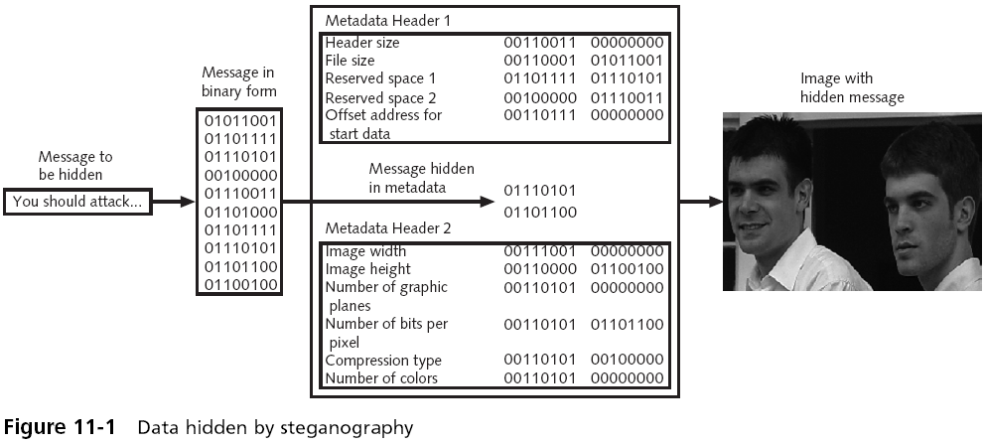

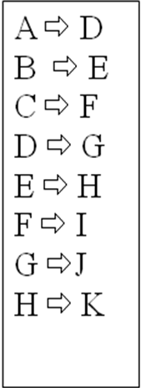

Caesar Cipher

Used by Julius Caesar

Caesar shifted each letter of his messages to his generals three places down in the alphabet

So BURN THE BRIDGE becomes EXUQ WKH EUKFIG

Encryption and Decryption

Encryption

Changing the original text to a secret message using cryptography

Decryption

Change the secret message back to its original form

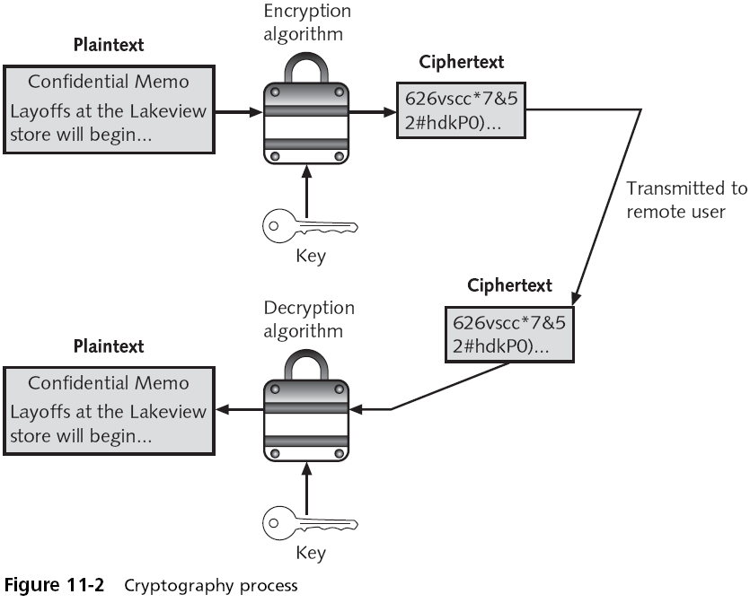

Cryptography and Security

Cryptography can provide:

Confidentiality of information

Integrity of the information

Availability of the data

To users with the key

Guarantee Authenticity of the sender

Enforce Non-repudiation

Sender cannot deny sending the message

Information Protection by Cryptography
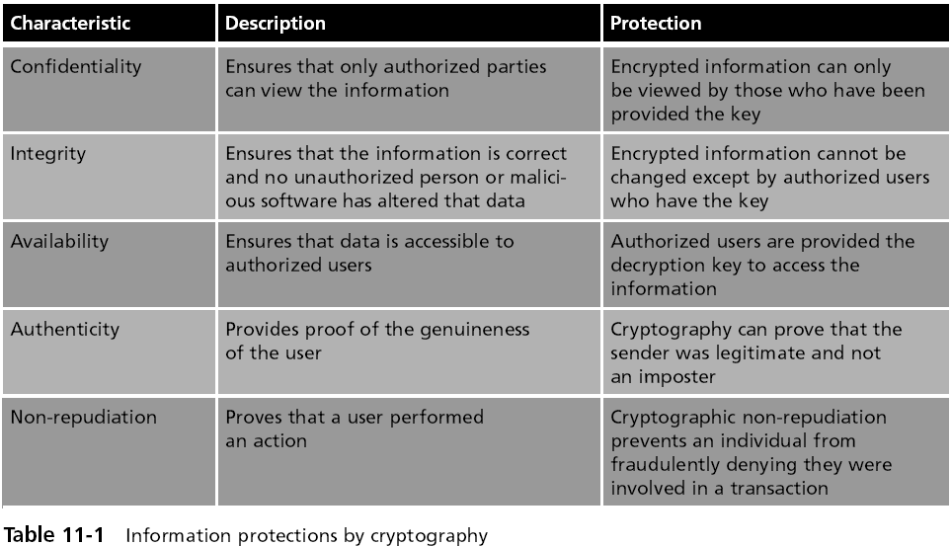

Cryptographic Algorithms

Cryptographic Algorithms

There are three categories of cryptographic algorithms:

Hashing algorithms

Symmetric encryption algorithms

Asymmetric encryption algorithms
Hashing Algorithms

Hashing Algorithms

Hashing is a one-way process

Converting a hash back to the original data is difficult or impossible

A hash is a unique “signature” for a set of data

This signature, called a hash or digest, represents the contents

Hashing is used only for integrity to ensure that:

Information is in its original form

No unauthorized person or malicious software has altered the data

Common hash algorithms

MD5, SHA-1

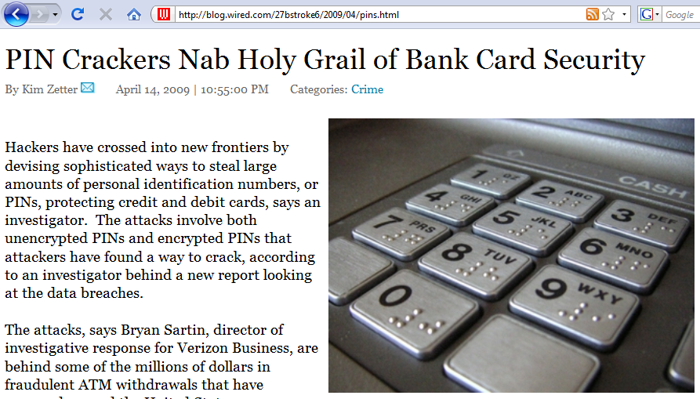
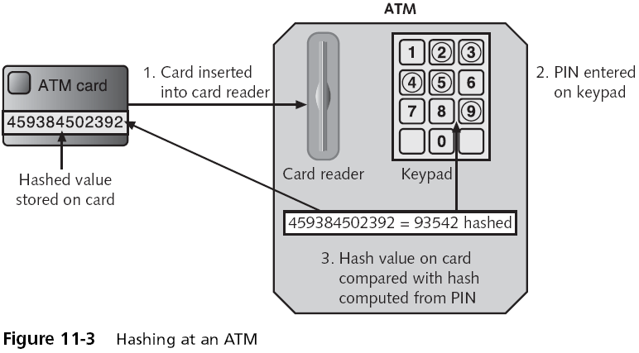
Link Ch 11a

Hashing Algorithm Security

A hashing algorithm is considered secure if:

The ciphertext hash is a fixed size

Two different sets of data cannot produce the same hash, which is known as a collision

It should be impossible to produce a data set that has a desired or predefined hash

The resulting hash ciphertext cannot be reversed to find the original data

Preventing a Man-in-the-Middle Attack with Hashing

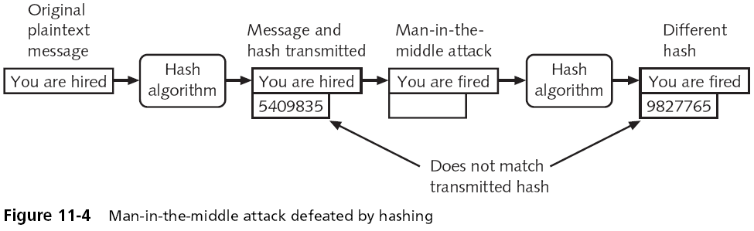

Hashing Algorithms (continued)

Hash values are often posted on Internet sites

In order to verify the file integrity of files that can be downloaded

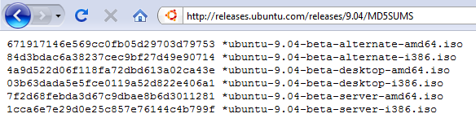

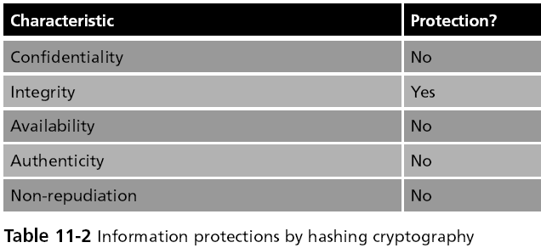
Hashing Algorithms Only Ensure Integrity

Message Digest (MD)

Message Digest (MD) algorithm

One common hash algorithm

Three versions

Message Digest 2 (MD2)

Message Digest 4 (MD4)

Message Digest 5 (MD5)

Suffer from collisions

Not secure

See links Ch 11b, c, d

Secure Hash Algorithm (SHA)

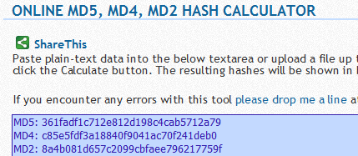
More secure than MD

A family of hashes

SHA-1

Patterned after MD4, but creates a hash that is 160 bits in length instead of 128 bits

SHA-2

Comprised of four variations, known as SHA-224, SHA-256, SHA-384, and SHA-512

Considered to be a secure hash

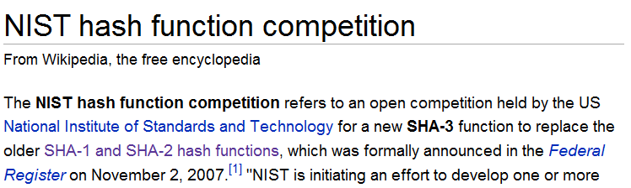
SHA-3 is Being Chosen Now

Link Ch 11d

Whirlpool

A relatively recent cryptographic hash function

Has received international recognition and adoption by standards organizations

Creates a hash of 512 bits

Password Hashes

Another use for hashes is in storing passwords

When a password for an account is created, the password is hashed and stored

The Microsoft NT family of Windows operating systems hashes passwords in two different forms

LM (LAN Manager) hash

NTLM (New Technology LAN Manager) hash

Most Linux systems use password-hashing algorithms such as MD5

Apple Mac OS X uses SHA-1 hashes
Symmetric Cryptographic Algorithms

Symmetric Cryptographic Algorithms

Symmetric cryptographic algorithms

Use the same single key to encrypt and decrypt a message

Also called private key cryptography
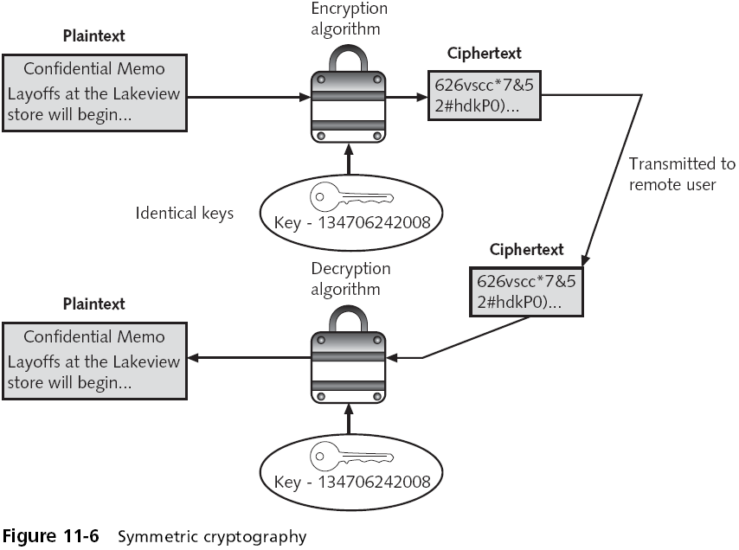

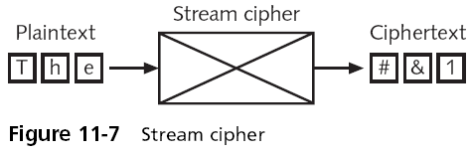
Stream cipher

Takes one character and replaces it with one character

WEP (Wired Equivalent Protocol) is a stream cipher

Substitution cipher

The simplest type of stream cipher

Simply substitutes one letter or character for another

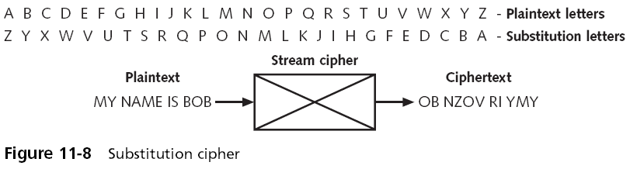
Substitution Cipher

XOR (eXclusive OR)

With most symmetric ciphers, the final step is to combine the cipher stream with the plaintext to create the ciphertext

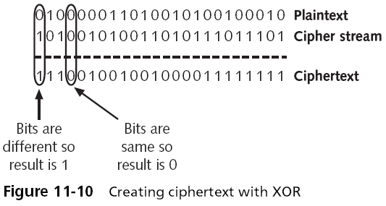
The process is accomplished through the exclusive OR (XOR) binary logic operation

One-time pad (OTP)

Combines a truly random key with the plaintext

Block Cipher

Manipulates an entire block of plaintext at one time

Plaintext message is divided into separate blocks of 8 to 16 bytes

And then each block is encrypted independently

Stream cipher advantages and disadvantages

Fast when the plaintext is short

More prone to attack because the engine that generates the stream does not vary

Block ciphers are more secure than stream ciphers

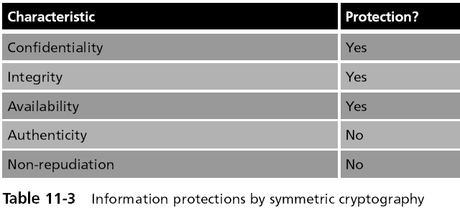
Information Protections by Symmetric Cryptography

DES and 3DES

Data Encryption Standard (DES)

Declared as a standard by the U.S Government

DES is a block cipher and encrypts data in 64-bit blocks

Uses 56-bit key, very insecure

Has been broken many times

Triple Data Encryption Standard (3DES)

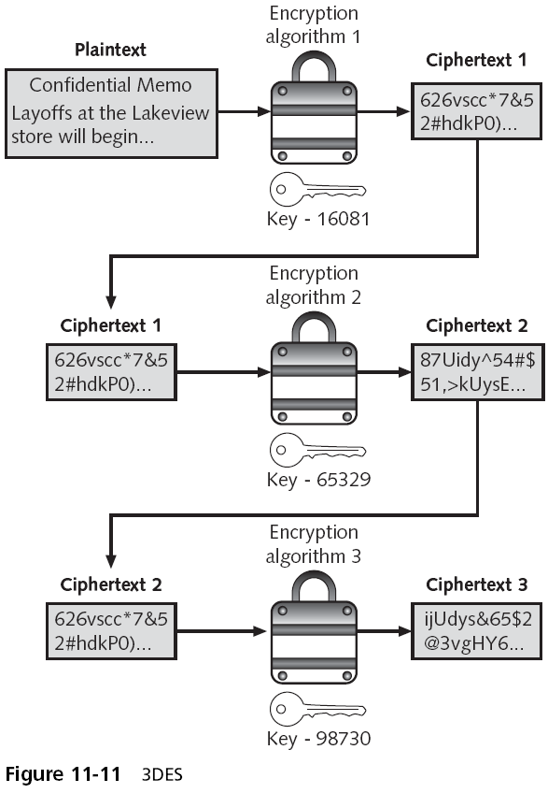
Uses three rounds of DES encryption

Effective key length 112 bits

Considered secure

Advanced Encryption Standard (AES)

Approved by the NIST in late 2000 as a replacement for DES

Official standard for U.S. Government

Considered secure--has not been cracked

Animation of AES Algorithm

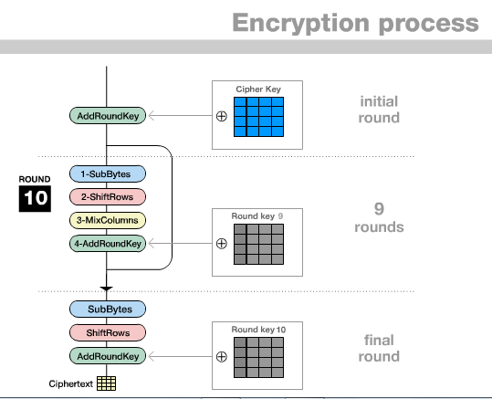
Link Ch 11e

Other Algorithms

Several other symmetric cryptographic algorithms are also used:

Rivest Cipher (RC) family from RC1 to RC6

International Data Encryption Algorithm (IDEA)

Blowfish

Twofish

Asymmetric Cryptographic Algorithms

Asymmetric Cryptographic Algorithms

Asymmetric cryptographic algorithms

Also known as public key cryptography

Uses two keys instead of one

The public key is known to everyone and can be freely distributed

The private key is known only to the recipient of the message

Asymmetric cryptography can also be used to create a digital signature

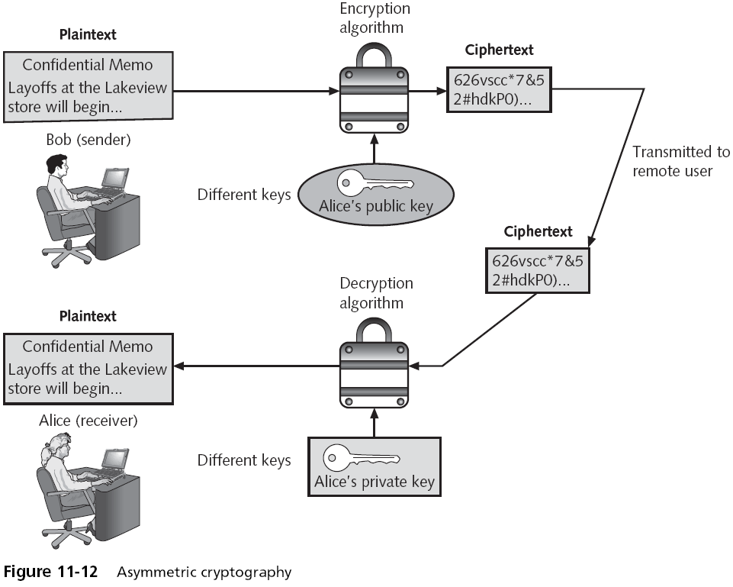

Digital Signature

A digital signature can:

Verify the sender

Prove the integrity of the message

Prevent the sender from disowning the message (non-repudiation)

A digital signature does not encrypt the message, it only signs it

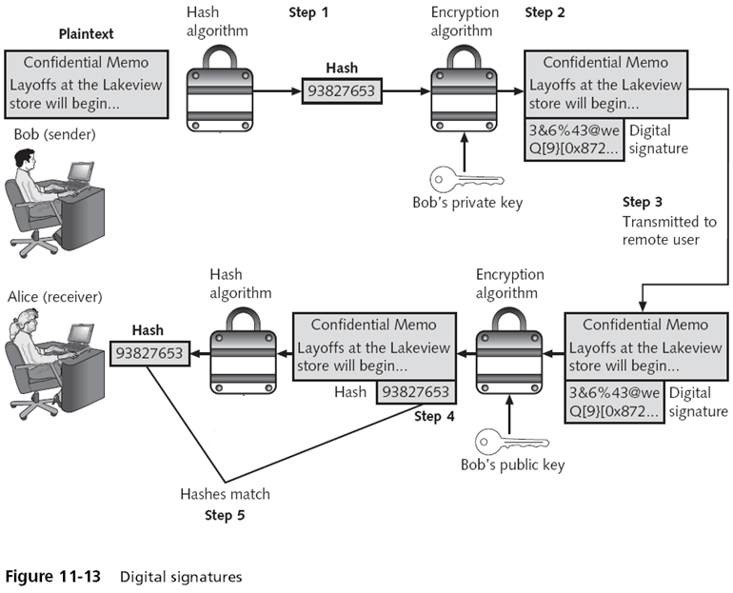

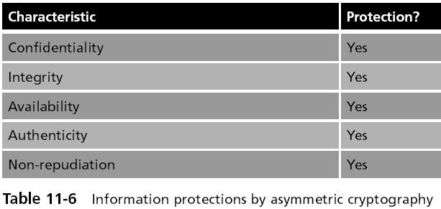

Information Protections by Asymmetric Cryptography

RSA

The most common asymmetric cryptography algorithm

RSA makes the public and private keys by multiplying two large prime numbers p and q

To compute their product (n=pq)

It is very difficult to factor the number n to find p and q

Finding the private key from the public key would require a factoring operation

RSA is complex and slow, but secure

100 times slower than DES

Diffie-Hellman

A key exchange algorithm, not an encryption algorithm

Allows two users to share a secret key securely over a public network

Once the key has been shared

Then both parties can use it to encrypt and decrypt messages using symmetric cryptography

HTTPS

Secure Web Pages typically use RSA, Diffie-Hellman, and a symmetric algorithm like RC4

RSA is used to send the private key for the symmetric encryption

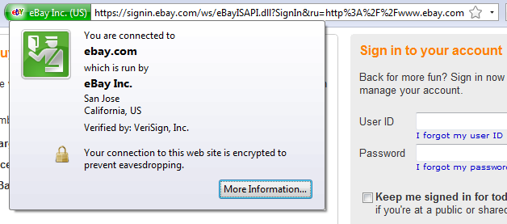

RSA Used by eBay
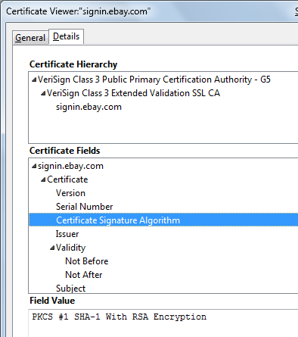

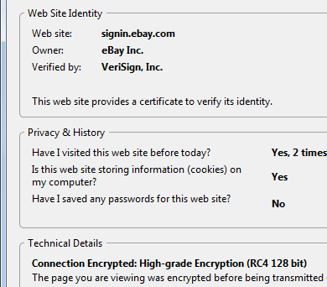

RC4 Used by eBay

Elliptic Curve Cryptography

An elliptic curve is a function drawn on an X-Y axis as a gently curved line

By adding the values of two points on the curve, you can arrive at a third point on the curve

The public aspect of an elliptic curve cryptosystem is that users share an elliptic curve and one point on the curve

Not common, but may one day replace RSA

Using Cryptography on Files and Disks

Encrypting Files: PGP and GPG

Pretty Good Privacy (PGP)

One of the most widely used asymmetric cryptography system for files and e-mail messages on Windows systems

GNU Privacy Guard (GPG)

A similar open-source program

PGP and GPG use both asymmetric and symmetric cryptography

Encrypting Files: Encrypting File System (EFS)

Part of Windows

Uses the Windows NTFS file system

Because EFS is tightly integrated with the file system, file encryption and decryption are transparent to the user

EFS encrypts the data as it is written to disk

On Macs, Filevault encrypts a user's home folder

Whole Disk Encryption

Windows BitLocker

A hardware-enabled data encryption feature

Can encrypt the entire Windows volume

Includes Windows system files as well as all user files

Encrypts the entire system volume, including the Windows Registry and any temporary files that might hold confidential information

TrueCrypt

Open-source, free, and can encrypt folders or files

Trusted Platform Module (TPM)

A chip on the motherboard of the computer that provides cryptographic services

If the computer does not support hardware-based TPM then the encryption keys for securing the data on the hard drive can be stored by BitLocker on a USB flash drive

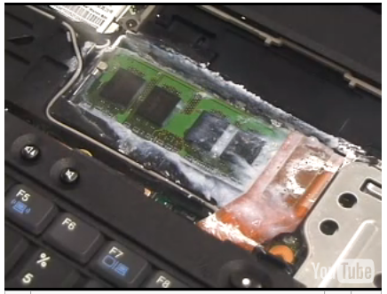
Cold Boot Attack

Can defeat all currently available whole disk encryption techniques (link Ch 11i)

Last modified 4-17-09

