Objectives

Define digital certificates

List the various types of digital certificates and how they are used

Describe the components of Public Key Infrastructure (PKI)

List the tasks associated with key management

Describe the different cryptographic transport protocols
Digital Certificates

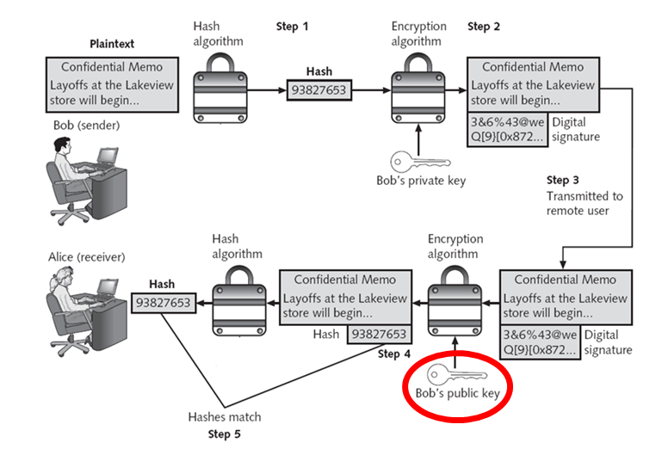
Weakness of Digital Signatures

Digital signatures require a reliable way to get public keys

A forged public key could be used to forge a digital signature

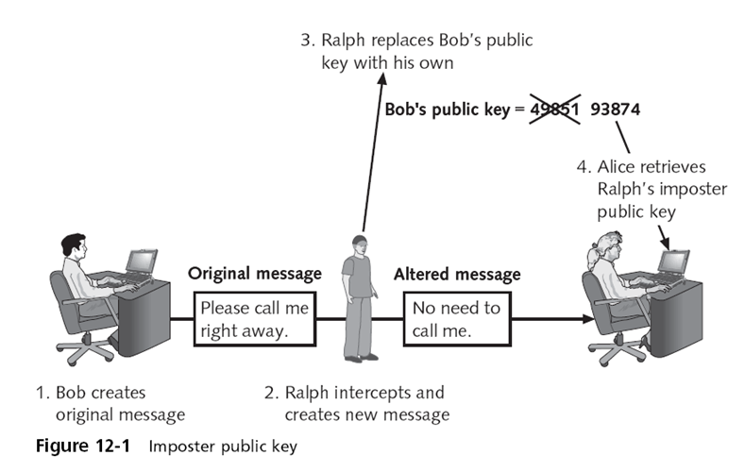

Digital Certificates

Can be used to associate or “bind” a user’s identity to a public key

The user’s public key that has itself been “digitally signed” by a reputable source entrusted to sign it

Digital certificates make it possible for Alice to verify Bob’s claim that the key belongs to him

When Bob sends a message to Alice he does not ask her to retrieve his public key from a central site

Instead, Bob attaches the digital certificate to the message

A digital certificate typically contains the following information:

Owner’s name or alias

Owner’s public key

Name of the issuer

Digital signature of the issuer

Serial number of the digital certificate

Expiration date of the public key

Authorizing, Storing, and Revoking Digital Certificates

Certificate Authority (CA)

An entity that issues digital certificates for others

A user provides information to a CA that verifies her identity

The user generates public and private keys and sends the public key to the CA

The CA inserts this public key into the certificate

Registration Authority (RA)

Handles some CA tasks such as processing certificate requests and authenticating users

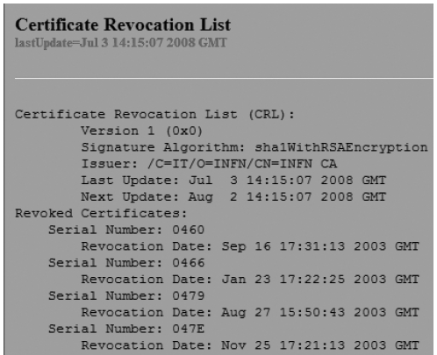
Certificate Revocation List (CRL)

Lists revoked certificates

Can be accessed to check the certificate status of other users

Most CRLs can either be viewed or downloaded directly into the user’s Web browser

Certificate Repository (CR)

A publicly accessible directory that contains the certificates and CRLs published by a CA

CRs are often available to all users through a Web browser interface (link Ch 12c)

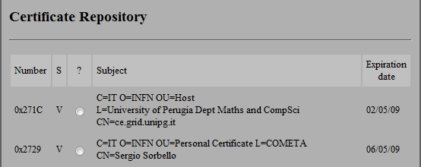

Uses of Digital Certificates

Bind a user's identity to a public key

Encrypt channels to provide secure communication between clients and servers

Encrypt messages for secure Internet e-mail communication

Verify the identity of clients and servers on the Web

Verify the source and integrity of signed executable code

Types of Digital Certificates

Personal digital certificates

Used to send email from one person to another

Free from Thawte (Link Ch 12a)

Server digital certificates

Used by Web servers to make HTTPS connections

$250 / year from Thawte

Software publisher digital certificates

$300 / year from Thawte

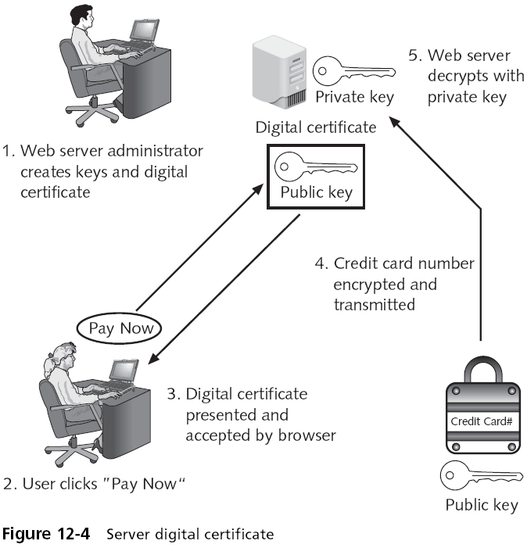

Extended Validation SSL

Company must be audited and follow EV standards

Company can't be "located in a country or be part of an industry identified on a government prohibited list"

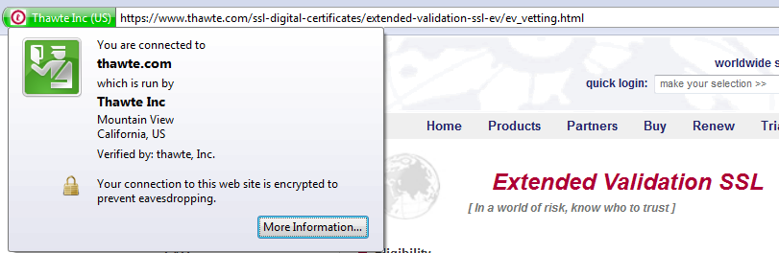
$900 / year, see Link Ch 12b

Single-sided certificate

Contains both the signature and the encryption information

Dual-sided certificates

Certificates in which the functionality is split between two certificates

Signing certificate

Encryption certificate

Types of Digital Certificates (continued)

Dual-sided certificate advantages:

Reduce the need for storing multiple copies of the signing certificate

Facilitate certificate handling in organizations

X.509 Digital Certificates

The most widely accepted format for digital certificates
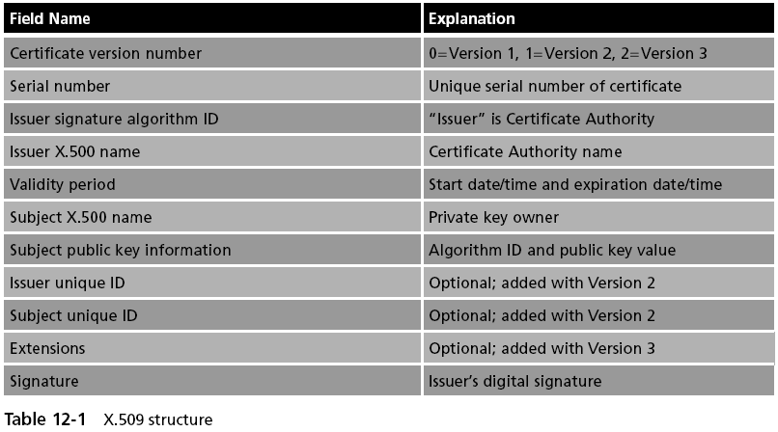

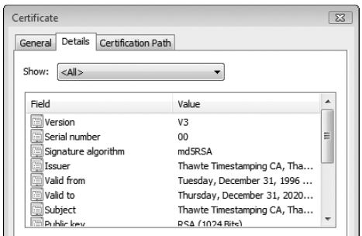

Public Key Infrastructure (PKI)

Managing Digital Certificates

For Alice and Bob to use asymmetric cryptography:

Alice and Bob must generate public and private keys

A Certificate Authority (CA) or Registration Authority (RA) must verify the identities of Alice and Bob

The certificates must be placed in a Certificate Repository (CR)

When they expire, they must be placed on a Certificate Revocation List (CRL)

All these things are done by Public key infrastructure (PKI)

Public Key Infrastructure (PKI)

Public key infrastructure involves

Public-key cryptography standards

Trust models

Key management

Public Key Infrastructure (PKI)

A framework for all of the entities involved in digital certificates to create, store, distribute, and revoke digital certificates

Includes hardware, software, people, policies and procedures

PKI is digital certificate management

Public-Key Cryptographic Standards (PKCS)

A numbered set of PKI standards that have been defined by the RSA Corporation

These standards are based on the RSA public-key algorithm
See pages 411-412 in textbook for complete list
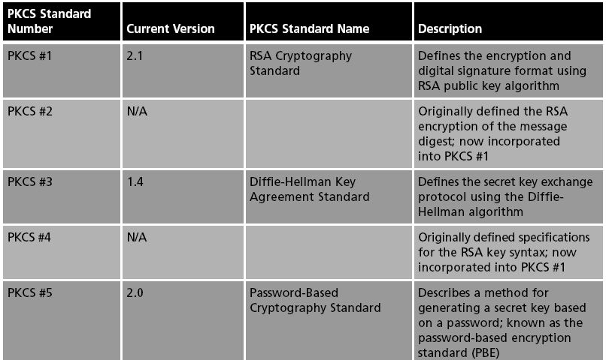

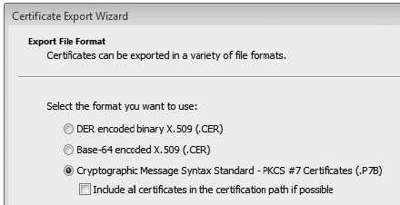
PKCS in Windows 7

Start

Internet Options

Content Tab

Certificates

Select a Cerrtificate

Export

Trust Models

Trust may be defined as confidence in or reliance on another person or entity

Trust model

Refers to the type of trusting relationship that can exist between individuals or entities

Direct trust

A relationship exists between two individuals because one person knows the other person

Third party trust

Refers to a situation in which two individuals trust each other because each trusts a third party

Web of Trust

Direct trust is not easily scaled to multiple users who each have digital certificates

PGP uses a "Web of Trust" in which people trust "friends of friends"

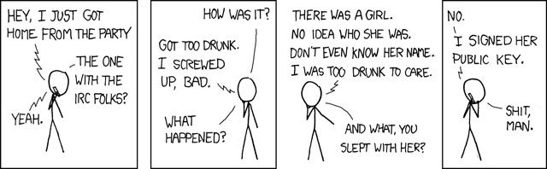
Not very secure or scalable (comic from xkcd.org)

Trust Models

Three PKI trust models that use a CA

Hierarchical trust model

Distributed trust model

Bridge trust model

Hierarchical Trust Model

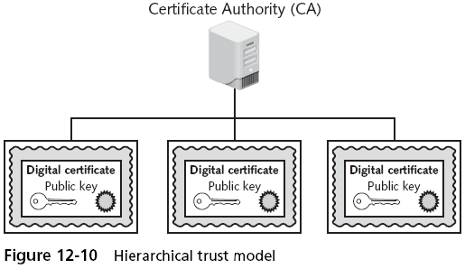
One master "root" CA signs all digital certificates with a single key

Single point of failure

Distributed Trust Model

Used on the Internet

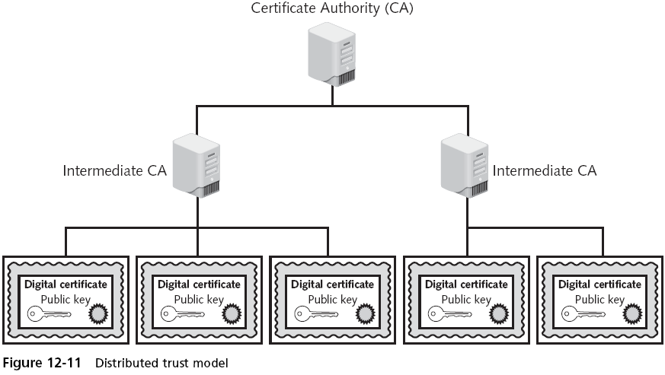

Trusted Root Certification Authorities

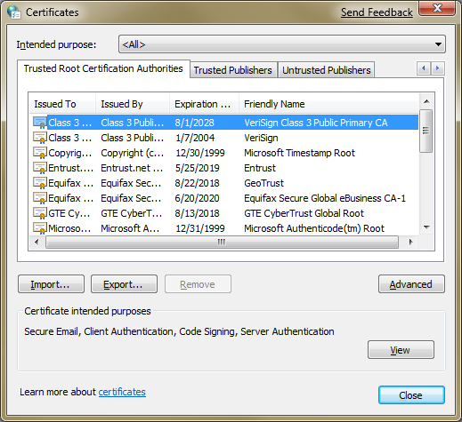
In Windows 7 Beta:

Start

Internet Options

Content Tab

Publishers

Bridge Trust Model

Used to link federal and state governments

Links military and civilian ID cards

(see next page)

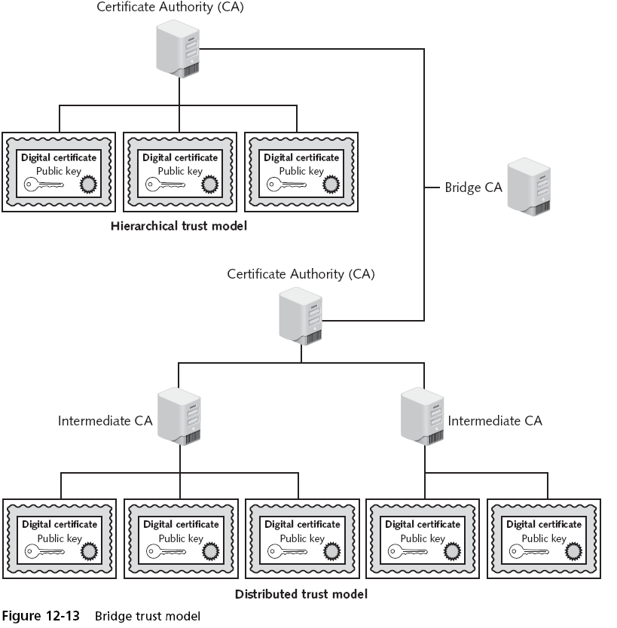

Managing PKI

Certificate policy (CP)

A published set of rules that govern the operation of a PKI

Provides recommended baseline security requirements for the use and operation of CA, RA, and other PKI components

Certificate practice statement (CPS)

Describes in detail how the CA uses and manages certificates

A more technical document than a CP

Certificate Life Cycle

Creation

Suspension

Certificate cannot be used while suspended

When an employee goes on leave

Revocation

Certificate goes on Certificate Revocation List (CRL)

When a private key is lost

Expiration
Key Management

Key Storage

Public keys can be stored by embedding them within digital certificates

While private keys can be stored on the user’s local system

The drawback to software-based storage is that it may leave keys open to attacks

Storing keys in hardware is an alternative to software-based storage

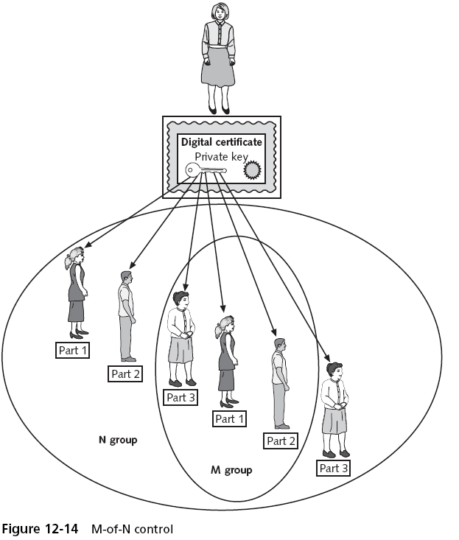
Private keys can be stored on smart cards or in tokens

Key Handling Procedures

Escrow

Private key is split in halves and stored by two separate trusted parties

Some people want the government to have everyone's keys in escrow so they can read all encrypted documents

Expiration

Renewal

Key Handling Procedures

Revocation

Recovery

Key recovery agent (KRA)

A highly trusted person authorized to recover others' keys

M-of-N control

A certain number of people need to agree to recover a key

Suspension

Destruction
Cryptographic Transport Protocols

File Transfer Protocols

File Transfer Protocol (FTP)

Part of the TCP/IP suite

Used to connect to an FTP server

Vulnerabilities

Usernames, passwords, and files being transferred are in cleartext

Files being transferred by FTP are vulnerable to man-in-the-middle attacks

One of the ways to reduce the risk of attack is to use encrypted Secure FTP (SFTP)

Secure Sockets Layer (SSL)

A protocol developed by Netscape for securely transmitting documents over the Internet

Uses a public key to encrypt data that is transferred over the SSL connection

Transport Layer Security (TLS)

A protocol that guarantees privacy and data integrity between applications communicating over the Internet

An extension of SSL

Are often referred to as SSL/TLS or TLS/SSL

A second protocol that can be used with SFTP is Secure Shell (SSH)

Also called SFTP/SSH

SSH

A UNIX-based command interface and protocol for securely accessing a remote computer

Suite of three utilities: slogin, scp, and ssh

Both the client and server ends of the connection are authenticated using a digital certificate

Passwords are protected by being encrypted

SSH Commands
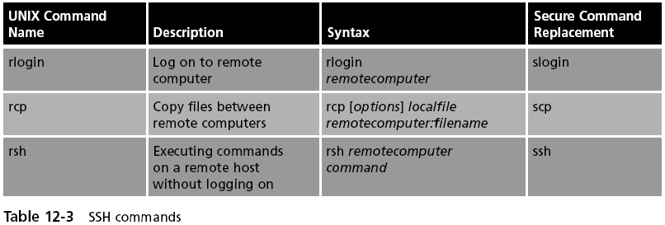

Web Protocols

Another use of SSL is to secure Web HTTP communications between a browser and a Web server

Hypertext Transport Protocol over Secure Sockets Layer

“Plain” HTTP sent over SSL/TLS

Secure Hypertext Transport Protocol

Allows clients and the server to negotiate independently encryption, authentication, and digital signature methods, in any combination, in both directions

VPN Protocols

Point-to-Point Tunneling Protocol (PPTP)

Most widely deployed tunneling protocol

Allows IP traffic to be encrypted and then encapsulated in an IP header to be sent across a public IP network such as the Internet

Based on the Point-to-Point Protocol (PPP)
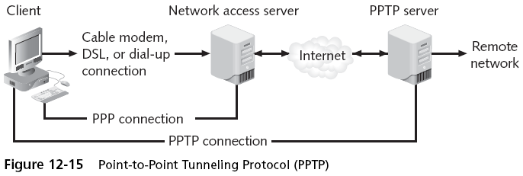

Point-to-Point Protocol over Ethernet (PPPoE)

Another variation of PPP that is used by DSL or cable modem connections

No encryption

Link Ch 12f

Layer 2 Tunneling Protocol (L2TP)

Merges the features of PPTP with Cisco’s Layer 2 Forwarding Protocol (L2F)

L2TP is not limited to working with TCP/IP-based networks, but supports a wide array of protocols

An industry-standard tunneling protocol that allows IP traffic to be encrypted

And then transmitted over any medium that supports point-to-point delivery

IP Security (IPsec)

A set of protocols developed to support the secure exchange of packets

Because it operates at a low level in the OSI model

IPsec is considered to be a transparent security protocol for applications, users, and software

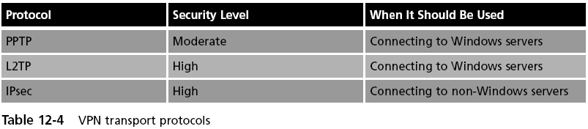
IPsec provides three areas of protection:

Authentication, confidentiality, and key management

E-mail Transport Protocol

S/MIME (Secure/Multipurpose Internet Mail Extensions)

One of the most common e-mail transport protocols

Uses digital certificates to protect the e-mail messages

Last modified 4-24-09

