Objectives

Define environmental controls

Describe the components of redundancy planning

List disaster recovery procedures

Describe incident response procedures
Environmental Controls

Environmental Controls

Fire suppression

Electromagnetic shielding

Configuring HVAC (Heating, Ventilating, and Air Conditioning) systems

Fire Suppression

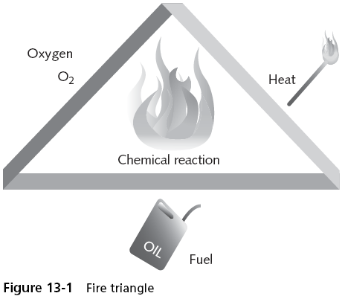
Damage inflicted as a result of a fire continues to remain high

Fire suppression is an important concern for the safety of employees and business continuity

In order for a fire to occur, four entities must be present at the same time:

A type of fuel or combustible material

Sufficient oxygen to sustain the combustion

Enough heat to raise the material to its ignition temperature

A chemical reaction that is the fire itself

Fire Triangle
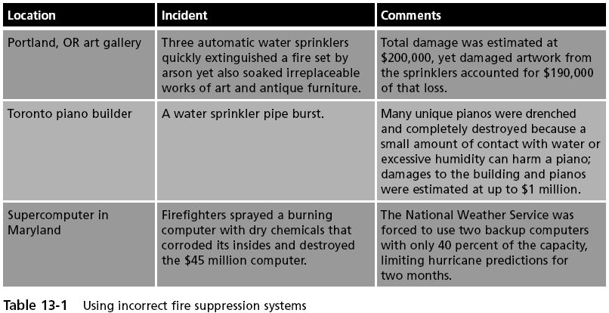

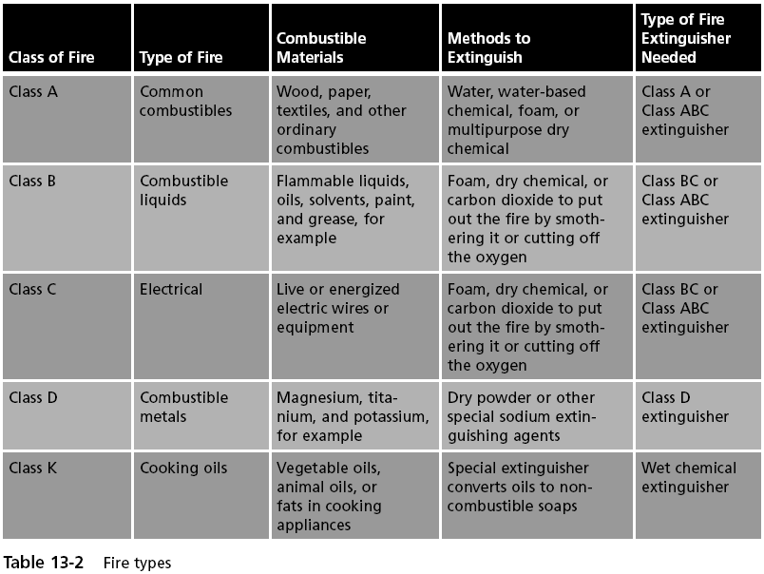
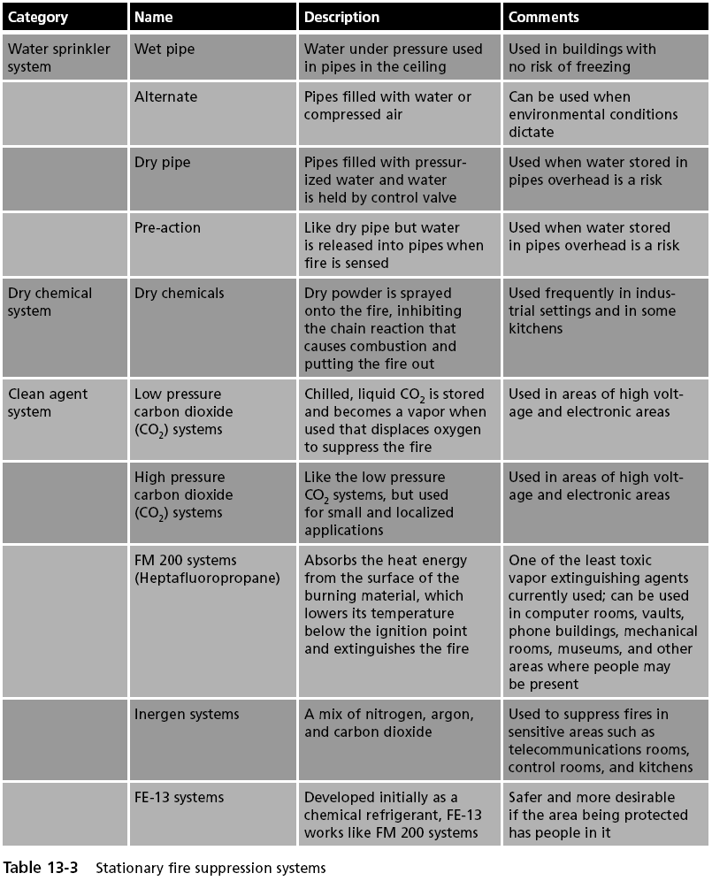

Fire Suppression

In a server closet or room that contains computer equipment

Using a handheld fire extinguisher is not recommended because the chemical contents can contaminate electrical equipment

Instead, stationary fire suppression systems should be:

Integrated into the building’s infrastructure

Release the suppressant in the room

Electromagnetic Shielding

Computer systems, cathode ray tube monitors, printers, and similar devices all emit electromagnetic fields

That are produced by signals or the movement of data

Van Eck phreaking

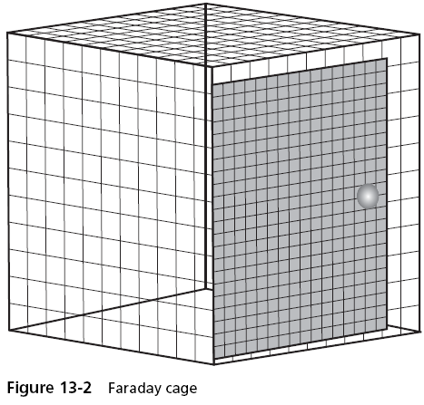
A form of eavesdropping in which special equipment is used to pick up telecommunication signals or data within a computer device

By monitoring the electromagnetic fields

Faraday cage

A metallic enclosure that prevents the entry or escape of an electromagnetic field

Consists of a grounded fine-mesh copper screening

Telecommunications Electronics Material Protected from Emanating Spurious Transmissions (TEMPEST)

A secret US government standard

Intended to “reduce the conducted and radiated emissions from within the sensitive environment to an undetectable level outside the shielded enclosure in uncontrolled areas”

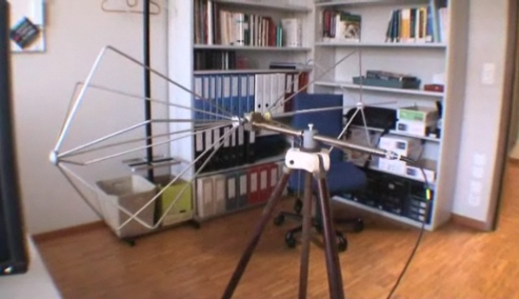
Compromising Electromagnetic Emanations of Keyboards

Link Ch 13e



HVAC

Heating, ventilation, and air conditioning (HVAC) systems

Provide and regulate heating and cooling for data centers

Controlling environmental factors can reduce electrostatic discharge (ESD)

The sudden flow of electric current between two objects, which can destroy electronic equipment

Don't put electronics above ceiling tiles

Smoke in the plenum can spread rapidly
Redundancy Planning

Building excess capacity in order to protect against failures

Redundancy for

Servers

Storage

Networks

Power

Sites

Servers

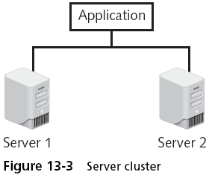
A crash of a single server that supports a critical application can have a significant impact

Single point of failure

Redundant Servers

Can replace failed server, but takes time to deploy

Server Clusters

Server cluster

The combination of two or more servers that are interconnected to appear as one

There are two types of server clusters:

Asymmetric server cluster

A standby server exists only to take over for another server in the event of its failure

Failover cluster

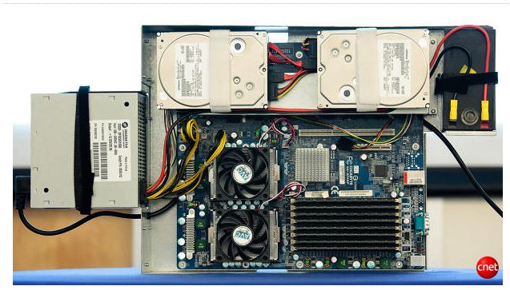
Symmetric server cluster

Every server in the cluster performs useful work

Load-balancing cluster

Google's Server Cluster

Over 450,000 servers

Links Ch 13g, 13h

Storage

Mean time between failures (MTBF)

Average time until a component fails

Fault tolerance

The ability to endure failures

Prevents a single problem from escalating into a major failure

Can often be achieved by maintaining redundancy

RAID (Redundant Array of Independent Drives)

Uses multiple hard disk drives for increased reliability and performance

The most common levels of RAID are:

RAID Level 0 (striped disk array without fault tolerance)

RAID Level 1 (mirroring)

RAID Level 5 (independent disks with distributed parity)

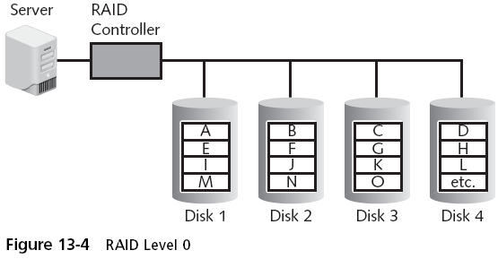
RAID 0+1 (high data transfer)

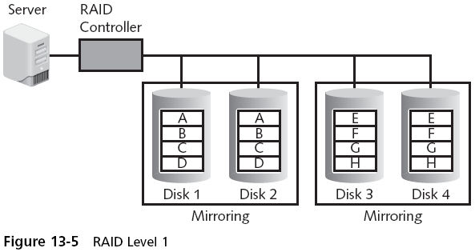

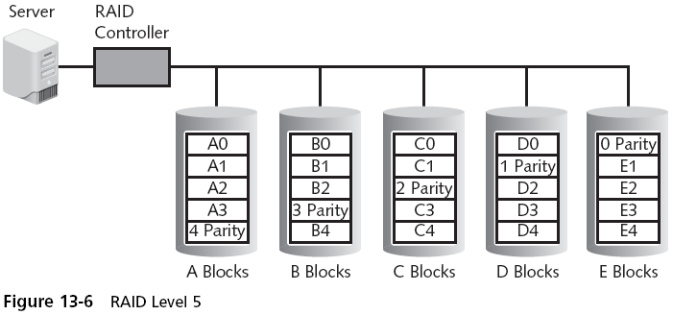

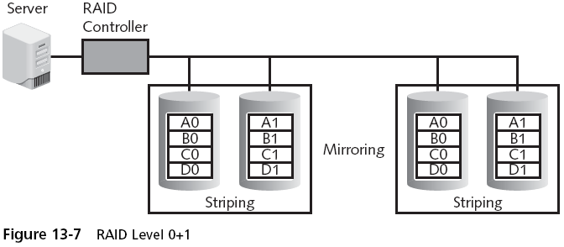

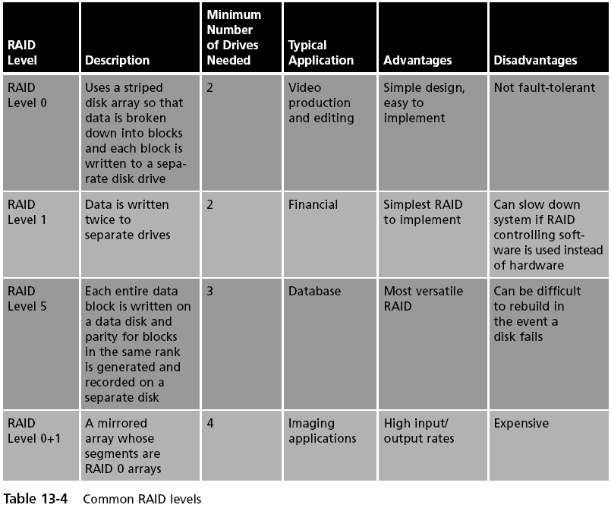

Networks

Redundant network

“Waits” in the background during normal operations

Uses a replication scheme to keep its copy of the live network information current

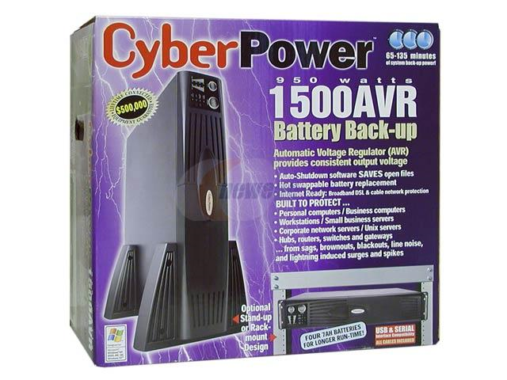
Virtually all network components can be duplicated to provide a redundant network

In addition, some organizations contract with more than one Internet Service Provider (ISP) for remote connectivity

Power

Uninterruptible power supply (UPS)

Maintains power to equipment if the line power fails

Off-line UPS

Switches to battery power rapidly when it detects a power outage

On-line UPS

Always uses battery power, charges when the line power is available

UPS Tasks

When the power fails, A UPS can:

Send a message to the network administrator’s computer, or page or telephone the network manager

Notify all users that they must finish their work immediately and log off

Prevent any new users from logging on

Disconnect users and shut down the server

Because a UPS can only supply power for a limited amount of time, some organizations turn to using a backup generator to create power

Sites

Redundancy can also be planned for the entire site itself

Hot site

Generally run by a commercial disaster recovery service

A whole duplicated office ready to go (link Ch 13j)

Cold site

Provides office space but the customer must provide and install all the equipment needed to continue operations

Warm site

Has all of the equipment installed but does not have active Internet or telecommunications facilities, and does not have current backups of data
Disaster Recovery Procedures

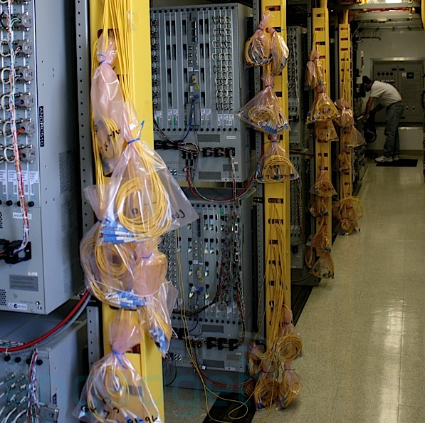
AT&T's Network Disaster Recovery Team

Trucks and vans with enough equipment and personnel to set up a main telephone central office in a vacant lot in a few hours

Link Ch 13i

Disaster recovery

Procedures and processes for restoring an organization’s IT operations following a disaster

Focuses on restoring computing and technology resources to their former state

Disaster recovery procedures include

Planning

Disaster exercises

Data backups

Planning

Disaster recovery plan (DRP)

A written document that details the process for restoring IT resources

Following an event that causes a significant disruption in service

Comprehensive in its scope, a DRP is intended to be a detailed document that is updated regularly

All disaster recovery plans are different

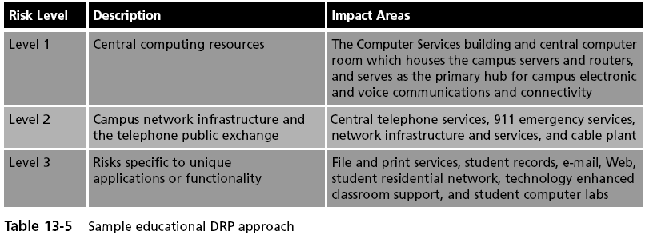
Sample DRP

Most disaster recovery plans address the common features included in the following typical outline:

Unit 1: Purpose and Scope

Unit 2: Recovery Team

Unit 3: Preparing for a Disaster

Unit 4: Emergency Procedures

Unit 5: Restoration Procedures

It is important that a good DRP contains sufficient detail

Sample DRP Excerpt
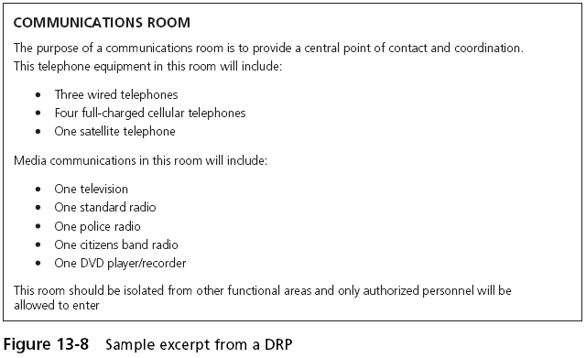

Disaster Exercises

Disaster exercises are designed to test the effectiveness of the DRP

Objectives of these disaster exercises:

Test the efficiency of interdepartmental planning and coordination in managing a disaster

Test current procedures of the DRP

Determine the strengths and weaknesses in responses

Data Backups

Information copied to a different medium and stored at an offsite location so that it can be used in the event of a disaster

Five basic questions that should be answered:

What information should be backed up?

How often should it be backed up?

What media should be used?

Where should the backup be stored?

What hardware or software should be used?

Fault Tolerance v. Backup

RAID is not a backup!

RAIDs provide fault tolerance

Data remains available even when a hard drive fails

Backups provide disaster recovery

Data can be restored even if the building burns down

Backup software can internally designate which files have already been backed up

By setting an archive bit in the properties of the file

Backing up to magnetic tape has been the mainstay of data backups for over 30 years

Grandfather-father-son backup system

Divides backups into three sets: a daily backup (son), a weekly backup (father), and a monthly backup (grandfather)

Types of Data Backups
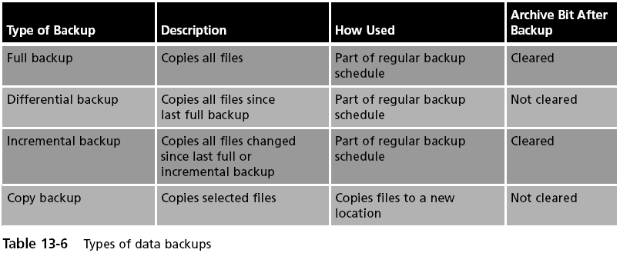

Recovery point objective (RPO)

The maximum length of time that an organization can tolerate between backups

Recovery time objective (RTO)

The length of time it will take to recover the data that has been backed up

An alternative to using magnetic tape is to back up to magnetic disk

Such as a large hard drive or RAID configuration

This is known as disk to disk (D2D)

D2D offers better RPO than tape

However, as with any hard drive, the D2D drive may be subject to failure or data corruption

Disk to disk to tape (D2D2T)

Combines the best of magnetic tape and magnetic disk

Uses the magnetic disk as a temporary storage area

Continuous data protection (CDP)

Performs continuous data backups that can be restored immediately

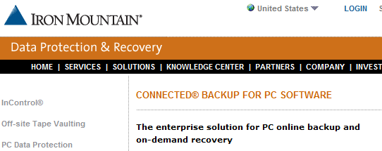
Web-based Backup

Ch 13k

Incident Response Procedures

Incident Response Procedures

Incident response procedures include using forensic science and properly responding to a computer forensics event

What Is Forensics?

Forensics, also known as forensic science

The application of science to questions that are of interest to the legal profession

Computer forensics

Can attempt to retrieve information—even if it has been altered or erased—that can be used in the pursuit of the attacker or criminal

Also used to limit damage and loss of control of data

The importance of computer forensics is due in part to the following:

High amount of digital evidence

Increased scrutiny by the legal profession

Higher level of computer skill by criminals

Responding to a Computer Forensics Incident

Secure the crime scene

The computer forensics response team should be contacted whenever digital evidence needs to be preserved and serve as first responders

The physical surroundings of the computer should be clearly documented

Photographs of the area should be taken before anything is touched

The computer should be photographed from several angles

Cables connected to the computer should be labeled

Preserve the evidence

Team should first capture any volatile data

The team should next focus on the hard drive

Mirror image backups replicate all sectors of a computer hard drive, including all files and any hidden data storage areas

Chain of custody

Documents that the evidence was under strict control at all times and no unauthorized person was given the opportunity to corrupt the evidence

Examine for evidence

After a computer forensics expert creates a mirror image of a system:

Original system is secured

Mirror image is examined to reveal evidence

Includes searching word processing documents, e-mail files, spreadsheets, and other documents for evidence

Hidden clues can also be mined and exposed

Including the Windows page file

Another source of hidden data is called slack

Examine for evidence (continued)

RAM slack

Can contain any information that has been created, viewed, modified, downloaded, or copied since the computer was last booted

Drive file slack (sometimes called drive slack)

Contains remnants of previously deleted files or data from the format pattern associated with disk storage space that has yet to be used by the computer

An additional source of hidden clues can be gleaned from metadata, or data about data
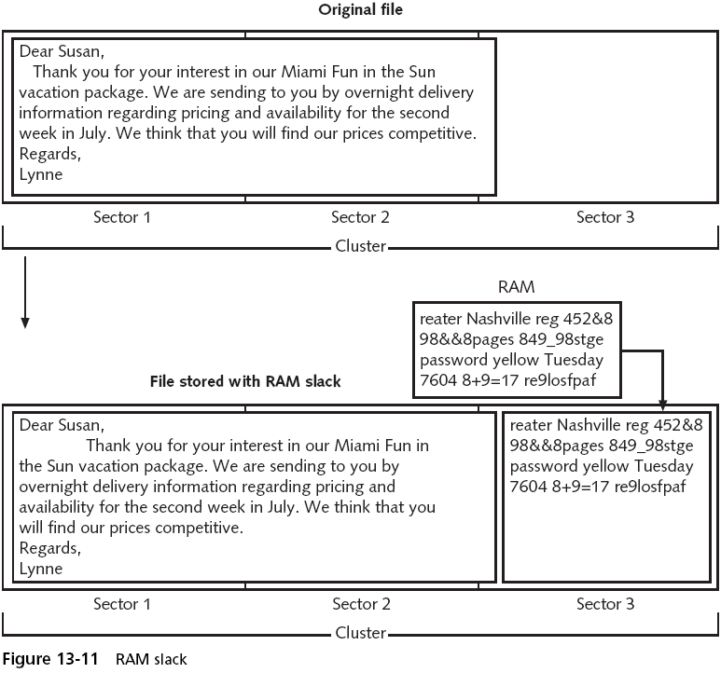

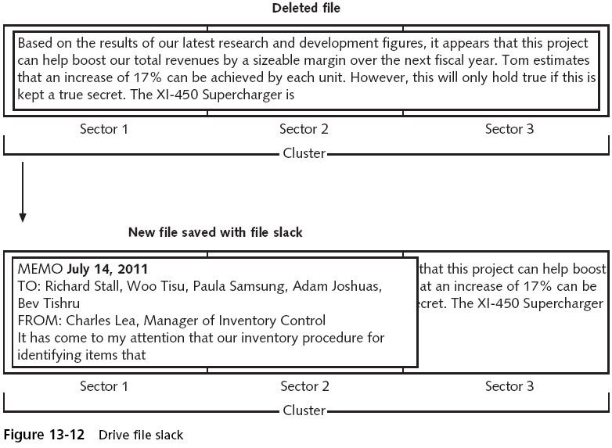

Last modified 4-30-09

