Objectives

Define organizational security policy

List the types of security policies

Describe how education and training can limit the impact of social engineering
Organizational Security Policies

Organizational Security Policies

Plans and policies must be established by the organization

To ensure that users correctly implement the hardware and software defenses

One of the key policies is an organizational security policy

Balancing Trust and Control

Three approaches to trust:

Trust everyone all of the time

Trust no one at any time

Trust some people some of the time

Deciding on the level of control for a specific policy is not always clear

The security needs and the culture of the organization play a major role when deciding what level of control is appropriate

What Is a Security Policy?

Security policy

A written document

Plan to protect information technology assets

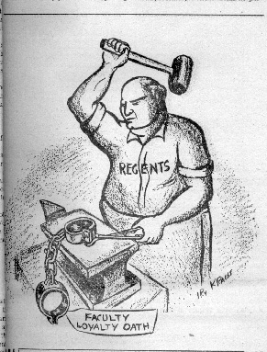
Security policy functions:

States overall intention and direction

Details specific risks and how to address them

Creates a security-aware organizational culture

Ensure that employee behavior is directed and monitored

UC Berkeley Loyalty Oath

In 1949, the University of California required all University employees to sign an oath

In 1950, thirty-one "non-signer" professors were dismissed

Another teacher was fired for the same reason in 2008 at Cal State

Links Ch 14a, 14b

Attitudes Toward Security
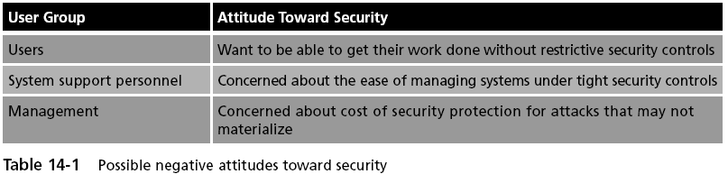

Terms Used to Describe Rules

Standard

A collection of requirements specific to the system or procedure that must be met by everyone

Example: Only fully patched laptops can connect to the network

Guideline

A collection of suggestions that should be implemented (not required)

Policy

Document that outlines specific requirements or rules that must be met

Frequently refers to standards and guidelines

What Policies Do

Communicate a consensus of judgment

Define appropriate behavior for users

Identify what tools and procedures are needed

Provide directives for Human Resource action in response to inappropriate behavior

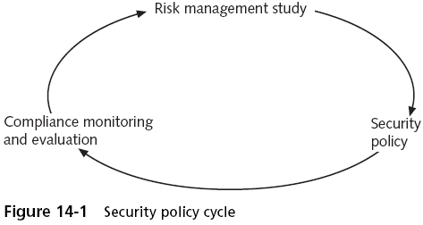
Policies may be helpful in the event that it is necessary to prosecute violators

The Security Policy Cycle

First phase--risk management study

Asset identification

Threat identification

Vulnerability appraisal

Risk assessment

Risk mitigation

Second phase--use the information from the risk management study to create the policy

Final phase--review the policy for compliance

Security Policy Cycle

Principles for Security Policy Development
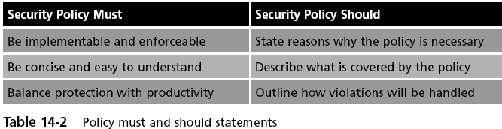

Development Team

Designing a security policy should be the work of a team

Including Management, Legal, Users

The team decides on scope and goals of the policy

Statements regarding due care are often included

Due Care

The obligations that are imposed on owners and operators of assets to exercise reasonable care of the assets and take necessary precautions to protect them

Link Ch 14c

Due Care Examples

Employees will exercise due care in opening email attachments

Technicians will exercise due care when installing new equipment

Don't leave password on a note taped to the monitor

Students will exercise due care when using computers in a lab setting

Don't let other students see your password

Guidelines for Designing a Security Policy

Notify users in advance that a new security policy is being developed

Explain why the policy is needed

Prior to deployment, give all users at least two weeks to review and comment
Types of Security Policies

Types of Security Policies

The term security policy becomes an umbrella term for all of the subpolicies included within it

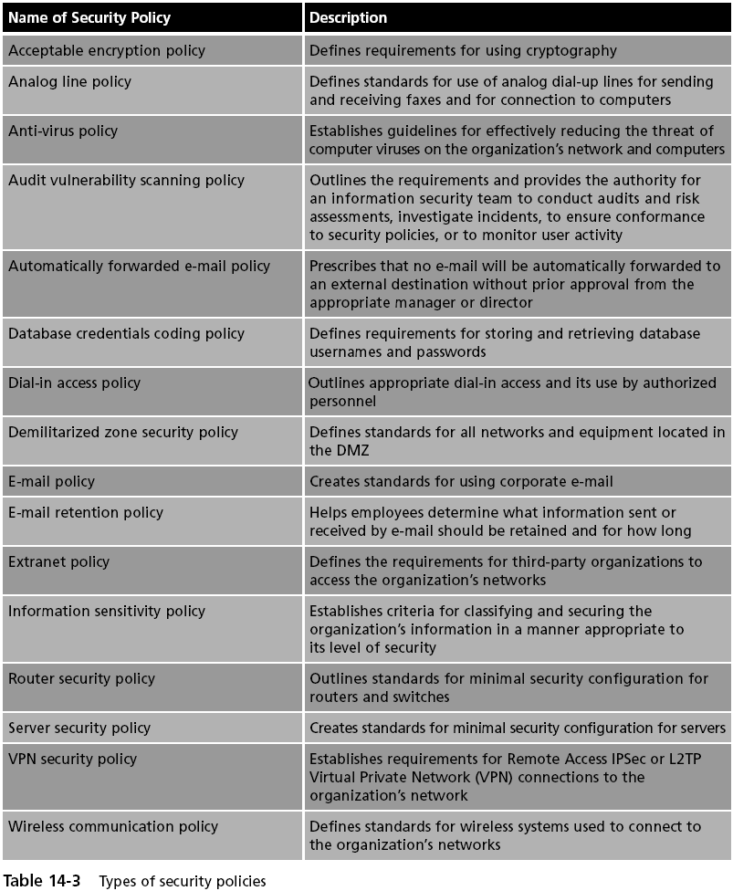

Most organizations have security policies that address:

Acceptable use

Security-related human resources

Password management and complexity

Personally identifiable information

Disposal and destruction

Service level agreements

Classification of information

Change management

Ethics

Acceptable Use Policy (AUP)

Defines the actions users may perform while accessing systems and networking equipment

May have an overview regarding what is covered by this policy

The AUP usually provides explicit prohibitions regarding security and proprietary information

Unacceptable use may also be outlined by the AUP

Acceptable use policies are generally considered to be the most important information security policies

Security-Related Human Resource Policy

Information about technology resources

How resources are used

Acceptable use and security policies

Penalties for violating policies

Due process

Treating all accused persons in an equal fashion, using established rules and principles

Due diligence

Any investigation into suspicious employee conduct will examine all material facts

Password Management and Complexity Policy

Can clearly address how passwords are created and managed

The policy should also specify what makes up a strong password

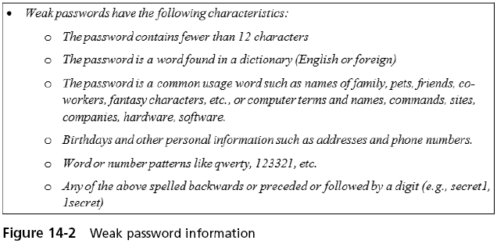

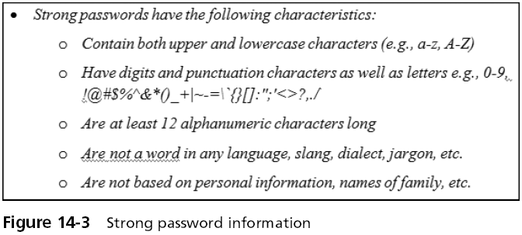

Personally Identifiable Information (PII) Policy
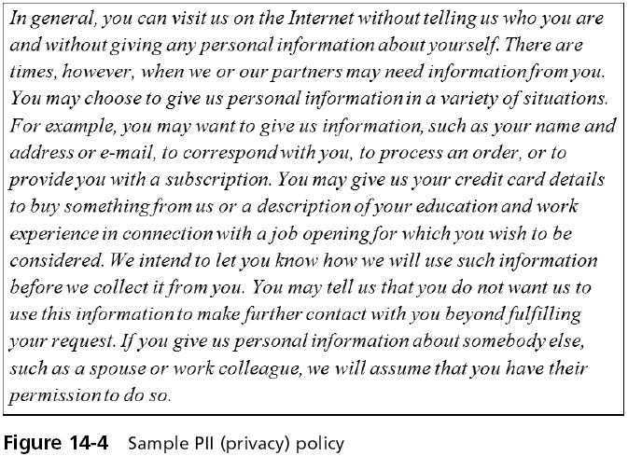

Disposal and Destruction Policy

Addresses the disposal of resources that are considered confidential

Often covers how long records and data will be retained

Involves how to dispose of equipment

Such as destroying hard drives (link Ch 14d)

Service Level Agreement (SLA) Policy

Service level agreement (SLA)

A service contract between a vendor and a client that specifies what services will be provided, the responsibilities of each party, and any guarantees of service

Service level agreement (SLA) policy

An organizational policy that governs the conditions to be contained in an SLA

Many SLA policies contain tiers of service

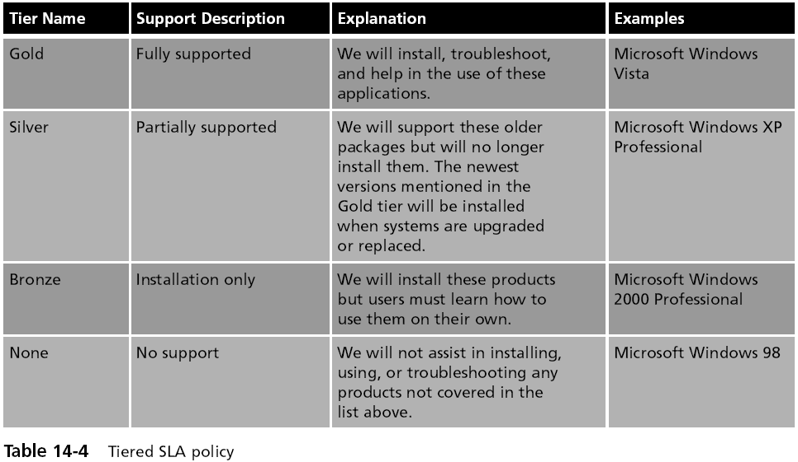
Classification of Information Policy

Designed to produce a standardized framework for classifying information assets

Generally, this involves creating classification categories such as high, medium, or low

And then assigning information into these categories

Change Management Policy

Change management

Refers to a methodology for making changes and keeping track of those changes, often manually

Seeks to approach changes systematically and provide documentation of the changes

Change management policy

Outlines how an organization will manage changes in a “rational and predictable” manner so employees and clients can plan accordingly

Ethics Policy

Values

A person’s fundamental beliefs and principles used to define what is good, right, and just

Morals

Values that are attributed to a system of beliefs that help the individual distinguish right from wrong

Ethics

The study of what a group of people understand to be good and right behavior and how people make those judgments

Ethics policy

A written code of conduct intended to be a central guide and reference for employees in support of day-to-day decision making

Intended to clarify an organization’s mission, values, and principles, and link them with standards of professional conduct

Education and Training

Organizational Training

Users need training in

The importance of securing information

Roles that they play in security

Steps to ward off attacks

All users need:

Continuous training in the new security defenses

To be reminded of company security policies and procedures

Traits of Learners
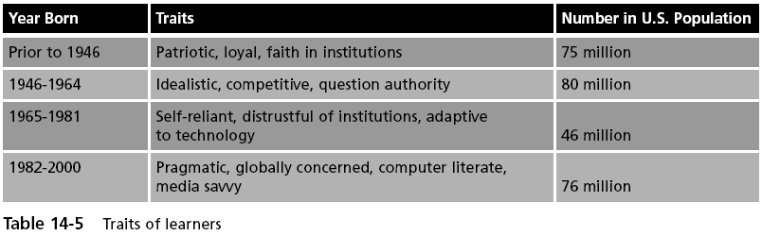

Training Styles

Pedagogical approach--treats students like children

Andragogical approach--helping adults learn

There are different learning styles

Visual learners

Auditory learners

Kinesthetic

Social Engineering

Tricking and deceiving someone to provide secure information

Phishing

Sending an e-mail or other messagee

Falsely claims to be from a legitimate enterprise

An attempt to trick the user into surrendering private information

Often links to a spoofed Web site

Variations on Phishing Attacks:

Spear phishing

Custom messages targeting specific people

Pharming

Planting false DNS entries to deflect traffic later

Data is stolen later from spoofed sites

Ways to Recognize Phishing Messages

Deceptive Web links

E-mails that look like Web sites

Fake sender’s address

Generic greeting

Pop-up boxes and attachments

Insecure Web sites (not HTTPS)

Urgent request
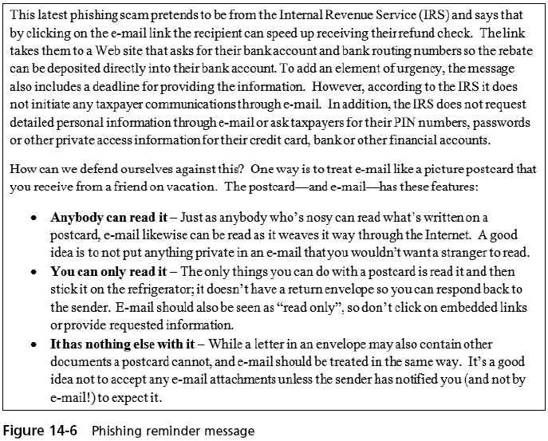

Other Forms of Social Engineering

Dumpster diving

Involves digging through trash receptacles to find computer manuals, printouts, or password lists that have been thrown away

Shoulder surfing

Watching an individual enter a security code or password on a keypad

Computer hoax

An e-mail message containing a false warning to the recipient of a malicious entity circulating through the Internet

Last modified 5-8-09

