Security Training at CCSF

Associate of Science Degree

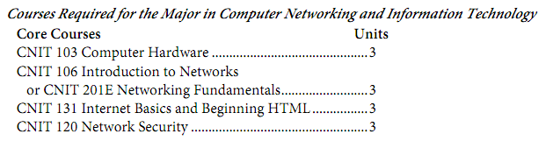

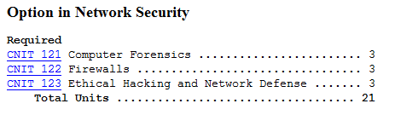

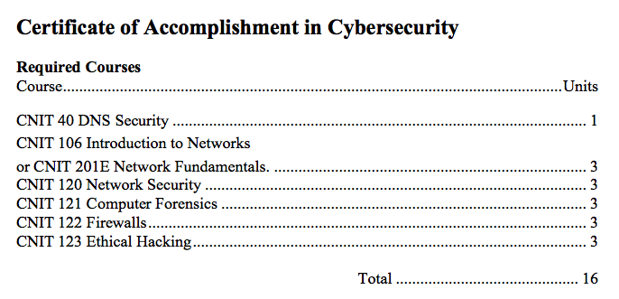


CNIT 120: Network Security

Fundamentals of Network Security

Preparation for Security+ Certification

Essential for any Information Technology professional

CNIT 40: DNS Security

Configure and defend DNS infrastructure

CNIT 121: Computer Forensics

Analyze computers for evidence of crimes

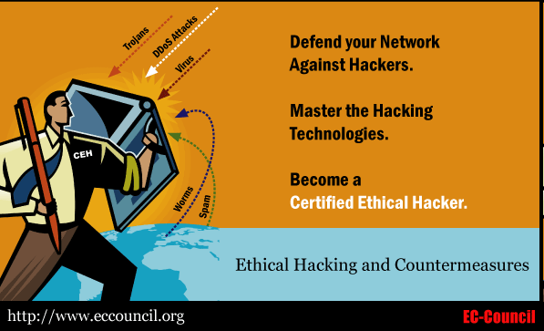
CNIT 122: Firewalls

Defend networks

Two Hacking Classes

Perform real cyberattacks and block them

CNIT 123: Ethical Hacking and Network Defense

CNIT 124: Advanced Ethical Hacking

Supplemental Materials

Projects from recent research

Students get extra credit by attending conferences

Certified Ethical Hacker

CNIT 123 and 124 help prepare students for CEH Certification

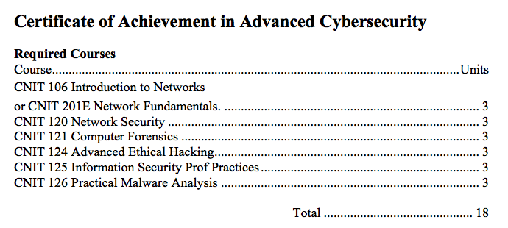

CNIT 125: Information Security Professional

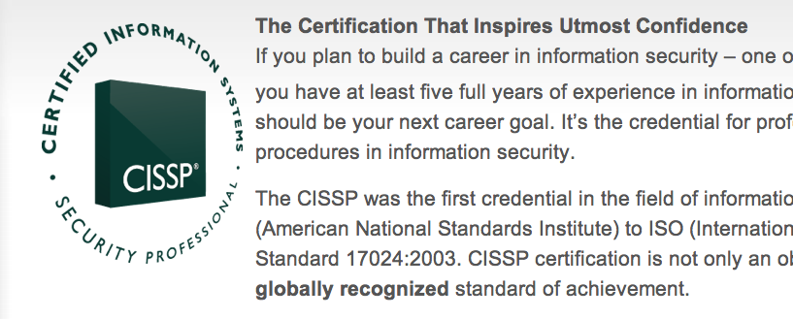
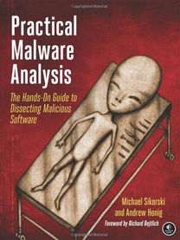
CISSP – the most respected certificate in information security

CNIT 126: Practical Malware Analysis

Incident response after intrusion

Exploring Core Security Principles

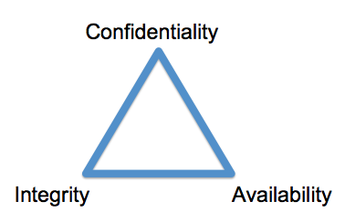
The CIA of Security

Confidentiality

Prevents unauthorized disclosure of data

Ensures that data is only viewable by authorized users

Some methods

Authentication combined with Access controls

Cryptography

Integrity

Assures that data has not been modified, tampered with, or corrupted

Only authorized users should modify data

Hashing assures integrity

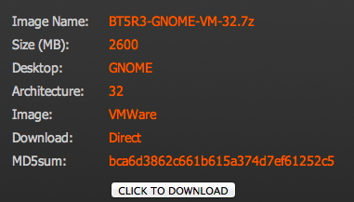
Hash types: MD5, SHA, HMAC

If data changes, the hash value changes

Hash Value for Download

Availability

Data and services are available when needed

Techniques:

Disk redundancies (RAID)

Server redundancies (clusters)

Site redundancies

Backups

Alternate power

Cooling systems

Balancing CIA

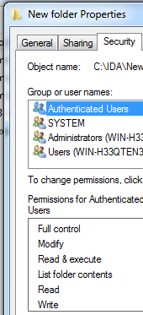
You can never have perfect security

Increasing one item lowers others

Increasing confidentiality generally lowers availability

Example: long ,complex passwords that are easily forgotten

Non-Repudiation

Prevents entities from denying that they took an action

Examples: signing a home loan, making a credit card purchase

Techniques

Digital signatures

Audit logs

Defense in Depth

Layers of protection

Example

Firewall

Antivirus

Deep Freeze

Implicit Deny

Anything not explicitly allowed is denied

Common Access Control Lists for

Firewalls

Routers

Microsoft file and folder permissions

Introducing Basic Risk Concepts

Risk

The likelihood of a threat exploiting a vulnerability, resulting in a loss

Threat

Circumstance or event that has the potential to compromise confidentiality, integrity, or availability

Insider threat

Vulnerability

A weakness

Risk Mitigation

Reduces chance that a threat will exploit a vulnerability

Done by implementing controls (also called countermeasures and safeguards)

Even if a threat can't be prevented, like a tornado

Risk can still be reduced with controls, like insurance, evacuation plans, etc.

Controls

Access controls

After Authentication, only authorized users can perform critical tasks

Business continuity and Disaster Recovery Plans

Reduce the impact of disasters

Antivirus software

Reduces the impact of malware
Exploring Authentication Concepts

Identification, Authentication, and Authorization

Identification

State your name (without proving it)

Authentication

Proves your identity (with a password, fingerprint, etc.)

Authorization

Grants access to resources based on the user's proven identity

Identity Proofing

Verifying that people are who they claim to be prior to issuing them credentials

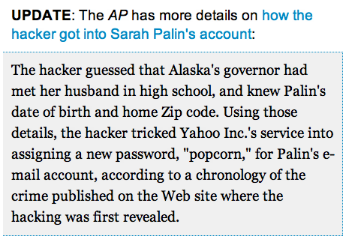
Or when replacing lost credentials

Sarah Palin's Email

Link Ch 1a

Three Factors of Authentication

Something you know

Such as a password

Weakest factor, but most common

Something you have

Such as a smart card

Something you are

Such as a fingerprint

Password Rules

Passwords should be strong

At least 8 characters, with three of: uppercase, lowercase, numbers, and symbols

Change passwords regularly

Don't reuse passwords

Change default passwords

Don't write down passwords

Don't share passwords

Account lockout policies

Block access after too many incorrect passwords are entered

Password history

Remembers previous passwords so users cannot re-use them

Account Lockout Policies

Account lockout threshold

The maximium number of times a wrong password can be entered (typically 5)

Account lockout duration

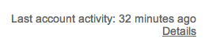
How long an account is locked (typically 30 min.)

Previous Logon Notification

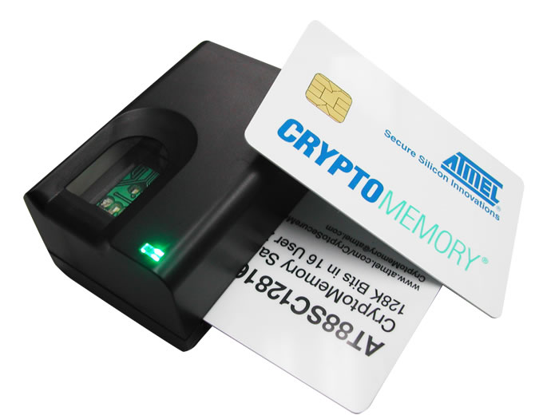
Gmail has it, at the bottom of the screen

Something You Have

Smart Card

Contains a certificate

Read by a card reader

Image from made-in-china.com/

Token or Key Fob

Image from tokenguard.com

Smart Cards

Embedded certificate

Public Key Infrastructure

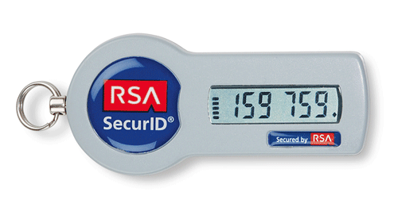
Allows issuance and management of certificates

CAC (Common Access Card)

Used by US Department of Defense

PIV (Personal Identity Verfication) card

Used by US federal agencies

Something You Are (Biometrics)

Physical biometrics

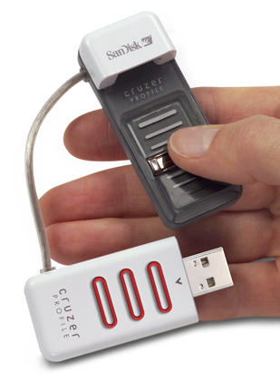
Fingerprint

Image from amazon.com

Retinal scanners

Iris scanners

Behavioral biometrics

Voice recognition

Signature geometry

Keystrokes on a keyboard

False Acceptance and False Rejection

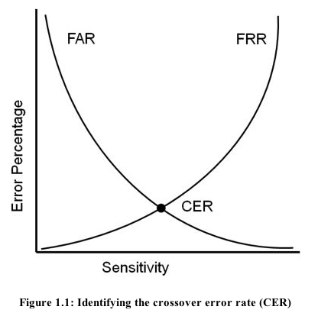
False Acceptance Rate

Incorrectly identifying an unauthorized user as authorized

False Rejection Rate

Incorrectly rejecting an authorized user

Multifactor Authentication

More than one of

Something you know

Something you have

Something you are

Two similar factors is not two-factor authentication

Such as password and PIN
Exploring Authentication Services

Authentication Services

Kerberos

Used in Windows Active Directory Domains

Used in UNIX realms

Developed at MIT

Prevents Man-in-the-Middle attacks and replay attacks

Kerberos Requirements

A method of issuing tickets used for authentication

Key Distribution Center (KDC) grants ticket-granting-tickets, which are presented to request tickets used to access objects

Time synchronization within five minutes

A database of subjects or users

Microsoft's Active Directory

Kerberos Details

When a user logs on

The KDC issues a ticket-granting-ticket with a lifetime of ten hours

Kerberos uses port 88 (TCP & UDP)

Kerberos uses symmetric cryptography

LDAP (Lightweight Directory Access Protocol)

Formats and methods to query directories

Used by Active Directory

An extension of the X.500 standard

LDAP v2 can use SSL encryption

LDAP v3 can use TLS encryption

LDAP uses ports 389 (unencrypted) or 636 (encrypted) (TCP and UDP)

Mutual Authentication

Both entities in a session authenticate prior to exchanging data

For example, both the client and the server

MS-CHAPv2 uses mutual authentication

Single Sign-On

Users can access multiple systems after providing credentials only once

Federated Identity Management System

Provides central authentication in nonhomogeneous environments

IEEE 802.1x

Port-based authentication

User conects to a specific access point or logical port

Secures authentication prior to the client gaining access to a network

Most common on wireless networks

WPA Enterprise or WPA2 Enterprise

Requires a RADIUS (Remote Authentication Dial-in User Service) or other centralized identification server
Remote Access Authentication

Remote Access

Clients connect through VPN (Virtual Private Network) or dial-up

A VPN allows a client to access a private network over a public network, usually the Internet

Remote Access Authentication Methods

PAP (Password Authentication Protocol)

Passwords sent in cleartext, rarely used

CHAP (Challenge Handshake Protocol)

Server challenges the client

Client responds with appropriate authentication information

MS-CHAP

Microsoft's implementation of CHAP

Deprecated

MS-CHAPv2

More secure than MS-CHAP

Seriously broken by Moxie Marlinspike at Defcon 2012 (Link Ch 1c)

He recommends using certificate authentication instead

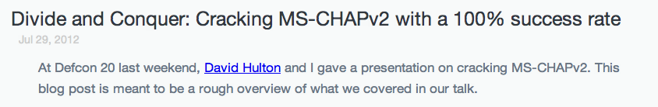

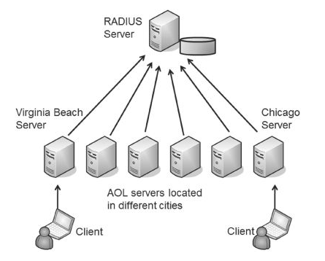
RADIUS (Remote Authentication Dial-in User Service)

Central authentication for multiple remote access servers

Encrypts passwords, but not the entire authentication process

Uses UDP

TACACS (Terminal Access Controller Access-Control System)

Was used in UNIX systems, rare today

TACACS+

Cisco proprietary alternative to RADIUS

Interacts with Kerberos

Encrypts the entire authentication process

Uses TCP

Uses multiple challenges and responses during a session

AAA Protocols: Authentication, Authorization, and Accounting

Authentication

Verifies a user's identification

Authorization

Determines if a user should have access

Accounting

Tracks user access with logs

RADIUS and TACACS+ are both AAA protocols

Kerberos doesn't provide accounting, but is sometimes called an AAA protocol

Last modified 8-22-13

